### Commonwealth Association of Legislative Counsel

**THE LOOPHOLE**



November 2020 (Issue No. 3 of 2020)

**THE LOOPHOLE—Journal of the Commonwealth Association of Legislative Counsel**

#### Issue No. 3 of 2020

*Editor in Chief* − John Mark Keyes

*Editorial Board* − Bethea Christian, Therese Perera, Bilika Simamba

###### CALC Council

*President −* Geoff Lawn, Parliamentary Counsel, Western Australia

*Past-president –* Brenda King, First Legislative Counsel, Northern Ireland

*Vice President −* Katy LeRoy, Parliamentary Counsel, Queensland

*Secretary −* Ross Carter, Parliamentary Counsel, New Zealand

*Treasurer −* John Mark Keyes, Sessional Professor, University of Ottawa, Canada

Council Members −

Md. Jakerul Abedin, Joint Secretary, Legislative and Parliamentary Affairs Division, Bangladesh

Michelle Daley, Senior Legislative Counsel, Cayman Islands

Angeline Dovo, Parliamentary Counsel, Vanuatu

Wendy Gordon, Deputy Law Clerk and Parliamentary Counsel, House of Commons, Canada

Adrian Hogarth, Parliamentary Counsel, United Kingdom

Lucy Marsh-Smith, Principal Legislative Drafter, Jersey

Andrew Nkunika, Permanent Secretary – Legislative Drafting, Zambia

Johnson Okello, Director, Legal Services, The Senate, Kenya

Therese R. Perera, P.C., Specialist in Legislation and Legislative Drafting/ Retired Legal Draftsman, Colombo, Sri Lanka

Lyanne Vaurasi, Deputy Chief Law Draftsperson, Fiji

###### Editorial Policies

The Loophole is a journal for the publication of articles on drafting, legal, procedural and management issues relating to the preparation and enactment of legislation. It features articles presented at its bi-annual conferences. CALC members and others interested in legislative topics are also encouraged to submit articles for publication.

Submissions should be no more than 8,000 words (including footnotes) and be accompanied by an abstract of no more than 200 words. They should be formatted in MSWord or similar compatible word processing software.

Submissions and other correspondence about *The Loophole* should be addressed to —

John Mark Keyes, Editor in Chief, *The Loophole*,

*E-mail:* [calc.loophole@gmail.com](mailto:calc.loophole@gmail.com)

###### Copyright

All rights are reserved. No part of this publication may be reproduced or transmitted without the permission of the holders of the copyrights. Unless otherwise stated, copyright is held by the authors of the published material. This restriction does not apply to transmission to CALC members or to reproduction for that purpose.

###### Disclaimer

The views expressed in the articles contained in this issue are those of the contributors alone and do not necessarily reflect those of the CALC Council.

**Contents**

Editor’s Notes 1

Interpretation Acts — Are they, and (how) do they make for, great law?

Ross Carter 2

The Procrastinating Executive: Uncommenced Legislation in Four Commonwealth Countries

Sonja Zivak 77

Public Health Legislation in the Time of a Pandemic

Michele Forzley, Jobin V George, Urvi Patel, Lauren McGee, Matthew Shevlin, Alisha Dwivedi 108

Unconstitutional: Who Says? A Comment on the *Reference re Genetic Non-Discrimination Act*

Donald L. Revell 126

___________________

# Editor’s Notes

This issue of the *Loophole* takes us from the sunny days of the 2019 CALC Conference in Zambia to the rather less certain times we are living in now with COVID-19. The first two articles consider what might be called legislative infrastructure: elements of our legislative systems that are critical to its operation, but which seldom attract attention.

We begin with Ross Carter’s monumental piece on *Interpretation Acts.* It journeys into the origins of these Acts in the 19th century and back again to contemporary questions about relying on them in drafting legislation and their effect on its interpretation.

Sonja Zivak also looks at an important dimension of legislative systems: *commencement*. This word is a word often associated with ceremonies celebrating academic graduation, but in the legislative context it is about how and when legislation comes into force. Sonja’s article provides a very helpful overview of the drafting techniques used for the former and asks some hard questions about the latter, particularly as concerns lengthy delays in commencement calling into question the enactment of the legislation in the first place.

This issue turns next to questions that are all too current: drafting *legislation to deal with a pandemic*. There is no shortage of commentary on this question, much of it taking place virtual, socially distanced events that have introduced words like “zooming” into our vocabularies. Michele Forzley and her students have something rather more enduring: an article surveying the principal public health practices for addressing disease outbreaks and the types of legislation needed to support these practices. Their research is focused on a range of Commonwealth countries and should be quite pertinent CALC members.

This issue concludes with a comment by Don Revell on a recent decision of the Supreme Court of Canada about *an Act on genetic testing* that had been passed despite the views of two attorneys general that was unconstitutional. Despite their views, a majority of Court concluded the Act was within the constitutional authority of the federal Parliament. Don discusses the implications of the case for legislative counsel drafting legislation.

As we move closer to the end of 2020, and what is customarily a festive season, I wish you all the best, and especially good health. I have high hopes for 2021.

Take care,

John Mark Keyes

Ottawa, November 2020

# Interpretation Acts — Are they, and (how) do they make for, great law?

Ross Carter[1]

Abstract: The paper considers the purposes and evolution of Interpretation Acts, including the following points:

* how, as default law, they inform and interact with other legislation:
* their scope as, and interaction with other, interpretation law (including links with interpretation legislation in related jurisdictions):
* ways they can stop being, or fail to be, great law (that is, law that is accessible, fit for purpose, and constitutionally sound):
* ways policy-makers and drafters can meet the challenges (in Te Reo Māori: ngā wero) of making them, and all the other law that interacts with them, great law.

**Table of Contents**

1 Purpose and overview 3

2 Interpretation Acts’ evolution and purposes 4

3 How, as default law, Interpretation Acts inform and interact with other legislation 46

4 Interpretation Acts’ scope as, and interaction with other, interpretation law (including links with interpretation legislation in related jurisdictions) 52

5 Ways Interpretation Acts can stop being, or fail to be, great law 55

6 Ways policy-makers and drafters can meet the challenges of making Interpretation Acts, and all the other law that interacts with them, great law 64

Appendix: development of, and literature about, Acts of different jurisdictions 67

"Thus I rediscovered what writers have always known (and have told us again and again): books always speak of other books, and every story tells a story that has already been told." – Umberto Eco, The Name of the Rose / Il Nome della rosa (1983), Postscript.

“A body of laws is a vast and complicated piece of mechanism, of which no part can be fully explained without the rest.” – Jeremy Bentham An Introduction to the Principles of Morals and Legislation (originally printed in 1780, and first published in 1789), ed. J.H. Burns, & H.L.A. Hart, Oxford, 1996 (CW), at 299.

“It is not easy to find a book that gives a convenient outline of the general history of legislation.” – Vince Robinson, “Codes, dooms, constitutions and statutes: the emergence of the legislative form of legal writing” [(1994) 1 Law Text Culture 106‒128](http://ro.uow.edu.au/ltc/vol1/iss1/11) at 117.

“The whole story remains to be told and I am selective.” – Ken J Keith, [Interpreting Treaties, Statutes and Contracts](https://www.victoria.ac.nz/law/centres/nzcpl/publications/occasional-papers/publications/interpreting-treaties-statues-and-contracts.pdf) (Occasional Paper No 19, NZCPL, 2009) at 28.

“The search is for order.”– Francis Bennion (with Kay Goodall and Geoffrey Morris) Bennion on Statutory Interpretation (5th ed, 2008), Introduction, at 1.

### 1 Purpose and overview

1 The paper’s purpose is to enhance drafters’ appreciation of whether and how Interpretation Acts are or can be, and may or do make for, great law.

2 The paper will cover these points:

* Interpretation Acts’ evolution and purposes,
* how, as default law, they inform and interact with other legislation,
* their scope as, and interaction with other, interpretation law (including links with interpretation legislation in related jurisdictions),
* ways they can stop being, or fail to be, great law (that is, law that is accessible, fit for purpose, and constitutionally sound),
* ways policy-makers and drafters can meet the challenges (in Te Reo Māori: ngā wero) of making them, and all the other law that interacts with them, great law.

### 2 Interpretation Acts’ evolution and purposes

#### Purposes and nature – interpretation – application – effect – meta-legislation

3 An Interpretation Act should deal with legislation’s interpretation (ascertaining its correct legal meaning). One example is general default (presumed) definitions of terms undefined expressly in legislation. Another example is general default (presumed) directions how to interpret legislation.

4 But an Interpretation Act may, also or instead, state legislation’s general default (presumed) application or effect – for example, when it commences or ceases effect (if it does not say those things), or what effect its repeal has (to the extent the repealing legislation does not indicate that effect), or what powers it contains by implication (because it does not give expressly or state those powers). This second, non-interpretation, subject, is default basic provisions (general clauses) of legislation.

5 Both those subjects show Interpretation Acts are meta-legislation (legislation about legislation). This suggests they should fit well with (use the same concepts or terms as) other legislation on legislation (for example, legislation on who is responsible for drafting or publishing legislation).

#### Evolution – literature – titles

6 This paper’s appendix traces the development of, and literature about, different jurisdictions’ Interpretation Acts.

7 Titles for this legislation vary (for example, Interpretation and General Provisions Act; General Provisions Act; Acts of Parliament Abbreviation Act; Language of Acts Act). However, Interpretation Act is a quite (and perhaps the most) common title.

#### Significant themes of evolutionary story

8 Significant themes of, or questions in, the evolutionary story, include—

* users’ different views of how useful Interpretation Acts are, and can be, in our systems
* these Acts form part of a body of legislation (“statute book”) in continual change
* general centralised default provisions vs repeated special self-contained provisions
* factors affecting drafters’ reliance on Interpretation Acts as useful drafters’ “toolboxes”
* balancing needs of different users of legislation (for example, “specialists” / “ordinary people”)
* legislation vs common law – roles in interpretation of legislative and judicial branches
* optimising the structure of statute books in general, and of these Acts in particular
* improving these Acts – should we deplore or celebrate differences in them?
* who does and should lead development and improvement of Interpretation Acts?

#### Lord Brougham’s Act 1850 (UK) – an early well-known Act, but not the earliest of its kind

9 An early well-known example is the 1850 UK Act (often called “Lord Brougham’s Act” – after Brougham, Henry Peter (1778‒1868) 1st Baron Brougham and Vaux, statesman, Lord Chancellor).[2] But, in the UK, the 1850 *Interpretation Act* was called for in the 1830s and 1840s – and is arguably a successor to similar earlier basic default provisions (for example, *Land Clauses Consolidation Act 1845* (UK)).

10 Earlier examples also come from elsewhere in the Commonwealth – namely Upper Canada (1837), South Australia (1843),[3] Western Australia (1844), and Canada (1849).

#### A key influence: Bentham’s Nomography

11 Jeremy Bentham’s work included some on improving legislation and the art of writing laws: *Nomography*. Bentham was critical of the form and expression of legislation, for example, failure to divide text into numbered sections, and repetition of enacting words. Bentham was also critical of long-windedness and over bulkiness. The editor of Bentham's *Of Nomography* records, during 1811‒1839 (*Of Nomography* was first published in 1839): [4]

... a few improvements have been made in the preparation of British Statutes, the most important of which is perhaps the introduction of the interpretation clause. There has been, however, up to the present time (January 1839), no such general alteration, as to render the remarks in the following pages less applicable to the subject, than they were at the time when they were written.

Fred Bowers[5] says that Bentham’s *Nomography* “is considered to have been one of the strongest influences in the reform of statute drafting in the nineteenth century”[6] and that “the principles set out in *Nomography* form the foundation of all subsequent reform.”[7] “The influence of Bentham had taken effect,” Sir Cecil T. Carr (1878‒1966, Counsel to the Speaker of the House of Commons) said in 1951, “through the efforts of Brougham and some of the Victorian Lord Chancellors, and through the devotion of less famous labourers in the statutory vineyard.”[8]

#### Development of interpretation sections, rules on gender, number, and people, and forms

12 “One of the earliest attempts to achieve the laudable aim of legislative brevity”, W A Leitch and A G Donaldson noted[9] in 1954, “was made by one James Deacon Hume, a Customs official who consolidated the customs statutes into ten Acts, which received Royal assent in 1825. Indeed, Hume might well be called ‘the father of modern drafting’; or, if one regards Lord Thring as the modern exemplar of parliamentary draftsmen, Hume is at least a direct ancestor of this somewhat esoteric cult. The [1825 (UK)] statute 6 Geo. 4 c.107, *An Act for the General Regulation of the Customs*, remained on the statute-book for a bare eight years, being repealed in 1833, but it is noteworthy in that it contained what is believed to be the first example of an interpretation section: [section CXV](https://books.google.co.nz/books?id=KP9MAQAAMAAJ&pg=RA2-PA190&lpg=RA2-PA190&dq=An+Act+for+the+general+regulation+of+the+customs+1825+(6+Geo+4+c+107)&source=bl&ots=XZS6dfVtk2&sig=ACfU3U3I9twCTkM-hs4q8yNguisNHVOFmw&hl=en&sa=X&ved=2ahUKEwi17N613KPgAhUbbisKHSuDDoAQ6AEwAnoECAMQAQ#v=onepage&q&f=false), enacted “in order to avoid the frequent use of numerous terms and expressions in this Act, and in other Acts relating to the customs, and to prevent any misconstruction of the terms and expressions used therein;”

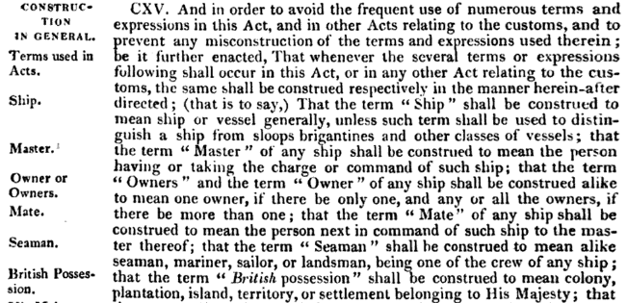

13 Leitch and Donaldson also point out (with thanks to Sir Cecil T. Carr for informing them) that in 1891, “an Irish Interpretation Bill was introduced, but this did not become law. Perhaps its chief claim to fame in the history of the statute law is that it contained a number of definitions in which various nouns were defined to include their diminutive form —for example, ‘cat’ was to include ‘kitten’.”

14 Chad Jacobi notes[10] rules on gender, number, and persons grouped together (separate in the 1850 UK Act) in one of [Home Secretary Robert] Peel’s criminal law consolidation statutes, [*Criminal Law Act* 1827 (UK) (7 & 8 Geo 4 c 28)](https://books.google.co.uk/books?id=BXZjAAAAcAAJ&dq=%22Administration%20of%20Justice%22%20statutes%201827&pg=PA69#v=onepage&q=%22Administration%20of%20Justice%22%20statutes%201827&f=false), s 14, which reads as follows:

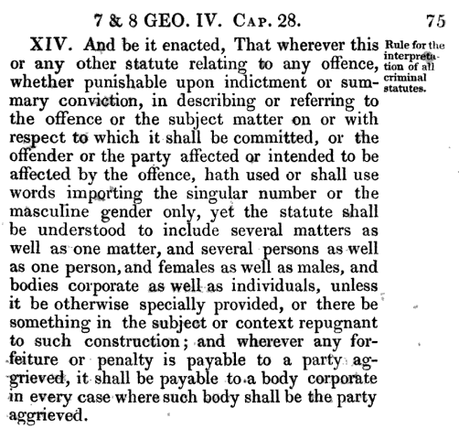

15 Jacobi also links the “recent legal innovation” of prescribed forms to an 1832 UK Act providing new processes for the bringing of civil actions: [Uniformity of Process Act 1832 (UK) (2 Wm 4, c 39)](https://books.google.co.nz/books?id=7jFHAQAAMAAJ&pg=PA344&dq=Uniformity+of+Process+Act+1832+(UK)&hl=en&sa=X&ved=0ahUKEwiy5evX-bzgAhXBb30KHUHADNcQ6AEIWTAJ#v=onepage&q&f=false),[11] the Schedule to which included, for example, a prescribed form for a writ of summons:

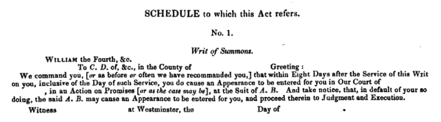

16 Jacobi explains that the excessive literalism of this period made minor irregularities, errors of form, or departures (such as incorrectly-added words) fatal on objection, so inclining Chitty writing in 1836 in the text [*The Practice of the Law in All its Departments with a View of its Rights, Injuries, and Remedies*](https://catalog.hathitrust.org/Record/100672778)[12] to express regret there was not a rule of substantial compliance (rather than a requirement of no deviation at all), saying: “But still it is to be regretted:[13]

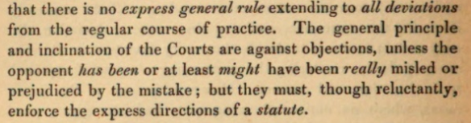

17 Jacobi suggests the first such rule of substantial compliance can be traced to an *Act for Revising and Consolidating the General Statutes of Nova-Scotia 1851* (Province of Nova Scotia) s 7, which provided: “Where forms are prescribed slight deviations therefrom not affecting the substance or calculated to mislead shall not vitiate them.”[14] He goes on to say “That provision was subsequently replicated in s 37 of the *Interpretation Act 1867* (Canada) (31 Vict, c 1) and from there in New Zealand [(*Interpretation Act 1908* (NZ), s 6(h))] and in all Australian jurisdictions save for Tasmania.”[15]

#### Symonds’ 1835 scheme for “A statute of directions and constructions”

18 Arthur Symonds was an attorney, working as counsel to the Board of Trade, and secretary to its president, Mr. Poulett Thomson (later Lord Sydenham and Governor General of Canada) when Arthur Symonds wrote the first published book on the preparation of bills. Symonds’ [*The Mechanics of Law-Making*](https://books.google.co.nz/books?id=3GxuKbFmKNIC&pg=PR1&lpg=PR1&dq=Arthur+Symonds%E2%80%99+The+Mechanics+of+Law-Making+(London+1835)&source=bl&ots=OlJw29Ti0G&sig=ACfU3U0fWma6lfQj_NSnZ4ujEtzrZNp1kw&hl=en&sa=X&ved=2ahUKEwjkwv3RoIzgAhXXQ30KHW24AeQQ6AEwB3oECAAQAQ#v=onepage&q=Arthur%20Symonds%E2%80%99%20The%20Mechanics%20of%20Law-Making%20(London%201835)&f=false) presents, in its last section (Part VII), a scheme for “A statute of directions and constructions” (an Interpretation Act):

some general scheme . . . by which the uniformity of expression and structure may be secured . . . a legislative enactment, affording directions for the framing of our laws, and laying down rules for the guidance of our courts in the construction of them . . . a scheme of rules by which the statutes may be reduced to one simple, clear, and regular mode of expression and of form.[16]

Symonds suggested a Statute of Constructions should consist of rules relating to the following matters:

1. 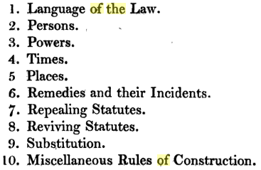

19 A closer look at Symonds’ suggested scheme shows much very familiar to us in modern Acts.

20 His scheme covered such issues as duties and discretions (“shall” and “may”), sex or gender (male and female – in an era not yet beyond the binary),[17] and singular and plural.[18] It also covered binding all “persons”, references to a Sovereign’s successors,[19] and references to an officer holder extending to an acting or deputy office holder. Symonds also mentions implied powers, needed to make effectual a power given, and the whole including every part: a power being exercisable more than once, and implied powers to revoke or to re-do in whole or in part.

21 As to “times”, Symonds mentions presumed prospective application only, and ambulatory meaning: “Statutes shall also affect subject matters, of subsequent creation, if such subject matters be of the same kind as that to which such statutes refer”.

22 Symonds’ discussion of “places” covers application to different subject jurisdictions (judicial or ecclesiastical) or territories (counties).

23 The discussion of “remedies” suggests a right or duty in a statute is, if the statute is silent on enforcement, covered by the general law: “the *general law* provides all necessary remedies . . . A right conferred by a statute gives therewith the remedy by action”.

24 The discussion of Repealing Statutes discusses repeal by implication and the effects of repeal – including continuing liability for pre-repeal contraventions, and repeal of a repealing statute not reviving the statute repealed.

25 As to miscellaneous rules of construction, Symonds suggests several principles related to textual and purposive construction:

[Statutes should] be construed according to their plain import . . . [but] what is within the reason of the law shall be within the law itself. Statutes made for the public good ought to be liberally construed . . . Statutes penal are to be construed strictly . . . the Act should be construed with reference to its object.[20]

26 Fred Bowers[21] continues the story, which has these key points from 1835‒1889:

* *1835*—Symonds' *Mechanics of Law-Making*, the century’s longest and most detailed legislative drafting manual, had a scheme for 'A statute of directions and constructions', i.e. an Interpretation Act ‒ “a reform …partially effected in Brougham's act of 1850,” Bowers says, “but not fully implemented until 1889”.
* *1836 and 1838*—Symonds also expressed views on legislative drafting in (a) his evidence to the 1836 House of Commons Select Committee on Public Bills, and (b) his *Papers relative to the Drawing of Acts of Parliament and to the Means of Ensuring the Uniformity thereof, in Language, in Form, in Arrangement, and in Matter* presented as an integrated report to Parliament in 1838.
* Symonds suggested use of formulae in the arrangement and language of statutes to ensure uniformity, use of interpretation clauses, an Interpretation Act (“a statute of constructions”) and the judiciary and legislature liaising to settle legal effect of expressions before they are enacted.
* *1843*—George Coode’s *On Legislative Expression or the Language of Written Law* was the introduction to a digest of the Poor Laws appendixed to the 1843 Report of the Poor Law Commission.
* Coode’s manual had, Bowers thought, “relevance and practicality which the works of Bentham [(for example, in *Nomography, or the Art of Inditing Laws*,which dates from 1811, but was not published until 1839)] and Symonds lacked”.
* Coode's main focus is how best to formulate the legislative sentence. The legal action should have only the auxiliaries 'shall' and 'may'. Legislative sentences should be in the active voice. Impersonal forms such as 'it shall be lawful for any person to' are more naturally and briefly expressed 'any person may'.
* Coode criticised a lot over-use of 'shall', pointing out that if it is used for any but the obligatory sense, it carries notions of futurity which are misleading. Coode thus observed that “in a statute, the law is constantly speaking, so that it is nowhere appropriate to use other than the present tense”.
* *1850*—Bowers thinks the 1850 reforms more likely arose from “a changing climate of opinion” than “specific suggestions in a particular document” but “in 1850, after the works of Bentham, Symonds and Coode had all appeared and much evidence had been given, Britain got its first Interpretation act ‒ Brougham's 'Act for shortening the Language used in Acts of Parliament'.”
* “Its provisions were modest …The effect … was to remove …repetition and redundancy, although not as much as Symonds would have approved”.
* *1857*—Of the 5 witnesses to the 1857 commission, most stressed uniformity of language and were in favour of an Interpretation Act. They also recommend simple sentence structure and a natural style, and Rickards suggested a “paper of instructions to draftsmen... containing the directions . . . most advisable” ‒ which Bowers calls “a suggestion anticipated by Symonds and Coode and put into effect a decade later by Thring”.
* *1869*—Robert Lowe, Chancellor of the Exchequer, established the office of Parliamentary Counsel to the Treasury, appointing Henry Thring to this post, giving him the duty of drafting government bills except the Scotch and Irish.
* *1875*—The report of the Select Committee of 1875 notes

the better style of drafting which has been recently introduced into the Acts … as well as with the arrangement of clauses and the subdivisions …into distinct parts, as also with regard to the language used, which, in simplicity and clearness, is far superior to the verbose and obscure language of former enactments.

* In the Committee's view, establishing official drafting removed all need for a board of bill revision (as the 1856 Statute Law Commission recommended).
* The 1875 Committee also recommended a new Interpretation Act on the lines of Brougham's act, that ministerial instructions to draftsmen be more formal, that bills should be accompanied by breviates explaining “the general object of the measure and the particular statutes which would have to be dealt with” and that “model forms or clauses might be prescribed for general use”. Bowers says that “All these recommendations were eventually adopted.”
* *1877*—Thring issued a detailed manual of drafting, reprinted as *Practical Legislation* (first edition 1877, second 1902). Bowers says “The manual everywhere demonstrates the principles of Bentham, Symonds and Coode in its consideration for the user of a statute.”
* Thring appreciated a drafter served many masters; “he recognised not only his duty to the ultimate user of a statute but also his duty to his Minister, in that the draftsman must help a bill to pass; as Thring pithily puts it, 'Bills are made to pass no less than the razors mentioned by the poet were made to sell'.”[22]
* *1889*—Drafting reform culminated with the passing of a new Interpretation Act, which Bowers said, in 1980, “is still in force today”,[23] adding “Ilbert refers to it as a Draftsman's Act in that it supplies 'a kind of legislative dictionary'.” Bowers said the 1889 Act “shortens statutory language further than Brougham's Act, defines more terms and states rules of construction.”

#### Coode’s 1840s report and books on “Legislative Expression” – on-going meaning – definitions

27 Fred Bowers, as a linguist, discerned expertly that George Coode, in the 1840s, proposed[24] a rule for use of verbs linked to legislation being presumed to have an ambulatory or on-going meaning (rather than a “fixed-time” meaning, frozen as at the time the legislation is enacted):

If the law be regarded while it remains in force as *constantly speaking*, we get a clear and simple rule of expression, which will, whenever a case occurs for its application, accurately correspond with the then state of facts. The law will express in the present tense facts and conditions required to be concurrent with the legal action . . .[25]

Chad Jacobi draws a link from the “always speaking” language of Coode’s 1845 and 1852 book to an 1858 report of Commissioners to revise and consolidate Canadian statutes, and the Interpretation Act 1859 of the United Province of Canada.[26] “Canada’s 1867 *Interpretation Act*”, Justice Susan Glazebrook adds, *“*also seems to have been responsible for New Zealand’s *1888 Act’s* first ambulatory provision, s 5(3)”:[27]

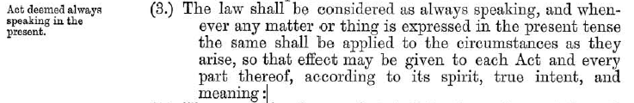

28 George Coode also discussed the use of definitions:

In modern Acts it has become very much the practice to give arbitrary senses to terms, by means of a declaration in an interpretation clause, that certain words or phrases shall have a more extended or more restricted meaning than they have by common usage. When the words are invariably used in the same Act, in the same extended or restricted sense, there is only one objection to this practice, and that is, that it demands an incessant consciousness in the writer and in the reader, that the words are arbitrarily used, and a constant vigilance least something proper to be included be lost, or something proper to be excluded be carried, by the arbitrary change in the sense of ordinary terms. The danger is evidently increased where it is intended that the restriction or extension is not to apply universally wherever the word is used in the Act; but only, as is commonly declared, when the context may reasonably admit of the arbitrary construction.[28]

29 Coode, in the same footnote, noted the very convenience, for drafters, of definitions, increased the likelihood of their use, even if it created uncertainty, resolved only by litigation, for people affected. Coode also warned against important substantive material being disguised in definitions, “nothing being more common, when a provision is wanted which cannot be openly proposed, than the enquiry whether it cannot be disguised as a construction clause.” Coode suggested courts weighed, so “pay a very small respect to”, definitions as indicators of “the real deliberate intention of Parliament”, but non-court users of legislation

are wholly confused by these definitions, instead of being, as is the proper effect of a definition, made by their aid more certain of the meaning. . . *Definitions should challenge attention by being placed before*, not as is the more common practice after, *the matter to which they have reference. . . . The words defined ought always to be distinguished, whenever used in the Bill, by some mark, as for instance, by quotation marks.*[29]

#### UK 1840s interpretation clauses – contrary intention – Jacobi – referential legislation – Carr

30 “The origin of the qualification of ‘contrary intention’”, says Chad Jacobi, “is to be found in the interpretation clauses inserted in special Acts in the United Kingdom in the 1840s concerned with words and expressions.”[30] The *Companies Clauses Consolidation Act* 1845 (UK) (8 Vict, c 16) s 3, therefore, provided that

The following Words and Expressions both in this and in the special Act have the meanings assigned to them, unless there be something in the Subject or Context repugnant to such Construction; (that is to say,) . . . Words importing the Singular Number only . . ..

Another important UK precursor to Lord Brougham’s Acts Of Parliament Abbreviation Bill of 1850 was an 1845 Act – the *Land Clauses Consolidation Act 1845* (UK) – 1845 c 18 (8 and 9 Vict) – for example, section 1 says:

This Act shall apply to every undertaking authorized by any Act which shall hereafter be passed, and which shall authorize the purchase or taking of lands for such undertaking, and this Act shall be incorporated with such Act; and all the clauses and provisions of this Act, save so far as they shall be expressly varied or excepted by any such Act, shall apply to the undertaking authorized thereby, so far as the same shall be applicable to such undertaking, and shall, as well as the clauses and provisions of every other Act which shall be incorporated with such Act, form part of such Act, and be construed together therewith as forming one Act.

31 Cecil T. Carr in 1940 noted the referential character of Interpretation Acts and also the need to apply them to delegated legislation:

All legislation, wrote Ilbert, is obviously referential in the widest sense; no statute is completely intelligible as an isolated enactment; every statute is a chapter, or a fragment of a chapter, of a body of law. It is common knowledge that some statutes were deliberately framed for the purpose of referential incorporation in subsequent statutes—for instance, the Clauses Acts of 1845. Then there is the Interpretation Act with its technical apparatus for the prospective standardization of statutory meanings. Its familiar provisions are meant, like algebraic symbols, to be expanded as required. This apparatus has been found equally indispensable for the drafting of Church Assembly Measures [See the *Interpretation Measure, 1925* [(UK)] (15 & 16 Geo. V, No. 1).]; it might some day also be extended more fully to the drafting of statutory rules and orders.[31]

32 Referential legislation is of course, as Horace Emerson Read observed in 1940, double-ended:

A referential statute, accurately so-called, operates in either of two ways: *first*, and most commonly, the new act adopts precepts, in whole or in part, from other law; or *second*, the act provides that it shall be incorporated into all acts of a certain kind that may be passed in the future. Common examples of the latter are the general interpretation acts.[32]

#### Lord Brougham’s Act 1850 – An Act for shortening the language used in Acts of Parliament

33 Lord Brougham was UK Lord Chancellor from 1830 to 1834. But he had a reputation for promise unfulfilled, owing in part to a maverick- and self-destructive-streak. He lived for another 34 years after leaving office, and continued to play an active role in political life, with a particular focus of his attention being law reform. In February 1828, he gave a 6-hour speech in the House of Commons on the topic. Exactly twenty years after this speech, Brougham made another law reform speech, ranging over a wide field of law and legislation, and returned again to the issue in another speech in 1855.[33] [Speaking in the House of Lords on 12 May 1848](https://hansard.parliament.uk/Lords/1848-05-12/debates/38f7bb4c-eca3-441c-939f-282887accec3/CriminalLawConsolidationAndAmendmentBill?highlight=famous%20freak%20modern%20lawgivers#contribution-6edf92ec-a7d3-476e-98b6-984fab65b069) about “the whole subject of the law and its defects”, Lord Brougham made these sceptical remarks about definitions and drafters’ use of them – remarks that might be thought at odds with his later (namely in 1850) proposing default general definitions:

For I now come to that famous freak of modern lawgivers, the Interpretation Clause. Its assumed office, its pretension, is to prevent all doubts by precisely declaring the sense in which words are used. Its actual result is the creation of fresh doubts, the failure in most difficulties to clear them away, and the inevitable carelessness which it encourages in drawing the statutes as well as in passing their provisions. This has become a very serious evil. For instead of weighing well the words employed, and taking constant care to preserve accuracy and uniformity of expression, all draughts are carelessly made to save trouble, in the expectation that everything will be cured by the Clause of Interpretation.[34]

34 Continuing, Brougham criticised infelicitous definitions with unclear exceptions, such as those subject to contrary intention:

Thus, ‘unless another sense plainly is shown by the context, or by some positive enactment to the contrary.’ Now, subtle men like lawyers, will very readily deny that the other sense is plainly shown, or by positive words, or to the very contrary, though they may admit that there are some conflicting words.

Brougham also criticised:

the practice so prevalent of borrowing into one from another Act framed with different scope; and a fruitful source of error as well as of considerable absurdity does this practice prove. Last year the General Act for giving Town Police Clauses passed, the 10 & 11 Vic. c. 89., and as this was to be the model statute by which all subsequent Police Acts were to be guided, we might expect it to have been carefully drawn, and not concocted by the scissors merely. Well, let us see how the interpretation is given in the third section. Cattle is defined to mean horses, mules, sheep, goats, swine; but not a word is said of oxen or cows, and yet an overdrove ox was a much more likely visitor of a town than a goat, or even swine. My respect for the drawers of such Acts, will not permit me to remark on their omitting also any reference to another animal, found in town as well as country, asses.

35 Despite Brougham’s scepticism about definitions, in 1850 he supported a Bill for *An Act for shortening the language used in Acts of Parliament* (Lord Brougham's Act, 13 Vict c 21) – sometimes also called the Acts of Parliament Abbreviation Act 1850 (UK). The Bill included some default definitions. The [House of Lords’ *Hansard* for 12 February 1850](https://hansard.parliament.uk/Lords/1850-02-12/debates/e1fcb14e-451e-49e5-ab4c-3ac4b3c21d7a/ActsOfParliamentAbbreviation) shows that Lord Brougham:

in presenting a Bill for abridging the wording of Acts of Parliament, observed that he had made frequent attempts in that House—he was going to say with more or less success, but it was hardly possible to do so with less success, unfortunately—to amend the only manufacture which had received no improvement for the last 150 years—that of Acts of Parliament. We went on from one generation to another without improvement, thereby causing the greatest evil to the subject, to the law, and to the courts of justice above all things. He had intended to introduce very large improvements in the law, but he would be contented to accept even the smallest possible improvement . . . with that view he begged to lay before their Lordships a Bill for shortening the language used in framing Acts of Parliament. One clause now introduced into every Bill he proposed to supersede altogether, for it was a ludicrous one—‘That this Act may be altered, amended, or repealed during the present Session of Parliament’—the ground on which it had been heretofore used being, that every Act was supposed to be part of one Act, all the Acts of a Session forming one statute. He proposed to enact that every Act should be alterable, repealable, or amendable during the Session. Another proposition was, that no necessity should exist of constantly repeating words ‘and further enacting;’ but that each section of each Act should follow the word ‘that,’ which would be perfectly sufficient . . . This, and one or two other points, might have been considered by the great Bentham as mock reforms, because they were of very small amount, but it did not therefore follow that they were of very small importance. Bill read.[35]

36 Having passed through both Houses, the Bill got Royal assent on 10 June 1850.

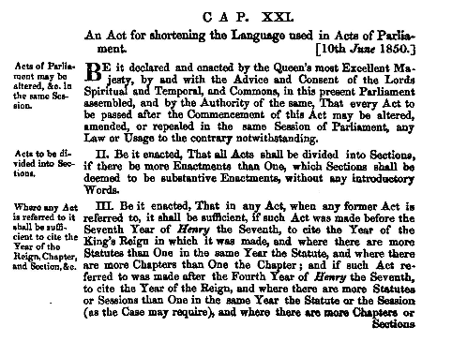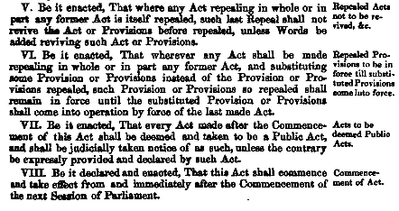

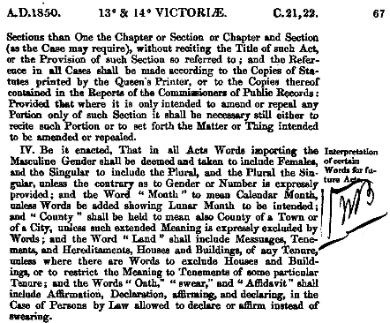



37 The 1850 Act is expressed to “commence and take effect from and immediately after the Commencement of the next Session of Parliament”. *The Times*, Tuesday, October 1, 1850 carried an item – [republished a century later](https://www.thetimes.co.uk/tto/archive/frame/article/1950-09-30/6/26.html) – about the “New Act to Shorten Acts of Parliament”.[36] The item says the 1850 Act “contains eight concisely worded sections, and, according to the provisions, very considerable improvements are expected to be made in future acts”. An editorial comment made in that 1950 republication says: “On the face of it this [1850 Act] should rank among the greater reforms of the Victorian age. Posterity has failed to recognise the centenary.”

38 Interestingly, the 1850 Act repeated serially “Be it enacted, That”, despite section 2 deeming each enactment to be substantive, and it lacked a Short Title, although sometimes called “the Acts of Parliament Abbreviation Act 1850”. Only the 1889 UK Act had a short title, even though it pre-dated the general reforms made by the UK Short Titles Acts of 1892 and 1896:



39 Another great reform of the Victorian age was the establishment of a centralised law drafting office in London. As Fred Bowers notes,

In 1869, Robert Lowe [Chancellor of the Exchequer] established the office of Parliamentary Counsel to the Treasury, appointing Henry Thring to this post and making him responsible for the drafting of all government bills except the Scotch and Irish.[37]

40 Thring discussed the use of the 1850 Act in what Bowers calls Thring’s “detailed manual of drafting [reprinted as *Practical Legislation*, first edition 1877,[38] second 1902][39] for the use of his assistants”.[40] Thring in 1877 said *Practical Legislation* “is based on *Instructions to Draftsmen*,which have for some years been in use in the Office of Parliamentary Counsel.”[41] Thring also thanked, for their assistance in the work, “Mr Jenkyns, the Assistant Parliamentary Counsel,[42] Mr CP Ilbert[43] and Mr GAR Fitzgerald”.[44]

41 The first, [1877 edition](https://archive.org/details/thringpracticall00thri/page/n6), says about drafting “interpretation clauses”[45]

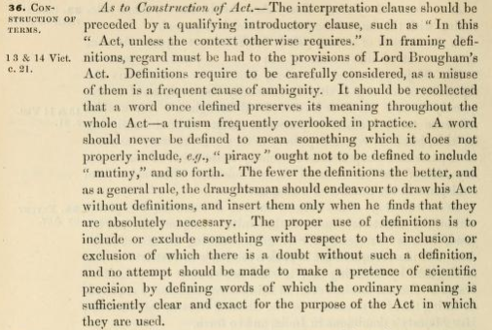

42 Thring adds this about the best place, in an Act, for definitions:[46]

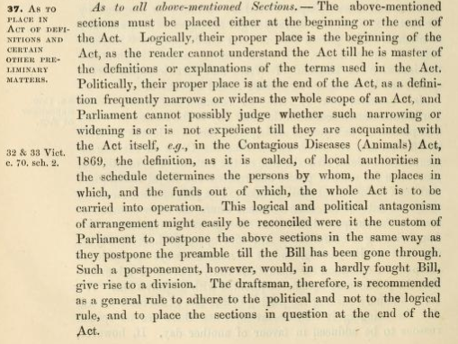

43 In the second, [1902 edition](https://books.google.co.nz/books/about/Practical_Legislation.html?id=DW0BAAAAYAAJ&redir_esc=y), Thring updated section 36 to recognise the *Interpretation Act 1889* (UK): “In framing definitions and other subsidiary clauses regard should be had to the *Interpretation Act 1889*, which is set out in the appendix, and which must be learnt by heart by the draftsman.”[47] Reproducing, in the second, 1902 edition, the preface to the 1877 first edition, Thring added a note that “The *Interpretation Act 1889* has been printed at the end of this work, as it is the duty of every draftsman to know it by heart and to bear its definitions in mind in every Bill which he draws.” [48]

44 In the third, 2015 edition, Madeleine MacKenzie and Professor David Purdie, understandably, do not reproduce the appendix (given the 1889 Act was replaced in 1978).

#### Interpretation Act 1889 (UK)

45 *The Times* of [5 June 1889](https://www.thetimes.co.uk/archive/article/1889-06-05/11/5.html?region=global#start%3D1785-01-01%26end%3D1985-01-01%26terms%3DShortening%20the%20language%20used%20in%20acts%26back%3D/tto/archive/find/Shortening+the+language+used+in+acts/w:1785-01-01%7E1985-01-01/2%26prev%3D/tto/archive/frame/goto/Shortening+the+language+used+in+act), included an item on a new Bill of Lord Halsbury’s:

few more useful Bills are now before Parliament than the Interpretation Bill introduced last week by the Lord Chancellor…It follows the lines of certain Indian Acts, one of which was prepared by Mr Ilbert; and it may be the first step in a series of far-reaching reforms…with all the many centuries of our experience, the art of legislation is still in a crude state. Thus, little care is taken to observe consistency, even in the use of technical terms. What Lord Brougham said years ago still in degree holds good…Lord Brougham’s Act made a few useful reforms . . . But the work is not half done. A further measure for “Shortening the Language Used in Acts of Parliament” is urgently needed”.[49]

46 The piece suggests parliamentary counsel Mr Jenkyns and Mr Ilbert deserve thanks for their useful work on the Bill, and notes ‘the advantage of a sort of lexicon of statutory terms and phrases with the authority, not of [lexicographers] Dr [Samuel] Johnson or Dr [James] Murray,[50] but of the Legislature; and the beginning of this we have in Lord Halsbury’s Interpretation Bill’.

47 Writing in his 1901 book, Courtenay Ilbert says:

[The Interpretation Act, 1889 (52 & 53 Vict. c. 63)](https://www.legislation.gov.uk/ukpga/1889/63/pdfs/ukpga_18890063_en.pdf), generalised several definitions which had been of frequent occurrence in Acts of Parliament. It also laid down certain general rules of construction. It thus tended to shorten and make more uniform the language of enactments. So far as it was retrospective it enabled the Statute Law Revision Bills to strike out of former Acts numerous definitions, and also various expressions, such as ‘the Commissioners of Her Majesty’s’ before the word ‘Treasury’ and the words ‘heirs and successors’ after reference to the Sovereign.[51]

Ilbert also reports on the results of replies to a series of questions which, in the year 1895, were, at the instance of the Society of Comparative Legislation, sent by the Colonial Office to the various Colonial Governments. The questions included the following:

6. Have any steps been taken to secure uniformity of language, style, or arrangement of statutes either by means of a measure corresponding to ‘Brougham’s’ Act (13 & 14 c. 21), or to the Interpretation Act, 1899 (52 & 53 Vict. c. 63), or by official instructions or otherwise?

Ilbert says:

Similar enactments are in force in British India (the General Clauses Act, 1897) and in most of the British colonies, and in some of the Crown colonies directions to observe uniformity in language, style and arrangement are embodied in the official instructions to the Governor.[52]

In advice as to the form and arrangement of statutes, Ilbert says at that “Lastly, the provisions of the *Interpretation Act, 1899*, must be carefully borne in mind.” [53] Many provisions of the Act are discussed in relation to various definitions or implied powers. The 1889 Act itself is set out in full, with commentary, in Appendix II. Ilbert says by way of introduction to the 1889 Act:

The *Interpretation Act, 1889*, may be described as a Draftsman’s Act. It supplies a kind of legislative dictionary, and its object is (1) to shorten the language of statutory enactments; (2) to provide as far as possible for uniformity of expressions by giving prima facie definitions of several terms in common use; (3) to state explicitly certain convenient rules of construction; and (4) to guard against accidental omissions by importing into Acts certain common form provisions, which would otherwise have to be inserted expressly, and which might be overlooked.

The Act supersedes and repeals Brougham’s Act (13 & 14 Vict. c. 21), and adds several new provisions, some of which were suggested by the Indian General Clauses Act of 1887. In framing the Act it was thought desirable to group separately the provisions re-enacted from Brougham’s Act, and those enacted for the first time in 1889.

48 Writing in 1914, after his Carpentier Lectures at Columbia University in 1913, Ilbert says:

the English draftsman must always bear in mind carefully the provisions of the Interpretation Act, 1889. I was responsible for drafting this Act, and therefore I would like to say a few words about it.

Bentham long ago preached the utility of definitions for avoiding, or reducing, the amount of prolixity, repetitions, and tautology in the language of Acts of Parliament, and also as a means of guarding against the danger of using different words to express the same thing in different parts of an Act. Find a suitable definition, he said, of phrase or combination of words which will be of frequent recurrence in your law, and stick to that definition. By doing so you will avoid cumbrous repetitions and secure uniformity of language. Bentham’s suggestions were adopted by many of the draftsmen who learnt from his teaching, found their way into Acts of Parliament, and were not only used, but used to an undue, excessive, and unreasonable extent. You would find in each of a large number of Acts a long list of definitions, forming a special dictionary for the interpretation of that particular Act. The inconvenience arising from the multiplication of these special dictionaries was soon perceived, and in 1850 Lord Brougham carried an Act which was commonly known as Brougham’s Act, generalising some of the more important statutory definitions then in common use. It enacted that in all future Acts particular phrases should have particular meanings unless the contrary intention appears from the Act. For instance, one of the earlier sections of Brougham’s Act enacts that in every future Act, words importing the masculine gender shall include females, words in the singular shall include the plural, and words in the plural shall include the singular. A provision to this effect had become common in Acts of Parliament passed during the thirties and forties of the last century, and you will see at once what a saving of words it effected.

Now the Interpretation Act of 1889 is an expansion, but a very large expansion, of Brougham’s Act. It embodies the definitions in Brougham’s Act, and adds a great many other definitions and general rules of construction. I framed it on purely empirical lines. I got my clerks to make comprehensive lists of numerous definitions to be found in Acts of Parliament, selected those which had been found by experience to be convenient and therefore had passed into common use, touched some of them up here and there where I thought them capable of improvement in form, and embodied them in the new Act. I believe that the Act has been very useful, and it has certainly tended to uniformity of language. Special definitions are still often necessary, though in my opinion they should be sparingly used. But a vast number of special definitions which have been repeated over and over again in particular Acts have disappeared from the modern English statute book.

The English draftsman has to consider not only the statutory rules of interpretation which are found in the Act of 1889, but also the general rules which are based on judicial decisions and which are to be found in a good many useful textbooks on the interpretation of statutes.[54]

49 Among 9 examples given by Ilbert of important common law principles are—

* the *ejusdem generis* (limited class) rule,
* the presumption that the legislature does not intend any alteration in the rules or principles of the common law beyond what it expressly declares,
* the presumption against any intention to contravene a rule of international law, and
* the presumption against the retrospective operation of a statute (*see now* the *Interpretation Act 1999* (NZ) s 7, *Crimes Act 1961* (NZ) s 10A, *New Zealand Bill of Rights Act 1990* (NZ) s 26(1), and *Sentencing Act 2002* (NZ) s 6).[55]

#### Common law and the 1889 UK Act

50 Equally or more important, perhaps, is that the 1889 UK Act did not attempt to capture in statute the Barons of the Exchequer’s ‘mischief rule’ in *Heydon’s Case*: “for the sure and true interpretation of all statutes in general” the court should consider the “mischief or defect” that the Act was passed to cure, and should construe the Act so as to “suppress the mischief, and advance the remedy”.[56] Hon James Jacob Spigelman AC says Lord Ellesmere’s treatise on statutory interpretation published in 1565 (20 years before *Heydon’s Case*) covered perennial issues such as the focus on the mischief to be remedied.[57]

51 The 1889 UK Act did not, however, disregard common law. Section 36(2), for example, ensures that an Act or provision of an Act comes into force, if no provision is made for its coming into force, at the start of the day that the Act receives the Royal assent. As noted by Mark Gobbi,[58] this likely reflects the common law rule disregarding fractions of a day, apparently from 1585 and *Clayton's Case*, and in 1879 applied to Acts in *Tomlinson v Bullock*.[59]

52 The 1889 UK Act did *not*, however, replace the [*Acts of Parliament (Commencement) Act 1793*](https://www.legislation.gov.uk/apgb/Geo3/33/13) (UK). It was “An Act to prevent Acts of Parliament from taking effect . . . prior to [their] passing”. It abolished the common law rule that an Act or provision of an Act comes into force, if no provision is made for its coming into force, from the first Day of the Session of Parliament in which the Act is passed.[60] The 1793 Act enacted, instead, a statutory rule of commencement at the start of the day on which the Act receives the Royal Assent (later reflected in s 4(b) of the *Interpretation Act 1978* (UK), which captured, in statutory form, *Tomlinson v Bullock*). The 1793 Act [is still in force](https://www.legislation.gov.uk/apgb/Geo3/33/13), and requires the “[Clerk of the Parliaments](https://www.parliament.uk/clerkoftheparliaments) to indorse on every Act the time it receives the royal assent, which shall be its commencement, where no other is provided.”

#### The 1969 British Law Commissions’ report

53 Sir Kenneth Keith reminds us that the British (English and Welsh, and Scottish) Law Commissions in 1969 recommended, unsuccessfully, a purposive direction, a provision calling for interpretation consistent with international obligations, and a provision allowing limited access to the drafting history but prohibiting access to parliamentary materials (the last overtaken in *Pepper v Hart* essentially adopting the New Zealand position).[61] Sir Kenneth also reminds us that 1969 also saw the adoption of the [Vienna Convention on the Law of Treaties](http://legal.un.org/ilc/texts/instruments/english/conventions/1_1_1969.pdf):

. . . recent codes on the interpretation of statutes and treaties emphasise the finding of the meaning of the text, by reference to its context and its purpose, and make no reference at all to intention. So article 31(1) of the Vienna Convention on the Law of Treaties 1969, in stating the general rule for interpreting treaties, provides:

A treaty shall be interpreted in good faith in accordance with the ordinary meaning to be given to the terms of the treaty in their context and in the light of its object and purpose.[62]

Three decades later the New Zealand Parliament similarly stated [in the *Interpretation Act 1999* (NZ) s 5(1), replacing a 1924 Act] the first principle for "ascertaining the meaning of legislation" as follows:

The meaning of an enactment must be ascertained from its text and in the light of its purpose.[63]

#### 1975 Renton report

54 In 1975, the Renton Report on *The Preparation of Legislation* noted that interpretation influences drafting, and encouraged the preparation of a comprehensive new Interpretation Act based on the 1969 report of the Law Commissions, and drawing on the detail in the Interpretation Act (Northern Ireland) 1954.[64] The Renton Report noted that “Sir William Graham-Harrison said in 1935 that the time had undoubtedly arrived for a new Interpretation Act.[65] Some 40 years later[ in 1975], it might be thought to be overdue.”[66] As Francesca Quint remarks:

What turned out to be one of Lord Renton’s most abiding interests and valuable legacies, however, was the improvement of the quality of legislation. As Sir David Renton he was chairman of the Renton Committee, which reported in 1974 on ‘The Preparation of Legislation’, and whose forward-looking recommendations remain highly relevant in the drafting of statutes and statutory instruments today. The recommendation that statutes contain a statement of purpose, for example, chimed well with the newly developing European legislation and foreshadowed the increasingly ‘purposive’ approach which the courts have since adopted towards interpretation, even though there was stiff opposition to them from traditionalists at the time.[67]

#### Interpretation Act 1978 (UK)

55 One member of the Renton Committee was Sir Noël Hutton GCB QC, UK First Parliamentary Counsel from 1956‒68, and succeeded in that office by Sir John Fiennes (1968–1972), Sir Anthony Stainton (1972–1977), and Sir Henry Rowe (1977–1981). “Hutton”, says A G Donaldson,[68] 114,

went to the Law Commission when he retired and, emulating Brougham and Ilbert, drafted the Interpretation Act 1978 [(UK)]. Another public duty he performed was to sit on the Renton Committee on the preparation of legislation, assessing the evidence of his two immediate successors (Fiennes and Stainton) . . ..

In 1980, Francis Bennion[69] criticized the 1978 UK Act as a "straight consolidation” and thus a lost opportunity for reform, and said “it is not the best arrangement to make [legislative drafting] what Sir Noël Hutton [(with the UK PCO 1938‒1968)] has called ‘a life engagement’”[70]. In a 1979 article, Hutton noted the Bill for the *Interpretation Act 1978* (UK) made use of the consolidation procedure, and retained a few ancient monuments. [71] He added:

Some of the provisions of Lord Brougham's Act and of the 1889 [UK] Act were applied to past as well as future Acts, but only where this could be done without changing the effect of the former. The same applies to the 1978 [UK] Act, and far too much of the time taken up in drafting the Bill for that Act was devoted to Schedule 2 (Application of Act to existing enactments) which is as likely to mystify as to instruct even the most scientific consumer. Nor have the British Acts attempted to give directions to the courts about how to decide a case in which the ascertained statutory meaning is uncertain. They have no clause (common in other jurisdictions) requiring a "beneficial construction" to be given Acts of Parliament, whatever that may mean, and nothing remotely like section 15 of the [Canadian] Uniform Statutory Construction Act [1965] so rightly described by Professor Dickerson[72] as a "mishmash of confusion". There was indeed a recent attempt to promote legislation of that character in a Report from the Law Commission (1969 Law Com. No. 21), but apart from the endorsement of some of the more innocuous proposals by a Government Committee on the Preparation of Legislation which reported in 1975 (Cmnd. No. 6053) nothing has resulted so far.[73]

56 A former First Parliamentary Draftsman, Northern Ireland, William A. Leitch, said:

Those who are in substantial agreement (as the Renton Committee do not appear to have been) with . . . the joint Law Commissions Report on 1969 on the Interpretation of Statutes, may well regard a Consolidation Bill as being, at the most, a case of the half-loaf.”[74]

On 20 February 1979, Patrick Mayhew asked the Attorney-General, Samuel Silkin, “why he has not yet sought to introduce an Interpretation Bill as recommended by the [Renton] Committee on the Preparation of Legislation in 1975; and when he proposes to do so.[75] Here is the Attorney-General’s response:

The *Interpretation Act 1978* [(UK)] consolidated the previous statute law on interpretation of statutes as proposed by the Renton committee. The Act made a number of corrections and minor improvements following the Law Commission's report of June 1978 which was prepared after consideration of some of the detailed recommendations for change in the Renton committee's report. The remaining recommendations relating to the interpretation of statutes could not be included within the scope of the Act of 1978, and their implementation would require further consideration.[76]

#### Lord Scarman’s efforts in 1980 and 1981

57 The matter was not at an end, thanks to Sir Leslie Scarman (Lord Scarman of Quatt, 1912‒2005), a Lord of Appeal in Ordinary 1977‒1986, and first Chair of the England and Wales Law Commission 1965‒1973.

58 The journal *Reform* reported:

In January 1980, Lord Scarman introduced into the House of Lords an Interpretation of Legislation Bill designed to implement the [1969] report of the Law Commission, *The Interpretation of Statutes* (Law Com 21). The measure was withdrawn, Lord Scarman promising to fight another day. See [1980] Reform 47. Now it has been reintroduced into the House of Lords on 29 January 1981.[77]

59 [The House of Lords’ debates in 1980 and 1981](https://hansard.parliament.uk/search?startDate=1980-01-01&endDate=1982-01-01&searchTerm=Interpretation%20of%20Legislation%20Bill&partial=False) are summarised in 2 items from *The Times*.

60 [The first item is from 15 February 1980](https://www.thetimes.co.uk/archive/article/1980-02-15/14/8.html?region=global#start%3D1980-01-01%26end%3D1982-01-01%26terms%3DInterpretation%20bill%26back%3D/tto/archive/find/Interpretation+bill/w:1980-01-01%7E1982-01-01/1%26prev%3D/tto/archive/frame/goto/Interpretation+bill/w:1980-01-01%7E1982-01-01/1%26next%3D/tto/archive/frame/g). It has the headline “Little support for Bill on interpreting the law”. It says that Lord Scarman, a Lord of Appeal, “on Wednesday night” moved in the House of Lords the second reading of an Interpretation of Legislation Bill embodying draft clauses on that topic which the Law Commissions in their joint report put forward in 1968. “He said the Bill offered no more than a limited degree of statutory intervention in the practice of statutory interpretation by the judges.” Lord Elwyn-Jones said the Bill would increase rather than reduce the scope for argument. Lord Diplock said the Bill would do more harm than good. Lord Hailsham, the Lord Chancellor, said there had been a chorus of disapproval for the Bill but he believed there was a great deal more to be said for it than other peers had said. He added Lord Scarman had little hope of getting the Bill through in the current session, but that he hoped Lord Scarman would not be too discouraged. [(Lord Scarman)] had done a public service by introducing this interesting and important Bill. Lord Scarman responded by saying that the right course was for the Law Commission[s] to think about a more comprehensive measure. The item concludes “The Bill was withdrawn.”

61 The headline of [the second item, on 10 March 1981,](https://www.thetimes.co.uk/archive/article/1981-03-10/4/12.html?region=global#start%3D1980-01-01%26end%3D1982-01-01%26terms%3DInterpretation%20bill%26back%3D/tto/archive/find/Interpretation+bill/w:1980-01-01%7E1982-01-01/1%26prev%3D/tto/archive/frame/goto/Interpretation+bill/w:1980-01-01%7E1982-01-01/2%26next%3D/tto/archive/frame/g) is “Law Lords support Bill to help courts interpret legislation”. It reports that Lord Scarman moved in the House of Lords the second reading of a second Interpretation of Legislation Bill. Lord Scarman in the debate mentioned that the Bill indicated matters of internal and extrinsic context relevant to interpretation, as well as principles of interpretation (purposive interpretation, meaning in line with international obligations, and the presumption against retrospective effect). Lord Renton reportedly said it was right to spell out that the judges should have regard to the general legislative purpose. No harm could be done by doing so. It would have a positive advantage. Various current and former Lords of Appeal debated the Bill with varying degrees of enthusiasm. The Lord Chancellor, Lord Hailsham, indicated that the Government was neutral, though it hoped the House would give the Bill a second reading. The report concludes: “The Bill was read a second time.”

62 In an article entitled “Another Reverse for the Law Commissions’ Interpretation Bill”, Francis Bennion explained and opined:

The draft Bill appended to the Law Commissions’ 1969 report *The Interpretation of Statutes* (Law Com No 21; Scot Law Com No 11) has once again failed to reach the statute book. In 1975 the Renton Committee recommended ‘the early enactment of a suitably modified version’ (Cmnd 6053, para 19.31). The Government continued to do nothing. Last year Lord Scarman, who was chairman of the Law Commission at the time of the report, introduced the Bill (without modifications) in the House of Lords. After heavy criticism on second reading he withdrew it. This year he introduced a version modified mainly as suggested by Renton. It passed the Lords but was objected to on the motion for second reading in the Commons. It is dead for the present session.

Lord Scarman has had a rough ride with his two attempts to secure the enactment of the Law Commissions’ Bill. For this one is bound to extend respectful sympathy. At the same time there is a sense of relief. The Bill is inadequate, and if enacted is likely to make matters worse. It is so incomplete as codification that doubts are bound to arise from it. Do the principles thus singled out for mention in an Act of Parliament thereby gain increased potency over those which are not? What priority is one principle (enacted or not) to be given when it conflicts with another? Clause 1(3) says that nothing in the section is to be construed as authorising Hansard reports to be considered ‘for any purpose for which they could not be considered apart from this section’. For what purposes (if any) can they be so considered?

The fact is that this subject is much too complex to be tided up by one or two simple clauses. Instead of a handful of general principles it a needs a large number of carefully-constructed statements each going no farther than it is practicable to go, and each dovetailing with the others. In other words a full-scale code. Failing this, the view of most people who have considered the Bill appears to be that we will do better if we continue to rely on judicial development.[78]

63 Jeffrey Barnes says

Despite its lack of success, the purpose rule was not specifically opposed at any time in its passage through the House of Lords. The support for the purpose rule in that House was significant because it was later used to demonstrate the strengths of the rule when it was eventually introduced into the federal Parliament in Australia.[79]

#### UK common law and Australian and Model or Uniform statute law in and after the 1980s

64 In a lecture given in Melbourne, in September 1980, Lord Scarman said, "In London no one would dare to choose the literal rather than a purposive construction of a statute: and 'legalism' is currently a term of abuse".[80] Sir Kenneth Keith notes, “The *Fothergill* case . . . in which Lord Scarman and his [House of Lords] colleagues adopted a purposive approach [to the *Carriage by Air Act 1961* (UK), Sch 1, art 26(2)] had been argued and decided earlier in [1980].”[81] The leading UK statutory interpretation textbooks still unsurprisingly suggest purpose is a key factor in ascertaining meaning, albeit the authority for this remains only case law.[82] “Modern Judges in the United Kingdom do use a purposive approach to statutory interpretation.”[83]

65 About the same time, on 12 June 1981, the purpose or object direction in section 15AA was added to the *Acts Interpretation Act 1901* (Aust) by the *Statute Law Revision Act 1981* (Aust). In a perceptive article in the 9 June 1981 *Sydney Morning Herald*, the eminent legal authority Professor Julius Stone, said: “Intelligent lay people will feel no outrage at such a proposal [namely that embodied in s. 15AA]. I suspect that most of them think that this is what judges, in any case, are supposed to do”.[84] In some senses, this was the Commonwealth of Australia in 1981 “catching up” with similar, much earlier, general directions in other jurisdictions’ Interpretation Acts. For example, in Canada, the [Interpretation Act 1849 (12 Victoria, c. 10) s 5(28)](http://eco.canadiana.ca/view/oocihm.9_04444/2?r=0&s=1) (Canada) had a purposive direction, unlike an earlier 1837 Act.[85] Eric Tucker suggests “a conventional legal argument can also be made that the [1849] act constituted an attempt by the legislature to reform the common law of statutory interpretation by abolishing the distinction between remedial statutes that were to be read liberally and other categories of statutes that were to be read strictly”, having earlier noted that “Two American jurisdictions, Arkansas and Illinois, had enacted rules mandating liberal interpretation of penal codes prior to 1849, but neither had a provision that was of general application to all statutes.”[86] As Justice Glazebrook notes, New Zealand had a purposive direction with an ambiguity precondition from 1851–1868, no purposive provision in the 1868 and 1878 Acts, and reintroduction in and after the 1888 Act of a purposive direction *without* an ambiguity precondition. She adds the precise reason for New Zealand relying on Canadian precedent and reintroducing a purposive provision is unknown, as is the reason for introduction of the purposive provision in Canada, but Eric Tucker has speculated the 1849 Canadian Act direction was, given recently-won local control of government, the Legislature using the judiciary to ward off any threats of the Colonial Office retaking control.[87]

66 The 1980s were a busy time for interpretation legislation. In April 1983, the Commonwealth Secretariat published a Model Interpretation Bill prepared for it by Garth Thornton OBE, QC, at that time the Parliamentary Counsel in Western Australia, and the author of 2 editions in 1970 and 1979 of his leading book on *Legislative Drafting*, both of which include a chapter on Interpretation Acts. This 1983 Model Act, and the Uniform Interpretation Act prepared in 1984 by the Uniform Law Conference of Canada, were among the sources the New Zealand Law Commission used in 1990.[88]

67 On 15 May 1984 in Australia, section 15AB, on use of extrinsic material in interpretation, was added to the *Acts Interpretation Act 1901* (Aust) by the *Acts Interpretation Amendment Act 1984* (Aust). The New Zealand Law Commission commented:

The interpretation statutes in New South Wales, Western Australia and the Australian Capital Territory contain almost identical provisions to the [Australian] federal section [15AB], and all borrow heavily from the Vienna Convention on the Law of Treaties 1969 article 32.[89]

The Law Commission recommended, and the *Interpretation Act 1999* (NZ) ensured, “The use of parliamentary material in the interpretation of legislation should not be regulated by a general statute”.[90] Keith commented:

The courts were already using that material, an action which the Commission supported for reasons set out in some detail, and they should be left to develop the practice, without the kind of guidance provided by the Australian legislation and the Vienna Convention.[91]

Hong Kong’s Law Reform Commission in 1997 [recommended](https://www.hkreform.gov.hk/en/docs/rstatutorys-e.pdf) a provision modelled on Australia’s s 15AB.[92] While Hong Kong’s *Interpretation and General Clauses Ordinance[93]* contains no such provision, use of extrinsic material seemed routine at HK common law in 2010.[94] The Australian section 15AB has not precluded use, at common law (apart from that section), of extrinsic material at the initial stage of the interpretive process to establish a provision’s purpose[95]. And, at common law (apart from that section), extrinsic material can be similarly used to ensure that the meaning given to the provision conforms, so far as its language permits, with Australia’s international obligations[96]. Pearce and Geddes have commented

[T]he common law principles dealing with the use of extrinsic materials continued to h(ave a role, notwithstanding the enactment” in Australia of provisions like section 15AB. … Australian courts and tribunals have become accustomed to readily admit extrinsic materials tendered by parties to litigation . . . Section 15AB . . , and its equivalent state and territorial provisions were cited in support. . . . More commonly in recent years, however, the *CIC Insurance* case has been cited in support, or ‘the modern approach to statutory interpretation’ has been mentioned, or no authority has been relied on in support of the practice at all.[97]

In 2011, Australia’s Act was, after reviews, modernised in language, concepts, and structure.

#### Since the 1980s in the UK

68 Since the 1980s, the biggest reform in UK statutory interpretation legislation is the *Human Rights Act 1998* (UK), s 3: “So far as it is possible to do so, primary legislation and subordinate legislation must be read and given effect in a way which is compatible with the Convention rights.”

69 The 2010 Scottish legislation,[98] and the proposed (now passed) Welsh legislation,[99] perhaps unsurprisingly, do *not* include general interpretation directions *not* also found in the UK’s *Interpretation Act 1978*.[100] The [Consultation Paper](https://www2.gov.scot/Resource/Doc/87945/0076308.pdf) for the Bill for the 2010 Scottish Act noted, after surveying 9 other Commonwealth jurisdictions’ Acts, that

quite a few now include provisions that are not to be found in the 1978 Act. Even within the United Kingdom, the Interpretation Act (Northern Ireland) 1954 contains a wider range of provisions than the 1978 Act.[101]

The [Consultation Document](https://beta.gov.wales/sites/default/files/consultations/2018-02/170619-consultation-doc-en.pdf) for the Welsh Bill says “it is uncontroversial to state that the 1978 Act is now relatively outdated and, when compared to other interpretation Acts, quite narrow in its scope”.[102] Samuels in 2019 said the 1978 Act could hardly be more “basic, Spartan, and unhelpful”.[103]

70 Section 23ZA is to be inserted into the *Interpretation Act 1978* (UK), by the [*European Union (Withdrawal) Act 2018*](http://www.legislation.gov.uk/ukpga/2018/16/contents).[104] Section 23ZA is to ensure that most of the Interpretation Act 1978 (UK) will apply to “retained direct EU legislation” (as defined in s 20 of that 2018 Act) so far as it is amended by UK law on or after exit day (as so defined), unless the contrary intention appears. Norbury and Bailey note, however,

Where retained EU law (that is, EU-related domestic legislation, or EU law that becomes part of domestic law or continues to be enforceable in the UK) is amended on or after exit day (by UK law), it will be important to consider whether the amendments have been drafted in accordance with EU drafting practices or in accordance with the practices adopted for normal UK legislation.[105]

#### Purposes of interpretation legislation

71 Key purposes are to simplify and shorten, guide interpretation, and help achieve more consistency (so, in turn, informing and enhancing drafting), for more accessible and understandable legislation.

72 Reed Dickerson suggested interpretation legislation has these 8 purposes:

(1) To codify an existing usage of words, a general principle of communications, or an otherwise tacit assumption.

(2) To change the meaning of existing statutes.

(3) To provide a rule of law for deciding cases in which the ascertained statutory meaning is unresolvably uncertain.

(4) To terminate a judicial rule of law for applying statutes.

(5) To establish a new or different usage of words or a new or different principle of communication.

(6) To establish specific rules to supplement recurrent general rules.

(7) To enact legislative boilerplate.

(8) To determine the boundaries of effective legislation. [106]

73 The Renton Committee’s 1975 report stated “A general Interpretation Act can help to shorten and simplify particular Acts of Parliament, to clarify their effects by enacting rules of construction, and to standardise common-form provisions”.[107]

74 New Zealand’s Law Commission in 1990 noted Interpretation Acts’ “two purposes of shortening legislation and assisting its interpretation by the statement of approaches to interpretation”, plus a third: to “help promote greater consistency in the form and language of the whole statute book”, with all 3 purposes helping make the law more accessible and understandable.[108]

75 Dennis Pearce refers to Interpretation Acts as “Acts that are intended to reduce the size and simplify the reading of legislation”.[109] He adds that the simplified outline for the Commonwealth *Acts Interpretation Act 1901* (Aust) says:

The Act is like a dictionary and manual to use when reading and interpreting Commonwealth Acts and instruments made under Commonwealth Acts.

The definitions and many of the interpretation rules are aimed at making Commonwealth legislation shorter, less complex and more consistent in operation.

76 Nick Horn analyses that 1901 Act as having rules of 5 types:

A—Internal operation (for example, application);

B—Life-cycle of Acts;

C—Shortening rules: meaning of words and expressions;

D—Other shortening rules;

E—General interpretive principles.[110]

Nick Horn also notes that Act has rules or other provisions of a 6th type (namely, ones for the purpose of ensuring formal consistency of the statute book, for example, material part of, or the boundaries of, the enacted Act).[111]

77 New Zealand’s [Legislation Bill 2017 (275—2)](http://www.legislation.govt.nz/bill/government/2017/0275/latest/DLM7298125.html), as reported on 1 June 2018, states the purpose of Part 2 (“Interpretation *and application* of legislation”, *emphasis added*) as follows:

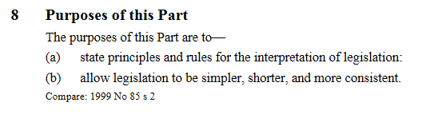

78 The long title of the [Legislation (Wales) Bill 2018](http://www.assembly.wales/laid%20documents/pri-ld11927/pri-ld11927-e.pdf), as introduced on 3 December 2018, describes it as a Bill for “An Act of the National Assembly for Wales to promote the accessibility of Welsh law; to provide for the interpretation and operation of Welsh legislation; and for connected purposes.”

79 Some view with scepticism, or doubt the value of, enacted directions or guides to courts (and to all other interpreters) about how to interpret legislation.

80 Ruth Sullivan, for example, discussing “Some Implications of Plain Language Drafting”, says:

In my view, it is almost always a mistake for legislatures to enact interpretation rules. If the purpose is to control or constrain interpretation, the rules rarely succeed. A surprising number of lawyers and judges remain ignorant of them, and those who know about them apparently find it hard to take them seriously. This is probably because a given rule can only be part of the overall picture. Although it may draw the attention of interpreters to a particular concern, one that is considered to be important, in practice there is almost always a range of important concerns. Rather than distorting the picture by focussing on just one or two, the legislature would do well to leave it to interpreters to work out an appropriate balance among relevant concerns in the circumstances of each case.[112]

81 Another, and typically compelling, view, is offered by Sir Kenneth Keith:

But against the doubters and deniers are the efforts over the centuries to state and apply rules or principles or approaches for finding the meaning of legal texts. In a broader sense those efforts must reflect the commitment of those undertaking those tasks to the integrity of the legal process and indeed the very existence of law as an autonomous discipline.[113]

82 An Interpretation Act is inevitably constitutional, as New Zealand’s Chief Parliamentary Counsel (1996–2007), George Edwin Tanner QC, noted in 2006:

Interpretation legislation is sometimes perceived as merely technical. It is, however, important constitutional law because it is the legislature’s directive to readers of legislation and to the courts as to how legislation is to be interpreted. For this reason, it ought to be the most accessible of all the statutes. [114]

83 The [*Uniform Statute and Rule Construction Act* (1995)](https://www.uniformlaws.org/committees/community-home?CommunityKey=aeacd732-88fa-4f23-ae86-4e383f416cf3#:~:text=The%20Model%20Statute%20and%20Rule,state's%20statutes%20and%20administrative%20rules.&text=Approved%20by%20the%20American%20Bar,Uniform%20Law%20Commission%20in%201995.) of the USA says, in a Prefatory note:

This Act informs courts of a legislature’s expectations as to how its product should be construed. Inasmuch as the court's aim in construing statutes is to carry out the legislative intent or purpose, this Act assists the courts in performing that function. It is, therefore, not a legislative infringement of the judiciary's special function of construing a statute; it is merely an aid to the courts in performing that function. The existence and use of statutory construction acts for over a century without successful challenge further demonstrates that these acts do not violate the fundamental constitutional principle of separation of powers. *Commonwealth v. Trent*, 77 S.W. 390 (Ky. App. 1903); see *Simpson v. Kilcher*, 749 S.W.2d 386 (Mo. 1988); but see *State v. Parsons*, 220 N.W. 328 (Iowa 1928), a ruling that has gathered little support.[115]

84 But reference to the Act as being “an aid” should not disguise that the Act imposes legal duties, and that, whether an Interpretation Act direction is applied, or not, is not “at the option of the judges”.[116]

85 An Interpretation Act direction does, anyway, give interpreters much flexibility or “room to move”. The direction may be displaced expressly or by context. Even if applicable, it may leave choices of weighting, or balancing, of different key interpretative factors. So, for example, George Tanner spoke of the Interpretation Act 1999 (NZ), s 5(1), as achieving a “beautiful balance” between text and purpose (section 5(1) “achieves a beautiful balance between literal meaning and wider object. Text is enlarged by purpose, and purpose is constrained by text.”).[117]

86 Ruth Sullivan has, in this connection, referred to a post-realist conception that permits contemporary jurists to integrate statutory interpretation into law

by thinking of it as a principle-governed rather than a rule-governed activity. As [Professor Ronald] Dworkin might say, statutory interpretation is law because it is an activity carried out within a practice-based legal principle. . . . While the modern principle [(in *Rizzo v. Rizzo Shoes Ltd* [1998] 1 SCR 27)] is not immune from criticism, it must be admired for the way it accommodates the post-realist conception of law as a practice within a tradition. . . . On this approach, judges have considerable discretion, but . . . structured and constrained by a principle-based practice of decision-making.[118]

87 Arie Rosen has, more recently, highlighted interpreters’ choices and balancing of factors both by reference to, and beyond, both the statutory text and the legislative intent. Rosen notes “correctness-oriented” interpretation may go beyond the content of the legislation itself “for attaining substantively desirable results in concrete cases”:

Dworkinian interpretivism, advocating interpretation of statutes in light of moral principles,[119] or modes of purposive interpretation that emphasise the import of objective purpose and the consideration of values in statutory interpretation,[120] can be seen as correctness-oriented in this sense. They call upon interpreters to put statutes to good use and read them as fulfilling basic values and moral principles. [121]

Rosen also says

It is possible . . . to classify different interpretive approaches based on their position on the following two questions . . . (i) the question of the scope or particular content of legislative decisions and (ii) the question of the proper mode of application for these decisions once their scope has been identified. The interpretive implications of these questions are summarised in Table 1.[122]

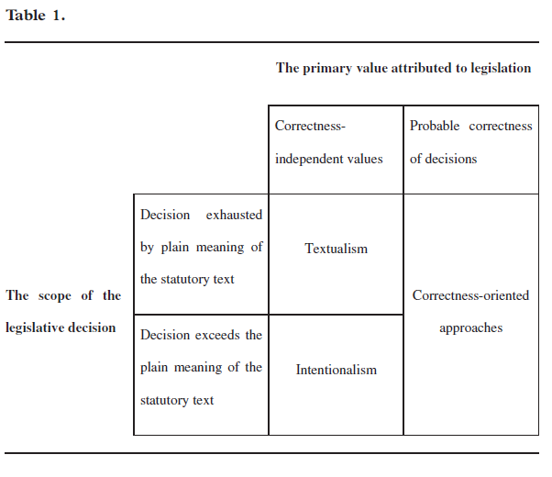

88 “The basic values and moral principles” that interpreters use may be those made relevant by common law – or by statutory duties to give, if one can be given, a rights-consistent meaning (for example, the principle that a person may not take advantage of their own wrong-doing,[123] and the duty under the *New Zealand Bill of Rights Act 1990*, s 6). Even so, as Justice Susan Glazebrook notes,“there comes a point when it is not possible to claim that a decision is interpreting legislation rather than ignoring or rewriting it”.[124]

89 Rosen thinks a plurality of legitimate modes of statutory interpretation is virtuous and proper, but adds a theory should delineate properly (and also predictably?) the province of each approach.[125]

90 In New Zealand, legislation makes clear the four main statutory interpretation factors: text, purpose, context, and values. The default main interpretative direction[126] says: “The meaning of legislation must be ascertained from its text and in the light of its purpose and its context”. This section is to be re-enacted in the Legislation Bill 2017 (275–2) cl 10(1) (how to ascertain meaning of legislation). A sentence diagram highlights the main factors of text, purpose, and (now stated clearly) context:[127]

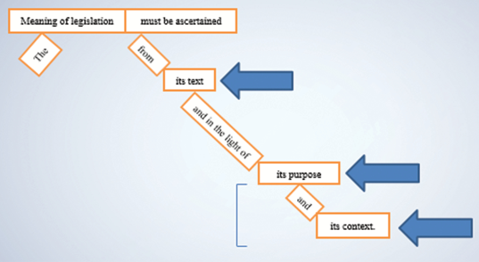

91 The *New Zealand Bill of Rights Act 1990*, section 6, applies to legislation that can be given a meaning consistent with the rights and freedoms in that Act, and requires that ‘rights-consistent’ meaning to be preferred to any other meaning.

92 Stating these basic rules of statutory interpretation in legislation

“helps to ensure that both drafters and users are applying the same rules in dealing with legislation, and makes those rules more accessible to users (they do not have to be extracted from the case law by each individual user).”[128]

93 The four main factors tend, at some point, to blur into one another. (For example, purpose usually embodies values and, if purpose is expressed, purpose is also both text and context.) Even so, those four main factors are, for an adequate analysis, key compass points or guides.

94 As noted by Justice Glazebrook (using the Law Commission’s 1990 report as extrinsic context to inform our understanding of the likely correct legal meaning of s 5(1) of the *Interpretation Act 1999* (NZ)):

The democratic argument that the courts must give effect to the law enacted by Parliament was seen as a factor in favour of a purposive provision to discourage “the unthinking use of presumptions which might be used to defeat parliamentary purpose”. A major reason for a purposive provision would be to remind judges that statutes should not be interpreted in a manner that is protective of the common law. Statutes are a “major source of legal development” and must be “seen as an integral part of an organic body of law” and not merely as a gloss on the common law[129] . . .

The Commission did not see its suggested new interpretation legislation as all-encompassing of the approach to legislation. Its proposal did not expressly mention the scheme or structure of the legislation. The draft also did not make express reference to the history of the legislation before and since enactment. . . .

The draft legislation also did not indicate, even in a broad way, how “the purpose” of the legislation is to be determined. . . . The Commission considered [an express statement of purpose in purpose clauses in a Bill] would help both Parliamentary consideration of legislation and its subsequent interpretation. . . .

Finally the draft legislation did not attempt to define “context”. The Commission noted that the rest of the enactment is one obvious part of the context. So too is the particular area of law from which the legislation arises. It was noted that the courts sometimes invoke an even wider context. Context might be used not to expand but to restrain the apparent meaning of legislation, particularly in light of New Zealand’s international obligations. [130]

95 Clause 10(1) of the 2017 Bill alters s 5(1) of the 1999 Act by requiring the meaning of legislation to be ascertained from its text and in the light of its purpose *and its context*.

96 Addition of a reference to context was *not* proposed in the 2013 [discussion paper](http://www.pco.govt.nz/assets/Uploads/pdf/Interpretation-Act-1999-discussion-paper-2013-03-06.pdf), but is intended only to align this general interpretation direction with existing law and practice, and not to alter significantly its substance.[131]

97 This change in cl 10(1) is in line with the Law Commission’s original recommendation on the 1999 Act (NZLC R17, 1990). However, the recommendation was not implemented in the 1999 Act.[132]

98 The explanatory note to the Bill for the 1999 Act suggested this omission arose from concern about the imprecision of the term, and concern that it could lead to “a meaning that might well go beyond the approach of the Courts currently”. The Justice and Electoral Committee’s report on the 1997 Bill similarly showed a concern that including context might result in a “more liberal interpretation” that departs from Parliament’s words and aims.

99 However, submissions on that Bill opposed this omission. Moreover, the courts have continued to be informed by internal and extrinsic context (including parliamentary history) in interpretation. “While the reference to ... context was not enacted”, Glazebrook J observed in *Agnew v Pardington* “there is no doubt that the text of a provision must be interpreted having regard to the Act as a whole and the legal system generally.”[133] Indeed, “[in] determining purpose”, Tipping J said in *Commerce Commission v Fonterra Co-operative Group Ltd*, “the Court must obviously have regard to both the immediate and the general legislative context.”[134] Cabinet therefore approved this proposed change in the 2014 Bill, and also in the 2017 Bill.

100 Interpretation informed[135] by context is thus now, and has perhaps always been, both orthodox and routine. So, in *Vector Ltd v Electricity Authority*, Simon France J said “the meaning must be ascertained from its text, in light of its purpose, and from the context of the legislation”.[136] Clause 10(1) requires interpretation to be *informed* by context. (It does not, however, allow interpretation to be *distorted* by context.)

101 *Affco NZ Ltd v NZ Meat Workers and Related Trades Union Inc* discusses departures from the defined meaning of a term subject to a context qualification ("Unless the context otherwise requires").[137] Arnold J said:

The starting point for the court’s consideration of context will be the immediate context provided by the language of the provision under consideration. We accept that surrounding provisions may also provide relevant context, and that it is legitimate to test the competing interpretations against the statute’s purpose, against any other policy considerations reflected in the legislation and against the legislative history, where they are capable of providing assistance. While ... the context must relate to the statute rather than something extraneous, we do not see the concept as otherwise constrained.[138]

102 Interpretation Acts’ purposes include that they are essential drafting tools. Levert has noted that “[S]ome drafters tend to forget that their Interpretation Act can be not only a useful interpretation tool, but also a useful drafting tool.”[139] Salembier comments:

“[A]n Interpretation Act . . . can assist drafters to draft more simply and concisely, and can provide greater certainty to legislative texts generally . . . All drafters will benefit from a knowledge of the types of interpretive provisions applicable in other jurisdictions, giving them the option to replicate any beneficial Interpretation Act provisions that would not otherwise apply as interpretive provisions in the statutes they draft. [Such knowledge can also inform proposals for amendments to their own Interpretation Act, to make such beneficial provisions available on an ongoing basis.”[140]

The Prefatory note to the USA’s Uniform Statute and Rule Construction Act (1995) says: “This Act will assist drafters in preparing legislation and rules, government officials and lawyers in applying them, and courts and administrative agencies in construing them.” Roger Rose’s [*Commonwealth Legislative Drafting Manual*](https://www.thecommonwealth-ilibrary.org/commonwealth/governance/commonwealth-legislative-drafting-manual_9781848599635-en) says, “An Interpretation Act is a fundamental aid to drafting legislation.”[141] Sir Robert Garran described Australia’s new Act in 1901 as “the draftsman’s tool for securing economy of words in all Acts”.[142] John Leahy stated in 1992:

The Interpretation Act is, from the drafter’s perspective, no ordinary statute since it impacts on the way in which all other legislation is drafted and interpreted. To the drafter, the Interpretation Act is the fundamental statute against which all drafting takes place. [143]

### 3 How, as default law, Interpretation Acts inform and interact with other legislation

#### Interpreters ignore the Interpretation Act at their peril

103 In “Interpretation Acts and clear drafting”, the inaugural George Tanner Memorial Address (given at the 2014 Australasian Parliamentary Counsel’s Committee’s Conference in Perth), Geoff Lawn noted:

The New South Wales Acts of 1851 and 1858 were the subject of an item in the *Sydney Morning Herald* of Thursday, 28 April 1870.[144] The author of the item criticised the fact that their provisions had been constantly lost sight of by legislators, and forgotten by officials and even experienced legal practitioners. To address this problem, the author had prepared an abstract of the provisions of these Acts, and encouraged readers who were charged with the performance of public duties, or had a special need to consider the meaning of legislative enactments, to cut out this abstract and paste it into a book to which they had ready and constant access.

It is hard to imagine an article about interpretation legislation appearing in the press today. However, the sentiment expressed in that article . . . holds true. . . Interpretation legislation is important, and persons reading and interpreting legislation ignore it at their peril. [145]

#### A design feature – but also a design flaw?

104 Interpretation Acts *don’t* need to be applied expressly, by other legislation, in order to apply to that other legislation. Even so, other New Zealand legislation sometimes refers to the *Interpretation Act*[146] – say, to adopt expressly by reference a definition,[147] or to emphasise that (despite specific provisions in the other legislation) provisions of the *Interpretation Act 1999* still apply to the other legislation.[148] The *Income Tax Act 2007* (NZ) s AA 3, for example, provides as follows:

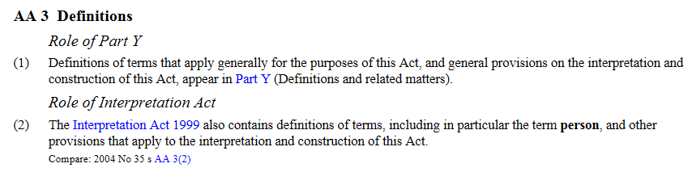

105 Such “explanatory provisions” may show a sense, by drafters, of a need to help legislation’s users. This need arises because, as John Christensen commented in 2000, “[Interpretation Acts] have evolved primarily in response to the needs of government and only incidentally to meet the needs of other users of legislation.”[149] Christensen notes (p 5) that because interpretation legislation may apply to all other legislation, “the potential audience of its users is as wide as the potential audience of users of the statute book as a whole”. But while users within government are likely to be aware of its existence and have a working knowledge of its contents, occasional users would not. It is therefore (p 6) “both all-pervasive and obscure”.

106 Geoff Lawn analysed the use, in Australia, of drafting techniques (for example, notes) to alert users of an enactment to the existence and impact of interpretation legislation. As he notes:

The 4th and 5th editions of *Thornton* suggest that the balanced approach to reliance on interpretation legislation on the part of drafters, an approach recommended in the 3rd edition of that work, should now be weighted more heavily in favour of communicating more effectively with the users of a particular enactment, particularly lay users. So Thornton includes the following advice:

A provision already in interpretation legislation may be repeated in particular legislation if the need to communicate that provision effectively justifies it. Of course, there is no technical need to do this and the critic may cry redundancy. However, the drafter has a continuing need to communicate and this need can be more important than the sin of a little repetition.

An alternative approach is to include a note beneath any section in which a term defined in interpretation legislation is used. Footnotes or endnotes to the legislation are other possibilities. [150]

117 Geoff Lawn concludes

there are problems with the view that interpretation legislation is essentially a drafter’s toolbox. We need to be careful that, for the increasingly wide range of users of legislation, it is not a Pandora’s box. A failure to alert users of legislation to the existence and importance of interpretation legislation, and the inclusion in it of obscure, arcane and counter-intuitive rules and provisions, can undermine the accessibility of legislation by militating against clarity, predictability and certainty. Interpretation legislation needs to assist rather than hinder access to legislation by non-specialist users, including members of Parliament who are expected to understand and debate the merits of legislative proposals.[151]

Among listed related ‘matters to be considered’, Geoff says

drafters should consider making individual enactments more self-contained by repeating definitions found in interpretation legislation, or at least including signpost provisions alerting the user that a particular term is defined in interpretation legislation. Notes alerting users to applicable provisions in interpretation legislation, such as those commonly used in ACT legislation, should be considered”. [152]

#### Exclusion – expressly or because of contrary intention (context qualification)

108 Interpretation Act provisions can also be excluded, expressly or impliedly. One expert says exclusion by context (contrary intention) alone is “very much a matter of impression that must be based on the terms of the legislation” – and arises most in 2 areas – effect of repeal and application of default definitions.[153] Roger Rose’s [*Commonwealth Legislative Drafting Manual* (2017)](https://www.thecommonwealth-ilibrary.org/commonwealth/governance/commonwealth-legislative-drafting-manual_9781848599635-en)[154] says:

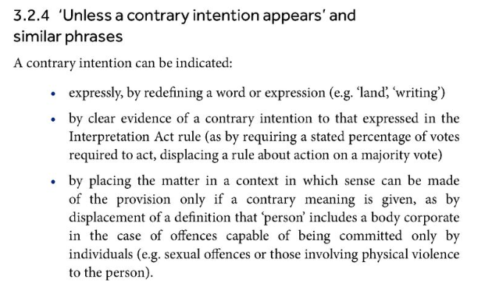

#### Gender – “a most unaccountable supposition” – and the modern position reframing

109 Uncertainties about gender are, it seems, not new ‒ as Geoff Lawn said in 2014

It is interesting that an attempt was made by a Mr John Stuart to repeal [Lord Brougham’s Interpretation Act 1850] in the following year. One of his concerns was the provision in the 1850 Act that all words importing the masculine gender should be taken to include females. The operation of that provision, he considered, would mean that a Bill then before the UK Parliament that entitled male persons paying rent, and occupying a house of a certain value, to vote would mean that females would be entitled to vote. According to Stuart “... no man could hereafter decide upon the construction of an Act of Parliament unless he had that Act by heart, or at least a copy of it in his pocket.”[155] The Attorney General opposed the repeal Bill on the basis that the 4 provisions of the 1850 Act were of a highly useful character. As for the provision about gender, he said that “*it was really a most unaccountable supposition that this provision in the Act under consideration would enable females to vote at Parliamentary elections;*”.[156] The repeal Bill was put off for 6 months, and (as far as I can tell) not pursued after that.[157] (*emphasis added*)

110 What is, now, “a most unaccountable supposition”, may be just as unclear. New drafting practice should avoid wording that, contrary to purpose, applies to only a particular gender.[158] Clause 16(1) of the Legislation Bill 2017 (NZ) thus updates s 31 of the *Interpretation Act 1999* (NZ), so words denoting a gender (are presumed to) include every other gender.[159] Chad Jacobi notes the “modern position” is that, “Typically, the rule has been reframed in terms that words importing a gender include every other gender.”[160] He also suggests the (single-)gender rule was not from common law but UK drafters’ practice following ordinary usage and Roman Law and Civil Law[161] and notes, a drafting direction issued by the First Parliamentary Counsel at the Australian OPC suggests repeating the noun is often better than using both masculine and feminine pronouns, which is required “except in the very rare case of legislation intended to apply to people of one sex but not the other (for example maternity leave legislation)”.[162]

#### Recent New Zealand Supreme Court decision – Affco – and drafters’ practice achieving clarity

111 Context qualifications, and when, exceptionally, they displace defined meanings, featured in a recent case in New Zealand’s Supreme Court: *Affco New Zealand Limited v. New Zealand Meat Workers and Related Trades Union Inc*.[163] If the meat workers laid off between seasons were ‘employees’ for the *Employment Relations Act 2000* (NZ), s 82(1)(b), then there was an unlawful lockout. The Supreme Court held the meat workers, because of their discontinuous employment, did *not* fall within the Act’s s 6(1)(b) definition of ‘employee’. But it also agreed with the Court of Appeal that ‘employees’ in s 82(1)(b) has, because of the context qualification, a broader meaning than the definition of ‘employee’ in s 6. So, the broader meaning of ‘employee’ in s 82(1)(b) *did* cover or apply to the meat workers with their discontinuous employment. Context will only very exceptionally displace the defined meaning (which, ideally, would differ expressly where needed). *Affco* reiterates earlier New Zealand authority which confirms that strong and exceptional contextual reasons are needed to displace the defined meaning in favour of a different one. But strong contextual reasons existed in *Affco*. Those reasons included the language of the unlawful lockout provisions and of surrounding provisions, their purpose and underlying policy considerations, and any helpful legislative history. *Affco* innovates by helping make clear what counts as ‘context’ for this purpose (and perhaps also for other purposes). Context in this connection is broad, including purpose, policy considerations reflected in the legislation, and legislative history.

112 Geoff Lawn suggests that:

Understanding and applying the subtleties of this relationship between interpretation legislation and individual enactments is likely to be beyond the average lay user of legislation, and probably a lot of lawyers. It is therefore incumbent on drafters to ensure, so far as they can, that the intention to exclude the application of interpretation legislation provisions is expressed as clearly as possible.[164]

113 This is only reinforced by Nick Horn’s valuable analysis of contrary intention, concluding that:

On any view, the operation of the presumption will not necessarily be clear in any particular case. . . . The criteria of whether the application of a default rule would be consistent with the ‘general character’ of the subject Act, or ‘would appropriately work’ or ‘lead to confusion’ leave a lot of room to manoeuvre.[165]

114 Procedural requirements of legislatures, and drafting office legislative drafting practice directives, can also affect actual reliance on Interpretation Acts. For example,

* Standing Orders may require a Bill to contain an express commencement provision,[166] so *preventing* reliance on the Interpretation Act’s default commencement rules for Acts;
* drafting directives may *require* a drafting practice relying on default rules and so preventing self-contained or idiosyncratic repetition of default provisions (for example, avoiding “from time to time” to make a power (as it is by default) exercisable repeatedly, and avoiding re-conferring expressly, in particular cases, general default powers to amend, revoke, or replace).

115 In New Zealand, George Tanner regarded a new Interpretation Act as just one of “three limbs of a tripod of interrelated measures designed to make legislation more accessible”: ‘interpretation, format [of legislation], and [a drafting manual optimising] the structure and style of legislation”.[167]

### 4 Interpretation Acts’ scope as, and interaction with other, interpretation law (including links with interpretation legislation in related jurisdictions)

#### Interaction with supreme law Constitution

116 Does an Interpretation Act apply to, and affect interpretation of, a higher law Constitution? “The Act will be expressed to apply to all legislation (except for the Constitution, unless the Constitution itself expressly otherwise states).”[168] Reviewing the *General Clauses Act 1897* (India) in the 1970s, the Law Commission of India considered article 367 of India’s Constitution, which provided:

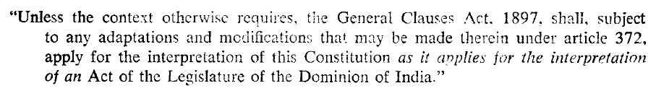

117 The Commission considered whether, given article 367, the 1897 Act could be repealed or modified. It concluded the 1897 Act *could* be repealed or modified, but *not* so as to affect the Constitution, (and, if the 1897 Act were repealed and re-enacted, the reference to the 1897 Act in article 367 would *not* be construed as a reference to the re-enacted Act, that presumption would be excluded). [169] A corollary of this higher law status is the interpretive presumption of constitutionality. Australia’s Acts Interpretation Act 1901, section 15A says: “Every Act [including an Interpretation Act] shall be read and construed subject to the Constitution”. Canada’s *Interpretation Act* (R.S.C., 1985, c. I-21), s 3(1) says that

Every provision of this Act applies, unless a contrary intention appears, to every enactment, whether enacted before or after the commencement of this Act.

Section 10 (Law always speaking) says:

The law shall be considered as always speaking, and where a matter or thing is expressed in the present tense, it shall be applied to the circumstances as they arise, so that effect may be given to the enactment according to its true spirit, intent and meaning.

The doctrine of progressive or “living tree” interpretation is one way in which the *Constitution Act 1867* (Canada) has been able to adapt continuously to changes in circumstances since, and not be “frozen” in meaning as at, 1867. So, the 1867 Act, “although undeniably a statute, is not a statute like any other; it is a ‘constituent’ or ‘organic’ statute, which has to provide the basis for the entire government of a nation over a long period of time.”[170] The difficulty of amendment also means adaption to changing conditions must fall more upon the courts.

#### Special provisions in particular legislation – and all general interpretation law in one place?

118 Other aspects of Interpretation Acts’ interaction with other law are interaction with: (a) other “ordinary” statute law about interpretation (many examples of which have already been given, and some of which clearly displace or exclude the Interpretation Act); and (b) common law about interpretation (which is not excluded by the Interpretation Act if not inconsistent with that Act).[171]

119 Christensen’s comment that “The view that [general] provisions closely related to the interpretation of legislation ought to be found in the one place”[172] is understandable, but views on its detailed application may differ. For example, should general rules about maximum penalties[173] or overlapping offences[174] be in an Interpretation Act or in a Crimes Act (even if legislation other than that Crimes Act creates offences)? The *Age of Majority Act 1970* (NZ), s 4(2), for example, defines terms relating to the age of majority “in any enactment or instrument” absent a definition or any indication of a contrary intention. However, it has not been absorbed into the general interpretation legislation. New Zealand might also consider, by analogy with the *Acts Interpretation Act 1901* (Aust), s 37 (Expressions of time), ensuring that Part of the Legislation Bill 2017 (275—2) cross-refers to the *Time Act 1974* (NZ), if not also the *Calendar (New Style) Act 1750* (UK) (so far as it is part of the laws of New Zealand).

#### Uniformity or divergence?

120 Federal and multi-layered jurisdictions also raise questions of uniformity or divergence (for example, in sub-national legislatures, plus in delegates’ secondary or subordinate legislation, such as district plans[175]). This paper asks, earlier, should differences in Interpretation Acts be deplored or celebrated? It is tempting to say that the answer is: “both”. As Geoff Lawn said in 2014, “the adoption of uniform interpretation legislation by Australian jurisdictions would simplify access to Australian legislation, and uniform Australasian interpretation legislation might also be considered desirable”.[176] But comparable common law jurisdictions – as this paper and the highly cross-fertilised history shows – are windows both into alternative approaches, and into learning from others and the past. Also, as is made clear by the introductory notes to the 1983 Model Interpretation Bill prepared for Commonwealth Secretariat by Garth Thornton OBE, QC, a “core” selection of provisions collated and made harmonious, and on which a new Interpretation Act for a jurisdiction might be modelled, must be related appropriately to the jurisdiction: “its shape must take into account a host of local matters of a constitutional or legal nature, for example whether the legislature is unicameral or bicameral, whether the country is a monarchy or a republic, the nature of the court structure and indeed the state of the statute book in a host of respects.”[177]

### 5 Ways Interpretation Acts can stop being, or fail to be, great law

#### Omitting to provide any general default interpretive direction

121 Gaps in Interpretation Acts can stop them being, or ensure they fail to be, great law.

122 An example is omitting to provide any general default interpretive direction. An “Interpretation Act” is arguably now incomplete without one. It is remarkable that there is no such direction in the 1978 UK Act (or in the interpretation legislation, enacted and proposed, of Northern Ireland, Scotland, and Wales). Ambivalence towards an Interpretation Act’s clarifying the law by enacting general rules of statutory interpretation is shown, for example, by Rupert Cross in 1976:

The adoption of the [England and Wales and Scottish] Law Commissions’ [1969] proposals might do a little good and could do little harm, but it is doubtful whether it would have much practical effect on the action of the courts. An updated Interpretation Act would merely tend to shorten future legislation and facilitate its drafting by rendering definitions of a variety of expressions unnecessary and by enacting some helpful presumptions. At the more exalted level of general principles the subject [(ie, statutory interpretation)] does not lend itself to legislation. This fact enhances rather than diminishes the role of the academic writer and it will be submitted in the next section that challenge has, in England [and in 1976][178] at any rate, hardly been acknowledged, let alone accepted.[179]

123 Referring to New Zealand’s purposive direction in s 5(j) of the Acts Interpretation Act 1924 (NZ), Cross also suggested “some countries have more ambitious interpretation acts”.[180] Introducing his 1983 Model Interpretation Bill for the Commonwealth Secretariat, Garth Thornton said:

Whether a [general interpretation direction requiring purposive interpretation] modelled on one of the above examples [from Canada and Australia] is necessary or desirable is a question that is capable of being answered adequately only in the light of current judicial trends and attitudes in a particular country and for this reason the [Model Bill] draft does not contain such a provision. The practical results of attempting to direct courts in this manner can only be a matter of speculation.[181]

In New Zealand, with its long history since the 1850s of purposive directions, Justice Glazebrook recently summarised as follows the practical results of the latest, 1999, direction:

The *Interpretation Act 1999* meant the increased use of s. 5(j) of the *Acts Interpretation Act 1924* and thus the move to purposive interpretation had been endorsed by Parliament. It has remained the central approach to interpretation in the courts ever since. For example, in *Commerce Commission v Fonterra Co-operative Group Ltd*, the Supreme Court held that, “[e]ven if the meaning of the text may appear plain in isolation of purpose, that meaning should always be cross-checked against purpose in order to observe the dual requirements of s. 5.”[182]

124 Answering, in 2003, the question, “Is s. 5 used?”, Professor John Burrows QC said:

The fact is . . . that the New Zealand Courts have in recent times cited s. 5(1), and its predecessor s. 5(j), with very great frequency. . . .

What is more difficult to say is whether s. 5(1) has been used to arrive at the decision, or whether it has been used to legitimate a decision already reached. For there is little doubt that, even if s 5(1) had not been passed, our courts would still be using a purposive approach. In the UK, where there is no such statutory direction, the purposive approach also holds sway, and there are statements of it as strong as, and in some cases even stronger than, anything one finds in New Zealand. . .

The cooperative partnership between legislature and the Courts that the purposive approach mandates is a modern necessity. . .

So a purposive approach would have come to New Zealand without s 5(1) anyway, but its presence in the legislation is a clear reminder, and has led to more uniformity of approach and reasoning than might otherwise have been the case.[183]

#### Binding the Crown – a gap made in the rule of law?

125 Another gap in an Interpretation Act (and perhaps also “the rule of law”[184]) might be a failure to simplify and clarify legislation by reversing, for future legislation, the presumption that legislation does not bind the Crown. The doctrine of legislation binding the Crown by necessary implication[185] (if that doctrine is not abolished statutorily[186]) complicates unhelpfully the law in this area – and Scotland and Wales have reversed, or are in the process of reversing, respectively, the presumption for future legislation – along with abolishing binding by necessary implication and making the reversal *not* excludable by context.[187] As George Tanner noted in 2003, the omission from the Interpretation Bill 1997 (NZ) of the reversal of the presumption “largely accounted for the nearly two years taken to finally enact the new [1999] law”[188] – the *Interpretation Act 1999* (NZ). New Zealand’s Law Commission in 1990 recommended such a reversal. Reversal was not adopted in the *Interpretation Act 1999* (NZ), however. That was in part because the effects of reversal were unpredictable. As Lady Hale notes in *Black*,

the presumption . . . is so well established . . . that many, many statutes will have been drafted and passed on the basis that the Crown is not bound except by express words or necessary implication.[189]

The answer may be to reverse the presumption for future legislation only. New Zealand’s Cabinet in 2001 agreed to make explicit decisions about whether a draft Government Bill should include a provision stating that the Act will bind the Crown. The general principle is that the Crown should be bound by Acts unless the application of a particular Act to the Crown would impair the efficient functioning of the Government.[190]

#### Integration with other legislation about legislation

126 Failure to fit with related law (for example, law on drafting, publishing, scrutiny) is another weakness. “Interpretation Acts” should fit well with (for example, use the same concepts or terms as) other legislation on legislation (for example, legislation on who is responsible for drafting or publishing legislation). This is a major goal of the Legislation Bill 2017 (275—2), as the Law Commission recommended.[191] How does one optimise the structure of an Interpretation Act, or of interpretation provisions in and as a part of a Legislation Act? Two basic structural approaches are (1) most to least important, with ‘importance’ linked to generality and significance of application or effect in practice; and (2) the ‘life-cycle’ of a law (the key structuring principle used in the Legislation Act 2001 (ACT)). Organisation of interpretation provisions is key and, as Paul Salembier says, they should make clear definitions that apply (1) only within the provisions; and (2) to all, or at least all new, legislation.[192]

#### Multi-lingual, and mixed or multi-jural, legislation

127 Failure to recognise mixed or multi-lingual, and mixed or multi-jural, legislation, might well be another weakness.[193] However, caution and incremental change is, perhaps, understandable in legal systems evolving towards more and more such legislation. Special interpretative rules can be used in this context (for example, *Te Ture mō Te Reo Māori 2016* / *Māori Language Act 2016* (NZ) s 12). Notably the Legislation Bill 2017 (275—2), cl 13 ensures the terms North Island/*Te Ika-a-Māui* and South Island/*Te Waipounamu* are changed to reflect that those Māori names are now [official names](http://www.linz.govt.nz/north-island-and-south-island-nzgb-decisions-17-october-2013).

#### Failing to keep up-to-date

128 Language changes are only one aspect of failing to keep up-to-date. Rupert Cross in *Statutory Interpretation* says

The current English Interpretation Act is that of 1889. . . There is no doubt that this Act needs to be up-dated . . . there are far too many obsolete provisions relating, for example, to various defunct poor law institutions and the British Government of India.[194]

The [Legislation (Wales) Bill 2018](http://www.assembly.wales/laid%20documents/pri-ld11927/pri-ld11927-e.pdf) cls 5 and 41 usefully provide as follows for updating regulations which may be made if laid before, and approved in draft by a resolution of, the National Assembly:

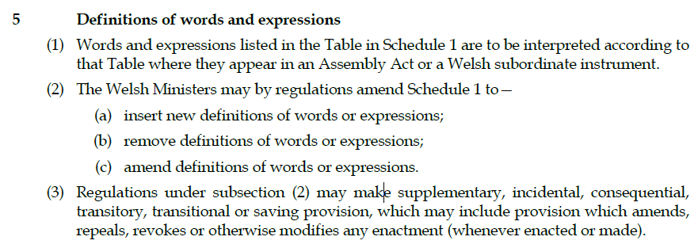

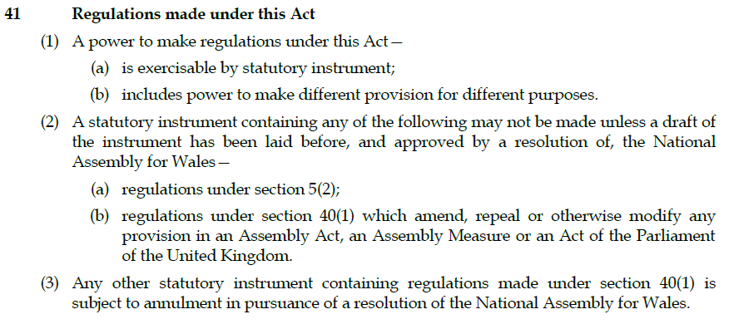

129 New Zealand’s attitude to amending primary legislation by secondary legislation would make it hard to adopt this technique in New Zealand. But it is still a useful technique for updating.

130 New Zealand had the same Interpretation Act, albeit amended, from 1924 to 1999. The world changed hugely while the 1924 Act was in force. Technology change is such that presumptions about delivery by Post are now supplemented by presumptions about electronic transactions – to which the Legislation Bill 2017 (NZ) (275—1) cross-refers in cl 17(5):

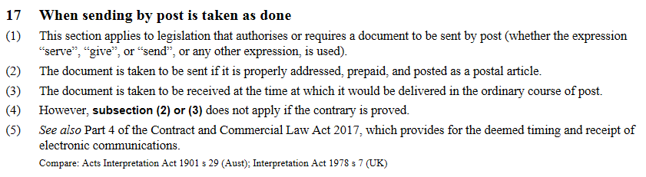

131 Prescribed forms are also, increasingly, replaced by approved forms, or prescribed information to be supplied using an approved or prescribed method, format, or medium (for example, online-user forms). New Zealand’s Legislation Bill 2017 (275—2), cl 53 proposes to extend traditional powers to approve or prescribe forms to cater for these new developments.

#### Clarity of exclusion

132 Interpretation Act provisions are, as this paper has discussed a lot, also excludable, and so, sometimes excluded. As Geoff Lawn has argued, Interpretation Acts can also fail to be great law where it is unclear whether they have been excluded by other legislation.[195] Drafters have a key role to play in helping make it as clear as possible whether an Interpretation Act is or is not excluded.[196]

#### Provisions too arcane for (especially non-lawyer) users of legislation – text and indications

133 Interpretation Acts can also fail to be great law when their provisions are too arcane (for users, especially non-lawyer users). An example is provisions for 1 of Reed Dickerson’s 8 purposes: “[to] determine the boundaries of effective legislation”. As Geoff Lawn said in 2014, “A lay reader looking at an enactment is likely to regard every word on the page [or screen] to be part of the enactment and contribute to its meaning. Any other approach is counter-intuitive.”[197] In the Legislation Bill 2017 (275—2) (NZ), cl 10(3) rewords s 5(2) to clarify that “text” and “indications” are on the same footing for interpretation purposes.

134 An historical distinction existed, in the Acts Interpretation Act 1924, between substantive “text” of an enactment, and certain “indications provided in” (for example, headings in) the enactment. The Law Commission in 1990 found this distinction unhelpful: (NZLC R17, 1990), paras [88]–[99]. The Commission therefore proposed s 5(2) of the 1999 New Zealand Act to enable clearly all “indications provided in the enactment” to be taken into account in ascertaining meaning.

135 However, nowadays, interpreters consider routinely not only an enactment’s text, but also all “indications provided in” the enactment. The s 5(2) wording “the matters *that may be* considered” can also be misunderstood as creating a discretion to disregard (instead of only making clear the abolition of former prohibitions on using certain) enacted “non-text” indications. (For example, headings, which, under section 5(f) the 1924 New Zealand Act, could be used *for reference*, but had to be disregarded *in interpretation*.)

136 Clause 10(3) therefore links to the word “text” in clause 10(1), and requires meaning to be ascertained from text *including indications provided in the legislation* (*emphasis added*).

137 This position reflects better both (a) that legislators also approve indications provided in legislation, and (b) current legislative drafting and interpretation practice.[198]

138 For example, as New Zealand’s Court of Appeal said in a recent decision:

We…begin with the text …and the associated heading. [...section headings may be considered in ascertaining the meaning of an enactment: s 5...] …the words gain definition from the section heading, which states the purpose of the section...[199]

#### Usefulness in practice – measuring a distance?

139 Assembling the Commonwealth Secretariat’s 1983 Model Interpretation Bill, Garth Thornton QC stated that “My study of many existing Interpretation statutes has led me to make a subjective selection of provisions I consider useful and beneficial.”[200] Evidence of the use and usefulness of some Interpretation Act provisions can, for some provisions, be a little hard to find. As Professor John Burrows QC has noted, the main interpretation direction (as 5(1) of the 1999 Act in New Zealand) is often and properly cited extensively in and by the courts.[201] More arcane rules arise less obviously.

140 An example is s. 36 on how to assess distances.[202] This was discussed in [*Mountz v Craig*](http://www.nzlii.org/cgi-bin/sinodisp/nz/cases/NZHC/2016/1558.html).[203] The issue was the proper registry of the Court in which to file proceedings. Associate Judge Osborne said:

The facts involved in this proceeding give rise to an unusual question[204] in relation to the proper registry. Is Wanaka nearer to Dunedin [276 kms, three hours, 25 minutes away] or Invercargill [242 kms, three hours, 19 minutes away]? Put another way, is it the registry at Dunedin or the registry at Invercargill which is nearest to Wanaka?[205]

The case highlights conceptual choices and legal tests. High Court Rule 5.1(1)(a) made the proper registry the one that is “nearest” to (the first-named defendant’s residence in) Wanaka. High Court Rule 1.3 defines **nearer** or **nearest**, unless the context otherwise requires, in relation to any place, as nearer or nearest “*by the most practicable route*” (*emphasis added*). Associate Judge Osborne said:

The practicability of a route contrasted with straight line measurement

[24] The requirement to consider the practicability of a route may be contrasted with the provision in s 36 *Interpretation Act 1999* which is:

**36 Distance**

A reference to a distance means a distance measured in a straight line on a horizontal plane.

[25] It is initially surprising to learn that the *Interpretation Act* provision (preceded by s 25(c) *Acts Interpretation Act 1924*), was enacted to overcome what were seen as difficulties in determining what was the most practicable route. The parallel English development is explained in *Maxwell on the Interpretation of Statutes* where the authors write:3

Distances were formerly measured by the nearest and most usual road or way, and this is undoubtedly the popular manner of measuring them. But ‘in the measurement of any distance for the purposes of any Act passed after’ January 1, 1890 ‘that distance shall, unless the contrary intention appears, be measured in a straight line on a horizontal plane’. And this solution has, on grounds of convenience, been applied to older statutes as well. For if we are to take ‘the nearest practicable road … does that mean a footway or a carriageway? Or, if a footway will not do, will a bridle path? In an aquatic country are we to take a boat? All these are questions of doubt avoided by the simple rule now adopted’.

[26] The interpretation provisions of the *Interpretation Act 1999* do not apply where an enactment provides otherwise or the context of the enactment requires a different interpretation.

[27] The express adoption of a test of “practicability” in rr 5.1 and 1.3 High Court Rules is shared with a number of other statutes dealing with matters of judicial administration.4 All such provisions require a different approach to construction than would occur through s 36 *Interpretation Act 1999*. [206]

3 P St J Langan *Maxwell on the Interpretation of Statutes* (12th ed, Sweet & Maxwell, London,

1969) at 312 – 313.

4 See, for instance, Juries Act 1981, s 5(3); Summary Proceedings Act 1957, ss 18 and 168A (since repealed); Disputes Tribunals Act 1988, s 24; High Court Rules rr r 24.13(a) and 31.4(1).

141 Associate Judge Osborne concluded that Invercargill is the registry of the Court nearest to the first defendant’s residence (at Wanaka). The main issue was “practicability”, and the possibility that the predictable, temporary impassability of a particular route (the Crown range road), or its passability only with snow chains, did not make that route “impracticable”. The *Interpretation Act 1999* s 36 helped show the Court’s procedural rules had departed from the “straight line on a horizontal plane” approach in favour of the alternative approach (nearer or nearest *by the most practicable route*).

142 Chad Jacobi traces the “straight line on a horizontal plane” language to the common law as settled in [*Lake v Butler*](http://www.commonlii.org/uk/cases/EngR/1855/468.pdf),[207] which Jacobi says is case law that, itself, drew on the language of s 76 of the *Registration Act* (UK) (6 & 7 Vict, c 18), a provision to reckon eligibility to vote in a local election. [208] Jacobi also quotes from the submission of Hayes for the defendant in *Lake v Butler*: “And, if it is to be the nearest practicable way for horses, does that mean the nearest way when the fens are dry in summer or frozen in winter, or the nearest way when they are flooded”. The New Zealand Law Commission in 1988 traced the New Zealand origin of the “straight line on a horizontal plane” rule to section 7 of the [*Acts Interpretation Amendment Act 1908*](http://www.nzlii.org/nz/legis/hist_act/aiaa19088ev1908n242403/). [209] The Bill for this Act has an explanatory [memorandum](http://www.nzlii.org/nz/legis/hist_bill/aiab1908312320/) by John W Salmond, Counsel to the Law Drafting Office, saying

If this Bill is passed immediately after the enactment of the [1908] Consolidated Statutes, the advantage will be obtained of uniform language and interpretation throughout the new series of statutes which then commences. . . . Most of the provisions of the Bill are already in force either in England or in Australia.

An example of a provision of the Bill for the 1908 New Zealand Act that was a provision “already in force” in England is s 34 of the *Interpretation Act 1889* (UK).

### 6 Ways policy-makers and drafters can meet the challenges of making Interpretation Acts, and all the other law that interacts with them, great law

#### Who are the policy makers for Interpretation Acts? Who should be?

143 As this paper has shown, they surely include law drafters, alongside Law Commissioners, Judges, and academic lawyers, and, of course, departments of State (such as Attorney-General’s departments and Ministries of Justice). Cross-fertilisation, or learning via comparative law,[210] also feature strongly in the evolutionary story.

144 New Zealand’s legislative counsel’s contributions include the following:

* Sir John Salmond attempted boldly, and unsuccessfully, in the 1908 Bill for the *Acts Interpretation Amendment Act 1908* (NZ), to abolish the *ejusdem generis* (limited class) rule, as well as to alter the presumption that Acts do not bind the Crown.[211] As James Christie said in 1939: “Sir John was in advance of his time, and the offending [*ejusdem generis* (limited class)] rule remains to harass the draftsman.”[212] Paul Salembier points out that Malaysia’s Interpretation Acts 1948 and 1967 s 26 enhances interpretive certainty by displacing the *ejusdem generis* (limited class) rule as it applies to general powers, accompanied by specific powers, to make subsidiary legislation.[213]
* D A S (Denzil Antony Seaver) Ward in the 1950s and 1960s urged judges to put aside inconsistent ancient common law presumptions or canons of interpretation and apply faithfully the general legislated interpretation direction (the *Acts Interpretation Act 1924* (NZ) s 5(j)), which he described as “a modern version of the mischief rule in statutory form”, so as to give effect, wherever possible, to the particular social policy that Parliament had tried to embody in the Act.[214]
* Garth Thornton OBE, QC, a New Zealander, in April 1983 the Parliamentary Counsel in Western Australia, prepared the Model Interpretation Bill published by the Commonwealth Secretariat:
* George Edwin Tanner ONZM, QC, prepared the 1997 Bill for the Interpretation Act 1999 (NZ), drawing on the work of Sir Kenneth Keith (assisted by Janet McLean and Nicola White), and later of Sir David Baragwanath and Padraig McNamara, at the New Zealand Law Commission:[215]
* New Zealand’s PCO is currently engaged in helping to re-enact the *Interpretation Act 1999* (NZ), with updating, in a new Legislation Act – a major goal of the Legislation Bill 2017 (275—2), and as the Law Commission recommended in 2008.[216] As with the Law Commission’s review that led to the 1999 Act (NZLC R17, 1990), the 2017 Bill, and its 2014 predecessor Bill, are based on review and consultation, including with experts and interested members of the public.[217] However, the new interpretation law for Wales may perhaps be enacted before New Zealand’s.[218]

145 In all, the role of analysis, commentary, and the lawyer as academic, should not be forgotten. As John Burrows ONZM, QC, shows,[219] the academic writer’s role has been great in New Zealand, taking up the wero (challenge) of helping us understand past, present, and best future. As Justice Glazebrook notes,

Professor Burrows said in 1969 that judicial attitudes to purposive provisions in statutes ranged from reference to a ‘curious provision’ relegated to the category of a ‘forlorn hope of desperate counsel’ to a reference to it as ‘the cardinal rule of statutory construction’.[220]

And as Burrows notes,

Since [earlier eras’ emphasis on literalism], however, there has been an inevitable shift to a purposive approach. These days that has to be so. . . . This simple imperative, now contained in section 5(1) of the *Interpretation Act 1999* [(NZ)], is continually followed.[221]

#### Awareness is essential – and an infinity of improvement

146 Nick Horn suggests, with typical insight,

[L]ow-level Interpretation Act rules are not necessarily, in themselves, beneficial. … To enhance interpretative coherence, *they need to be supplemented with an awareness of their presumptive impact* by drafters and interpreters alike. (*emphasis added*)[222]

147 Improvement is infinite. Legislative counsel might think of New Zealand’s first Governor, Hobson, addressed graveside in C K Stead’s 1990 poem:[223]

. . . everywhere this language both subtle and strong. You didn’t start it, Governor. As we do, you fashioned what time, and the times that live in us, required. It doesn’t finish. These verses have no end.”

### Appendix: development of, and literature about, Acts of different jurisdictions

#### Australia

* Commonwealth

[Acts Interpretation Act 1901 (Aust)](https://www.legislation.gov.au/Details/C2019C00028)

Christensen (2000) at 4 says “There was in fact a second [Australian] Commonwealth IA between 1904 and 1937 (when the provisions of the 1904 Act were incorporated into the 1901 Act).”

Carmel Meiklejohn *Fitting the Bill – A History of Commonwealth Parliamentary Drafting* (Australian Government, Office of Parliamentary Counsel, 2012) at pp 35, 66, 69, 160, 162, 204‒206, 216, 231, 296‒297, and 344.

A. R. Butterworth, E. L. de Hart, W. F. Craies, A. Buchanan, J. W. Fearnsides, H. E. Gurner, R. W. Lee and Godfrey R. Benson “Australasia” (1902) 4(2) Journal of the Society of Comparative Legislation 250‒299

Dennis Pearce “The Interpretation of Interpretation Acts and Clauses” (1971) 2 Australian Current Law Review 114

[Geoffrey Sawer, ‘Singulars, Plurals, and Section 57 of the Constitution’ (1976) 8 Federal Law Review 45](http://classic.austlii.edu.au/au/journals/FedLawRw/1977/3.pdf)

[Interpretation reform [1981] Reform 83](http://classic.austlii.edu.au/au/journals/ALRCRefJl/1981/29.pdf)

Australian Attorney-General’s Department *Symposium on Statutory Interpretation* (AGPS, Canberra, 1983)

Statute Law Revision Act 1981 adds to the Acts Interpretation Act 1901 (Aust) s 15AA, which is a purposive direction

Acts Interpretation Amendment Act 1984 adds to the Acts Interpretation Act 1901 (Aust) s 15AB, relating to the use of extrinsic material

Barnes [(1994) 22 Federal Law Review 116](http://classic.austlii.edu.au/au/journals/FedLawRw/1994/5.pdf) and [(1995) 23(1) Federal Law Review 77](http://classic.austlii.edu.au/au/journals/FedLawRw/1995/3.html)

*Review of the Commonwealth Acts Interpretation Act 1901* (Commonwealth of Australia, 1998)

Dennis Pearce, ["Removal From office and Section 33 of the Acts Interpretation Act 1901" [2007] AIAdminLawF 18](http://www.austlii.edu.au/cgi-bin/viewdoc/au/journals/AIAdminLawF/2007/18.html?context=1;query=Interpretation%20Act;mask_path=au/journals)

[Acts Interpretation Amendment Bill 2011 (Aust) – Explanatory memorandum](https://www.legislation.gov.au/Details/C2011B00083/Explanatory%20Memorandum/Text)

[Acts Interpretation Amendment Bill 2011 (Aust)](https://www.aph.gov.au/Parliamentary_Business/Bills_Legislation/Bills_Search_Results/Result?bId=r4565)

Jacinta Dharmananda, “The Commonwealth strikes back: Clarifying amendments to the Acts Interpretation Act 1901 (Cth)” (2011) 35(2) Australian Bar Review 116‒127

Michael Kirby, “"The Never-Ending Challenge of Drafting and Interpreting Statutes - A Meditation on the Career of John Finemore QC" [(2012) 36(1) Melbourne University Law Review 140](http://classic.austlii.edu.au/au/journals/MelbULawRw/2012/4.html) (Finally, the article examines the terms of s 15AA of the Acts Interpretation Act 1901 (Cth), as amended in 2011. It concludes that the amended section does not ‘swamp’ the operation of other interpretative rules. It clarifies the operation of a statutory provision that itself reinforces the common law trend towards a purposive interpretation of enacted words, so long as those words permit that approach)

Margaret MacLean Pringle, ["Acts Interpretation Amendment Act 2011" [2011] NSW Bar Assoc News 35](http://www.austlii.edu.au/cgi-bin/viewdoc/au/journals/NSWBarAssocNews/2011/35.html?context=1;query=Interpretation%20Act;mask_path=au/journals)

Anna Lehane and Robert Orr "Amendments to the Commonwealth Acts Interpretation Act" [[2013] AIAdminLawF 12; (2013) 73 AIAL Forum 40](http://classic.austlii.edu.au/au/journals/AIAdminLawF/2013/12.pdf)

* Australian Capital Territory

[Interpretation Ordinance 1967](https://www.google.co.nz/url?sa=t&rct=j&q=&esrc=s&source=web&cd=2&ved=2ahUKEwjauLHTw9PgAhUGWysKHTQND8EQFjABegQIBRAC&url=https%3A%2F%2Fwww.legislation.act.gov.au%2FDownloadFile%2Fa%2F1967-48%2F19890511-9605%2FPDF%2F1967-48.PDF&usg=AOvVaw0nKBmqhSsqYqyFksEJGEk_)

[Legislation Act 2001](https://www.google.co.nz/url?sa=t&rct=j&q=&esrc=s&source=web&cd=3&ved=2ahUKEwjauLHTw9PgAhUGWysKHTQND8EQFjACegQICBAC&url=https%3A%2F%2Fwww.legislation.act.gov.au%2FDownloadFile%2Fa%2F2001-14%2Fcurrent%2FPDF%2F2001-14.PDF&usg=AOvVaw2HRGKYhmcEvnsq5djGObsb)

* New South Wales

Acts Shortening Act 1851 (16 Vict No 1)

Acts Shortening Act 1858 (22 Vict No 12)

[Interpretation Act 1987](https://www.legislation.nsw.gov.au/#/view/act/1987/15)

* Northern Territory

[Interpretation Act 1978](https://legislation.nt.gov.au/en/Legislation/INTERPRETATION-ACT-1978)

Northern Territory Law Reform Committee [*Report on Statutory Interpretation* (Report No 12, December 1987)](https://justice.nt.gov.au/__data/assets/pdf_file/0009/483426/NTLRC-Report-12-Report-on-Statutory-Interpertation-1987.PDF)

* South Australia

[Construction of Ordinances Act 1843 (6 and 7 Vic., 1843, No. 1)](http://classic.austlii.edu.au/au/legis/sa/num_act/cooa1o6a7v1843384/)

“Australian interpretation legislation actually pre-dates Lord Brougham’s Act. South Australia was the first Australian colony to enact an Ordinance “for avoiding unnecessary repetitions in the Ordinances of the Governor and the Legislative Council of South Australia”.38 [6 & 7 Vic., 1843, No. 1.] The Ordinance passed the Legislative Council on 13 October 1843, and provided that, unless there was something in the subject or context repugnant to it, words importing the masculine gender or singular number were to be construed to include the feminine and plural, and vice versa, and bodies politic and corporate as well as individuals. In addition, references in Ordinances to the Governor or any public officer were to be construed to mean the person lawfully acting as such for the time being.

Western Australia enacted an Ordinance in essentially the same terms on 5 June 1844,39 [8 Vict, 1844, No. 11.] but also added a provision that the word “Act” was to be construed to mean “Ordinance” and vice versa.”: Geoff Lawn [“George Tanner Memorial Address: Interpretation Acts and clear drafting” Paper for 7th Australasian Drafting Conference, Perth, Western Australia, 30 July – 1 August 2014](https://www.pcc.gov.au/pccconf/2014/papers/S08p.pdf).

[Acts Interpretation Act 1915](https://www.legislation.sa.gov.au/lz/c/a/acts%20interpretation%20act%201915.aspx)

* Victoria

[Interpretation of Legislation Act 1984](http://classic.austlii.edu.au/au/legis/vic/consol_act/iola1984322/)

* Queensland

[Acts Interpretation Act 1954](http://www8.austlii.edu.au/cgi-bin/viewdb/au/legis/qld/consol_act/aia1954230/)

[Duffy and O’Brien (2017) 40(3) UNSW LJ 952](https://eprints.qut.edu.au/105379/14/105379.pdf)

* Western Australia

[Shortening Ordinance 1844 (8 Vict. No 11)](http://classic.austlii.edu.au/au/legis/wa/num_act/i8vn11247/)

[Shortening Ordinance 1853 (16 Vict. No 11)](http://classic.austlii.edu.au/au/legis/wa/num_act/so185316vn11270/)

“See Imperial Act [Lord Brougham’s Act], 13 & 14 Vic., c. 21; also, 8 Vic., No. 11 ; and 14 Vic., No. 5, s. 30” – the last is the WA [Summary Offences, Justices Ordinance 1850 (14 Vict. No 5) s 30](http://classic.austlii.edu.au/au/legis/wa/num_act/jso14vn5343/) (penalty for an offence when uncertain in the discretion of Magistrate, application of penalty).”

Interpretation Act 1984

* Tasmania

[Acts Interpretation Act 1931](https://www.legislation.tas.gov.au/view/html/inforce/current/act-1931-059)

John Leahy, Parliamentary Counsel, Queensland, *The Quest for a Uniform Interpretation Act*, (and commentary by Peter Conway, Chief Parliamentary Counsel, Tasmania) 1st Australasian Drafting Conference, Canberra, ACT, 15‒17 July 1992

John Christensen, [Developments in Interpretation Legislation, 2nd Australasian Drafting Conference, Wellington, New Zealand, 9‒11 February 2000](https://www.pcc.gov.au/pccconf/2000/papers/session2-chris.pdf)

PCC Standard interpretation provisions for model legislation

Stephen Gageler "Legislative Intention" (2015) 41(1) Monash University Law Review 1 at 6‒7 (on the Acts Interpretation Act 1901 (Cth) new s 15AB, and State and territory equivalents)

Dennis Pearce *Interpretation Acts in Australia* (LexisNexis Butterworths: Chatswood, 2018)

[Chad Jacobi, *Interpretation Acts: Origins and Meaning* (Thomson Reuters, Australia, 2018)](https://legal.thomsonreuters.com.au/interpretation-acts-origins-and-meaning/productdetail/126391)

Nick Horn, “Interpretation Acts: coherent interpretation and a coherent statute book”, in Jeffrey Barnes (ed) *Coherence and Statutory Interpretation* (Federation Press, 2019), ch 13 at 164:

“Australia’s State and Territory Interpretation Acts also owe their origins to the Imperial laws, but differ significantly from the [Australian] Commonwealth Act, and from each other, in some ways. John Leahy describes two broad approaches, the ‘minimalist’ (30 to 40 short sentences) and the ‘maximalist’ approach. As he indicates, the Interpretation Acts of the United Kingdom, New Zealand, Canada and South Australia are at the minimalist end of the spectrum, while those of the Commonwealth, the other States, the Northern Territory and the Australian Capital Territory (‘the ACT’) are towards the maximalist end. Among those, the interpretation laws of Queensland and the ACT are considerably more expansive than the others. . . . In particular, the ACT Act covers the territory of the other Acts, but ranges considerably wider, running to over 300 sections with 2 large Dictionaries (one internal to that Act and the other defining terms for other Acts), compared with the Commonwealth Act’s 80 sections, itself not the shortest of Interpretation Acts.”

#### Bermuda

[Interpretation Act 1951](http://bermudalaws.bm/laws/Consolidated%20Laws/Interpretation%20Act%201951.pdf)

#### Canada

[Statutes of Upper Canada (1837) 7 Wm IV, chap 14](http://eco.canadiana.ca/view/oocihm.9_10042_44_1/50?r=0&s=1)

[Interpretation Act 1849 (12 Victoria, c. 10)](http://eco.canadiana.ca/view/oocihm.9_04444/2?r=0&s=1)

“An Act for putting a legislative Interpretation upon certain terms used in Acts of Parliament, and for rendering it unnecessary to repeat certain provisions and expressions therein, and for ascertaining the date and commencement thereof, and for other purposes”

s 5(28) (purposive direction)

Eric Tucker "The Gospel of Statutory Rules requiring liberal interpretation according to St Peter's" (1985) 35 UTLJ 113

[Interpretation Act—(1859) 22 Victoria, c. 5 (An Act respecting the Provincial Statutes)](http://eco.canadiana.ca/view/oocihm.9_08189/41?r=0&s=1)

Interpretation Act 1859—(1859) 22 Vict c 29 (UPC) (An Act respecting the Consolidated Statutes of Canada)

[Federal Canada's first interpretation Act, the Act respecting the Statutes of Canada (1867, 31 Vict, c 1), s 7(39)](http://eco.canadiana.ca/view/oocihm.9_08050_1_1/58?r=0&s=1)

[Ritchie “Alice Though the Statutes” [1975] 21 McGill LJ 685](http://www.lawjournal.mcgill.ca/userfiles/other/6093764-ritchie.pdf)

“In 1973 the fifth Annual Meeting of the Conference of Commissioners on Uniformity of Legislation in Canada endorsed an impressive [33 section Uniform Interpretation Act](https://www.ulcc.ca/en/uniform-acts-new-order/476-josetta-1-en-gb/uniform-actsa/interpretation-act/302-uniform-interpretation-act-1973) specially drawn with the needs of the Canadian Provinces in mind”: Leitch (1980) 1(1) Statute Law Review 5‒8 at 6.

[1984 Uniform Interpretation Act](https://www.ulcc.ca/en/uniform-acts-new-order/476-josetta-1-en-gb/uniform-actsa/interpretation-act/1354-interpretation-act-1984) (Uniform Law Conference of Canada, Proceedings of the Sixty-sixth Annual Meeting held at Calgary, Alberta, August 1984)

The current 2015 Model Interpretation Act with commentary is at <https://www.ulcc.ca/images/stories/2015_pdf_en/2015ulcc0011.pdf>

M David Keeshan & Valerie M Steeves The 1996 Annotated Federal and Ontario Interpretation Acts (Carswell, Thomson Canada Ltd, 1996)

Hunt, Neudorf, and Rankin (eds) Legislating Statutory Interpretation: Perspectives from the Common Law World (Thomson Reuters Canada: Toronto, 2018) <https://store.thomsonreuters.ca/product-detail/legislating-statutory-interpretation-perspectives-from-the-common-law-world/>

Paul Salembier Legal and Legislative Drafting (2nd ed, LexisNexis Canada, 2018) as reviewed by Lionel Levert in [(Sept 2018, Issue No 3 of 2018) The Loophole](http://www.calc.ngo/sites/default/files/loophole/Loophole%20-%202018-03%20%282018-09-26%29-revised.pdf) 92 to 96 who at 93 says:

“A full chapter is dedicated to Interpretation Acts and how they can assist both legislative and legal drafters. Along the way, the author suggests various improvements that could be made to existing Interpretation Acts in order to make them even more relevant as drafting tools. This is a particularly important chapter given that some drafters tend to forget that their Interpretation Act can be not only a useful interpretation tool, but also a useful drafting tool.

[Interpretation Act, RSA 2000, c I-8](https://www.canlii.org/en/ab/laws/stat/rsa-2000-c-i-8/latest/rsa-2000-c-i-8.html) (Alberta)

[Interpretation Act, RSBC 1996, c 238](https://www.canlii.org/en/bc/laws/stat/rsbc-1996-c-238/latest/rsbc-1996-c-238.html) (British Columbia)

[Interpretation Act, CCSM c I80](https://www.canlii.org/en/mb/laws/stat/ccsm-c-i80/latest/ccsm-c-i80.html) (Manitoba)

[Interpretation Act, RSNB 1973, c I-13](https://www.canlii.org/en/nb/laws/stat/rsnb-1973-c-i-13/latest/rsnb-1973-c-i-13.html) (New Brunswick)

[Interpretation Act, RSNL 1990, c I-19](https://www.canlii.org/en/nl/laws/stat/rsnl-1990-c-i-19/latest/rsnl-1990-c-i-19.html) (Newfoundland and Labrador)

[Interpretation Act, SNWT 2017, c 19](https://www.canlii.org/en/nt/laws/stat/snwt-2017-c-19/latest/snwt-2017-c-19.html) (Northwest Territories)

[Interpretation Act, RSNS 1989, c 235](https://www.canlii.org/en/ns/laws/stat/rsns-1989-c-235/latest/rsns-1989-c-235.html) (Nova Scotia)

[Interpretation Act, RSNWT (Nu) 1988, c I-8](https://www.canlii.org/en/nu/laws/stat/rsnwt-nu-1988-c-i-8/latest/rsnwt-nu-1988-c-i-8.html) (Nunavut)

[Legislation Act, 2006, SO 2006, c 21, Sch F](https://www.canlii.org/en/on/laws/stat/so-2006-c-21-sch-f/latest/so-2006-c-21-sch-f.html) (Ontario)

[Interpretation Act, CQLR c I-16](https://www.canlii.org/en/qc/laws/stat/cqlr-c-i-16/latest/cqlr-c-i-16.html) (Quebec)

[Legislation Act, S.S. 2019, c. L-10.2](https://www.canlii.org/en/sk/laws/stat/ss-2019-c-l-10.2/latest/ss-2019-c-l-10.2.html) (Saskatchewan)

[Interpretation Act, RSY 2002, c 125](https://www.canlii.org/en/yk/laws/stat/nav/i.html) (Yukon)

#### Commonwealth Secretariat

Commonwealth Secretariat draft Interpretation Bill (prepared by G C Thornton, OBE, QC, April 1983)

Roger Rose [*Commonwealth Legislative Drafting Manual* (Commonwealth Secretariat, 2017)](https://read.thecommonwealth-ilibrary.org/commonwealth/governance/commonwealth-legislative-drafting-manual_9781848599635-en#page28) at 3.2 (The Interpretation Act)

#### Cyprus – Sovereign Base Areas of Akrotiri and Dhekelia

[Interpretation Ordinance 2012](https://www.sbaadministration.org/home/legislation/01_02_09_04_INCON/I/20160503_Interpretation-Ordinance-2012.pdf)

#### Falkland Islands

[Interpretation and General Clauses Ordinance 1977](https://www.legislation.gov.fk/view/whole/inforce/2018-12-03/fiord-1977-14)

#### Ghana

Interpretation Act 2009 (Act 792)

#### Hong Kong

[Interpretation and General Clauses Ordinance (Cap. 1)](https://www.elegislation.gov.hk/hk/cap1)

HKLRC report on [*Extrinsic materials as an aid to statutory interpretation* (1997)](https://www.hkreform.gov.hk/en/docs/rstatutory-e.pdf)

Eamonn Moran, Frances Hui, Allen Lai, Mabel Cheung, & Angie Li, [“Legislation about Legislation: A general overview of Hong Kong’s Interpretation and General Clauses Ordinance (Cap. 1)” (2010)](https://www.doj.gov.hk/eng/public/pdf/2010/ldd20101118e.pdf)

#### India

General Clauses Act 1867

General Clauses Act 1887

General Clauses Act 1897

Law Commission of India, [*Sixtieth Report, on The General Clauses Act, 1897* (Government of India, Ministry of Law, Justice, and Company Affairs, May 1974](http://lawcommissionofindia.nic.in/51-100/report60.pdf))

P M Bakshi “Review: V D Mahajan General Clauses Acts: Central and States” [(January‒March 1994) 36(1) Journal of the Indian Law Institute 130‒133](https://www.jstor.org/stable/43951523?seq=1#page_scan_tab_contents)

#### Ireland

[Interpretation Act 2005](http://www.irishstatutebook.ie/eli/2005/act/23/enacted/en/html)

[Donland and Kennedy “A Flood of Light?: Comments on the Interpretation Act 2005” (2006) 6:1 Judicial Studies Institute Journal 92](https://papers.ssrn.com/sol3/papers.cfm?abstract_id=991334)

#### Isle of Man

[Interpretation Act 2015 (Isle of Man)](https://www.google.co.nz/url?sa=t&rct=j&q=&esrc=s&source=web&cd=1&cad=rja&uact=8&ved=2ahUKEwjSk-Kxj4_gAhVIfSsKHanhCd8QFjAAegQIBRAC&url=https%3A%2F%2Flegislation.gov.im%2Fcms%2Flegislation%2Facts-of-tynwald-as-enacted%2Fcategory%2F20-acts-of-tynwald-as-enacted-primary-2015.html%3Fdownload%3D244%3Ainterpretation-act-2015&usg=AOvVaw08exDIveBSUrqJLF-2o-_x)

#### Jersey

[Interpretation (Jersey) Law 1954](https://www.jerseylaw.je/laws/revised/Pages/15.360.aspx)

#### Kenya

[Interpretation and General Provisions Act (Revised Edition 2014)](http://kenyalaw.org/lex/rest/db/kenyalex/Kenya/Legislation/English/Acts%20and%20Regulations/I/Interpretation%20and%20General%20Provisions%20Act%20Cap.%202%20-%20No.%2038%20of%201956/docs/InterpretationAndGeneralProvisionsAct39of1956.pdf)

#### Nauru

[Interpretation Act 2011](http://ronlaw.gov.nr/nauru_lpms/index.php/act/view/802)

#### New Zealand

[Interpretation Ordinance 1851](http://www.nzlii.org/nz/legis/hist_act/ia185115v1851n3311/)

Provincial Interpretation Ordinances – for example, [Interpretation Ordinance 1854 (Auckland)](http://www.nzlii.org/nz/legis/auk_ord/io1854244/), [Interpretation Ordinance 1854 (Wellington)](http://www.nzlii.org/nz/legis/wgn_ord/io1854244/), [Interpretation Ordinance 1855 (Taranaki)](http://www.nzlii.org/nz/legis/tki_ord/io1855244/io1855244.html), [Interpretation Ordinance 1856 (Auckland)](http://www.nzlii.org/nz/legis/auk_ord/io1856244/io1856244.html), [Interpretation Ordinance 1862 (Southland)](http://www.nzlii.org/nz/legis/stl_ord/io1862244/io1862244.html), [Interpretation Ordinance 1862 Amendment Ordinance 1863 (Southland)](http://www.nzlii.org/nz/legis/stl_ord/io1862ao1863398/io1862ao1863398.html), [Interpretation Ordinance 1868 (Canterbury)](http://www.nzlii.org/cgi-bin/sinodisp/nz/legis/can_ord/io1868244/io1868244.html)

[Interpretation Act 1858](http://www.nzlii.org/nz/legis/hist_act/i002a185821a22v1858n1327/)

[Interpretation Act 1868](http://www.nzlii.org/nz/legis/hist_act/ia186832v1868n81311/)

[Interpretation Act 1878](http://www.nzlii.org/nz/legis/hist_act/ia187842v1878n14311/)

[Interpretation Act 1888](http://www.nzlii.org/nz/legis/hist_act/ia188852v1888n15268/)

[Acts Interpretation Amendment Act 1908](http://www.nzlii.org/nz/legis/hist_act/aiaa19088ev1908n242403/) – Salmond’s unsuccessful amendment to abolish ejusdem generis (limited class) rule – [Acts Interpretation Amendment Bill 1908](http://www.nzlii.org/nz/legis/hist_bill/aiab1908312320/) – Alex Frame *Salmond: Southern Jurist* (VUP, 1995) and pp 92‒95; Paul Salembier *Legal and Legislative Drafting* (2nd ed, LexisNexis Canada, 2018) at pp 556‒557 on Malaysia’s Interpretation Acts 1948 and 1967 s 26

As a successor Law Draftsman, Denzil Ward, notes, “Clause 5 declared that every future Act was to bind the Crown unless a contrary intention appeared; but there were exceptions relating to taxes, rates, assessments, and ‘other like charges’, by-laws, rules, and regulations made by local authorities and other bodies, the taking of proceedings against the Crown except under the Crown Suits Act or other statutory authority, and any restriction on appeals to the Privy Council.” The Bill was introduced in and passed by the Legislative Council (Upper House) and sent to the House of Representatives. But Ward felt the Bill’s second reading in the lower House showed “that the ‘legal people’ . . . were opposed to these sweeping proposals . . . The Prime Minister (Sir Joseph Ward) said, without elaboration, that clause 5 would be dropped”, and it was at the Bill’s Committee stage in that House: R B Cooke (ed) *Portrait of a Profession* (1969) pp 184‒185.

[Acts Interpretation Act 1924](http://www.nzlii.org/nz/legis/hist_act/aia192415gv1924n11302/)

D A S Ward (1957) 2 VUWLR 155

D A S Ward, "A Criticism of the Interpretation of Statutes in the New Zealand Courts" [1963] NZLJ 293

Burrows (1969) 3 NZULR 253

[Glover (1986) 3 Canta LR 61](http://www.austlii.edu.au/au/journals/CanterLawRw/1986/5.pdf)

Price (1990) 20 VUWLR 213

[New Zealand Law Commission, Legislation and its Interpretation: The Acts Interpretation Act 1924 and Related Legislation (NZLC PP1, 1987)](https://www.lawcom.govt.nz/our-projects/legislation-and-its-interpretation?id=770)

[New Zealand Law Commission, *A New Interpretation Act: To Avoid “Prolixity and Tautology”* (NZLC R17, 1990)](https://www.lawcom.govt.nz/our-projects/legislation-and-its-interpretation?id=770)

[New Zealand Bill of Rights Act 1990 s 6](http://www.legislation.govt.nz/act/public/1990/0109/latest/DLM225502.html)

[Interpretation Act 1999](http://www.legislation.govt.nz/act/public/1999/0085/latest/DLM31459.html)

McNamara “Interpretation Act 1999” [2000] NZLJ 48

George Tanner, [Developments in Interpretation Legislation – A New Zealand Perspective – The Interpretation Act 1999](https://www.pcc.gov.au/pccconf/2000/papers/session2-tanner.pdf), 2nd Australasian Drafting Conference, Wellington, New Zealand, 9‒11 February 2000

John Burrows “The Interpretation Act 1999” (and related commentary by JJ McGrath) in Rick Bigwood (ed) *The Statute: Making and Meaning* (LexisNexis, Wellington, 2004)

[LAC Guidelines: 2001 edition](http://www.lac.org.nz/assets/documents/0675e03dbf/LAC-Guidelines-2001-edition.pdf), chapter 3A (Statutory interpretation)

Tanner and Carter “Purposive Interpretation of New Zealand Legislation” Australasian Drafting Conference Paper, Sydney, August 2005

[Gobbi (2010) 31 (3) Statute Law Review 153](https://academic.oup.com/slr/article/31/3/153/1628942)

[LAC Guidelines: 2014 edition](http://www.lac.org.nz/assets/documents/92c6a8d0cd/LAC-Guidelines-2014-edition.pdf), chapter 12 (Statutory interpretation and the Interpretation Act 1999)

[Law Commission, *Presentation of New Zealand Statute Law* (NZLC IP 2, 2007)](https://www.lawcom.govt.nz/our-projects/presentation-new-zealand-statute-law?id=748)

[Law Commission, *Presentation of New Zealand Statute Law* (NZLC R104, 2008)](https://www.lawcom.govt.nz/our-projects/presentation-new-zealand-statute-law?id=748)

[Interpretation Act 1999: A discussion paper (PCO, 2013)](http://www.pco.govt.nz/interpretation-act-discussion-paper/)

[Legislation Amendment Bill 2014 (213—1)](http://www.legislation.govt.nz/bill/government/2014/0213/latest/DLM6109418.html)

[Legislation Bill 2017 (275—2)](http://www.legislation.govt.nz/bill/government/2017/0275/latest/DLM7298125.html)

[LDAC Guidelines: 2018 edition](http://www.lac.org.nz/guidelines/legislation-guidelines-2018-edition/), chapter 13 (Statutory interpretation and the Interpretation Act 1999)

#### Northern Ireland

[Interpretation Act (Northern Ireland) 1954](http://www.legislation.gov.uk/apni/1954/33/contents)

W A Leitch and A G Donaldson “A Commentary on the Interpretation Act (Northern Ireland) 1954” (May 1955) 11(2) Northern Ireland Legal Quarterly 43

W A Leitch “The Interpretation Act—Ten Years Later” (1965) 16 Northern Ireland Legal Quarterly 215

#### Scotland

[Interpretation and Legislative Reform (Scotland) Act 2010](http://www.legislation.gov.uk/asp/2010/10/contents)

[Scottish Government consultation paper in relation to a number of technical procedures, including those for making secondary legislation and for interpreting Acts (2009)](https://www2.gov.scot/Publications/2009/01/12112118/0)

[Scotland Act 1998 (Transitory and Transitional Provisions) (Publication and Interpretation etc. of Acts of the Scottish Parliament) Order 1999 (S.I. 1999/1379)](http://www.legislation.gov.uk/uksi/1999/1379/contents/made)

#### South Africa

[Interpretation Act 1957](https://www.gov.za/documents/interpretation-act-24-may-1957-0000)

South African Law Reform Commission [*Statutory Revision: Review of the Interpretation Act 33 of 1957 (Project 25)* (Discussion Paper 112, September 2006)](http://salawreform.justice.gov.za/dpapers/dp112_interpretation.pdf)

#### Sri Lanka

[Interpretation Ordinance 1901](http://www.commonlii.org/lk/legis/consol_act/i12234.pdf)

#### Wales

Welsh Government Consultation Document, Interpreting Welsh legislation—Considering an interpretation Act for Wales (19 June 2017)

[Legislation (Wales) Bill](http://senedd.assembly.wales/mgIssueHistoryHome.aspx?IId=23311) (introduced 3 December 2018)

#### United States of America (USA)

Ken J Keith, [*Interpreting Treaties, Statutes and Contracts*](https://www.victoria.ac.nz/law/centres/nzcpl/publications/occasional-papers/publications/interpreting-treaties-statues-and-contracts.pdf) (Occasional Paper No 19, NZCPL, 2009) at pp 28‒29: “[In the 1850s] Many such purposive provisions were also beginning to be enacted in North American jurisdictions, with several in the United States substantially to this effect:79

Common law rule of construction.

The rule of the common law, that statutes in derogation thereof are to be strictly construed, has no application to this Code. Its provisions and all proceedings under it shall be liberally construed with a view to promote its objects and assist the parties in obtaining justice.

79 Iowa Code, title 1, ch 4-2. For valuable discussions and collections of the provisions see Livingston Hall "Strict or Liberal Construction of Penal Statutes" (1935) 48 Harv L Rev 748, who traces general provisions in the United States back to 1838 for penal laws (ibid, 735‒755; see also ibid, Appendix 771‒774); Jefferson B Fordham and Russell Leach "Interpretation of Statutes in Derogation of the Common Law" (1950) Vand L Rev 438, 448‒453; Charles A Beckham "The Judicial Avoidance of Liberal Statutory Construction": Is Article 10, Section 8 Lost and Forgotten?" (1978) 10 St Mary's LJ 163; and especially Alan R Romero "Interpretive Directions in Statutes" (1994) 31 Harv J on Legis 211.

[Uniform Statute and Rule Construction Act (1995)](https://www.americanbar.org/content/dam/aba/directories/policy/1996_my_105c.authcheckdam.pdf)

Prefatory note: “This Act provides assistance in the construction and drafting of state statutes and administrative rules. . . In 1965, the Uniform Statutory Construction Act was promulgated by the National Conference of Uniform Laws (NCCUSL) and in 1975 its name was changed to the Model Statutory Construction Act (MSCA). Although only three States (Colorado, Iowa, and Wisconsin) adopted substantially all of that Act, many of its provisions are found in the statutes of over 43 other States. In 1989 the Executive Committee of the NCCUSL approved a proposal to revise the MSCA. The first reading of this Act was held at the 1991 Annual Conference in Naples, Florida and the Act was adopted at the 1993 Annual Conference in Charleston, South Carolina. It was revised at the 1995 Annual Conference in Kansas City, Missouri. The revisions were limited to Sections 18 and 20 and were made in response to comments made by the Section of Administrative Law and Regulatory Practice of the American Bar Association.”

Bernard S Meyer [[1987] 15(2) Hofstra Law Review at 177‒178](http://scholarlycommons.law.hofstra.edu/hlr/vol15/iss2/1):

“The Commissioners on Uniform Laws, as part of their Uniform Statutory Construction Act, included as section 15 a list of what may be considered when a statute is ambiguous.57 . . .

The Pennsylvania and Minnesota statutes and the Uniform Act, although useful in defining the context in which the purpose of a particular statute is to be sought, are not helpful with the problem we are now considering since they simply authorize the use of "legislative history" without defining the kind of materials that may be considered. 64 . . . the Uniform Act has been enacted only in the States of Colorado,66 Iowa, 67 and Wisconsin 68 in the twenty-odd years since it was prepared, a fact which resulted in its designation being changed from that of a Uniform Act to that of a Model Act in 1975.69 In this author's view, the present mishmash of rules and results has brought the problem to crisis proportions requiring more standardized criteria so that legislatures will have a clearer picture of what they are enacting, and contrived history or chance remarks can no longer play a part in interpretation.”

#### Zambia

[Interpretation and General Provisions Act 1964](http://www.parliament.gov.zm/sites/default/files/documents/acts/Interpretation%20and%20General%20Provisions%20Act.pdf)

_____________________________________

# The Procrastinating Executive: Uncommenced Legislation in Four Commonwealth Countries

Sonja Zivak[224]



Abstract

This paper examines the problem of uncommenced legislation in Australia, New Zealand, the UK and Canada. Following a brief survey of the types of commencement provisions most commonly used in those jurisdictions, the paper considers the most problematic of commencement provisions—commencement by proclamation—and posits that an over-reliance on proclamations increases the potential for abuse of Executive discretion. The paper then considers approaches to drafting and accountability mechanisms that may reduce, if not completely eliminate, the risk that a law will not be commenced within a reasonable period of time following enactment. In concluding, the author posits that solving the problem of uncommenced legislation requires, in the first instance, acknowledgment by the Executive that the problem exists and, in the second, genuine collaboration between the legislative and executive branches of government to address the issue.

**Table of Contents**

1. Introduction 78

2. Types of Commencement Provisions 79

3. Implications of Executive Discretion 93

4. Approaches to Drafting and Accountability Mechanisms 100

5. Conclusion 107

### 1. Introduction

*“A useful service to control the procrastinating minister is to fix a time limit.”*[225]

A layperson could be forgiven for thinking that a law comes into force the moment it is enacted by Parliament. Of course, that is frequently not the case. An Act may commence at the same time or shortly after enactment, or it may be significantly delayed.[226] In those jurisdictions where a degree of retrospectivity is permitted, an Act may be said to commence before it is enacted (for example, at the beginning of the day on the day of assent). [227]

If users of legislation are to order their affairs in accordance with the law, it goes without saying that they need to know *what* the law is.[228] However, to truly make sense of their rights and obligations, users must also know *when* the relevant law becomes operational. In the words of Canadian scholar Ruth Sullivan:

The key inaugural event in the operation of legislation is commencement. Upon commencement legislation becomes binding and can be applied with legal effect to whatever facts come within its description.[229]

Drafters in Commonwealth jurisdictions routinely draft commencement provisions, for both primary and subsidiary legislation. And yet, in the four jurisdictions the subject of this paper—Australia, New Zealand, the UK and Canada—the statute books are laden with legislation that has been duly enacted by Parliament but that has yet to come into force.[230] The precise extent of the problem is not clear, as most jurisdictions do not endeavour to publish easily accessible information about uncommenced legislation. (This is a big part of the challenge for users, who are too often in the dark about the very existence of uncommenced legislation.)

This paper is intended to be a starting point for considering the issue of uncommenced legislation in the Commonwealth. I begin by surveying the types of commencement provisions that are most commonly used in my four chosen jurisdictions. I then ask if the particular type of commencement provision adopted by the drafter increases the risk that the law (or parts of the law) will fail to come into operation within a reasonable period of time.

Next, I focus in on the main offender—commencement by proclamation—arguing that an overreliance on proclamations may result in the abuse of Executive discretion (a key theme of this paper) in that the legislation may not be commenced within a reasonable period of time, or at all.

Finally, I consider some possible solutions to the problem of uncommenced legislation, arguing that the problem is far from insurmountable, but that addressing it requires, in the first instance, acknowledgment by the Executive that the problem exists and, in the second, genuine collaboration between the legislative and the executive branches to address the issue.

### 2. Types of Commencement Provisions

The basic function served by a commencement provision—to specify *when* a particular law is to commence—belies the complexity of the task facing drafters. The variety of commencement provisions and drafting approaches, both within a single jurisdiction and right across the Commonwealth, speaks to that complexity.

While some commencement provisions are short and simple, others can be convoluted and their meaning difficult to decipher. Of course, there is a limit to the uniformity that can be imposed on commencement provisions, as different Bills call for different drafting approaches. Nevertheless, the commencement provisions in the four jurisdictions I have surveyed share some common characteristics, as set out below.

First, when it comes to location of the commencement provision, Australia and New Zealand tend to put theirs at the start of the Act, right after the short title (or naming) provision. Meanwhile, the UK and Canada tend to place theirs at the end of the Act. The following is an example of a commencement provision commonly included in an Australian (federal) Act:

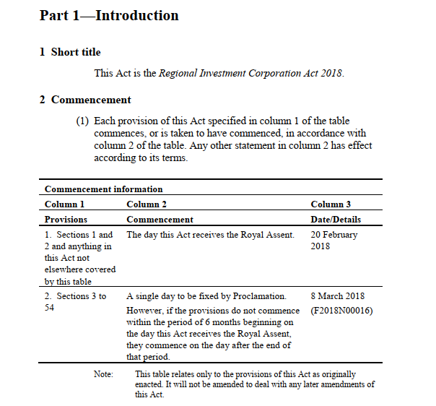

Secondly, it is not uncommon for a commencement provision to provide that different parts or sections of an Act may be brought into force on different days. Many Interpretation Acts provide that, unless the Act otherwise provides, the Executive is not required to bring the legislation into force on an “all or nothing” basis. See, for example, the Interpretation Act of British Columbia:[231]

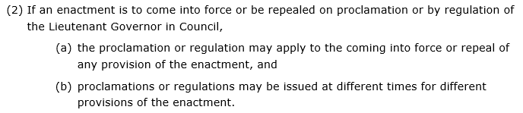

Thirdly, apart from allowing the Executive to bring the provisions of an Act into force on different days, most jurisdictions also allow different provisions to be brought into force for different purposes. The use of such a commencement provision is rare, as the Act typically has to be constructed from the outset with this device in mind, but it provides another useful example of the complexity that can characterise commencement. One such provision is section 37(3)(c) of the *Financial Guidance and Claims Act 2018* (UK):

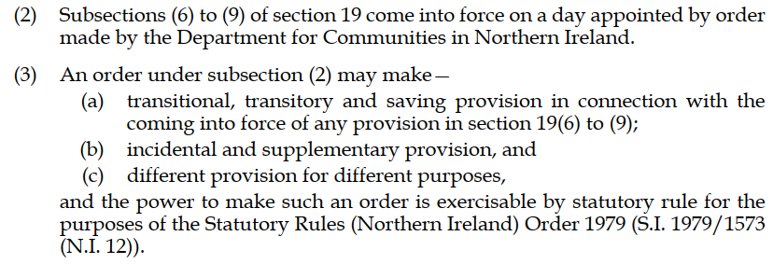

Fourthly, commencement clauses, like title clauses, come into being for the purposes of their respective Acts the moment they are enacted.[232] This is why those clauses do not themselves require a commencement clause (if they did, we would end up with a problem of “infinite regression”).[233] UK Acts sometimes explicitly state in the commencement provision itself that the provision commences on the day on which the Act is passed, and the substantive provisions commence on a later day, as in this example:[234]

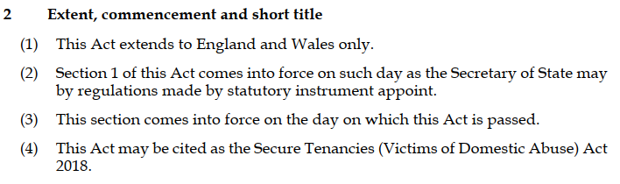

If the Act omits a provision to the effect that the commencement provision should be brought into operation before the substantive provisions of the Act, numerous Interpretation Acts provide that the short title and the commencement clause commence on the day on which the Act receives the Royal Assent.[235]

Finally, commencement provisions in Australia, New Zealand, the UK and Canada can be sorted into five broad categories, which are discussed in turn below:[236]

1. No commencement clause
2. Act specifies commencement date (or period)
3. Governor (or Governor-General) appoints commencement date (proclamations)
4. Act deemed to commence on a particular date
5. Hybrids

#### 2.1 No commencement clause

Not all jurisdictions require the inclusion of a commencement clause in an Act as a matter of standard practice. For example, my survey of the 2018 UK Public General Acts indicates that at least 6 out of a total of 34 do not have a commencement provision.[237] In such jurisdictions, reliance tends to be placed on statutory rules such as Interpretation Acts to provide for when an Act should commence.[238]

In Australia, almost all legislation enacted by the Commonwealth contains a commencement clause. However, in the event that such a clause is left out of an Act, each jurisdiction has an Interpretation Act which provides when the Act will commence.[239] See, for example, section 3A(2) of the *Acts Interpretation Act 1901* (Cth):

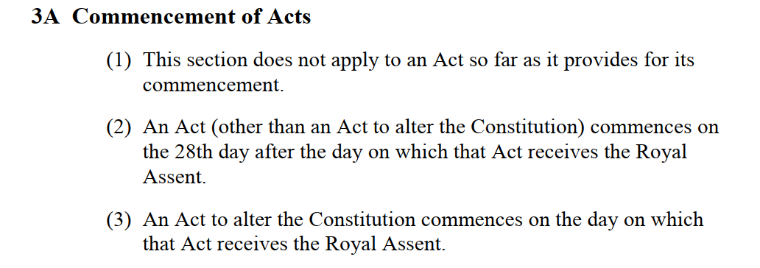

Not having a commencement date used to be common practice in New Zealand, but since 1999, all Acts have a commencement clause.[240] This requirement has now been included in SO 256(1) of the Standing Orders of the New Zealand House of Representatives:[241]

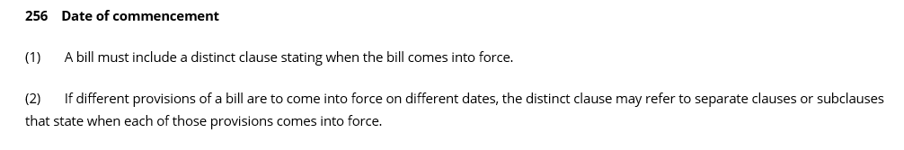

If an Act does manage to slip past the House without a commencement provision, section 8 of the *Interpretation Act 1999* (NZ) provides that it will commence the day after assent:

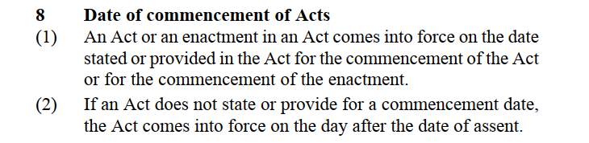

In the UK, Acts without a commencement clause come into force at the beginning of the day on which they receive assent pursuant to section 4 of the *Interpretation Act 1978* (UK), which permits a modicum of retrospectivity (up to a day):

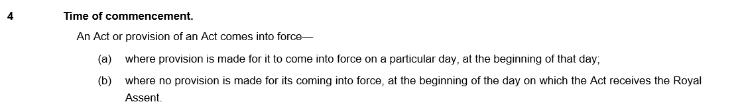

It is common for Canadian legislation to omit a commencement date. My survey of the 2018 Acts enacted by the Canadian Parliament shows that almost half (14 out of 31) do not have a commencement provision. In such cases, section 6(2) of the Canadian Interpretation Act applies:[242]

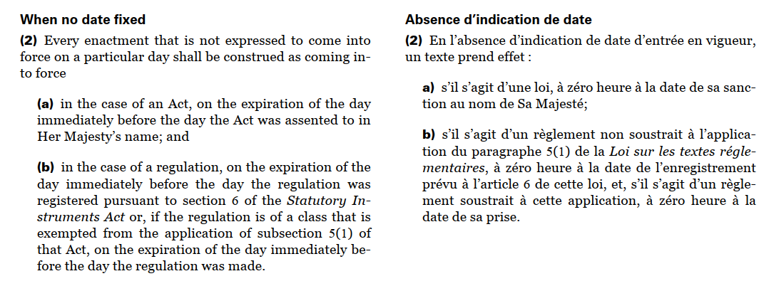

A provision to this effect is also found in the Interpretation Acts of most Canadian provinces.[243]

#### 2.2 Act specifies commencement date

An Act may indicate the day on which it is to come into force by specifying:

1. the actual date on which it will commence (sometimes expressed as a period of time following assent);
2. the day of assent; or
3. the day after assent; or
4. the day that another Act will commence (“tied commencement”).

Examples of each of these types of commencement clauses are provided below.

##### 2.2.1 Act specifies date

An Act which specifies the commencement date provides the most clarity and certainty for users, but the inflexibility of this device means that it is not commonly used to commence an entire Act.

In my survey of the legislation enacted by the Australian Parliament in 2018, 19 out of 170 Acts commence the entire Act on a specific date (apart from the title and commencement clauses, which typically commence on the day of, or the day after, assent). The following is an example of a simple commencement provision specifying the actual commencement date:[244]

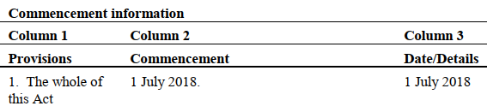

An additional 44 Acts provide that certain provisions of the Act (for example, a Schedule to the Act) are to commence on a specific date or dates (many of which are complex hybrid provisions, as discussed below).

New Zealand Acts also commonly specify a commencement date. In his survey of New Zealand legislation, Gobbi found that a significant proportion had a specific commencement date (23% of principal Acts and 13% of amending Acts).[245] In my survey of the 2018 Acts, approximately one third (21 out of 61) provide that either the whole Act or some provisions of the Act commence on a specified date. However, this number should arguably be even higher, at least according to the general principle articulated by the Regulations Review Committee of the New Zealand Parliament in its 1996 report, which recommended that Acts should fix a precise commencement date as a matter of practice, thereby helping to promote access to the law by eliminating uncertainty.[246]

In the UK, very few Acts specify a commencement date. In 2018, less than a quarter of UK parliamentary enactments provided that either the entire Act or provisions of the Act are to come into force on a particular date. The following is an exception to the general rule:[247]

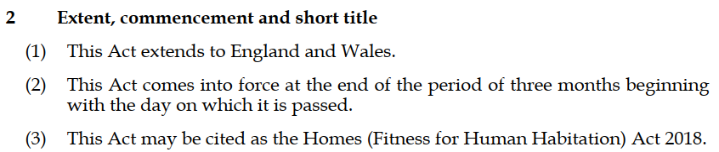

Canadian legislation does not frequently specify a commencement date. Approximately 10% of the 2018 Acts surveyed provide that the Act or certain provision of the Act are to commence on a particular date. An example is section 52 of *An Act to amend the Criminal Code (offences relating to conveyances) and to make consequential amendments to other Acts*, S.C. 2018, c. 21:

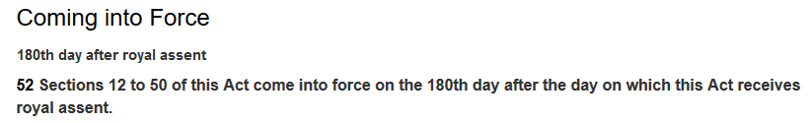

##### 2.2.2 Act commences day of assent

Commencement clauses which provide that the Act will come into force at the beginning of the day on which it receives assent necessarily result in a modicum of (technical) retrospectivity because the Act is taken to commence at the beginning of the day, *before* it receives assent.

In my survey of the legislation enacted by the Australian Parliament in 2018, only 18 Acts out of 170 provide that either the Act (or certain provisions of the Act) are to commence on the day of assent (not including the title/commencement clauses). For example:[248]

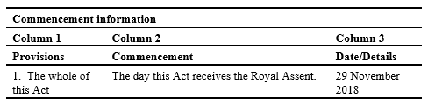

This practice used to be more common in New Zealand but is now relatively uncommon. In the 2018 legislation surveyed, there is not a single commencement provision which states that the entire Act commences on the day of assent, and only two which provide that some provisions of the Act commence on the day of assent. One of them is section 2 of the *Taxation (Neutralising Base Erosion and Profit Shifting) Act 2018* (NZ):

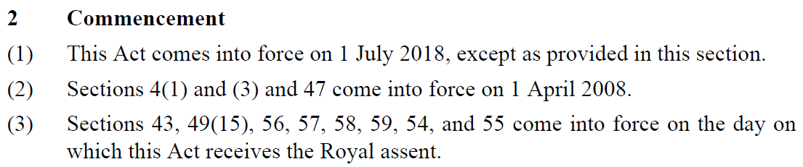

In Gobbi’s survey of UK legislation, he found that this type of commencement clause was used in only 3% of the Acts. In my survey of the Acts passed by the British Parliament in 2018, I found 3 such provisions (out of a total of 34) which commenced the entire Act. A further 6 state that certain provisions of the Act, but not all, commence on the day of assent (not taking into account the commencement/title clauses).

I did not find a single Act passed by the Canadian Parliament in 2018 which used this device.

##### 2.2.3 Act commences day after assent

It is quite common for Australian legislation to provide that an Act commences the day after assent. More than 80 out of the 170 Acts passed in 2018 contain such a provision. The following is an example:[249]

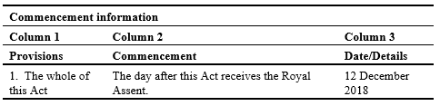

Although the “day after assent” clause is a comparatively recent phenomenon in New Zealand, it is now used frequently. [250] My survey shows that more than half of all Acts passed in 2018 (33 out of 61) commenced the day after Royal Assent. The *Electoral (Integrity) Amendment Act 2018* (NZ) is one such Act:[251]

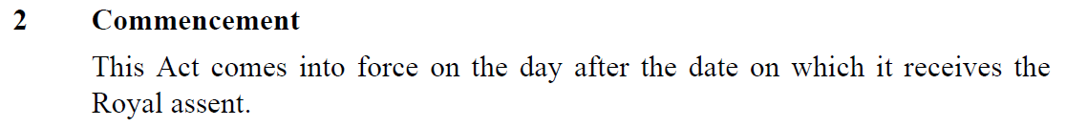

A further 10 Acts provide that certain provisions of the Act commence on the day after assent, which means that over two-thirds of New Zealand Acts in 2018 provide that provisions of the Act commence in a timely manner, immediately following assent.

UK and Canadian legislators seem to rely on this device only occasionally.

##### 2.2.4 Tied commencement

Tied commencement clauses provide that the Act will commence when another Act (or a provision of another Act) comes into force, or when an event occurs that acts as a trigger for commencement. While not commonly used in any of the four jurisdictions, this can be a useful device if the scheme being implemented by the Act is really a set of amendments that is dependent entirely on the commencement of some other Act or, commonly, the implementation of an international treaty.

However, given the risk that the other legislation will never commence or that the treaty will never be ratified, reliance on such provisions should be rare and justifiable by reference to specific facts. Furthermore, since these triggering events are external to the Act, and there is no clear mechanism for informing the public if and when they do occur, an overt notification of the commencement of an Act (or provision) is essential.

In my survey of the legislation enacted by the Australian Parliament in 2018, approximately one-quarter of Acts provide that either the entire Act or certain provisions of the Act are to commence when some other enactment commences. The following is an example of a simple tied commencement clause which provides that Schedule 1 to the Act does not commence until certain provisions of another Commonwealth Act commence:[252]

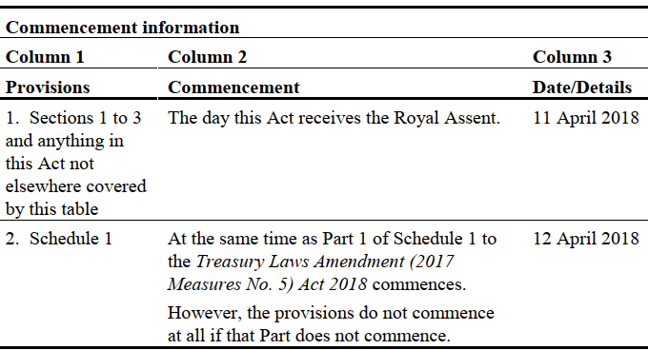

As this example illustrates, sometimes the commencement provision states that the Act or the provisions of the Act will not come into operation at all until the other enactment does. At other times, the provisions must come into force, regardless of the status of the other Act. For example:[253]

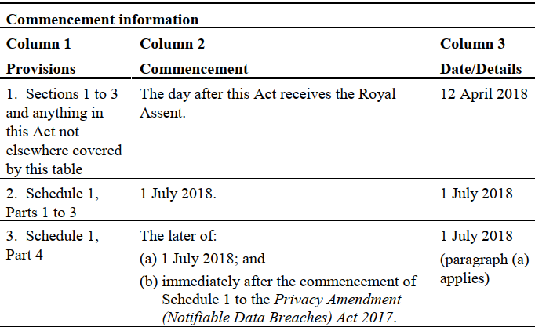

The challenge there, of course, is that the automatic commencement of tied provisions may result in the provisions of an Act coming into force which are instantly obsolete because they refer to Acts or treaties which do not exist or which have not yet commenced. In such cases, a commencement provision providing for automatic repeal of the relevant provisions may be a better option.

Tied commencement provisions are not frequently used in New Zealand, the UK or Canada. The following is an interesting example of a tied commencement provision used by the Canadian parliament which hinges on the occurrence of “Brexit”:[254]

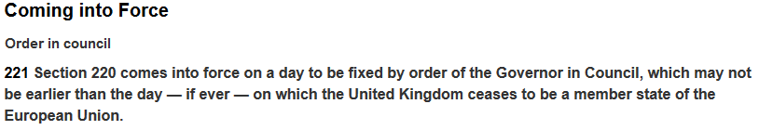

#### 2.3 Governor-General appoints commencement date (proclamations)

A commencement clause which gives the Governor-General (sometimes referred to simply as “the Governor”) the power to proclaim the commencement date is really giving the Executive discretion to determine when the law should commence, because in practice the Governor-General acts on the Minister’s advice.[255]

The main advantage of this type of clause is flexibility, as the Executive has time to ensure that the necessary legal, administrative and operational requirements are met before the Act is brought into force. However, allowing the Executive to decide when or if legislation should commence has a number of clear disadvantages, which will be discussed in greater depth in the next section of the paper. For now, I will provide an overview of the extent to which Australia, New Zealand, the UK and Canada rely on commencement by proclamation provisions.

The Australian Parliament once relied heavily on proclamations and continues to pass Acts with such clauses. However, my survey of the 170 Acts passed by the Australian Parliament in 2018 shows that only 19 rely on the Executive to proclaim the entire Act (not including the commencement/titling clause). For example:[256]

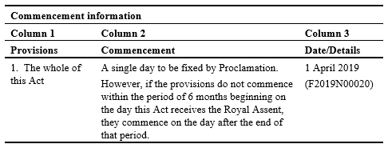

An additional 16 rely on proclamations to proclaim certain provisions of the Act (typically a Schedule or Part of a Schedule). The following is an example:[257]

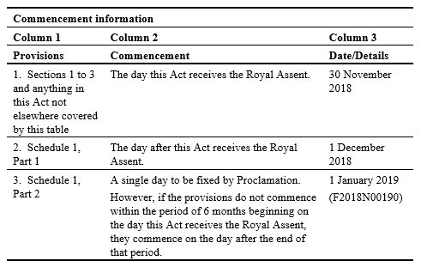

Further, the Acts that do commence by proclamation now include a safeguard designed to avoid undue delay. As the above example illustrates, this safeguard involves specifying a date by which the Act (or certain provisions of the Act) must come into force, even if the Executive has not yet proclaimed the legislation, thereby putting clear limits on the exercise of Executive discretion.

According to Gobbi, the use of commencement by proclamation clauses in New Zealand is cyclical, hovering at around 10% for the past four decades.[258] In the 1970s, 1980s and 1990s, certain New Zealand Acts took a very long time to commence, creating uncertainty and confusion regarding whether an Act was in force or not. This prompted the aforementioned Regulations Review Committee to recommend in a 1996 report that the use of the device of proclamation “should be rare and exceptional”.[259]

My survey of the legislation enacted in 2018 shows that proclamations are indeed relatively uncommon in New Zealand. Only three Acts provide that the entire Act is to commence on a date specified by the Governor-General by Order in Council, and two of them put a time limit on the exercise of that discretion.[260] Thus, section 2 of the *Social Assistance (Residency Qualification) Legislation Act 2018* (NZ) provides:

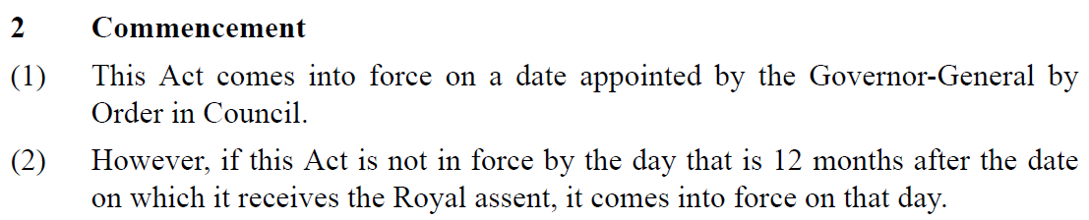

The UK statute book shows a greater reliance on proclamations. Out of 34 Acts passed in 2018, 19 Acts provide that either the entire Act or certain provisions of the Act will commence on a day appointed by the Executive (and typically proceed to grant the Executive a regulation-making power to that end). For example:[261]

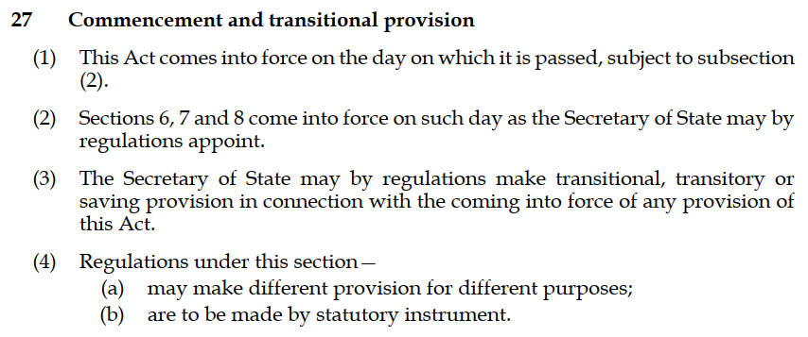

About a third of the Canadian Acts surveyed provide that the Act comes into force on a day or days fixed by the Governor in Council, as in the following example:[262]



#### 2.4 Act deemed to commence on a particular date (retrospective)

While it is not possible for legislation to commence before it is enacted, sometimes legislation can indicate that it is intended to have a retrospective effect “by declaring that it is deemed to have come into force on a day that antedates its actual enactment and commencement”.[263] Deeming provisions thus create a legal fiction regarding the operation of legislation prior to commencement.[264]

Because the presumption against retrospectivity tends to be strong in Commonwealth countries, particularly where the legislation imposes sanctions or burdens, this type of provision is quite rare. Of course, there are certain situations which call for a modicum of retrospectivity (for example laws designed to benefit those who will be affected by the retrospective measures, laws which make changes to the tax code, or laws which validate acts which were understood to be lawful but which turned out to be unlawful due to a technicality). The following is an example:[265]

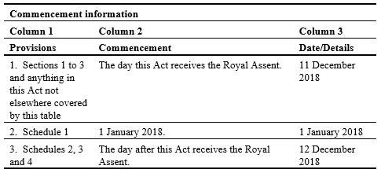

#### 2.5 Hybrids

A hybrid commencement clause uses two or more of the devices discussed above. While the main advantage of a hybrid clause is its flexibility, its “main drawback concerns the level of complexity that they can add to the process of understanding the current effect of legislation or the process of determining which provisions apply to a given case”.[266]

Hybrid provisions are very common in Australia and are becoming more common in New Zealand, with 13 out of 61 of the Acts passed by the New Zealand Parliament in 2018 containing a hybrid commencement provision.

In the UK, approximately a third of the 34 Acts passed in 2018 relied on a hybrid commencement provision, as in this Act:[267]

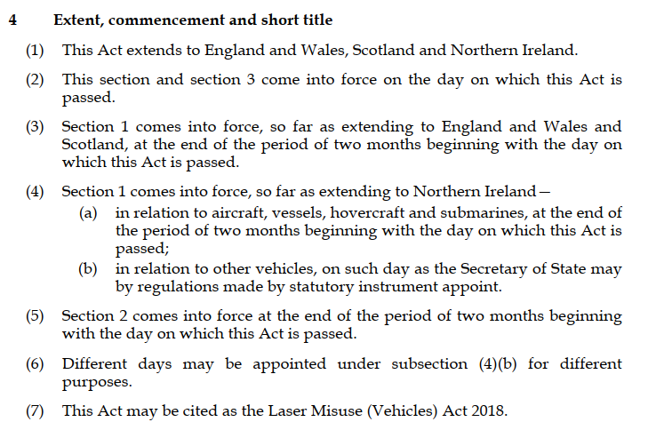



In the case of those Canadian Acts that have a commencement provision, most are hybrid. The following is an example of a provision which combines several different types of commencement provisions (Executive to fix date, tied commencement and period of time after assent):[268]

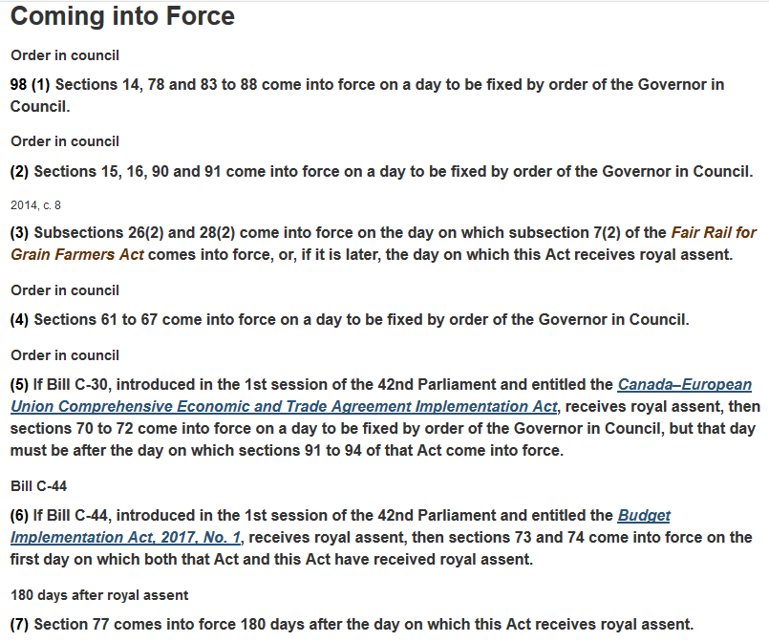

### 3. Implications of Executive Discretion

This section of the paper considers the implications of relying on proclamations to commence an Act.

#### 3.1 The advantages

Proclamations have a number of practical advantages over other types of commencement provisions, the most important of which is flexibility. A delayed commencement allows the government time to prepare for the administration of the Act, which often requires a number of “matters to be put in place before the legislation can operate effectively or at all.”[269] For example, regulations may need to be promulgated or agencies may need to be established.

Delayed commencement also provides an opportunity to inform the public about upcoming changes and to give businesses time to adopt new systems or processes in preparation for the new laws. There may also be a need to coordinate the commencement of an Act with some other event or actions, such as the ratification of an international treaty or convention, or the enactment by all other sub-federal jurisdictions of comparable legislation.

Because the Executive’s ability to implement the Act’s aims prior to commencement is extremely limited (as there is no power to act until the legislation is in force), most Interpretation Acts explicitly contemplate the possibility of Executive action prior to commencement.[270] See, for example, section 7 of the Canadian Interpretation Act which provides:[271]

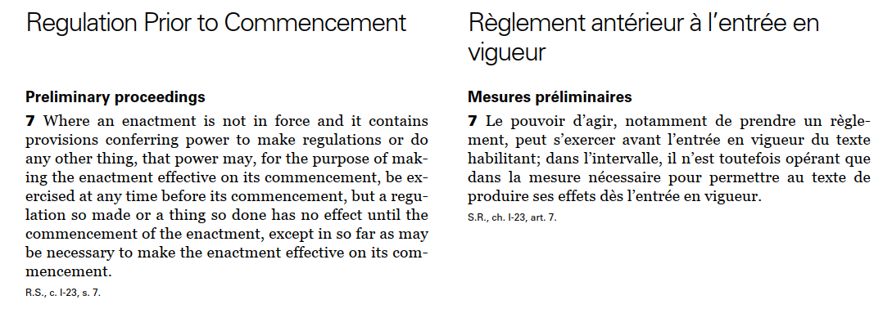

#### 3.2 The disadvantages

While flexibility is undoubtedly important, there are also many reasons why it may be desirable to put strict limits around the exercise of Executive discretion in relation to proclamations.

##### 3.2.1 Negative implications for parliamentary sovereignty and democratic processes

Delayed or uncommenced legislation may undermine parliamentary sovereignty and democratic processes. In parliamentary democracies such as Australia, New Zealand, the UK and Canada, Parliament makes the law and the Executive implements it. However, too much Executive discretion shifts the balance of power from Parliament to the Executive: “the Parliament, in relinquishing its legislative authority to the executive, is giving up a basic right, and its most important function—that of legislating.”[272]

The most extreme example of such a shift in power occurs when, apart from merely delaying the commencement of legislation, the Executive chooses notto commence the legislation *at all*.[273] For example, the Executive may choose to “shelve” controversial legislation by refusing to proclaim it, either indefinitely or until after the next election: “The risk of this happening would appear to be highest when an election produces a change of government or when a minority government supports the enactment of legislation it does not want in exchange for support for the enactment of legislation that it does want.”[274]

Another example might be the enactment of a Private Member’s Bill that the Government does not wish to support. By refusing to proclaim the legislation for reasons that lack transparency and justification, the Executive may undermine parliamentary sovereignty and democratic processes.

##### 3.2.2 The procrastinating Executive

There is arguably very little pressure on the Executive to implement legislation in a timely manner if it has unfettered discretion to decide *when* the relevant legislative scheme is to commence. This means that the social problems that Parliament tried to address through legislative action (such as the establishment of a compensation tribunal in the famous *Fire Brigades* case) will remain unaddressed as long as the Executive fails to proclaim the Act.[275]

A related but less obvious example of the way democratic processes may be frustrated is where the statute provides for the relevant legislative scheme to be implemented largely through regulations and then those regulations are never promulgated by the Executive.[276] This effectively inactivates the law that was enacted by Parliament (at least to the extent that the Act is unable to operate without regulations) and clearly undercuts the legislator’s will.

##### 3.2.3 Proclamations create uncertainty

Uncommenced legislation makes it difficult to determine what is in force and what is not, and may result in uncommenced legislation being referred to, or even applied, as if it had commenced. As Lynch has argued, this brings one of the central tenets of a representative democracy into question—the principle of certainty under the law:[277]

The obscurantism of general legislative provisions is bad enough. To be forced to hunt through documentation other than the Act to establish whether a law is operative is appalling. It has been a long-established dictum that ignorance of the law is no excuse for transgression. With the myriad of difficulties placed in the way of even the experts in law in establishing what is the law, justice demands that the dictum might well need to be superseded.

The case of *Queensland v Central Queensland Land Council Aboriginal Corp*, which is concerned with the validity of acts done pursuant to uncommenced provisions, is a good illustration of the confusion (and protracted litigation) that can sometimes result from the use of such provisions.[278]

In order to address this key shortcoming of proclamation provisions—the inability to tell just by looking at the Act whether or when it has commenced—the Australian Government’s Office of Parliamentary Counsel has developed a practice of retrospectively “filling in” the date that legislation commenced in the commencement table located in the commencement provision itself. This means that crucial information regarding commencement is easily accessible by anyone looking at the latest version of the Act. See, for example, the section 2 of the *Public Sector Superannuation Legislation Amendment Act 2018* (Cth):

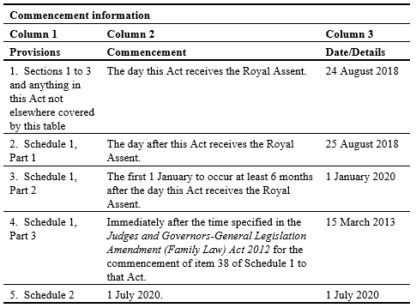

Some New Zealand Acts also attempt to remedy this problem by putting commencement information in a note below the commencement provision. See, for example, the note for section 2 (the commencement provision) of the *Customs and Excise Act 2018* (NZ):

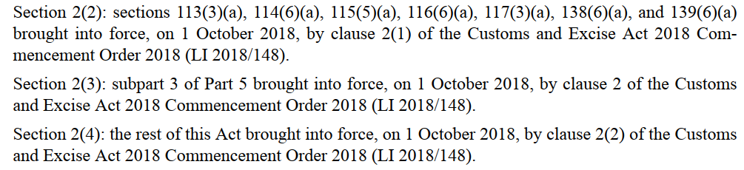

##### 3.2.4 Detrimental to statute book

According to Teasdale, in a representative democracy, legislation must—in the very least—be “physically accessible, reliable and in a format which is comprehensible”.[279] Uncommenced legislation necessarily detracts from this project, as it tends to clutter the statute book with Acts (or provisions of Acts) that are not yet in operation. The *European Union (Withdrawal) Act 2018* (UK) contains an example of a particularly complex commencement provision which makes the process of figuring out when particular sections and subsections come into force almost impossible:[280]

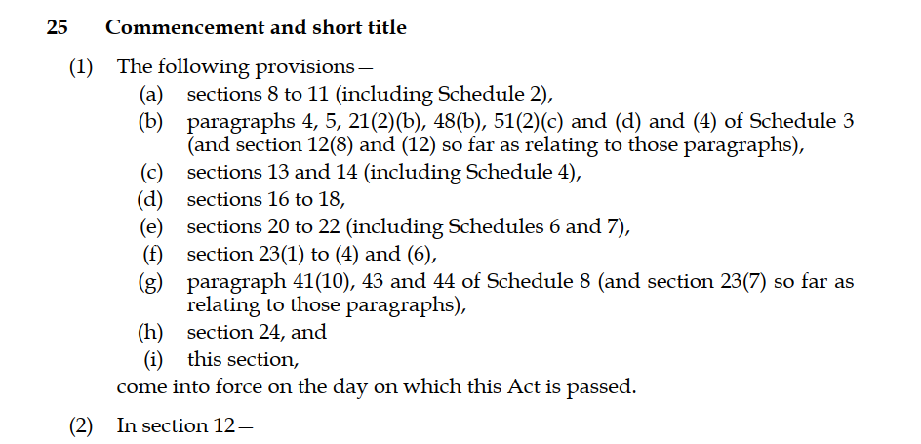

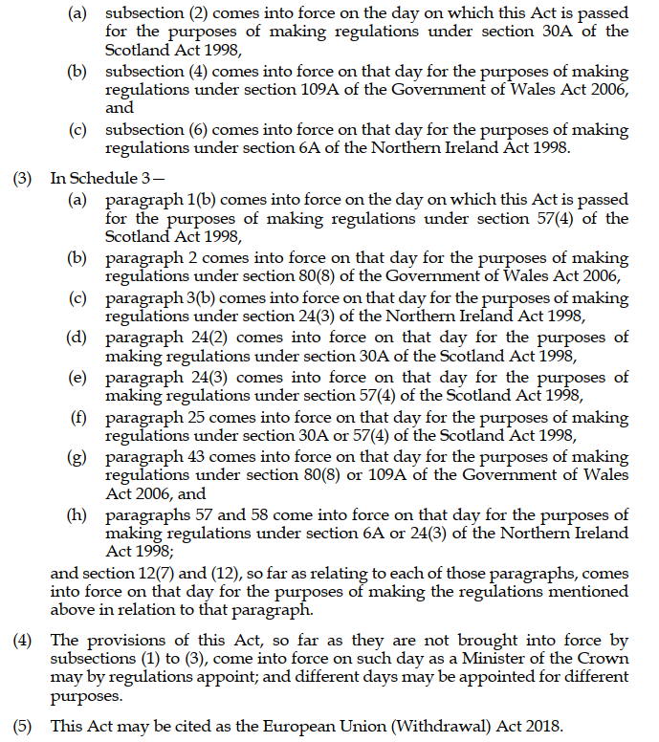



The *European Union (Withdrawal) Act 2018 (Commencement and Transitional Provisions) Regulations 2018* (UK)were promulgated by the Secretary of State on 3 July 2018. Perhaps unsurprisingly, they are even more complex than the above commencement provision.

##### 3.2.5 Wasted resources

As drafters, we are all keenly aware of the resources required to pass a new law. A Bill may be many years in the making and involve the work of hundreds of people, many hours of community consultation, many research initiatives and extensive collaboration between government and the non-government sector. The process of getting the Bill through Parliament also consumes extensive parliamentary resources. When the Executive fails to commence a Bill, all those resources are effectively wasted. The problem is compounded in cases where government and non-government bodies act in anticipation of the legislation commencing (for example supplementary delegated legislation is drafted, a new body is established, appointments are made to new agencies, new infrastructure is built and so on) and the legislation never commences.

##### 3.2.6 Judicial review may be limited

While the Executive’s failure to proclaim legislation enacted by Parliament may constitute an abuse of Executive discretion, the extent to which courts are empowered to review Executive (in)action in this respect differs from jurisdiction to jurisdiction.

For example, in the UK, it is generally accepted that the Legislature expects the Executive to enact the legislation in a reasonable amount of time and that the Executive’s action (or lack thereof) in this regard is subject to judicial review. In the *Fire Brigades* case, the House of Lords held that the Home Secretary could not simply abandon the scheme enacted under that Act because he did not like it and that he had a duty to keep the bringing of the Act into force “under consideration”.[281] However, the Court also held that the Executive *could not be compelled* to fix a commencement date for an Act. In the words of Lord Browne‑Wilkinson:[282]

In my judgment it would be most undesirable that, in such circumstances, the court should intervene in the legislative process by requiring an Act of Parliament to be brought into effect. That would be for the courts to tread dangerously close to the area over which Parliament enjoys exclusive jurisdiction, namely the making of legislation.

The power of the Canadian federal Government to proclaim some sections of an Act but not others was examined in the leading Canadian case on commencement by proclamation—*Reference re Criminal Law Amendment Act*.[283] In that case, the commencement provision of the relevant Actprovided that “This Act *or any of the provisions of this Act* shall come into force on a day or days to be fixed by proclamation” (emphasis added). The Governor in Council subsequently brought into force some, but not all, subsections of section 16 which established a new regime for dealing with driving under the influence. The Executive failed to proclaim the provisions which granted the accused a right to be provided with a specimen of the accused’s own breath sample, thereby denying the accused a legal benefit that Parliament clearly intended to confer on the accused. The question before the Court was whether the Executive had the power to do so.

The majority of the Supreme Court concluded that, since the Legislature explicitly granted the Executive the power to proclaim different provisions on different days, the Court could not question *the manner in which* the Executive chose to exercise that power.[284] However, the Court emphasised that its decision was specific to the law in question, because it seemed that Parliament turned its mind to the potential for abuse of discretion and decided that the risk was justified.[285] The Court thus distinguished this case from situations where the Executive may be relying on a *general* power to commence different provisions on different days, as may be found in a provincial Interpretation Act.

This approach seems extremely deferential to the Executive. As Sullivan has opined, given that it is now widely accepted that the Executive’s power to commence legislation “is subject to the limits fixed by Parliament both express and implied”, it is not at all clear that the Supreme Court would take the same approach today if faced with a similar set of circumstances.[286] Indeed, in a strong dissent, Martland J (with whom Ritchie, Spence and Pigeon JJ agreed) held that the Executive’s actions frustrated Parliament’s intentions:[287]

Section 224A contains certain safeguards for the protection of an accused person [...]. These are the provisions directed to be omitted by the Proclamation which purported to bring the remaining portions of s. 16 of the Act into effect. In my opinion what that Proclamation declared to be in effect was not, by reason of the omission, that which Parliament had enacted in s. 16. By proclaiming only a part of s. 16, the Governor in Council was, in essence, amending that which Parliament itself had provided, and, in so doing, exceeded the powers given by s. 120.

Jones notes that the practice of commencing some provisions but not others is fairly routine in some Canadian provinces, such as British Columbia, and is “principally the quest for expedience, rather than executive power”.[288] Nevertheless, Jones cautions that the ramifications of this practice could be serious, depending on the extent to which the Executive’s choices can be said to frustrate Parliament’s intentions.[289] This is so even when the legislature explicitly allows for partial commencement in the commencement provision itself.[290]

##### 3.2.7 Unique challenges for drafters

Finally, uncommenced provisions pose unique challenges for drafters, who are required to keep in mind not only the laws that are in force, but also provisions of Acts which have been enacted but have not yet commenced. This becomes particularly tricky when a drafter is amending legislation that Parliament has already amended, but the amending provisions have not yet commenced (and it is unclear if they ever will). In such cases, the drafter may need to prepare alternative provisions that depend for their application on whether and when particular uncommenced provisions come into operation.[291]

### 4. Approaches to Drafting and Accountability Mechanisms

This section sets out approaches to drafting and some accountability mechanisms which may help to address the issue of uncommenced legislation.

#### 4.1 Drafting commencement provisions

##### 4.1.1 Avoid proclamations

Proclamations should be used sparingly and restricted to situations where the Executive can substantiate the need for one (for example, because precisely coordinated legislative action between jurisdictions is required). As Lynch has argued, Parliament should be more discerning regarding the types of commencement clauses it accepts in Bills: “the more desirable and effective method of avoiding the problem [of uncommenced legislation] is to prevent it at the source—during the passage of a Bill through the Parliament.”[292]

##### 4.1.2 Avoid partial or phased commencements (where possible)

As noted above, most jurisdictions explicitly permit the Executive to proclaim different provisions of an Act on different days, or for different purposes, despite the risk that some provisions may never commence. That risk materialised in the Canadian case discussed earlier, where the legislative scheme enacted by Parliament was altered by the Executive when it chose to proclaim some subsections but not others.[293]

Alec Samuels has been critical of the tendency to commence an Act in phases and has argued forcefully that proclamations “should be as few as possible and rationalized and grouped and timed as far as possible”.[294] In cases where it is known in advance that certain parts of the Act will need to be commenced separately, those provisions should be passed as a separate enactment: “Separate subjects should have separate statutes, or separate groupings”.[295]

However, while Samuels’ proposition may work in theory, in practice it is not very workable. Separating different provisions into different statutes would increase the time taken for parliamentary debate and it would also unnecessarily “shred” the statute book where it is important that particular provisions are in the same Act for legal, administrative and interpretative reasons.

While piecemeal or selective commencement without any safeguards is likely to frustrate what Parliament has carefully provided for, there are times when the phased commencement of an Act is appropriate (for example, where there are strong administrative reasons to do so). In such cases, a safeguard should be included to ensure that all provisions *do* eventually come into force (for example by including an automatic commencement clause). Certainly, the commencement of particularly important provisions (for example those that provide for oversight, scrutiny, reporting and review) should be tied to the commencement of the relevant operative provisions, so that the Executive has no choice but to proclaim those provisions at the outset.

##### 4.1.3 Specify commencement date

The commencement date should be specified whenever possible to provide the most certainty for users of legislation. While this device lacks flexibility (it can be difficult to amend a commencement provision once it is enacted), it may still be appropriate in circumstances where it is important to ensure that the Act commences by a certain date and that the Executive does not procrastinate in making arrangements to administer the Act. Some jurisdictions also provide that the commencement date may be extended by a deferring proclamation for a reasonable period of time (for example, a year) to account for the possibility that the Executive will not be ready to implement the legislation in time.[296]

##### 4.1.4 Use default commencement provisions

Default commencement provisions (so-called “Macklin clauses”) which provide for the automatic commencement of unproclaimed provisions if not proclaimed within a certain period or by a specific date “should be used extensively.”[297] The Australian Parliament has all but done away with uncommenced legislation by including additional language in commencement provisions which states that the Act is to commence after a specified period following the day of assent (usually 6 or 12 months) regardless of whether the relevant sections have been proclaimed by that date.[298] The South Australian Interpretation Act contains a similar provision:[299]

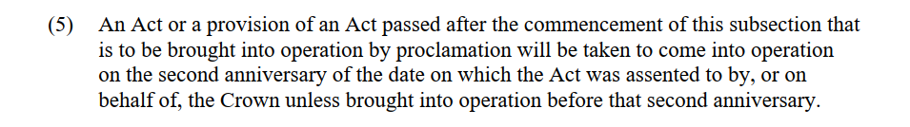

However, although this provision is useful, it would be more desirable—and user-friendly—to include automatic commencement provisions in the Act itself, rather than concealing important provisions about the automatic commencement of Acts in a jurisdiction’s Interpretation Act.

In the New Zealand Government’s response to the 1996 Report of the Parliament’s Regulations Review Committee, the Government recognised that a fixed commencement date is preferable to proclamations and that the Executive should have to justify why a deferred commencement is proposed for a particular Bill.[300] This would, in the Government’s view, accommodate both Parliament’s discretion to permit a commencement by proclamation clause and provide for continued scrutiny by Parliament of whether the Executive is deferring commencement for an improper duration or purpose. Although the Government stopped short, for practical reasons, of requiring that a default commencement provision be included in all Bills, an automatic commencement clause is nevertheless frequently included in New Zealand Acts. An example is section 2 of the *Marriage (Definition of Marriage) Amendment Act 2013*:

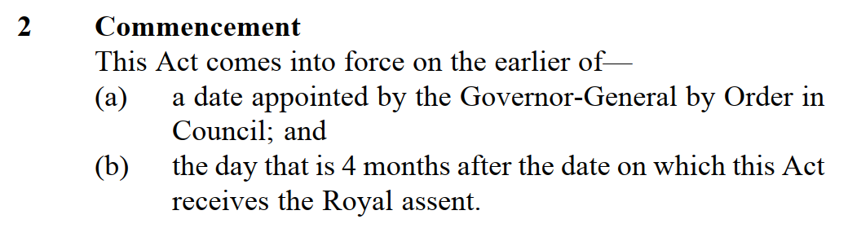

##### 4.1.5 Use plain language

These best-practice approaches to the drafting of commencement provisions also conform with a policy of plain language drafting, which can be understood as “legal communication that is clear, understandable accessible, and also user-friendly”.[301] There is great variety between the language used in commencement provisions across the four jurisdictions, and within in each jurisdiction.

Australian commencement provisions tend to be the most economical and direct (for example, they use “commences” rather than “comes into force”).[302]

The following is an example of a commencement provision which could have been stated in a clearer and more accessible manner:[303]

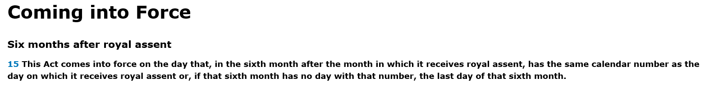

##### 4.1.6 Avoid retrospectivity

Finally, accepting that the presumption against retrospectivity is important, commencement rules should provide that Acts which commence on the day of assent come into effect at the end of the day of assent, and not at the start of that day (to avoid partial day retrospectivity). Where retrospectivity is deemed necessary, express words to that effect should be used, instead of relying on commencement rules (such as Interpretation Acts) to achieve the same result.

#### 4.2 Accountability mechanisms

##### 4.2.1 Parliamentary scrutiny (in general)

To ensure that all legislation enacted by Parliament commences at some (reasonable) point in time, Parliaments should play a greater supervisory role when it comes to the exercise of Executive discretion. Those jurisdictions that have managed to eliminate, or at least reduce, instances of uncommenced legislation have done so consciously, by implementing mechanisms for identifying and dealing with uncommenced provisions.

Canada has gone one step further than most jurisdictions by passing legislation with the explicit aim of ridding the statute book of uncommenced provisions. Pursuant to the *Statutes Repeal Act*, SC 2008, c 20, the Minister of Justice must table a report before both Houses of Parliament at the start of each year listing every unproclaimed Act or legislative provision that received Royal Assent more than nine years ago. The listed provisions are repealed automatically on December 31 of the year in which the report is tabled unless they come into operation before that day, or unless a House of Parliament resolves to “save” them. The Minister must also publish a list of all repealed legislation in the Canada Gazette. The 2019 report lists 18 Acts with uncommenced provisions, down from 45 Acts that were listed in the first iteration of the report in 2011.[304]

In those jurisdictions where no similar legislation exists, Parliament can keep informed regarding the status of unproclaimed provisions by enshrining a reporting requirement on the part of the Executive in a House’s Standing Orders. For example, Standing Order 139 of the Australian Senate provides:

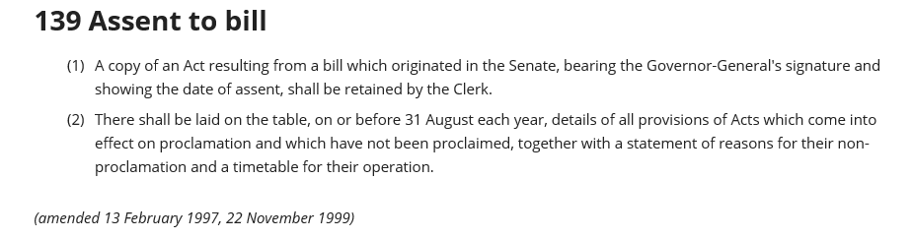

The New Zealand Government has also taken steps to enable users to search for Acts that are not yet in force. While the New Zealand legislation website does not indicate which in-force Acts have provisions that are waiting to be proclaimed, this information is provided in an annual report on unproclaimed legislation produced by the New Zealand Parliamentary Counsel Office (which can be colloquially referred to as a “name and shame” report). The 2019 report showed 26 Acts with unproclaimed provisions and each was accompanied by a comment from the Department responsible for the administration of that Act explaining why the provisions have not yet been commenced. [305]

Also, while proclamations are typically not regarded as subsidiary legislation, and are therefore not generally disallowable, an Act could provide that they are, thereby giving the Parliament more power to supervise the Executive.[306] Finally, where the scheme of an Act is to be implemented largely through regulations, Parliament should request that “at as early stage as possible the minister should indicate the general nature of the proposed regulations and the proposed timetable for implementation, and make periodical statements on the progress of implementation.”[307]

##### 4.2.2 Parliamentary scrutiny (Western Australia)

Western Australia’s Parliament is increasingly taking an active role in monitoring the overall state of the statute book and, in particular, the prevalence of uncommenced legislation. In November 2019, the Standing Committee on Uniform Legislation and Statutes Review (**the Committee**) published a report as a result of its Inquiry into the Form and Content of the Statute Book, making a number of findings about the impact of uncommenced legislation on the legislative process.[308]

Unsurprisingly, the report was highly critical of the Government for allowing a number of potentially obsolete enactments to remain on the Western Australian statute book. It found that the use of commencement by proclamation provisions without a requirement that the legislation be commenced within a specified time impinged on parliamentary sovereignty and should therefore be used rarely.

The Committee then made 11 recommendations, a number of which mirror the suggestions I have made in this paper. Most notably, the Committee urged the Government to:[309]

* Introduce an omnibus Bill repealing obsolete legislation and to maintain the currency of the statute book through periodic legislative reviews.
* Make greater use of sunset provisions in subsidiary legislation to facilitate the identification and repeal of obsolete legislation.
* Ensure that commencement provisions specify the date or dates when provisions of an Act are to come into operation.
* Introduce a Bill to amend the *Interpretation Act 1984* to provide for the automatic repeal of Acts or the provisions of Acts that are to come into operation by proclamation and that are not proclaimed within 10 years of the Act or provision receiving Royal Assent.
* Examine the merits of adopting a regulatory stewardship approach, as a statutory obligation, for government departments in Western Australia.

It is clear from the above that the Committee considered the approach taken by other jurisdictions and was particularly impressed with Canada’s efforts to rid its statute book of uncommenced legislation.

The Government’s response to the Committee’s recommendations was tabled on 11 February 2020.[310] Interestingly, while the Government did not support the recommendation to amend the *Interpretation Act 1984* on the grounds that it was too inflexible a solution, the Government did promise to consider the implementation of a more flexible mechanism, such as that adopted in Canada.

Then, on 9 September 2020, the Government took a step in the right direction by introducing the *Statutes (Repeals and Minor Amendments) Bill 2020,* described by the Hon. Sue Ellery (Leader of the House in the Legislative Council) as “a routine part of legislative review [to] ensure that the State’s statute book is regularly updated and streamlined”.[311] In addition to the repeal of seven obsolete Acts and eight obsolete Imperial enactments,[312] the Bill aims to make a number of amendments across the statute book, which “range from inserting missing words to correcting typographical, cross-referencing and formatting errors”, and which implement changes resulting from “updates to and repeals of other legislation”.[313]

In reviewing the Government’s Bill, the Committee will likely insist—in line with its prior recommendations—that periodic legislation such as this one, while helpful, is insufficient in itself to address the problem of uncommenced and obsolete legislation. The Committee is likely to press the Government to follow its remaining recommendations, and in particular the Committee’s request that the Government enshrine a legislative requirement to review obsolete or uncommenced legislation, to ensure that the statute book is kept up to date.

### 5. Conclusion

Uncommenced legislation largely “flies under the radar” in all four jurisdictions surveyed. Given the potentially negative implications for parliamentary sovereignty and democratic processes, one would expect the Executive’s actions (or lack thereof) in this area to cause a bit more controversy. Perhaps, as Jones has postulated, this lack of controversy “says more about historical executive restraint than any secure constitutional foundation for its existence.”[314]

Whatever the reason, there appears to be plenty of scope for further research on the underexamined topic of uncommenced legislation. Such research will hopefully be accompanied by greater transparency on behalf of executive governments everywhere and by action on behalf of legislators, drafters and other interested parties to ensure that legislation, once enacted, commences in a timely manner and, when it does not, that the public is made aware of the reasons for the delay and the expected date of either commencement or repeal.

______________________________________

# Public Health Legislation in the Time of a Pandemic

Michele Forzley, Jobin V George, Urvi Patel, Lauren McGee, Matthew Shevlin, Alisha Dwivedi[315]



Abstract

The world has been faced with a pandemic of unprecedented proportions since the beginning of 2020. Countries are experiencing varying degrees of success in dealing with COVID-19 depending on the public health laws and practices in place before the pandemic. The primary body of normative public health law is the World Health Organization International Health Regulations (IHR) revised in 2005. Since then, many countries have revised their laws in line with the IHR, but in light of COVID-19 and despite revisions, questions remain as to whether public health legislation is fit for purpose or if there is a need to finely tune it to address pandemics.

This article highlights four elements of public health practice critical to detect and prevent disease outbreaks, namely, testing, vaccination, surveillance, and reporting. To help answer the question the authors surveyed the public health laws of Commonwealth Nations in relation to the IHR and known best public health practices. The article identifies gaps in legislation and practice that become glaring in a pandemic, suggesting that even though legislative reform is difficult, it may be essential even now. The article concludes with recommendations on minimum elements the law should address for all four functions.

**Table of Contents**

Introduction 109

Testing 110

Vaccination 114

Surveillance 116

Reporting 121

Conclusion 124

### Introduction

As scientists foresee an accelerating trend in the future in the outbreaks of diseases with reverberations similar to COVID-19, we considered whether public health laws enable governments to effectively detect, prevent, and respond to pandemics such as COVID-19.[316] Public health interventions range from combating sources of human and animal disease, such as unclean food and water and waste management, to disease prevention, combating poor nutrition and other causes of ill-health at a population level. More importantly, they address infectious disease control, the aspect of population health on which this article is focused.

Public health laws provide the legal architecture that underpins well-established public health functions. Given the scope of this paper, we selected just four of the functions of public health: testing, vaccination, surveillance, and reporting, and reviewed relevant laws and practices from Commonwealth countries. To perform these functions, legal authorities must be in place and other powers, such as those to declare a public health emergency, are needed. These are often found among the general powers and duties of a ministry of health and can be supplemented by topic-specific authorizations, such as those that many countries have enacted in response to COVID-19.

Adopted in 2005 by 196 World Health Organization (WHO) Member States (MS), the WHO *International Health Regulations* (IHR) act as a normative international public health legal instrument against which national public health laws can be measured.[317] The IHR aim to preserve global health security by setting standards for core public health activities or capacities, the term used in the IHR, including the four functions examined in this article. These are to be supported by legislation which, according to the IHR, includes any policy instrument required by a national legal system.[318]

Controlling the spread of infectious diseases requires actions to be taken on the domestic level, but in recognition that diseases cross borders, the IHR contain measures that permit interference with international trade and the movement of people across borders, including tourists, business travelers, residents returning home from abroad, and migrant workers.  Thus the IHR set out the core public health capacities for disease detection, prevention, and response to be directed internally and also to comply with IHR obligations to the WHO and other WHO MS if a disease is of international concern.[319] If so, IHR measures include some regarding the management of border crossings and identify the core capacities of assessment, care, quarantine, and other measures, including entry and exit controls for arriving and departing travelers, and cargo and vessels.[320]

In the 15 years since the IHR were adopted, there have been several global public health emergencies including outbreaks of Ebola, SARS and now COVID-19. And although many countries have embarked on extensive legislative revisions to national public health Acts, questions remain whether there is a need to fine tune laws to specifically address pandemic situations such as COVID-19 or if they are sufficiently fit for purpose. To explore this question, this paper highlights the four public health functions of testing, vaccination, surveillance, and reporting and how the law supports each or is a barrier to its functioning. All four are essential components in the detection and prevention of disease outbreaks, along with other functions known to be effective in public health which are not covered in this article due to space limitations. In conclusion, we recommend good practices that achieve a sufficient legal architecture to enable a rapid response during a pandemic. We also suggest approaches to better equip a country to detect and prevent an emerging infectious disease from becoming pandemic or endemic.

### Testing

To confirm or rule out disease, simply put, testing is required. Speaking about the COVID-19 pandemic, Dr. Tedros Adhanom Ghebreyesus, Director-General of the WHO, stated that “large-scale testing allows health services to quickly identify who has the disease and arrange for them to receive the care needed. Isolating known cases prevents them from encountering others and slows the rate of transmission.”[321] Testing is vital in determining the nature of the pathogen, enabling the government to chart a course of the disease to prevent further transmission by quarantine, stay at home orders, mask mandates, social distancing, and other public health measures. Effective testing can ease the pressure on health services by identifying and isolating infected individuals within the community and can “flatten the curve.”[322] Results from these tests can provide vital information on disease spread and help determine whether physical-distancing and other public measures are working.

Evidence on the spread of disease can only be gathered if public health officials have the authority to conduct tests.[323] Several conditions must be present for testing to be successful. Those we explore here are quick access to authorized test kits – which means kits must be developed, imported and gain market approval quickly and efficiently; legislation to enable mandatory mass testing; modifications to the list of notifiable diseases; and continued testing as restrictions are lifted.

Under normal circumstances, gaining marketing approval for medical technologies, such as medicines and test kits, is a time-consuming process. The COVID-19 pandemic has created an unprecedented demand for test kits to confirm a diagnosis. In the face of this demand, countries have adopted new or deployed existing accelerated approval mechanisms. Canada, for example, passed an *Interim Order Respecting the Importation and Sale of Medical Devices for use in Relation to COVID-19*.[324] The Minister of Health did so by relying on the Minister’s powers under section 30.1 of the *Food and Drugs Act* on March 18th.[325]

The speed within which a regulatory approval can be completed in a time of emergency is critical. Still, accelerated approval procedures or emergency use authorizations can be problematic, as was the case in Bangladesh. There was a long delay between the first suspected cases of COVID-19 in Bangladesh on March 8, and when the first rapid test kits were approved for performance testing, on May 3.[326] Bangladeshi authorities even rejected one locally produced test kit through their regulatory process.[327] Other factors such as lack of laboratory capacity worsened the delay of testing until March 25.

Even after the new rapid test kits were introduced, the Bangladeshi government delayed declaring parts of the country as red zones, which would place residents within the zones in quarantine, due to a lack of granular data on exactly where cases were located.[328] Of all the lessons to be learned for future pandemics, one might be that to accurately track the spread of any disease, governments must give laboratories the legislative, financial and technical staff resources to enable them to work efficiently.[329]

#### Mandatory mass testing

Under normal circumstances, mandatory testing is rarely used because it is regarded as an infringement on citizens’ rights. There are some exceptions, such as testing as a condition precedent to obtaining a marriage license, as a condition of military service, education, and some kinds of employment. Nonetheless, mass testing on a mandatory basis, is an important public health strategy to locate and isolate undetected cases of disease, which is crucial to controlling its spread regardless of how citizens might view it.[330]

To accomplish mass testing, legislation is necessary to give governments the legal authority to collect the data necessary to control the spread of any disease. Some countries passed legislation specifically to mandate testing for COVID-19. For example, the United Kingdom’s Parliament approved the *Health Protection (Coronavirus) Regulations 2020*.[331] The legislation gives police officers and health ministers the power to test those they suspect are carriers of the virus. Other governments that have passed legislation granting similar emergency powers include New South Wales, Australia[332] as an example of a power extending within a state and Botswana, an example of a power extending nationally.[333]

#### Notifiable Diseases

For the past century, lists of notifiable diseases have been deployed for a variety of public health purposes, such as to indicate notifiable diseases, vaccine preventable diseases for which vaccines may be mandated, for vital statistics reporting and for other purposes. Whether a disease is placed on the national list is fundamental in the management of the public health activities this article discusses and for other functions. Adoption of the IHR in 2005 broadened the concept of a notifiable disease from just three to many on a list of known and highly infectious diseases, such as yellow fever and SARS. It also added events of potential public health concern such as those of unknown causes or that are unusual or unexpected with a significant risk of international spread.[334] Lists of notifiable diseases are maintained by most countries and are located either in the main public health Act, a regulation, or the gazette.

Legislation authorizing changes to the list by publishing the list in the gazette is a best practice because it allows a technical agency, such as the ministry of health, to rapidly adjust the list as conditions change compared with the time it takes to change regulations or legislation. Before the pandemic, COVID-19 could not have been included on the Belize list, however, the Belize *Public Health Act* now grants the Director of Health and Minister of Health the power to add to the list of notifiable diseases.[335] New Zealand also updated its notifiable disease list within weeks of COVID-19 entering their borders, contributing to their rapid success in containing the spread of the virus.[336]

#### Testing after Restrictions are Lifted

The spread of the COVID-19 virus has impacted the economy globally, with some of the worst of those impacts being felt by tourism-dependent countries. Some rely on sectors that are responsible for as much as two-thirds of gross domestic product.[337] Of the 20 most tourism-dependent small, or island countries of the world, eight are Commonwealth nations.[338] Many island countries, including the Bahamas, Maldives, Fiji, and Jamaica, closed their borders in some form, resulting in lost earnings for those citizens who depend on tourism. The governments have stepped in to provide aid. But in the absence of a diversified economy, resources are limited. Island nations dependent on tourism are now trying to balance the need for citizen safety against the economic imperative to reopen to tourism, a balance that might be more feasible with testing and quarantine.

Antigua and Barbuda’s Cabinet declared a state of emergency pursuant to section 6(1) of the *Emergency Powers Act*.[339] But, in an effort to restart its economy, Antigua and Barbuda executed a COVID-19 specific regulation requiring travelers to declare whether they were exposed to COVID-19, to submit to a health screening, and, if necessary, to be quarantined. The regulation empowers the Quarantine Authority to manage the process and authorizes any health officer to conduct testing by taking what it terms as ‘the appropriate sample’ for the purpose of determining the COVID-19 status of a person arriving.[340] Each tourist will be tested as they enter the country at various designated ports of entry, by air or sea and, upon entry, travelers are required to have a valid medical certificate stating they tested negative COVID-19 within the previous 48 hours. Moreover, the Quarantine Authority can require each traveler to submit to regular temperature checks while they are on the island. Any visitors or residents, whose certificates state that they have tested positive for COVID-19 or display symptoms, are allowed entry but on the condition that they submit themselves to quarantine at a designated government facility, hotel, private home, yacht or sea vessel, dormitory or any facility that allows them to be safely separated from others and monitored for symptoms of COVID-19.

To support the policy objective of rapid testing, this review suggests that measures that enable authorities to mandate mass testing in emergencies and to readily expand the list of notifiable diseases are essential public health functions that should be supported with sufficient legislative authority. . In addition, adopting accelerated regulatory approval procedures for test kits and, when available, treatments and therapeutics such as vaccines, will enhance the ability of a government to respond to pandemics; as long as in practice approval procedures observe safety, quality and efficacy standards.

### Vaccination

Vaccinations are one of public health’s greatest success stories.[341] Measles, polio, and smallpox are examples of infectious diseases that were once prevalent globally but are now under control or even eliminated, because vaccines have been successfully deployed at sufficiently high rates across national populations to achieve both individual and herd immunity. For example, smallpox, one of the deadliest diseases in history, is the only disease to have been eradicated primarily because every country aimed to achieve an 80% smallpox vaccination rate.[342] As COVID-19 continues, the level of global interest in developing a COVID-19 vaccination has increased, as vaccines may be the most effective method of preventing infection. Yet, achieving high levels of vaccine coverage may require mandatory vaccinations, which can be a challenge considering the anti-vaccination movement, and religious and medical objections.[343] Along with mandates there will be calls for exceptions, which should be narrowly limited since exceptions for religious, cultural, or other beliefs have led some countries to have outbreaks of vaccine-preventable diseases, such as measles.

Despite the widespread consensus that vaccines work to prevent disease, national vaccination policies are varied. Different countries approach achieving vaccination coverage through a variety of legal mechanisms, including outright mandates, penalties, and incentives. Where there is a risk that herd immunity may not be reached, some countries have turned to regulations that mandate vaccines. But mandatory regulations can be very controversial, so it is notable that even the world’s public health normative institution, the WHO, has no official policy guidance on mandating vaccinations.[344] Legislation should distinguish routine vaccinations from those that are optional and those that maybe mandatory such as in emergencies. Though not covered in this article, social distancing and mask requirements are also important parts of prevention that maybe encompassed in the same body of legislation. Compliance with such requirements maybe improved through measures like those deployed to increase vaccination coverage. The examples that follow showcase different approaches.

Malta’s law is an example of a mandatory vaccination policy and one that accords government flexibility to change its list of conditions for which vaccinations are required, a list like the list of notifiable diseases. Malta’s ordinance, entitled, “Prevention of Disease Ordinance”, lists the diseases against which there must be immunization, but more importantly, the law provides a way to update the list, by referring to “diphtheria, tetanus, poliomyelitis and such other diseases as the Superintendent of Public Health may by notice in the Gazette determine.”[345]

Pakistan’s 1978 Expanded Programme of Immunization, is an example of an incentive approach to tackle vaccine-preventable diseases such as measles and polio that was changed to improve results.[346] As this initiative was not as effective as desired, even for routine vaccinations, Pakistan attempted to make vaccination mandatory for all children in Pakistan’s capital in 2019 with the Islamabad Compulsory Vaccination and Protection Health Workers Bill, which was not adopted.[347]

New Zealand and Australia have had success with incentives for routine vaccinations. Prior to COVID-19, to improve immunization rates, many countries such as New Zealand and Australia relied on an incentive approach to achieve routine vaccinations, such as certain tax exemptions for proof of child vaccinations. New Zealand also created a national immunization register that enables authorized health professionals to access patient immunization records, so that they can determine whether immunizations are up to date.[348] National registers or similar mechanisms that include COVID-19 vaccines, should they become available, may be helpful in aiding governments to track vaccine coverage and will allow governments to efficiently determine vaccine coverage among their population.

Australia’s approach to vaccination involves financial incentives to boost routine vaccine compliance. Parents receive a non-taxable payment of $129 for each child who meets their immunization rates through the Immunization Allowance and Child Care Benefit.[349] In contrast, the Australian state of Victoria uses a penalty mechanism that requires documentation of immunization status before a child is enrolled in primary school.[350] Neighboring state New South Wales amended its *Public Health Act 2010* to include the provision that children who are unvaccinated because of parents’ conscientious objections cannot be enrolled in childcare.[351] Given the widespread use of the pre-school vaccination requirements, it appears this penalty approach does work, therefore, a similar approach might be employed for COVID-19 vaccinations, given appropriate changes to the regulations or lists of vaccine preventable diseases.

### Surveillance

Public health surveillance is “the systematic, ongoing collection, collation, and analysis of data for public health purposes and the timely dissemination of public health information for assessment and public health response, as necessary.” Surveillance fulfills a critical function which is to inform decision-making on public health responses and disease prevention.[352] A key purpose of surveillance, when data is systematically collected, collated, and analyzed, is to track changes in disease patterns or the emergence of novel diseases. This informs decision-makers, who then craft a response. Depending on the data, the results may trigger the government’s ability to declare a public health emergency, impose stay-at-home orders and quarantines, or activate emergency response systems or even close the borders. Crucially, decisions to engage in any of these responses must be informed and justified by the analysis of surveillance data.

#### Surveillance Requirements

The IHR mandate that all WHO MS must have the capacity to conduct public health surveillance. Indeed, Annex 1 of the IHR outlines those capacities for surveillance and response that each WHO Member State must achieve and maintain in order to comply with the IHR.[353] At the local health authority level, states must be able to detect events involving diseases, or death above expected levels; the intermediate level must confirm cases and assess reported events; and the national level must assess all reports of urgent events received from the international level within 48 hours and notify WHO.[354] MS must also “establish a National IHR Focal Point (NFP)” and staff it with “authorities responsible … for the implementation of health measures under these Regulations.”[355]

Because surveillance is an analytical activity conducted by skilled technical personnel, and a functioning surveillance system demands resources such as interoperability to be effective, it is considered best practice to institutionalize the activity as a function established by legislation. A public health Act can either direct the ministry of health to conduct surveillance activities or indirectly does so through detailing responsibilities of the ministry. The Act may define the responsible sub-unit of the ministry, sometimes establishing a public health institute or a distinct department that creates the surveillance structure throughout local, intermediate, and national levels.

The IHR does not impose an obligation to legislate around surveillance; rather, the obligation is to conduct it. Nonetheless, detailing the structure, responsibility for, and functions of surveillance can ensure the system is resilient through political change and that budget resources are allocated for this fundamental public health activity. For example, Zambia adopted and began to implement the *Integrated Disease Surveillance and Response Strategy* (IDSR), a collection of technical guidelines designed to help streamline and coordinate surveillance and response efforts in 2000. [356] Zambia was relatively successful in implementing IHR because it established a structure for gathering and analyzing information from the community level up to the national level. The Ministry of Health, “developed and operationalized the IDSR implementation structure,” which ensured the allocation of full-time staff and budget allocation.[357]

Countries that have not enshrined their surveillance systems in legislation may struggle. Take India, which has adopted IDSR, there called the *Integrated Disease Surveillance Programme*, but according to one analysis has struggled to implement the strategies. Because India’s disease surveillance program is housed within the government’s National Health Mission, “it was not conceived under law, but a government scheme.”[358] Adoption under such a scheme, rather than legislation, has resulted in inconsistent funding and inconsistent prioritization of surveillance.[359]

Examples of countries that have fulfilled the IHR surveillance requirements with national legislation include Tanzania, Zambia, and Uganda. In Tanzania, the Ministry of Health, Community Development, Gender, Elderly, and Children (MOHCDGEC) was created specifically with a mandate that includes preventative and curative services, while Uganda has institutionalized the National Disease Control Division as a department.[360] Importantly, the Division contains a specific program dedicated to epidemiology and surveillance.[361]

Similarly, in Zambia, a legal mandate created the National Public Health Institute (ZNPHI), which functions as a statutory body under the Ministry of Health.[362] The ZNPHI’s Surveillance and Disease Intelligence Team has four key objectives, one of which is, “immediate detection of changes in epidemiological trends, aggregation, analysis and use of data and dissemination to stakeholders.”[363] Uganda’s Ministry of Health has a department for National Disease Control and also a sub-program specifically responsible for epidemiology and surveillance.[364]

Given the scientific quality of necessary data once the architecture of the surveillance system is firmly in the law, the details on precisely what data must be collected and reported by the surveillance system can be determined by regulation or other policy instruments, as such details are inappropriate for legislation. Moreover, given that the field of surveillance is intimately tied to the rapidly expanding field of digital health, it is important to keep the digital aspects in mind when drafting surveillance legislation. Indeed, digital health policy is currently being developed within WHO and various countries. [365]

#### Patient Confidentiality and Contact Tracing

Newspaper articles around the world have revealed the stigma individuals face, whether they are COVID-19 positive or only suspected of having contact with COVID-19 patients, illustrating the fears surrounding the disease.[366] Take the headline, “For Canadian Doctor, the Virus Came with Stigma,” as one example. Or in India, even online, many people are being put off from been tested according to one news source due to harassment.[367]

These incidents make clear the importance of having laws in place to protect patient information as it moves through and is maintained within the health care and public health systems. States must pass legislation that addresses the conflicting interests between patient privacy and the requirement for information on patients to be handled by the public health system, especially for contact tracing.

Contact tracing is an important prevention technique, which has been used for other diseases notably HIV/AIDS and is now in use for COVID-19. By tracing interactions that a patient, found to have a disease, might have had with others, health officials can notify and monitor others who might have been infected and infect others too. An authority can empower a health officer to require such patients to identify those individuals they may have been in contact with and gather their contact information. When contact tracing occurs, all information with regards to the original patient must be kept confidential by the contact tracer. There are some exceptions, however. Disclosure of patient information might be authorized by another law; authorized by written consent of the patient; authorized by the director of public health in the interest of the public; or be disclosed to the WHO or a state entity as may be required by law, such as in a criminal case.

On one side of the conflict between patient privacy and the need for the public health system for the data are patients who fear stigma, losing their jobs, being ostracized from their community or, for other reasons, want their medical information to remain confidential. On the other side is the public health system that needs access to confidential patient information to track trends in infection and effectively conduct contact tracing to slow the spread of disease. This conflict can be resolved through legislation that details exactly what private information may be shared and when. Tonga’s *Public Health Act*, for example, allows reporting by health practitioners, hospitals, and laboratories, but only if patient anonymity is maintained. The confidential information known to the reporter must remain confidential but can be included in the reporting document submitted to the receiving health authority that has an exemption in terms of viewing protected data. [368] An exception to this rule arises when contact tracing is used.

Another example of a policy that balances patient confidentiality and the right to privacy, with public health requirements are the South African *Ethical guidelines for good practice in the health care professions*.[369] Patients have a right to confidentiality, which must be protected by health professionals.[370] When patient information must be shared by a health professional, they must obtain informed consent from the patient or anonymize data so the patient’s identity cannot be determined from the information shared, and limit disclosed information to the minimum necessary.[371] Exceptions allow practitioners to disclose patient confidential information in the case of a statutory provision, at the instruction of a court, or in the public interest. Contact tracing is listed as one of the exceptions that may be made in the public interest.[372]

Several countries have looked to modern technology to assist with contact tracing efforts. However, such technology presents a new set of privacy issues. Using mobile phone information, for example, may require new laws to address an individual’s private electronic information. The Parliament of Australia addressed confidentiality while using a contact tracing app on May 14, 2020, by passing the *Privacy Amendment (Public Health Contact Information) Act 2020*. The Act ensures that downloading and using the application is completely voluntary, while Part VIIIA provides privacy protection for personal information and ensures Commonwealth oversight.[373]

### Reporting

Surveillance is optimally performed through active, passive, sentinel, and systematic data collection and reporting by health professionals and others who are in contact with infected persons or those suspected of illness. Reporting is the process whereby a disease or other condition of public health importance is disclosed and reported to the appropriate health system entity. Reporting or communicating the state of population health to relevant health authorities, under normal and unusual conditions, is crucial so they can plan, carry out and evaluate health policies and the public health response. A pandemic or national emergency merely lends urgency to ensuring this foundational element of public health surveillance is in place. The IHR set out the core capacity requirements for domestic reporting within a country and added the obligation for MS to report defined public health events of international concern to the WHO.[374]

Under pandemic circumstances, reporting in strict accordance with a country’s IHR obligations and within national borders becomes particularly urgent as reported data such as test results play a critical role in deciding national and global steps to prevent the spread of disease.[375] Of global concern during the current pandemic, for example, is whether China complied with its IHR obligation to assess health data indicative of an unusual health event within 48 hours and report the information to the WHO immediately.[376]

National public health and other laws, notably professional society and veterinary laws combined, provide the legal authority and requirements for an effective reporting system. In recognition of the interface between human and animal health and agriculture, the One Health concept, the veterinarian, and agricultural sectors are also expected to report. This is a critical aspect under the IHR to achieve optimal public health outcomes.[377] However, even under normal circumstances, the implementation of reporting systems has proven challenging for many countries due to a lack of clear, integrated and effective legal regulation across the several bodies of law that comprise the primary “health law of a country.”[378] Countries such as the UK have had difficulty in implementing reporting systems that prove effective in pandemic circumstances because of defects and gaps in their current health system.[379]

To ensure collaboration between all actors and levels of the health system, it is considered best practice to legally bind all relevant public and private actors and institutions; doctors, nurses, pharmacists, other health and ancillary care persons and entities such as coroners and community health care workers and hospitals, clinics, laboratories, and diagnostic centers, to report to the appropriate level of the health system or unit of government. [380] This may mean that multiple policy instruments will need attention to ensure that all the actors and entities, depending on the regulatory system under which each is governed, are obligated to report. Given that many healthcare systems are a combination of public and private institutions, care must be taken to identify the legal pathways to ensure compliance in both sectors.

Health professional practitioner acts, hospital and clinic licensing standards and public health acts ordinarily provide the legal authority for reporting obligations and pathways. However, additional regulations, policies and standard operating procedures are usually required to detail specific reporting steps and pathways, such as the process of contact tracing as discussed above. Best practices for reporting are those that include measures that specify the time and manner of reporting, the individuals and entities (both health care persons and others responsible for reporting), the classification of reportable diseases and conditions, and the making of lists and registries for reportable diseases and conditions.[381]

In sum, according to the IHR and other normative guidance, the following four elements should be established, through legislation, to achieve an effective reporting system: 1) clear instructions to those required to report and what to report; 2) completeness and timeliness of reporting at all appropriate levels of healthcare response; 3) harmonized and interoperable collaboration between all levels of healthcare response within the national context and existing surveillance and response system, and 4) the creation and maintenance of a list of reportable diseases or other conditions of public health importance.

Member countries of the Commonwealth of Nations have established reporting systems, but some lack all the characteristics of an effective reporting system. When comparing the public health reporting systems established in countries such as Singapore, Tanzania, The Gambia, the Republic of Ghana, the Republic of Zambia, and Uganda, we observe that in countries that have refined their public health laws and policies to mirror the IHR elements, reporting systems are more robust than others under normal conditions and provide a better foundation for when pandemic conditions emerge and continue. Other countries have not established adequate or robust reporting policies. This is perhaps because these countries have not, prior to COVID-19, experienced any public health emergency of international concern. [382]

The Republic of Ghana relied on the *Public Health Act 2012* to establish reporting systems. The Act requires any individual who may have knowledge of someone suspected of or actually suffering from a disease to report such instance to an appropriate health authority.[383] The Act also preserves the power to create reporting regulations to the Minister of Health through Part One–Communicable Diseases and other sections of the Act, and there is a system for efficient reporting within the One Health framework. [384] Ghana is an example of a well-developed system in which information on disease outbreaks is gathered at the local level and transmitted from subdistrict, district, and region, to the national level. In addition, reports are verified at the subdistrict and district levels and shared across the human and animal health spectrum, such as with the Veterinary Services Directorate and other relevant stakeholders.

Similarly, Singapore’s proactive reporting system stems from its laws, specifically the *Infectious Diseases Act* and *National Registry of Diseases Act*. The Acts provide clearly defined reporting instructions to persons mandated to report, require periodic updating of the national disease registry, and create reporting channels between Singapore’s local, state, and national healthcare authorities. A Joint External Evaluation assessed Singapore’s IHR core capacities and confirmed that it has a strong interoperable, interconnected, electronic real-time reporting system for real-time surveillance and for efficient reporting.[385]

As another example of an IHR compliant approach, Tanzania has adopted the IDSR Guidelines, which include surveillance and response protocols for 34 diseases and conditions of public health importance. The Guidelines outline, in detail, necessary recording and reporting procedures and activities to be taken at all levels of the health system. [386] The *Public Health Act* also promotes interoperable collaboration amongst all levels of the healthcare system.[387]

Some countries, such as Zambia, impose penalties for failure to report instances of disease, those who are in contact with infected persons, or those suspected of illness. Its *Public Health Act* even requires heads of households to report anyone in their household suffering from a reportable disease to, “the nearest Medical Officer of Health.” [388] Failing to do so mandates a monetary penalty through Section 10(2). In contrast, Uganda’s *Public Health Act* of 1935 merely grants discretion to the Minister of Health as to whether to issue a rule requiring individuals to report suspicion or awareness of a notifiable or reportable disease.[389]

Multi-sector coordinated reporting ensures the timely reporting of specified and relevant data by those who encounter ill or symptomatic persons, if enabled by law and guidelines. Additionally, considering the new and rapidly expanding age of digital health, the process of reporting in every country should strive to closely intertwine with the primary aspects of digital health, which range from legal framework development and financial support, to the establishment of programs that foster innovation, when drafting reporting legislation.[390] Detailed reporting legislation can ensure that everyone who is required to report is aware of requirements, knows what to report, where to report it, and when it must be reported. Also, critical to reporting is ensuring public health authorities have a mechanism in place for quickly adding new infectious disease or condition to the state’s reportable disease list, so that emerging diseases in emergency situations can be managed using the same critical reporting and surveillance systems as existing diseases. Legislation outlining this mechanism can aid in accelerating this process.

### Conclusion

In this review, we conclude that a sufficient body of public health laws that support surveillance, reporting, testing, and vaccination, as well as other functions that comprise a functional public health approach, is essential for normal times and most urgent in the time of a pandemic. Any gaps in legislation and practice that show under normal times become glaring in a time of a pandemic, suggesting that even though legislative reform is difficult, it may be essential during this pandemic and in preparation for the next.

To improve pandemic response capacity, our analysis indicates that, at a minimum, for all four functions reviewed in this paper, the law should provide flexibility to the Minister of Health to add diseases and symptoms to the lists of notifiable and vaccine-mandated diseases. The widespread empowerment of ministers to mandate vaccinations and testing for COVID-19 may be the difference between success sooner rather than later in addressing any pandemic. Additionally, requiring all those who are in contact with ill or symptomatic persons to report and being clear on what, when, and where to report by all, but especially front-line workers and ensuring that a surveillance unit is within government, are critical elements of public health law for optimal functioning.

While all countries are still adapting to respond to COVID-19, several have adopted COVID-19-specific legislation. Others have relied on basic public health law and executive orders which, in declaring public health emergencies, trigger emergency powers, such as those that authorize mandatory quarantine for those showing symptoms. Others may not have the requisite elements of law this paper recommends.

While an emergency is not the optimal time to consider legislative review or reform, the circumstances COVID-19 presents do call for an evaluation of public health laws to determine if they are fit for purpose in the extraordinary time of this pandemic. And given scientific predictions for future pandemics, ensuring IHR compliance is essential for a public health system to be ready to respond to the next. Thus, we conclude that if public health law and practices are comprehensive enough to fully perform the functions of testing, vaccination, surveillance, and reporting during normal times, as well as all other public health functions, then it may be that no law reform is needed. However, to the extent that there are gaps in law and practice, countries should avoid delaying law, policy, and public health practice reforms.

______________________________________

# Unconstitutional: Who Says? A Comment on the *Reference re Genetic Non-Discrimination Act*

Donald L. Revell[391]



### Abstract

This case comment examines the implications for legislative counsel of a recent decision of the Supreme Court of Canada deciding that legislation was constitutional despite arguments to the contrary by two attorneys general.

The Supreme Court of Canada’s recent decision in the *Reference re Genetic Non-Discrimination Act* [392] will probably be the subject of many case comments. This one focuses narrowly on the decision’s implications for legislative drafting practice. Readers may find that surprising, since the case actually says nothing about the role of legislative counsel—but it is nevertheless instructive for drafters.

Some are of the view that a legislative counsel, when asked to draft a bill of highly questionable constitutionality, should decline to act. I disagree, and believe that refusing to draft in that situation would be unprofessional. The Supreme Court’s decision on the constitutionality of the *Genetic Non-Discrimination Act* [393] provides striking support for my view: the Attorneys General of Canada and Quebec both argued that the Act was unconstitutional, but the Supreme Court held otherwise.

Here are the facts. The Act started life in 2015 as a private member’s bill introduced in the Canadian Senate by Senator James Cowan.[394] It aimed to prohibit any person from requiring an individual to take a genetic test or disclose the results of a genetic test as a condition of providing goods or services to the individual.[395] The Government did not endorse the bill. In fact, during debate, the Attorney General advised the House that it trenched on provincial and territorial jurisdiction.[396] Despite this advice and despite the government’s majority in the House, the bill passed into law in 2017.[397]

For those not familiar with Canada’s governance, it is a federation that has a federal government, ten provincial governments, and three territorial governments. Under the *Canada Act, 1867,* as amended from time to time, certain powers are reserved exclusively to either the federal government or the provincial governments.[398] The Government of Quebec challenged the *Genetic Non-Discrimination Act* by referring a constitutional question to the Quebec Court of Appeal.[399] The province argued that the Act trenched on its powers under section 92(13) of the *Constitution Act,1867* [400]to exclusively make laws in respect of property and civil rights in the province and that it was beyond the federal criminal law power under section 91(27).[401] The Court of Appeal agreed unanimously.[402]

The Canadian Coalition for Genetic Fairness, an intervenor in the reference, appealed to the Supreme Court of Canada. In a 5 to 4 split decision, the court found that the Act was in fact within the federal government’s criminal law powers.[403]

As an interesting aside, Karakatsanis J. commented on the weight to be given to the arguments of an attorney general saying:

While the Court pays respectful attention to the submissions of attorneys general, they remain just that — submissions — even in the face of agreement between attorneys general. This Court’s reference to agreement between federal and provincial attorneys general in the past has been in the context where they agree that the legislation at issue *is* constitutional: see, for example, *OPSEU v. Ontario (Attorney General)*, [1987] 2 S.C.R. 2, at pp. 19‑20; *Kitkatla Band v. British Columbia (Minister of Small Business, Tourism and Culture)*, 2002 SCC 31, [2002] 2 S.C.R. 146, at paras. 72‑73. More fundamentally, agreement of the attorneys general that legislation is unconstitutional is not, in itself, persuasive. Parliament enacted the challenged provisions. The sole issue before us is whether it had the power to do so.[404]

I will examine this statement further below, but for now I turn to the dilemma of legislative counsel asked to draft a bill that is of highly questionable constitutionality and give reasons why they *should* proceed. We do not know if the Senate’s parliamentary counsel was asked to draft Senator Cowan’s bill but let’s assume they were. If the counsel had refused to draft it, it might never have been debated, unless the Senator used outside counsel. Parliament would have been denied the chance to put forward and debate important issues on the opinion of a “mere” legislative counsel. Protection of genetic information is an important policy issue that needed airing, regardless of the bill’s eventual fate in Parliament and the courts.

The privileges of a Westminster-type parliament are extensive. Subject to some exceptions, members are free to introduce and have debated bills on any subject without regard to the constitutionality of any resulting law. As Marleau and Montpetit note, “…while Speakers must take the Constitution and statutes into account when preparing a ruling, numerous Speakers have explained that it is not up to the Speaker to rule on the “constitutionality” or “legality” of measures before the House”.[405]

As we saw above, not even the opinion of an attorney general is dispositive on the issue of constitutionality. A bill may or may not contain provisions which, if enacted, are unconstitutional. All laws are presumed to be constitutional until a court rules otherwise[406]; it is for the courts to decide if Parliament or a legislature had the power to enact them.

If an attorney general’s opinion is not dispositive, and the Speaker will not rule on constitutionality, is there anything else our fictional legislative counsel should do?

Subject to one exception, the answer is *yes*. Legislative counsel are more than just drafters. They are also legal counsel. Their job requires seeing if there is a way to frame a bill in a manner that eliminates or reduces the risk of a constitutional challenge. This will require research and discussion with the client to understand the substance of the instructions and to see if the client is amenable to change. If that fails, the legislative counsel should refer the matter, if a government bill, together with a written opinion, to a higher level for advice. If it is a private member’s bill, the legislative counsel should advise the client of the counsel’s concerns in writing. This way, clients will be proceeding with knowledge of the risks they face and will not be taken by surprise.

As noted above there is one exception to the general rule that legislative counsel should draft bills even in a case where its constitutionality is highly questionable. As John Mark Keyes has argued there is a line counsel cannot cross: their professional duties require them to withdraw from drafting legislation having no credible argument to support its constitutionality.[407] I agree. In my opinion, before withdrawing, counsel should ensure that their opinion is correct and then consult with the client to see if there is a way to amend the instructions so that counsel would no longer find it necessary to withdraw. If counsel is still of the opinion that they must withdraw, this should be done in writing, setting out the reasons for the withdrawal.

In conclusion, the Supreme Court makes it clear: the role of the court is to rule on constitutionality. By extension, it is *not* the role of legislative counsel to assume the court’s mantle and decide on constitutionality. But nothing prevents counsel from exercising their lawyerly functions. Competent counsel will work with their clients to resolve issues or, if no resolution is possible, they will sign off with an opinion letter that informs the clients of the constitutional risks. Only as a last resort should counsel withdraw.

_____________________________________

1. Principal Counsel, New Zealand Parliamentary Counsel Office. This paper states personal views only, and does not state views of New Zealand’s Government or Parliamentary Counsel Office. Many thanks for their generous help with this paper, and with the usual disclaimer, to John Burrows ONZM QC, Jean-Paul Chapdelaine, Richard Dennis AM PSM, Michelle Egan, Nick Horn, Chad Jacobi, John Mark Keyes, Anand Kochunny, Geoff Lawn, Paul Salembier, and Edgar Schmidt. This paper was prepared for April 2019, and updated slightly in March 2020 and October 2020.
2. Brougham effected or supported various reforms (for example, the 1832 Reform Act, of which he was a staunch supporter, and the Slavery Abolition Act of 1833) while Lord Chancellor from 22 November 1830 – 9 July 1834. However, for more than 30 years after his fall he continued to take an active part in the judicial business of the House of Lords, and in its debates, having now turned fiercely against his former political associates, but continuing his efforts on behalf of reform of various kinds. He was an active support and chairperson of the Law Amendment Society founded in 1844 by barrister and MP James Stewart. The Society and Brougham were said to have been instrumental between 1844 and 1857 in securing the enactment of no fewer than 40 statutes to say nothing of the portions of some 50 other Bills, introduced by Brougham, and incorporated into other Acts. *See* O.R. McGregor [*Social History and Law Reform* (1979 Hamlyn Lectures, Stevens: London, 1979)](https://socialsciences.exeter.ac.uk/media/universityofexeter/schoolofhumanitiesandsocialsciences/law/pdfs/Social_History_and_law_Reform.pdf) Ch 3 citing Sir John E. Eardley-Wilmot, [*Lord Brougham's Law Reforms: Comprising the Acts and Bills introduced or carried by him through the legislature since 1811; with an analytical review of them*](https://books.google.je/books?id=JrdzqnnpvYMC&pg=PA241&hl=es&source=gbs_selected_pages&cad=2#v=onepage&q&f=false)(Longman: London, 1860) which at 145 says “We must not omit, however, among the Acts of 1850, to include the *Acts of Parliament Abbreviation Act*, 13 Vict. C. 21.✝[✝ Act for shortening the language used in Acts of Parliament] for which valuable measure the country is indebted to Lord Brougham.”:
3. The *South Australian Government Gazette*, 19 Oct 1843 at 272‒3 shows on 12‒13 Oct 1843 Mr John Morphett moved the 3 readings of the Bill for the Act successively under suspended Standing Orders. He was an early settler, non-official Member of the Legislative Council 1843‒1855, Speaker 1851‒5. From 1857‒73 he was a member of (and at times Chief Secretary in and President of) the bicameral Legislative Council.
4. [John Bowring (ed) *The Works of Jeremy Bentham – Volume III* (William Tait, Edinburgh, 1843) at 232](https://books.google.co.nz/books?id=j9wQAAAAYAAJ&pg=PA232#v=onepage&q&f=false).
5. Frederick Bowers was a Professor of English at the University of British Columbia who then became a communications consultant. He is well known for his study, *Linguistic Aspects of Legislative Expression* (University of British Columbia Press: Vancouver, 1989). See, for example, Ruth Sullivan *Sullivan on the Construction of Statutes*, 6th ed. (Lexis Nexis Canada: Markham, 2014) at §3.5 (quoting Bowers as to basic principle words assumed to have ordinary meaning).
6. Frederick Bowers, [“Victorian Reforms in Legislative Drafting” (1980), 48 Legal History Review 329](https://www.google.co.nz/url?sa=t&rct=j&q=&esrc=s&source=web&cd=1&ved=2ahUKEwiskJvJ7ozgAhVSSX0KHYRiC_EQFjAAegQICRAB&url=https%3A%2F%2Fbrill.com%2Fpreviewpdf%2Fjournals%2Flega%2F48%2F4%2Farticle-p329_2.xml&usg=AOvVaw19j-dmFyeeWHFJ8Mf6kKwK) at 334 says *Nomography’s* direct influence “acted by way of Walter Coulson, who was at one time Bentham’s amanuensis and later counsel to the Home Office and one of the principal witnesses to the 1857 Commission on ‘the Manner and Language of Statutes’.” At page 270 Bowers says: ‘The first officially appointed bill draftsman was a William Harrison whom William Pitt established as Parliamentary Counsel to the Treasury in 1798 to prepare Treasury bills and to help in the drafting of legislation in other departments as time permitted. This post lapsed with its holder in 1837, and the Home Office took responsibility for drafting, appointing Drinkwater Bethune in 1837, followed by Walter Coulson in 1848.” See also Ilbert’s remarks below at n. 54.
7. Bowers, ibid. at 333-336.
8. Sir Cecil Carr, “The Mechanics of Law Making”, *Current Legal Problems* 1951, at 122.
9. W A Leitch and A G Donaldson “A Commentary on the Interpretation Act (Northern Ireland) 1954” (1955), 11(2) *Northern Ireland Legal Quarterly* 43 at 56.
10. Chad Jacobi, *Interpretation Acts: Origins and Meaning* (Thomson Reuters, Australia, 2018) at [19.40].
11. Ibid. at [20.20].
12. 1st ed (PH. Nicklin & T. Johnson, Philadelphia, 1834), 2nd ed, (S. Sweet: London, 1836), vol III, at 68, 73‒74.
13. Jacobi, (n 10) at [20.20] and [20.30].
14. Ibid. at [20.30].
15. Ibid. at [20.30].
16. A. Symonds, *The Mechanics of Law-making* (Edward Churton: London, 1835).
17. Jacobi (n 10) at [19.40], Symonds (n 16) at 346: “Where the male sex is mentioned the female shall be included.”
18. Jacobi ibid. at [19.40], Symonds, ibid. at 346: “Where the singular or plural is used, the other shall be implied.”
19. Compare *Constitution Act 1986* (NZ) s 5(2). See also s 3(1) and (2) of that Act.
20. Symonds (n 16) at 360 to 367.
21. Bowers, (n 6) at 337, 339 to 341, and 343 to 347.
22. As to “the poet” mentioned by Thring, this is the [18th century] poet and satirist John Wolcot (pen-name “Peter Pindar”). See the discussion in [George Engle CB (1983), 4(2) *Statute Law Review* 7](https://academic.oup.com/slr/article/4/2/7/1629971) at 7 and 8 and in Carter [November 2011 (Issue No. 4 of 2011) *The Loophole* at 60 fn 54](http://www.calc.ngo/sites/default/files/loophole/nov-2011.pdf).
23. Fred Bowers’ article, (n 6), was published in 1980 and must have been prepared before, and not updated in light of, the enactment on 20 July 1978, and commencement on 1 January 1979, of the *Interpretation Act 1978* (UK). Bowers said: “That [the 1889 Act] is still in use affirms its lasting usefulness, although the Renton Commission of 1975 recommended the preparation of a new Interpretation Act, manpower permitting.”
24. See Coode’s 25 July 1842 introduction to the appendix, annexed to the Report of the Poor Law Commissioners on Local Taxation, presented to [the UK] Parliament in 1843, and his related book (published in editions in 1845 and 1852) entitled *Legislative Expression; or, The Language of the Written Law,* and republished in Elmer A Driedger, *The Composition of Legislation:* *Legislative Forms and Precedents* (Department of Justice: Ottawa, 1976), Appendix 1. For a critical look by another linguist at the “always-speaking” principle in law, see [*Neal Goldfarb (2013), 58(1) The Canadian Journal of Linguistics* 63](http://muse.jhu.edu/article/508733/pdf).
25. Bowers, (n 6), at 341. See also New Zealand Law Commission [*Legislation and its Interpretation: The Acts Interpretation Act 1924 and Related Legislation* (NZLC PP1, 1987)](https://www.lawcom.govt.nz/sites/default/files/projectAvailableFormats/NZLC%20PP1.pdf) at paras [88]‒[110] and fn 12. Compare [NZLC R17, 1990](https://www.lawcom.govt.nz/sites/default/files/projectAvailableFormats/NZLC%20R17.pdf) at [75]‒[87].
26. Jacobi, (n 10) at [2.20], citing Journals of the Legislative Assembly of the Province of Canada, *First Report of the Commissioners appointed to revise and consolidate the statutes which apply exclusively to Upper Canada*, vol 17, Appendix 3, [40]‒[45], and Interpretation Act 1859—(1859) 22 Vict c 29 (UPC) (An Act respecting the Consolidated Statutes of Canada).
27. S. Glazebrook in Hunt, Neudorf, & Rankin, ed., *Legislating Statutory Interpretation* (Thomson Reuters Canada: Toronto, 2018) 294 at 297; [*Act respecting the Statutes of Canada* (1867, 31 Vict, c 1)](http://eco.canadiana.ca/view/oocihm.9_08050_1_1/58?r=0&s=1), s 6(2) (Canada); [*Interpretation Act 1888* (52 Vict 1888 No 15) (NZ)](http://www.nzlii.org/nz/legis/hist_act/ia188852v1888n15268/) s 5(3).
28. Coode, above, n 24.
29. Coode, ibid. See also Geoff Lawn “George Tanner Memorial Address: Interpretation Acts and clear drafting” Paper for 7th Australasian Drafting Conference, Perth, Western Australia, 30 July – 1 August 2014, at 18‒22 (“if technology can be used to highlight terms defined in a particular enactment, it should also be used to highlight terms defined in interpretation legislation as well.”). See also New Zealand Law Commission, Report R27, 1993) and *Income Tax Act 2007* (NZ).
30. Jacobi, (n 10) at [4.20].
31. Cecil T. Carr “Referential Legislation” (1940), 22-4 *Journal of Comparative Legislation and International Law* 191 at 191. See also Renton Committee Report, Cmnd 6053 (1975) at [11.27] to [11.31].
32. Horace Emerson Read “Is Referential Legislation Worth While?” [(1940), 28 *Canadian Bar Review* 415](https://cbr.cba.org/index.php/cbr/article/view/730/730) at 417. On referential legislation, *see also* G C Thornton *Legislative Drafting*, 4th ed, (Butterworths: London, 1996) at 168‒171. Compare *Crown Entities Act 2004* (NZ) s 4, and *Regulatory Powers (Standard Provisions) Act 2014* (Aust) as that 2014 Australian Commonwealth Act is discussed by Luke Norbury, “Common Legislative Solutions” [(Issue No 3 of 2018) *The Loophole*](http://www.calc.ngo/sites/default/files/loophole/Loophole%20-%202018-03%20%282018-09-26%29-revised.pdf) 2 and Toni Walsh, “Complexity through process – finding common solutions to common problems” [(Issue No 3 of 2018) *The Loophole*](http://www.calc.ngo/sites/default/files/loophole/Loophole%20-%202018-03%20%282018-09-26%29-revised.pdf) 9.
33. Michael Lobban, “Henry Brougham and Law Reform” (2000), 115.464 *The English Historical Review* 1184.
34. 98 House of Lords *Hansard*, 12 May 1848.
35. 108 House of Lords *Hansard*, 12 February 1850.
36. *The Times,* (London: 30 September 1950) at 6.
37. Bowers, (n 6) at 345. The 150th anniversary of OPC London’s establishment is discussed in the February 2019 *CALC Newsletter*. On that OPC’s history, *see also* the sources noted in Carter (2011) 32(2) *Statute Law Review* 86–115 at 110 and 111, fn 54.
38. H. Thring, Practical Legislation: The Composition and Language of Acts of Parliament and Business Documents (Her Majesty’s Stationer Office: London, 1877).
39. H. Thring, *Practical Legislation: The Composition and Language of Acts of Parliament and Business Documents* 2nd ed. (John Murray, London, 1902). A [third edition](https://www.luath.co.uk/politics-and-current-issues/thrings-practical-legislation), edited by Madeleine MacKenzie and Professor David Purdie, was published in 2015 by Luath Press, Edinburgh, and is reviewed by [Ronan Cormacain (2015) 3(1) *The Theory and Practice of Legislation* 131‒133](https://www.tandfonline.com/doi/abs/10.1080/20508840.2015.1044238) and by [Daniel Greenberg (2015), 36(1) *Statute Law Review* 308‒309](https://academic.oup.com/slr/article/36/3/308/1646004).
40. Bowers, (n 6).at 346.
41. Thring, (n 38) at v.
42. Later Sir Henry Jenkyns KCB.
43. Later Sir Courtenay Ilbert KCSI (earlier, law adviser to the Viceroy of India's Council, drafter of the Ilbert Bill).
44. Thring, (n 39) at viii.
45. Thring, (n 38) at 38 (section 36).
46. Ibid. at 38 (section 37).
47. Thring, (n 39) at 95
48. Ibid. at 14.
49. *The Times* (London), 5 June 1889 at 11.
50. As to Sir James Murray, and lexicography in general, see Simon Winchester *The Meaning of Everything – The Story of the Oxford English Dictionary* (Oxford University Press: Oxford, 2003), Simon Winchester *The Surgeon of Crowthorne* (Penguin, 1998), and Robert Burchfield *Unlocking The English Language* (Faber and Faber, 1989). Consider also the modern link to “corpus linguistics” – as a tool to explore, objectively, a “plain meaning”.
51. C. Ilbert, *Legislative Methods and Forms* (Clarendon Press: Oxford,1901) at 71.
52. Ibid. at 186.
53. Ibid. at 248.
54. C. Ilbert,[*The Mechanics of Law Making* (Columbia University Press: New York, 1914)](https://archive.org/details/cu31924021826841) at 118 and 119.
55. Ibid. at 119-121.
56. *Heydon’s Case* (1584) 3 Co Rep 7a (EWHC Exch). “Estates for life” (used to avoid Henry VIII’s seizure of church property) thus included “copyholds” not specified in 31 Hen 8 c 13.
57. Spigelman (2007) 28 *Aust Bar Rev* 254, 277.
58. M. Gobbi, “When to Begin: A Study of New Zealand Commencement Clauses with Regard to those Used in the United Kingdom, Australia, and the United States” (2010), 31 (3) *Statute Law Review* 153 at 158.
59. *Clayton's Case* (1585) 5 Co Rep la, lb; *Tomlinson v Bullock* (1879) 4 QBD 230.
60. This rule’s absurdity is shown by *Panter v. Attorney-General* (1772) 6 Bro Parl Cas 486 (HL) in 2 English Reports 1217 (1901) and *Latless v. Holmes* (1792) 4 Term Rep 660 (KB) in 100 English Reports 1230 (1909) (citing and following *Panter*), discussed by Gobbi, (n 58) at 155‒158 and Jacobi, (n 10) at [10.10]. *See also* Leitch, “Interpretation and the Interpretation Act 1978” (1980), 1(1) *Statute Law Review* 5 at 10.
61. [1993] AC 593 (HL), See K. J. Keith in Dyson, Lee, and Wilson Stark (eds) *Fifty Years of The Law Commissions – The Dynamics of Law Reform* (Hart, 2016) at 408 to 409, citing [*The Interpretation of Statutes* (LC 21 and SLC 11, 1969, HMSO, reprinted 1974)](https://www.scotlawcom.gov.uk/files/3912/7989/6877/rep11.pdf) at 48 to 51.
62. K.J. Keith [*Interpreting Treaties, Statutes and Contracts* (Occasional Paper No 19, New Zealand Centre for Public Law, Wellington, 2009)](https://www.victoria.ac.nz/law/centres/nzcpl/publications/occasional-papers/publications/interpreting-treaties-statues-and-contracts.pdf) at 6. In the preface, he also explains: “My law reform work began in earnest in the United Nations Secretariat in New York as the Vienna Convention on the Law of Treaties was being prepared and other work on treaties was under way, and later, in Wellington, included the work which led to the report of the [New Zealand] Law Commission on a new Interpretation Act[ for New Zealand].” And at 37 fn 102 “Patrick Brazil. . .led the Australian delegation to the Vienna Conference and was Secretary of the Commonwealth Attorney-General's Department [for] the [1980s] reforms to the interpretation legislation.”
63. G.Tanner in Bigwood (ed) *The Statute: Making and Meaning* (LexisNexis: Wellington, 2004) at 68 says “The passage of the *Interpretation Act* owes much to the contribution of Sir Kenneth Keith’s successor, Justice [David] Baragwanath, as President of the [New Zealand] Law Commission. A number of difficult issues [eg, balance of principles and detailed rules, role of “context”] had to be resolved before the Bill was introduced.”
64. Renton, (n 31).
65. Ibid. at 19.6.
66. Sir William Graham-Harrison, "An Examination of the Main Criticisms of the Statute Book and the Possibility of Improvement " (1935), *Journal of the Society of Public Teachers of Law* 9.
67. Francesca Quint, [“Obituary: Lord Renton PC QC 1908–2007” *Clarity 58* (November 2007)](http://www.clarity-international.net/journals/58.pdf) 10 11.
68. A.G. Donaldson, ”High Priests of the Mystery: A Note on Two Centuries of Parliamentary Draftsmen” in W Finnie, C Himsworth, and N Walker (eds), *Edinburgh Essays in Public Law* (Edinburgh University Press: Edinburgh, 1991) 99 at 114.
69. F.A.R. Bennion, *Bennion on Statute Law* (Oyez Publishing: 1980) at 19 and 20 and 266.
70. Hutton, “Legislative Drafting Technique in the United Kingdom” (1979), 60-4 *The Parliamentarian* 253. 4. Hutton was a barrister before joining the London Office of Parliamentary Counsel.
71. Hutton ["The British Interpretation Act" (1979), 6(1) *Journal of Legislation* 15](http://scholarship.law.nd.edu/jleg/vol6/iss1/2).
72. Frederick Reed Dickerson, *The Interpretation and Application of Statutes* (Little Brown: Boston, 1975) at 267 (“Although superficially appealing, section 15 is a mishmash of confusion.”). At 280, Dickerson says

    a legislature may appropriately instruct the courts on how to resolve . . . evenly balanced uncertainties of meaning by prescribing rules of law for disposing of cases that cannot be decided by weighing the available evidences of legislative meaning.

    He also adds that “a legislature may direct the courts within its jurisdiction to refrain from using judicial rules whose application to statutes tends to subvert their meaning.”
73. Ibid. at 16.
74. Leitch, (n 60) at 5.
75. [Written answers (Commons) HC Deb 20 February 1979 vol 963 cc 135-6W: INTERPRETATION BILL, HC Deb 20 February 1979 vol 963 cc135-6W 135W](https://api.parliament.uk/historic-hansard/written-answers/1979/feb/20/interpretation-bill).
76. Ibid.
77. [Interpretation reform [1981] Reform 83](http://classic.austlii.edu.au/au/journals/ALRCRefJl/1981/29.pdf). *See also* Ian McLeod [*Legal Method*](https://link.springer.com/chapter/10.1007%2F978-1-349-14289-7_22)(Springer, 1996) at [22.4] (““Lord Scarman introduced the Law Commissions' draft Bill into the House of Lords but withdrew it at Second Reading in the face of criticism.”).
78. (1981) 131 *New Law Journal* 840 at 842.
79. Jeffrey W Barnes [(1994), 22 Federal Law Review 116](http://classic.austlii.edu.au/au/journals/FedLawRw/1994/5.pdf) at 153 to 154 (Fate of the Law Commissions’ report).
80. Lord Scarman "Ninth Wilfred Fullagar Memorial Lecture: The Common Law Judge and the Twentieth Century ‒ Happy Marriage or Irretrievable Breakdown?" (1980) 7 Monash UL Rev 1, 6.
81. *Fothergill v Monarch Airlines Ltd* [1980] 2 All ER 696, [1981] AC 251, [1980] 3 WLR 209, (HL); [*Interpreting Treaties, Statutes and Contracts* (Occasional Paper No 19, New Zealand Centre for Public Law, Wellington, 2009)](https://www.victoria.ac.nz/law/centres/nzcpl/publications/occasional-papers/publications/interpreting-treaties-statues-and-contracts.pdf) at 29‒30, n 81.
82. L. Norbury and D. Bailey (eds) *Bennion on Statutory Interpretation*, 7th ed. (LexisNexis: London, 2017) at 11.1 (citing *Attorney-General’s Reference (No 5 of 2002)* [2004] UKHL 40 at [31] per Lord Steyn: “No explanation for resorting to a purposive approach is necessary.” See also Daniel Greenberg (ed) *Craies on Legislation*, 11th ed. (Sweet & Maxwell: London, 2017) at Ch 18 and especially 18.1.4, citing *R (Quintavalle) v Secretary of State for Health* [2003] 2 WLR 692, HL, the speeches of Lord Bingham of Cornhill and Lord Steyn.
83. Glazebrook, (n 27) at 295 fn 18, citing Sales (2017), 38(2) *Statute Law Review* 125 at 127 to 129.
84. "Current Topics: Statutory guidelines for interpreting Commonwealth statutes" (1981), 55 ALJ 711. See also Jeffrey W Barnes [(1994), 22 *Federal Law Review* 116](http://classic.austlii.edu.au/au/journals/FedLawRw/1994/5.pdf) and [(1995), 23(1) *Federal Law Review* 77](http://classic.austlii.edu.au/au/journals/FedLawRw/1995/3.html).
85. [Statutes of Upper Canada (1837) 7 Wm IV, chap 14](http://eco.canadiana.ca/view/oocihm.9_10042_44_1/50?r=0&s=1).
86. Eric Tucker "The Gospel of Statutory Rules requiring liberal interpretation according to St Peter's" (1985), 35 UTLJ 113 at 126‒127. Compare the *Evidence Act 2006* (NZ) s 10(1)(b): “This Act— . . .(b) is not subject to any rule that statutes in derogation of the common law should be strictly construed . . . ”.
87. Glazebrook, (n 27) at 295 to 297. On how New Zealand’s purposive directions evolved, see George Tanner QC and Ross Carter, “Purposive Interpretation of New Zealand Legislation” Australasian Drafting Conference Paper, Sydney, August 2005.
88. *A New Interpretation Act* (NZLC R17, 1990) at [15].
89. Ibid. at [109]. See also Gageler (2015), 41(1) *Monash Uni LR* 1 at 6‒7.
90. Recommendation 6, at x, and paras 100–126. An example of a specific New Zealand direction on use of extrinsic material is the *Contract and Commercial Law Act 2017* s 210, re-enacting the *Electronic Transactions Act 2002* s 6. And arguably both of those provisions only declare what would otherwise be the general law.
91. Keith in Dyson, Lee, and Wilson Stark (eds) *Fifty Years of The Law Commissions – The Dynamics of Law Reform* (Hart, 2016) at 408‒409. See also Keith, (n 62) at 37‒39, citing at fn 102, Brazil (1988) 62 ALJ 503. Carmel Meiklejohn *Fitting the Bill – A History of Commonwealth Parliamentary Drafting* (Australian Government, Office of Parliamentary Counsel: Canberra, 2012) at 344 says “In 1982 with Patrick Brazil, then Deputy Secretary in the Attorney-General’s Department, Geoff [Kolts] carried out an overseas study on extrinsic aids to statutory interpretation; and drafted subsequent related amendments to the *Acts Interpretation Act 1901.*”
92. Law Reform Commission of Hong Kong, [*Extrinsic Materials As An Aid to Statutory Interpretation* (Report, March 1997).](https://www.hkreform.gov.hk/en/docs/rstatutory-e.pdf)
93. Cap 1, LN 88 of 1966 (HK).
94. Eamonn Moran, Frances Hui, Allen Lai, Mabel Cheung, & Angie Li, [“Legislation about Legislation: A general overview of Hong Kong’s Interpretation and General Clauses Ordinance](https://www.doj.gov.hk/en/publications/pdf/ldd20101118e.pdf) (Cap. 1)” ([Department of Justice Publications: Hong Kong](https://www.doj.gov.hk/en/publications/publications.html), 2010).
95. See for example, *Minister for Immigration and Citizenship v SZJGV* (2009), 238 CLR 642 (HCA).
96. See for example, *Minister for Immigration and Ethnic Affairs v Teoh* (1995) 183 CLR 273 (HCA).
97. Ibid, at [3.7]. See also Stephen Sedley, “Equality Legislation” [(2019), 41(3) London Rewview of Books 14](https://www.lrb.co.uk/v41/n03/stephen-sedley/short-cuts):

    In those years lawyers were forbidden to refer to *Hansard* in support of their arguments (they still are in all but the most intractable cases). But the union representing entry grade civil servants had sent along its head of research, who, when asked if he wanted to add anything to the arguments, produced a copy of *Hansard*. Howard shot to his feet: ‘You can’t look at that.’ ‘I know we can’t,’ the president of the tribunal said, ‘but I think we’re going to.”
98. [*Interpretation and Legislative Reform (Scotland) Act 2010*](http://www.legislation.gov.uk/asp/2010/10/contents) (2010 asp 10), replacing [*the Scotland Act 1998 (Transitory and Transitional Provisions) (Publication and Interpretation etc. of Acts of the Scottish Parliament) Order 1999 (S.I. 1999/1379)*](http://www.legislation.gov.uk/uksi/1999/1379/contents/made), especially Arts 6 and 7 and Schedule 1.
99. [Legislation (Wales) Bill 2018](http://senedd.assembly.wales/mgIssueHistoryHome.aspx?IId=23311).
100. Dennis Pearce, *Interpretation Acts in Australia* (LexisNexis Butterworths: Chatswood, 2018), Preface, at xi

     In 1967, when a very junior Commonwealth drafter, I was tasked with the preparation of an Interpretation Ordinance for the Australian Capital Territory. It was a job that I found fascinating but [I] regretted that I was constrained simply to converting the Commonwealth Acts Interpretation Act 1901 to Territory format.
101. Scottish Government, Interpretation and Legislative Reform (Scotland) Bill, Consultation Paper, at 6‒7.
102. Welsh Government, Consultation Document – Interpreting Welsh legislation (19 June 2017) at para 9.
103. Samuels, “Book Review: *Thinking About Statutes*” (2020), 41(2) *Statute Law Review* 289 at 289.
104. 2018, c. 16 (UK), s 23(5) and Schedule 8, para 20 on a date appointed under s 25(4) of the Act.
105. Norbury, (n 82) at [28.4]. On interpretation of EU law, see the general remarks at [28.1] of that text and William Robinson in Karpen and Xanthaki (eds) *Legislation in Europe* (Hart, 2017) at [13.8.5].
106. Frederick Reed Dickerson, *The Interpretation and Application of Statutes* (Little Brown: Boston, 1975) at 262‒263.
107. Renton (n 31) at [19.4].
108. (NZLC R17, 1990), at [8]‒[10].
109. Pearce, (n 100) at [1.1].
110. Nick Horn, “Interpretation Acts: coherent interpretation and a coherent statute book”, in Jeffrey Barnes (ed) *Coherence and Statutory Interpretation* (Federation Press: Alexandria (AU), 2019) at 160.
111. Ibid.
112. (2001), 22(3) *Statute Law Review* 145 at 179.
113. [*Interpreting Treaties, Statutes and Contracts*](https://www.victoria.ac.nz/law/centres/nzcpl/publications/occasional-papers/publications/interpreting-treaties-statues-and-contracts.pdf) (Occasional Paper No 19, NZCPL, 2009) at 2.
114. *Drafting the Law* Wellington District Law Society Seminar 2006. See also G. Tanner, *Confronting the Process of Statute-Making*, in Bigwood (ed) *The Statute: Making and Meaning* (LexisNexis NZ: Wellington, 2004) at 67‒68.
115. National Conference of Commissioners on Uniform State Law, 1995 at 2.
116. *R v Pora* [2001] 2 NZLR 37 (CA), at [103], per Keith J, on the *Interpretation Act 1999* (NZ), s 5(1): (“That ‘cardinal rule’, as it has rightly been dubbed, is not at the option of the Judges.”).
117. Tanner and Carter, “Purposive Interpretation of New Zealand Legislation” Australasian Drafting Conference Paper, Sydney, August 2005, para 66. In *Mailley v District Court at North Shore* [2014] NZHC 2816 at [66], Keane J called this striking “a sensible balance”.
118. R. Sullivan, ”Statutory Interpretation in a New Nutshell” (2003), 82 *Can Bar Rev* 51 at 53 to 55, citing Dworkin, *Law’s Empire* (Belknap Press: Harvard,1986), especially chs. 2, 7, and 9.
119. R Dworkin, ”Law’s Ambitions for Itself” (1985), 71 *VA L Rev* 173.
120. A Barak, *Purposive Interpretation in Law* (S Bashi tr, Princeton UP: Princeton, 2007) at 148–57, 350–69.
121. Arie Rosen, “Statutory Interpretation and the Many Virtues of Legislation” (2017), 37(1) *Oxford Journal of Legal Studies* 134 at 135‒138.
122. Ibid.
123. For example, a killer's claim against his or her victim's estate, as in *Re McCarthy* [2001] NZFLR 1073 (HC); Briggs (1999), 3 *Butterworths Family Law Jounal* 57; Peart (2002), 31 *Common Law World Rev* 1; *Succession (Homicide) Act 2007* (NZ), s 9.
124. S. Glazebrook (2017), 48 *Victoria University of Wellington Law Review* 237 at 247 and 248.
125. Rosen, (n 121) at 161‒162.
126. *Interpretation Act 1999* (NZ), s 5(1).
127. Sir Kenneth Keith said in 2003: “Any reference to intention was deliberately left out of s 5(1) of the *Interpretation Act*: the meaning was to be obtained from the words, the purpose, and the context.”, noting this in New Zealand and Australia aligned with the Vienna Convention on the Law of Treaties 1969 arts 31 and 32, reduced the room for subjective elements to intrude, was supported by an impressive array of opinion, reflected his personal opinion of what is useful to a judge, and fits with the s 6 ambulatory direction: Bigwood (ed) *The Statute: Making and Meaning* (LexisNexis, Wellington, 2004), Foreword, at viii. As Philip Sales notes in (2019), 40(1) Statute Law Review 53‒63 at 59: “An objective approach to identifying legislative intention and the meaning of statutes is necessary.” Robert French (2019), 40(1) Statute Law Review 40‒52 says values work without presumed intention.
128. Review of the Commonwealth *Acts Interpretation Act 1901* (Commonwealth of Australia, 1998) at [2.14]. At [2.15] it is also noted that some will argue codifying common law imposes undesirable restrictions on the courts’ ability to develop the common law to cope with new issues.
129. A statute might inadvertently reverse or abolish a common law rule, if the two cannot co-exist, given Frame's three modern “ultimate legal principles” (*Grey and Iwikau: A Journey into Custom* (2002) at 69, cited by Palmer (2007) 22 NZULR 565, 579), which use Salmond's terminology: “Acts are a source of law; common law or customary law is a source of law; and the first principle prevails over the second”.
130. Glazebrook, (n 27) at 312‒313, citing NZLC R17, 1990 at [24]–[34].
131. “While the [1997] Bill was still before Parliament John Burrows, the leading New Zealand commentator on statutory interpretation, suggested that the omission would make no difference in practice, a prediction which has been borne out by judicial practice and decisions.”: Keith, (n 62) at 36. See also [Jeffrey Barnes, "Contextualism: 'The Modern Approach To Statutory Interpretation" [2018] UNSW Law Jl 37](http://www.austlii.edu.au/cgi-bin/viewdoc/au/journals/UNSWLawJl/2018/37.html?context=1;query=Interpretation%20Act;mask_path=au/journals#fnB9).
132. Glazebrook, (n 27) at 311‒315 sets out the history, noting helpfully that the Law Commission’s 1990 proposed ambulatory direction contained a qualification ([*emphasised*] below and also dropped in what became s 6 of the Interpretation Act 1999) echoing the main direction’s 3 key factors: “An enactment applies to circumstances as they arise [*so far as its text, purpose, and context permit*].” That qualification arguably only duplicates gratuitously the general application rules (s 4 of the 1999 Act).
133. [2006] 2 NZLR 520 (CA).
134. [2007] 3 NZLR 767 (SCNZ).
135. “Wording remains important. The preposition ‘in the light of’ emphasised that.”: Glazebrook, (n 27) at 312.
136. [2017] NZHC 1774 at [62].
137. [2017] NZSC 135.
138. Ibid. at [65]
139. Lionel Levert in [(Sept 2018, Issue No 3 of 2018) *The Loophole*](http://www.calc.ngo/sites/default/files/loophole/Loophole%20-%202018-03%20%282018-09-26%29-revised.pdf) 92 at 93, reviewing Paul Salembier *Legal and Legislative Drafting*, 2nd ed. (LexisNexis Canada: Markham, 2018), especially Ch 12.
140. Salembier, ibid. at 541 and n 2.
141. Commonwealth Legislative Drafting Manual (Commonwealth Secretariat: London, 2017) at [[3.2.1]](https://read.thecommonwealth-ilibrary.org/commonwealth/governance/commonwealth-legislative-drafting-manual_9781848599635-en#page28).
142. RR Garran *Prosper the Commonwealth* (Angus and Robertson, Sydney, 1958) at 146, as cited by Carmel Meiklejohn *Fitting the Bill – A History of Commonwealth Parliamentary Drafting* (Australian Government, Office of Parliamentary Counsel, 2012) at 35.
143. John Leahy, Parliamentary Counsel, Queensland, The Quest for a Uniform Interpretation Act, 1st Australasian Drafting Conference, Canberra, ACT, 15‒17 July 1992 at. 2.
144. Available at <http://trove.nla.gov.au/ndp/del/article/13204312>.
145. Geoff Lawn “George Tanner Memorial Address: Interpretation Acts and clear drafting” Paper for 7th Australasian Drafting Conference, Perth, Western Australia, 30 July – 1 August 2014, at 8‒29.
146. See, for example, references to the *Interpretation Act 1999* amended by the [Legislation Bill 2017 (NZ), Sch 6, Part 1](http://www.legislation.govt.nz/bill/government/2017/0275/latest/DLM7298648.html).
147. The *Hurunui/Kaikōura Earthquakes Recovery Act 2016* (NZ) s 4(1) defines “enactment” in part by reference to the definition of that term in s 29 of the *Interpretation Act 1999* (NZ) (cf cl 13, Legislation Bill 2017 (NZ)). Compare the *Income Tax Act 2007* (NZ) s AA 3(2).
148. See, for example, *Evidence Act 2006* (NZ) s 10(2); *Parliamentary Privilege Act 2014* (NZ) s 4(2); *Social Security Act 2018* (NZ) s 2(5); *Residential Care and Disability Support Services Act 2018* s 2(5).
149. John Christensen, “Developments in Interpretation Legislation,” 2nd Australasian Drafting Conference, Wellington, New Zealand, 9‒11 February 2000, at 3.
150. Lawn, (n 145) at 13 citing Helen Xanthaki, *Legislative Drafting*, 5th ed. (Bloomsbury Professional: London, 2013) at [6.3]‒[6.4].
151. Ibid. at 25.
152. Ibid. at 25.
153. Pearce, (n 100) at [1.29].
154. Commonwealth, (n 141) at 3.2.4.
155. [HC Deb 16 June 1851 vol 117 cc843-6](https://api.parliament.uk/historic-hansard/commons/1851/jun/16/acts-of-parliament-abbreviation-act#S3V0117P0_18510616_HOC_226).
156. See also *Chorlton v. Lings* (1868) L.R. 4 C.P. 374 and *Henrietta Muir Edwards v. Attorney-General for Canada* [1930] A.C. 124 (JCPC), as discussed by [Marguerite E. Ritchie, Q.C., “Alice Though the Statutes” [1975] 21 McGill LJ 685](http://www.lawjournal.mcgill.ca/userfiles/other/6093764-ritchie.pdf) and [Geoffrey Sawer, ‘Singulars, Plurals, and Section 57 of the Constitution’ (1976) 8 Federal Law Review 45](http://classic.austlii.edu.au/au/journals/FedLawRw/1977/3.pdf). On gender-neutral drafting in general, see Petersson (1998) 19(2) *Statute Law Review* 93 and (1999), 20 *Statute Law Review* 35. See also R. Carter (ed) *Burrows and Carter Statute Law in New Zealand*, 5th ed, (Lexis Nexis: Wellington, 2015) at 448‒450. See also at 433 fn 23 (“Alison Quentin-Baxter says of women's suffrage [1993] NZLJ 132, 133 that “[t]he process by which the Electoral Act [1893 (NZ)] was eventually passed in 1893 was not edifying. … Contrary to the principle of law drafting that substantive provisions should not be contained in definitions, the great reform was achieved by providing in s 3 that ‘“Person” includes woman’”. Section 3 also says “Words and expressions in this Act importing the masculine gender include women, except where otherwise expressly stated”.) In the UK, the Representation of the People Act 1918 (UK) enfranchised women at least 30 years old who met property qualifications. Then the Representation of the People (Equal Franchise) Act 1928 (UK) gave the vote to all women at least 21 years old.
157. Lawn, (n 145) at 10.
158. See, for example, *New South Wales Registrar of Births, Deaths and Marriages v Norrie* (2014) 250 CLR 490, [2014] HCA 11.
159. Compare Acts Interpretation Act 1901 (Aust), s 23(a). A default provision of this kind was recommended the New Zealand Law Commission in A New Interpretation Act (NZLC R17, 1990) paras [422]–[430].
160. Jacobi, (n 10) at [19.40]‒[19.50].
161. Ibid. at [19.10]‒[19.20], citing [Samuel H Gael, *A Practical Treatise on the Analogy Between Legal and General Composition, Intended as an Introduction to the Drawing of Legal Instruments, Public and Private*](https://books.google.bf/books?id=9xoGDZP2MIAC)(W. Clowes and Sons, 1840) at 83, and Petersson, (n 156) at 94.
162. [Drafting Direction No. 2.1 – English usage, gender-specific and gender-neutral language, grammar, punctuation and spelling (1 March 2016)](https://www.opc.gov.au/sites/default/files/dd2.1.pdf) at [15].
163. [2017] NZSC 135. This paragraph is from my [book review](https://academic.oup.com/slr/advance-article/doi/10.1093/slr/hmy023/5272430) in the (2020), 41(2) *Statute Law Review* 240 of Luke Norbury and Diggory Bailey, *Bennion on Statutory Interpretation,* 7th ed., (2017) (with Professor David Feldman QC).
164. Lawn, (n 145) at 18.
165. Nick Horn, “Interpretation Acts: coherent interpretation and a coherent statute book”, in Jeffrey Barnes (ed) *Coherence and Statutory Interpretation* (Federation Press, 2019), ch 13, at 173 discussing especially *Attorney-General (Qld) v Australian Industrial Relations Commission* [[2002] HCA 42](http://eresources.hcourt.gov.au/showCase/2002/HCA/42), and noting that “The ACT Interpretation Act [Legislation Act 2001 (ACT)] sets out a unique and comprehensive approach to the presumption, applying an express exclusion test (‘express exclusion or manifest contrary intention’) to some specified ‘determinative’ provisions and a contrary intention test to all other (‘non-determinative’) provisions of the Interpretation Act, including the singular/plural rule and the gender rule.”.
166. See, for example, New Zealand House of Representatives, Standing Orders of the House of Representatives (2017), [SO 256 (Date of commencement)](https://www.parliament.nz/en/pb/parliamentary-rules/standing-orders-2017-by-chapter/chapter-5-Legislative-procedures/#_Toc490063022).
167. Tanner, (n 63) at 49, citing the New Zealand Law Commission’s 3 reports: (NZLC R17, 1990); (NZLC R27, 1993), and (NZLC R35, 1996). See also Justice K J Keith and Nicola Grant [*Court of Appeal Report for 1999*](https://www.courtsofnz.govt.nz/publications/judicial-reports/CourtofAppealReport1999.PDF), Part 6, at 41‒47.
168. Commonwealth, (n 141) at [[3.2.1]](https://read.thecommonwealth-ilibrary.org/commonwealth/governance/commonwealth-legislative-drafting-manual_9781848599635-en#page28).
169. Law Commission of India, [*Sixtieth Report, on The General Clauses Act, 1897* (Government of India, Ministry of Law, Justice, and Company Affairs, May 1974)](http://lawcommissionofindia.nic.in/51-100/report60.pdf) at [1.27] to [1.31].
170. Peter W Hogg *Constitutional Law of Canada* (Carswell, Looseleaf edition, 1992) at [15.9(f)] – the “living tree” language is that of Lord Sankey in *Edwards v Attorney-General for Canada* [1930] AC 124 at 126 (JCPC).
171. For example, “Nothing in this Act excludes the application to an enactment of a rule of construction applicable to that enactment and not inconsistent with this Act.”: Canada’s Interpretation Act (R.S.C., 1985, c. I-21) s 3(3).
172. John Christensen, Developments in Interpretation Legislation, 2nd Australasian Drafting Conference, Wellington, New Zealand, 9‒11 February 2000, at 3.
173. Fr example, *Crimes Act 1914* (Aust) s 4D (Penalties).
174. For example, *Crimes Act 1961* (NZ) s 10 (Offence under more than 1 enactment).
175. In *Rawlings v Pilcher* [2014] NZEnvC 49 at [20], Environment Judge Hassan says:

     *Powell v Dunedin City Council* [2005] NZRMA 174 (CA)] endorsed *Beach Road Preservation Society v Whangarei District Council* [2001] NZRMA 176 (HC) in holding that the *Interpretation Act 1999* applies to rule interpretation (by virtue of section 76, *Resource Management Act 1991* (NZ)). [Fn 14: See *Powell*, [33], [35]. I am aware that in *AMI Insurance Ltd v Christchurch City Council* A055/01 (22 June 2001), at [175‒176] this Court reached a different view, based on how "regulations" is defined in the *Interpretation Act 1999*. However, *Powell* is the higher authority. I am also satisfied section 76 operates to expand on the Interpretation Act definition.
176. Lawn, (n 145) at 25. Lawn adds that “The problem has been recognised in the context of uniform legislation where the Parliamentary Counsel’s Committee has generally agreed on a standard set of interpretation provisions that displace those of each participating jurisdiction.” See, for example, the *Electronic Conveyancing National Law* Schedule 1, which is contained in the Appendix to the *Electronic Conveyancing (Adoption of National Law) Act 2012* (NSW). See also Leahy, (n 143) and Peter Conway, A Uniform Interpretation Act: Comments, 1st Australasian Drafting Conference, Canberra, ACT, 15‒17 July 1992.
177. G C Thornton QC *A Model Interpretation Bill* (Commonwealth Secretariat, April 1983), at vii to xiii.
178. Arguably Cross’s challenge was later accepted, for example, by academic writers (including Francis Bennion).
179. Rupert Cross, *Statutory Interpretation* (Butterworths: London, 1976) at 176.
180. Ibid. at 6.
181. Thornton, (n 177).
182. Glazebrook, (n 27) at 315, *Commerce Commission v* *Fonterra Co-op Group Ltd* [2007] 3 NZLR 767 (SC) at [22], Tipping J.
183. Burrows, “The Interpretation Act 1999” (and related commentary by JJ McGrath) in Rick Bigwood (ed) *The Statute: Making and Meaning* (LexisNexis, Wellington, 2004) at 214‒215. In applying s 5(1), the consequences of the preferred meaning, and “making the Act work” in a common sense and practical manner, is emphasised by Hon Douglas White QC [*(2016), 47(4) Victoria University of Wellington Law Review* 699](https://ojs.victoria.ac.nz/vuwlr/article/view/4781) at 702‒3.
184. Glanville Williams, *Crown Proceedings* (Stevens: London, 1948) at 49, as cited by Lady Hale in *R (Black) v. Secretary of State for Justice* [2017] UKSC 81 at [33].
185. Legislation can bind the Crown by necessary implication. A necessary implication can arise (*Attorney-General v Body Corporate 68792* [2007] 2 NZLR 671 at [78] (HC)) if—

     * the legislation’s purpose is frustrated if the Crown is not bound (see, for example, *Province of Bombay v Municipal Corporation of Bombay* [1946] UKPC 41 at 2; [1947] AC 58 at 63 (PC)); or
     * the legislation’s subject-matter makes it unthinkable that the Crown is not bound (*Rankin v Attorney-General* [2001] ERNZ 412 at 419 and 420 (EmCt)).

    
186. The *Interpretation Act (Northern Ireland) 1954* s. 7 purported to abolish this doctrine: W A Leitch and A G Donaldson (May 1955), 11(2) *Northern Ireland Legal Quarterly* 43 at 73.
187. See my  [book review](https://academic.oup.com/slr/advance-article/doi/10.1093/slr/hmy023/5272430) , (n 163). See also Welsh Government [*Interpreting Welsh legislation—Considering an interpretation Act for Wales*](https://beta.gov.wales/sites/default/files/consultations/2018-02/170619-consultation-doc-en.pdf) (19 June 2017) at para 30(a) and p 35. See also [Legislation (Wales) Bill 2018](http://www.assembly.wales/laid%20documents/pri-ld11927/pri-ld11927-e.pdf) cls 4(2)(b) and 26. The Bill’s [Explanatory Memorandum](http://www.assembly.wales/laid%20documents/pri-ld11927-em/pri-ld11927-em-e.pdf) at [45] says:

     Section 4(2) provides that the exceptions in section 4(1) do not apply in relation to sections 9 (time of day), 26 (application of Welsh legislation to the Crown) and 31 (revival of law previously repealed or abolished). This reflects the fact that each of those sections provides that the rule in question can only be disapplied with express words (and not by implication).

     Compare *Interpretation and Legislative Reform (Scotland) Act 2010* ss. 1(2)(b) and (3) and 20. Other jurisdictions who have reversed the presumption are British Columbia, Prince Edward Island, South Australia, and the Australian Capital Territory: see Hogg, Monaghan, & Wright *Liability of the Crown* (4th ed, 2011) at Ch 15.4(b). See also [Law Reform Commission of Saskatchewan, *Crown Immunity—Final Report* (December 2013)](https://lawreformcommission.sk.ca/Crown_Immunity_Report.pdf), recommendations 1 and 2.
188. Tanner, (n 63) at 68; [(NZLC SP 6, 2000)](https://www.lawcom.govt.nz/sites/default/files/projectAvailableFormats/NZLC%20SP6.pdf) and Ministry of Justice “Report Required by Section 28 of the *Interpretation Act 1999*” (June 2001).
189. Williams, (n 184).
190. [Cabinet Office Circular CO (02) 4 (Acts Binding the Crown: Procedures for Cabinet Decision)](https://dpmc.govt.nz/publications/co-02-4-acts-binding-crown-procedures-cabinet-decision).
191. Relocating the 1999 Act into a new Legislation Act completes implementation of the Law Commission’s recommendation (in *Presentation of New Zealand Statute Law* (NZLC R104, 2008)) to put in 1 Act all of the provisions about legislation. The *Legislation Act 2012* (NZ) brought forward and combined the law on legislation that was contained in the *Acts and Regulations Publication Act 1989* (NZ), the *Regulations (Disallowance) Act 1989* (NZ), and the *Statutes Drafting and Compilation Act 1920* (NZ).
192. Salembier, *Legal and Legislative Drafting*,2nd ed, (LexisNexis Canada: Markham, 2018) at 566‒567.
193. For a proposal that the *Interpretation Act 1999* should be amended to insert a provision to the effect that provisions incorporating the Māori language, if enacted, are presumed to be interpreted according to tikanga Māori (Māori custom), see Carter, (n 156)at 153.
194. Cross, (n 179) at 6.
195. Lawn, (n 145) at 18.
196. A routine area of exclusion is savings and transitional matters, where specific provisions are often needed. *Quake Outcasts v The Minister of Canterbury Earthquake Recovery* [2017] NZCA 332 at [101] makes it clear the Court could rely, “were it necessary to do so”, not just on transitional provisions in, or in Sch 1 of, a 2016 Act, but also on the interpretation legislation (*Interpretation Act 1999*, s 21). This helps make clear that schedules in Acts of specific transitional, savings, and related provisions can be added to by general interpretation law.
197. Lawn, (n 145) at 22‒24.
198. Compare Nick Horn, “Legislative Section Headings: Drafting Techniques, Plain Language, and Redundancy” (2011), 32(3) *Statute Law Review* 186 at 191 and 206, citing Sullivan (2001), 22(3) *Statute Law Review* 145 at 162–167 and 170–171 discussing

     [her] argument that interpretation should be an empirical evidence-based exercise, whether undertaken by primary users (whom she calls ‘unofficial interpreters’) or official interpreters . . . She would abandon the reductive ‘plain meaning rule’ (by which the courts emphasize the ‘plain’ or ‘ordinary’ meaning of the text taken to form part of the law) in favour of an empirical evidence-based approach to determining the official meaning of the law. The text of the law is not equivalent to the law, but evidence of the law: as she says: ‘[i]n reading statutes, not less than in reading cases, readers are required to construct the relevant legal rule from variable materials’. . . all components of plain language statutes should be regarded as legal text, as declaring and not just commenting on the law.:

     See also Sullivan, ibid. at 173: “all components included in a statute should be considered an integral part of the statute and an integral part of the law enacted by the statute. All should have equal status.” The *Legislation Act 2001* (ACT), s 127(1), specifically excludes legislative notes from being regarded as “part” of the Act. This lets the Parliamentary Counsel, using editorial powers, update legislative notes when compilations are published from time to time.
199. *Accident Compensation Corporation v Algie* [2016] NZCA 120 at [16]−[17] and fn 12, per Winkelmann J.
200. Thornton, (n 177).
201. Burrows, (n 183) at 214‒217.
202. Another example could, perhaps, be interpretation provisions on whether rewritten and re-enacted provisions are presumed *not* to change the law (for example, *Acts Interpretation Act 1901* (Aust)s 15AC and *Interpretation Act*, RSC, 1985, c. I-21 ss 45(2)‒(4), and compare in the *Social Security Act 2018* (NZ) s 9 and *Income Tax Act 2007* (NZ) s ZA 3). Paul O’Brien and Richard Haigh, “Does a Change of Words Mean Something or Nothing? Interpreting Substance or Style in Legislative Amendments” in in Hunt, Neudorf, & Rankin *Legislating Statutory Interpretation* (Thomson Reuters Canada: Toronto, 2018) at 394‒423 conclude that generally the courts have shown themselves to be capable of deciding the relevant questions without these provisions.
203. [2016] NZHC 1558 at [24] to [33].
204. Cases referring to s 36 of the *Interpretation Act 1999* (NZ) are so rare that this case may be the only one.
205. [*Mountz v Craig* [2016] NZHC 1558](http://www.nzlii.org/cgi-bin/sinodisp/nz/cases/NZHC/2016/1558.html) at [1] per Osborne AJ.
206. Ibid. at [24] to [27].
207. (1855) El & Bl 92; 119 ER 416, also about the proper court, but for the purposes of 9 & 10 Vict c 95, s 128.
208. Jacobi, (n 10) at [27.10].
209. (NZLC R17, 1988), Appendix B, Table 2, at 193.
210. The evolution or “direction of travel” of Interpretation Acts may be inevitably towards greater detail – because comparative law review exercises tend to throw up new or more detailed provisions that are adopted by other jurisdictions – to some extent this can be seen in the 1889 UK Act – plus Scotland’s 2010 Act. This may also explain, too, the tendency towards higgledy-piggeldy Topsy-evolved structures. See, for example, Ilbert’s comments above at para [47] about framing the 1889 UK Act, where it was thought desirable to group separately the provisions re-enacted from Brougham’s 1850 Act, and those enacted for the first time in 1889: Ilbert, (n 51), Appendix II (“In framing the Act it was thought desirable to group separately the provisions re-enacted from Brougham’s Act, and those enacted for the first time in 1889.”).
211. R.B. Cooke (ed) *Portrait of a Profession* (1969), Chapter 12, “Law Draftsmen”, by D.A.S. Ward C.M.G., at 184–185. Alex Frame *Salmond: Southern Jurist* (Victoria University Press: Melbourne, 1995) at 92‒95.
212. Book review J. Christie, “Russell, Sir Alison, *Legislative Drafting and Forms*”, (1939), 21(1) JCL & IL (3rd Series), 304.
213. Salembier, (n 139) at 556‒557.
214. Ward (1957) 2 VUWLR 155 and (1963) NZLJ 293, as discussed, for example, by Sir John McGrath in Bigwood (ed) *The Statute: Making and Meaning* (LexisNexis, Wellington, 2004) at 227‒229, and by Glazebrook, (n 27) at 302‒303.
215. Tanner, (n 63) at 66‒68; McNamara [2000] NZLJ 48.
216. Relocating the 1999 Act into a new *Legislation Act* completes implementation of the Law Commission’s recommendation (in *Presentation of New Zealand Statute Law* (NZLC R104, 2008)) to put in 1 Act all of the provisions about legislation. The *Legislation Act 2012* (NZ) brought forward and combined the law on legislation that was contained in the *Acts and Regulations Publication Act 1989* (NZ), the *Regulations (Disallowance) Act 1989* (NZ), and the *Statutes Drafting and Compilation Act 1920* (NZ).
217. See, for example, [*Interpretation Act 1999: A discussion paper*](http://www.pco.govt.nz/interpretation-act-discussion-paper/) (PCO, 2013).
218. The Legislation (Wales) Bill 2018 was passed by the Welsh National Assembly on 16 July 2019.
219. Sir Kenneth Keith in 2003 referred to the impressive range of opinion on which the Law Commission’s recommendations were based as including that of “a great New Zealand scholar, John Burrows”: Sir Kenneth Keith in Bigwood (ed) *The Statute: Making and Meaning* (LexisNexis, Wellington, 2004), Foreword, at viii. See, for example, Professor Burrows’ contribution to *Legislation and Its Interpretation: Discussion and Seminar Papers* (NZLC PP8, 1988). See also KJ Keith "Sources of Law, especially in statutory interpretation" in Bigwood (ed) *Legal Method in New Zealand* (Butterworths, Wellington, 2001) 86‒87.
220. Glazebrook, (n 27) at 298, citing Burrows (1969) 3 NZULR 253.
221. Burrows (2002) 33 VUWLR 981 at 983‒984.
222. Nick Horn, “Interpretation Acts: coherent interpretation and a coherent statute book”, in Jeffrey Barnes (ed) *Coherence and Statutory Interpretation* (Federation Press, 2019) ch 13, at 162. Interpretation Acts are ineffective if not known or applied. Yet, ironically, they are sometimes thought, by users of legislation (including some lawyers), to be somewhat arcane and specialised (even though they contain default provisions presumed to apply routinely and generally to all legislation)! This must mean that law drafting offices are not being at all insular in reviewing regularly their interpretation legislation to ensure that it is, indeed, great law. Compare Stephen Argument (2015), 26 PLR 12 at 13‒14, on the definition of “prescribed” in the *Acts Interpretation Act 1901* (Aust): “If, indeed, a definition that has been in the AIA since 1904 is ‘not . . . widely known by users of legislation’, why is the first response not to attempt to make it more widely known?”
223. C K Stead ‘At the Grave of Governor Hobson’ (1990) in Bornholdt, O’Brien, and Williams (eds) *An Anthology of New Zealand Poetry in English* (OUP NZ, Auckland, 1997) 257‒258.
224. Assistant Parliamentary Counsel, Parliamentary Counsel’s Office, Perth, Western Australia.
225. Alec Samuels, ‘Is it in Force? Must It be Brought into Force?’ (1996) 17(1) *Statute Law Review* 62, 64.
226. While a discussion of application provisions is beyond the scope of this paper, it is useful to note that a commencement provision is not the only method by which the Executive can delay commencement. Even if a Bill contains a clause which explicitly provides that the Act is to commence in a timely manner, the actual commencement date for certain provisions may be affected by the relevant application provisions contained in the Act. One example is Part 5A of the *Waste Avoidance and Resource Recovery Act 2007* (WA) which gives the Minister the power to determine the application date for certain provisions by way of an order published in the *Government Gazette*. Because such provisions give the Executive the power to decide when particular provisions of the Act are to come into operation, they may still result in significant or indefinite delays.
227. Mark Gobbi, ‘When to Begin: A Study of New Zealand Commencement Clauses with Regard to those Used in the United Kingdom, Australia, and the United States’ (2010) 31(3) *Statute Law Review* 153, 154.
228. Dennis Pearce, *Interpretation Acts in Australia* (LexisNexis Butterworths, 2018) 13.
229. Ruth Sullivan, *Sullivan and Driedger on the Construction of Statutes* (Butterworths Canada, 6th ed., 2014) 523.
230. This includes all types of legislative instruments, although the focus of this paper is on principal legislative enactments (Acts) rather than on subsidiary legislation.
231. *Interpretation Act,* RSBC 1996, c 238, s 5.
232. Gobbi (n 4) 175.
233. Ibid. As Gobbi explains, if a commencement were to contain a provision that the commencement clause comes into force on a particular date, the provision could not as a matter of logic come into force because the commencement clause must already be in force for this occur.
234. *Secure Tenancies (Victims of Domestic Abuse) Act 2018* (UK)s 2.
235. Pearce (n 5) 16-17.
236. Gobbi (n 4). Gobbi discusses these categories of commencement clauses (in addition to others) in detail as part of his survey of New Zealand commencement clauses.
237. Ibid, 177. Gobbi’s survey of the UK parliamentary output showed that, in the year 2007-8, almost a third of all Acts enacted had no commencement clause. According to Gobbi, while it is always preferable to include commencement information for an Act in the Act itself, this practice of using statute law to set out the rules regarding the commencement of legislation is a feature of the Westminster model and is reflected in a number of former colonies.
238. Gobbi (n 4) 154.
239. *Legislation Act 2001* (ACT) s 73(1); *Interpretation Act 1987* (NSW) s 23; *Interpretation Act 1978* (NT) ss 5, 6A; *Acts Interpretation Act 1954* (Qld) ss 15A, 15D-15DA; *Acts Interpretation Act* *1915* (SA) s 7; *Acts Interpretation Act 1931* (Tas) s 9; *Interpretation of Legislation Act 1984* (Vic) ss 10A, 11; *Interpretation Act 1984* (WA), ss  20, 22-23.
240. Gobbi (n 4) 176.
241. New Zealand Parliament, *Standing Orders* *of the House of Representatives* (at 25 March 2019).
242. *Interpretation Act*, RSC 1985, c I-21, s 6(2).
243. See, for example, *Legislation Act*, SO 2006, c 21, s 8(1): “Unless otherwise provided, an Act comes into force on the day it receives Royal Assent.”
244. *Treasury Laws Amendment (National Housing and Homelessness Agreement) Act 2018* (Cth) s 2.
245. Gobbi (n 4) 180.
246. Regulations Review Committee, Parliament of New Zealand, *Investigation into the Commencement of Legislation by Order in Council* (Report, 1996) 3, 14.
247. *Home (Fitness for Human Habitation) Act 2018* (UK) s 2.
248. *Aviation Transport Security Amendment Act 2018* (Cth) s 2.
249. *Fair Work Amendment (Family and Domestic Violence Leave) Act 2018* (Cth) s 2.
250. Gobbi (n 4) 198.
251. *Electoral (Integrity) Amendment Act 2018* (NZ) s 2.
252. *ASIC Supervisory Cost Recovery Levy Amendment Act 2018* (Cth) s 2.
253. *Intelligence Services Amendment (Establishment of the Australian Signals Directorate) Act 2018* (Cth) s 2.
254. *Budget Implementation Act*, SC 2018, No 1, s 221.
255. In the Australian Territories, where there is no Governor, the Administrator or some other person might appoint the day.
256. *Shipping Registration Amendment Act 2018* (Cth) s 2.
257. *Electoral Legislation Amendment (Electoral Funding and Disclosure Reform) Act 2018* (Cth) s 2.
258. Gobbi (n 4) 196.
259. Ross Carter, *Burrows and Carter: Statute Law in New Zealand* (LexisNexis Butterworths, NZ, 5th ed, 2015) 589, referring to the Regulations Review Committee, Parliament of New Zealand, *Investigation into the Commencement of Legislation by Order in Council* (Report, 1996).
260. *Tariff (PACER Plus) Amendment Act 2018* (NZ) s 2; *Friendly Societies and Credit Unions (Regulatory Improvements) Amendment Act 2018* (NZ) s 2; *Social Assistance (Residency Qualification) Legislation Act 2018* (NZ) s 2.
261. *Haulage Permits and Trailer Registration Act 2018* (UK) s 27.
262. *An Act to amend the Customs Act*, SC 2018, c 30, s 9.
263. Sullivan (n 6) 526.
264. Ibid 526-7. In Sullivan’s opinion, this legal fiction could be avoided altogether by providing that the legislation commences at or after enactment, but that it applies to acts or events which occurred before that day.
265. *Fair Work Amendment (Repeal of 4 Yearly Reviews and Other Measures) Act 2018* (Cth) s 2.
266. Gobbi (n 4) 209.
267. *Laser Misuse (Vehicles) Act 2018* (UK) s 4.
268. *Transportation Modernization Act*, SC 2018, c 10.
269. DC Pearce and RS Geddes, *Statutory Interpretation in Australia* (LexisNexis, 8th ed, 2014) 263.
270. Pearce (n 5) 21. This obviates the need to place a provision allowing for limited anticipatory action in every Act.
271. *Interpretation Act*, RSBC 1996, c 238, s 7.
272. Anne Lynch, ‘Legislation by Proclamation: Parliamentary Nightmare, Bureaucratic Dream’ (1988) *Papers on Parliament No. 2* (unpaginated).
273. Peter Byrnes, ‘Constitutional Validity of Commencement Clauses in Legislation’ (1990) 9 *The Queensland Lawyer* 152, 152. Byrnes is concerned that the practical effect of a commencement by proclamation may be to “give the executive branch of government the right to determine *if* or when an Act will come into force”.
274. Gobbi (n 4) 186.
275. *R v Secretary of State for the Home Department; Ex parte Fire Brigades Union* [1995] 2 AC 513.
276. This approach to legislating brings up its own so-called “Henry VIII” issues that are beyond the scope of this paper. See, for example, Sean Brennan, ‘Rethinking the Henry VIII Clause in New Zealand’ (2018) 29(3) *Public Law Review* 187, 241.
277. Lynch (n 49).
278. (2002) 125 FCR 89.
279. Jonathan Teasdale, ‘Statute Law Revision: Repeal, Consolidation or Something More?’ (2009) 11(2) *European Journal of Law Reform* 157, 158.
280. *European Union (Withdrawal) Act 2018* (UK) s 25.
281. *R v Secretary of State for the Home Department; Ex parte Fire Brigades Union* [1995] 2 AC 513, 554 (Lord Browne-Wilkinson).
282. Ibid 550.
283. *Reference re Proclamation of Section 16 of the Criminal Law Amendment Act, 1968-69* (1970) 10 DLR (3d) 699 (SCC).
284. Ibid 783.
285. Ibid.
286. Sullivan (n 6) 526.
287. *Reference re Proclamation of Section 16 of the Criminal Law Amendment Act, 168-69* (1970) 10 DLR (3d) 699 (SCC), 795.
288. Craig Jones, ‘Partial Commencement of Acts: A Constitutional Criticism of the Lieutenant Governor in Council's Line-Item Veto Power’ (2000) 5 *Review of Constitutional Studies* 173, 176.
289. Ibid 178.
290. Ibid 194.
291. See, for example, *Public Health Act 2016* (WA).
292. Lynch (n 49).
293. *Reference re Proclamation of Section 16 of the Criminal Law Amendment Act, 168-69* (1970) 10 DLR (3d) 699 (SCC).
294. Samuels (n 2) 64.
295. Ibid 65.
296. See, for example, the deferral of expiry provisions in the *Transfer of Land Act 1893* (WA) s 182AA. Using a deferring proclamation is preferable to using a different type of instrument, such as regulations.
297. Samuels (n 2) 65. An alternative to mandatory commencement is to provide for mandatory repeal of provisions which have not commenced within a certain period of time.
298. Pearce (n 5) 18.
299. *Acts Interpretation Act 1915* (SA) s 7(5).
300. Regulations Review Committee (n 23).
301. Bernard Bekink and Christo Botha, ‘Aspects of Legislative Drafting: Some South African Realities (or Plain Language Is Not Always Plain Sailing)’ (2007) 28(1) Statute Law Review 1, 37.
302. Gobbi (n 4) 181.
303. *An Act to amend the Canada Elections Act (political financing)*, SC 2018, c 20, s 15.
304. Government of Canada, ‘2019 Annual Report Statutes Repeal Act’ (25 March 2019) available at <https://laws-lois.justice.gc.ca/eng/Reports/2019.html>.
305. New Zealand Parliamentary Counsel Office, ‘Legislation waiting to be brought into force by Order in Council as at 1 January 2019’ (25 March 2019) <http://www.pco.govt.nz/legislation-waiting-to-be-brought-into-force/>.
306. See, for example, *Transfer of Land Act 1893* (WA) s 182AA.
307. Samuels (n 2) 65.
308. Standing Committee on Uniform Legislation and Statutes Review, Parliament of Western Australia, *Report of the Inquiry into the Form and Content of the Statute Book* (Report 124, November 2019), available at <https://www.parliament.wa.gov.au/Parliament/commit.nsf/(Report+Lookup+by+Com+ID)/35D500A524BA6233482584B2001E327E/$file/us.sta.191112.rpf.124.pdf>.
309. I have paraphrased for ease of reading.
310. Parliament of Western Australia, *Government Response to the Report of the Inquiry into the Form and Content of the Statute Book* (11 February 2020), available at <https://www.parliament.wa.gov.au/publications/tabledpapers.nsf/displaypaper/4013528cf3c17a22ac723d4e4825850c0005d0b8/$file/tp-3528.pdf>.
311. Western Australia, *Parliamentary Debates*, Legislative Council, 9 September 2020, 5553 (Sue Ellery, Leader of the House).
312. *Statutes (Repeals and Minor Amendments) Bill 2020* (WA) cl 3, 4.
313. Western Australia, *Parliamentary Debates*, Legislative Council, 9 September 2020, 5553 (Sue Ellery, Leader of the House).
314. Jones (n 65) 174.
315. Michele Forzley, JD, MPH is the Director of Forzley & Associates a global public health legal advisory firm. She is the corresponding author and may be reached at [michele@micheleforzley.com](mailto:michele@micheleforzley.com). Co-authors George, Patel, McGee, Shevlin and Dwivedi are law students at New England Law, Boston.
316. ADME Osterhaus, C Vanlangendonck, M Barbeschi, “Make science evolve into a One Health approach to improve health and security: a white paper” (2020), 2 One Health Outlook 6, available at <https://doi.org/10.1186/s42522-019-0009-7>.
317. World Health Organization, *International Health Regulations*, 2005, available at <https://www.who.int/ihr/publications/9789241580496/en/>.
318. World Health Organization, “IHR Toolkit for implementation in national legislation: Questions and answers, legislative reference and assessment tool and examples of national legislation”*,* 2009, available at. <https://www.who.int/ihr/publications/WHO_HSE_IHR_2009.3/en/>.
319. Centers for Disease Control and Prevention, *Global Health Protection and Security*, 19 August 2019, available at <https://www.cdc.gov/globalhealth/healthprotection/ghs/ihr/index.html>,.
320. *International Health Regulations*, (n 3), Annex 1 B: Core Capacity Requirements for Designated Airports, Ports, and Ground Crossings.
321. Johnny Wood, “The World Health Organization has called on countries to ‘test, test, test’ for coronavirus-this is why”, *World Economic Forum*, 17 Mar 2020, available at <https://www.weforum.org/agenda/2020/03/coronavirus-covid-19-testing-disease/>.
322. Ruth Cummins, “Statewide Covid-19 testing proves instrumental in flattening the curve”, University of Mississippi Medical Center, 13 April 2020, available at <https://www.umc.edu/news/News_Articles/2020/04/Statewide-COVID-19-testing.html>.
323. Anthony Costello, “Mandatory Testing is the only way to stop the virus- it’s long overdue” *The Guardian,* 25 March 2020, available at <https://www.theguardian.com/commentisfree/2020/mar/25/mass-covid-19-testing-is-vital-but-the-data-must-be-localised>, 25 March 2020.
324. *Interim order respecting the importation and sale of medical devices for use in relation to COVID-19*’, *Canada Gazette*, Part I, Vol 154, No. 13 (2020). Available at <http://www.gazette.gc.ca/rp-pr/p1/2020/2020-03-28/html/notice-avis-eng.html#ne2>.
325. RSC 1985, c. F-27, s. 30.1.
326. “Gonoshasthaya kit test: Dr Zafrullah thanks PM”, *United News of Bangladesh*, <https://unb.com.bd/category/Bangladesh/gonoshasthaya-kit-test-dr-zafrullah-thanks-pm/51038>, 3 May 2020.
327. Shohel Mamun, “DGDA: No plans to use Gonoshasthaya Kendras rapid test kits.” *Dhaka Tribune*, 27 April 2020. Available at <https://www.dhakatribune.com/bangladesh/2020/04/27/dgda-slams-gonoshasthaya-for-allegedly-spreading-misleading-information-about-them>,
328. Erik Fliegauf, “Coronavirus in South Asia, June 2020: Cases in India, Bangladesh, and Pakistan Spike”, *Asia Unbound,* Council on Foreign Relations, 18 June 2020. Available at <https://www.cfr.org/blog/coronavirus-south-asia-june-2020-cases-india-bangladesh-and-pakistan-spike>.
329. *Ibid.*
330. Robert Tjian, “Fighting the COVID-19 Pandemic Through Testing”, Howard Hughes Medical Institute, *News*, 18 June 2020. Available at <https://www.hhmi.org/news/fighting-the-covid-19-pandemic-through-testing>,
331. “COVID-19 Control Measures - UK Police Powers”, Sidley Austin LLP, *Insights*, 31 March 2020. Available at <https://www.sidley.com/en/insights/newsupdates/2020/03/covid-19-control-measures--uk-police-powers>.
332. Paul Gregorie, “Australia: The new police powers in NSW to deal with COVID-19”, *Mondaq*, 4 April 2020. Available at <https://www.mondaq.com/australia/crime/912212/the-new-police-powers-in-nsw-to-deal-with-covid-19>.
333. Joel Konopo, “Censorship, the unexpected side-effect of COVID-19”, *Mail and Guardian*, 11 May 2020. Available at <https://mg.co.za/africa/2020-05-11-censorship-the-unexpected-side-effect-of-covid-19/>,
334. *International Health Regulations*, (n 3) Annex 2. Article 59, Paragraph 3, of the IHR (2005)
335. *Public Health Act*,Laws of Belize, Revised Edition 2000, Chapter 40, s 67(1).
336. “COVID-19: Key New Zealand legislation and legislative instruments” *Thomson Reuters Practical Law*, *New Zealand*, 8 October 2020. Available at <https://content.next.westlaw.com/Document/I047fb93f6ae711eaadfea82903531a62/View/FullText.html?originationContext=document&transitionType=DocumentItem&contextData=(sc.Default)&firstPage=true&bhcp=1>
337. Gemma Handy, “Coronavirus outbreak: Caribbean tourism struggles as visitors stay home” *BBC News*, 25 May 2020. Available at <https://www.bbc.com/news/world-latin-america-52723056>,
338. Jacqueline Charles, “Coronavirus is hurting the Caribbean’s tourism economies. Why no one is offering bailout” *Miami Herald*, 14 April 2020. Available at <https://www.miamiherald.com/news/nation-world/world/americas/haiti/article241998336.html>,
339. Anthony Liverpool, “Antigua and Barbuda Travel Advisory”, Antigua and Barbuda Ministry of Public Utilities, Civil Aviation, Transportation, and Energy, 22 May 2020. Available at <https://ab.gov.ag/pdf/covid_nws/Travel_Advisory_Protocols.pdf>.
340. *The Antigua and Barbuda Official Gazette*, No. 40, 3 June 2020. Available at <http://gazette.laws.gov.ag/wp-content/uploads/2020/06/No.-40-Extraordinary-Gazette-3rd-June-2020.pdf>,
341. FE Andre and R Booy, “Vaccination greatly reduces disease, disability, death and inequity worldwide” *Bulletin of the World Health Organization*, Volume 86, Number 2, February 2008 at 81-60, Available at <https://www.who.int/bulletin/volumes/86/2/07-040089/en/>.
342. “Smallpox vaccines”, Emergencies preparedness, response, World Health Organization. Available at <https://www.who.int/csr/disease/smallpox/vaccines/en/>.
343. Christopher A. Swingle, “How Do We Approach Anti-Vaccination Attitudes?” (2018) 115 *Missouri Medicine* 180. Available at [www.ncbi.nlm.nih.gov/pmc/articles/PMC6140172/](http://www.ncbi.nlm.nih.gov/pmc/articles/PMC6140172/).
344. Erin Walkinshaw, “Mandatory vaccinations: The international landscape” (2011), 183(16) *Canadian Medical Association Journal* E1167. Available at <https://www.cmaj.ca/content/183/16/E1167>.
345. *Prevention of Disease Ordinance*, Laws of Malta, Cap. 36, s 56, available at <http://www.justiceservices.gov.mt/DownloadDocument.aspx?app=lom&itemid=8931>.
346. World Health Organization, Expanded Programme on Immunization – Pakistan. Available at [www.emro.who.int/pak/programmes/expanded-programme-on-immunization.html](http://www.emro.who.int/pak/programmes/expanded-programme-on-immunization.html).
347. Senate of Pakistan, Islamabad Compulsory Vaccination and Protection Health Workers Bill, available at <http://www.senate.gov.pk/uploads/documents/1551778681_351.pdf>.
348. New Zealand Ministry of Health, New Zealand National Immunisation Register, available at [www.health.govt.nz/our-work/preventative-health-wellness/immunisation/national-immunisation-register](http://www.health.govt.nz/our-work/preventative-health-wellness/immunisation/national-immunisation-register).
349. *National Health Act 1953*, No. 95, 1953 (Cth), available at <https://www.legislation.gov.au/Details/C2014C00353>.
350. *Public Health and Wellbeing Act 2008*, No. 46, 2008 (Victoria), available at <https://australiantattooistsguild.com.au/resources/Documents/08-46a.pdf>.
351. *Public Health Act 2010*, No 127 (New South Wales), available at <https://www.legislation.nsw.gov.au/#/view/act/2010/127/full>.
352. *International Health Regulations*, (n 3), Article 2.
353. *Ibid.*, Annex 1. Note the time frame has been extended for many countries such that at present many are not in compliance with IHR capacity requirements.
354. *Ibid.*, Annex 1 A: Core Capacity Requirements for Surveillance and Response, Rules 4(a), 5(a) and (b), and 6 (a)(ii) and (b).
355. World Health Organization, *National IHR Focal Point Guide*, Designation / establishment of National IHR Focal Points, available at <https://www.who.int/ihr/English2.pdf?ua=1&ua=1>.
356. BB Mandyata, LK Olowshi, and W Mutale, “Challenges of implementing the integrated disease surveillance and response strategy in Zambia: a health worker perspective” (2017), 17 *BMC Public Health* 746. Available at <https://bmcpublichealth.biomedcentral.com/articles/10.1186/s12889-017-4791-9>.
357. *Ibid.*
358. Kim D’Souza, “India kept improvising during coronavirus. Age of Pandemics needs a new public health law”, *The Print*, 12 July 2020. Available at <https://theprint.in/opinion/india-kept-improvising-during-coronavirus-age-of-pandemics-needs-a-new-public-health-law/459122/>.
359. *Ibid.*
360. Tanzania, Government Notice No. 144. See also Tanzania Ministry of Health, Community Development, Gender, Elderly, and Children, About MoHCDGEC, available at [www.moh.go.tz/en/about-ministry/about-mohcdgec](http://www.moh.go.tz/en/about-ministry/about-mohcdgec).
361. National Disease Control Division, Ministry of Health (Uganda). http://ghdx.healthdata.org/organizations/national-disease-control-division-ministry-health-uganda.
362. See Zambia National Public Health Institute, About ZMPHI, available at <https://znphi.co.zm/about.html>.
363. See Zambia National Public Health Institute, Surveillance and Disease Intelligence, available at <http://znphi.co.zm/surveillance-and-disease-intelligence.html>.
364. National Disease Control Division, (n 47).
365. World Health Organization, Draft global strategy on digital health 2020-2024, 25 February 2020. Available at <https://www.who.int/docs/default-source/documents/gs4dh.pdf?sfvrsn=cd577e23_2#:~:text=The%20vision%20of%20the%20global,Programme%20of%20Work%2C%202019%E2%80%932023>.
366. Ahmad Foyez, “COVID-19 Related Social Stigma Rises”, *New Age*, 21 June 2020, available at [www.newagebd.net/article/108974/covid-19-related-social-stigma-rises](http://www.newagebd.net/article/108974/covid-19-related-social-stigma-rises).
367. J Lee and S Rai, “No One Wants to Be Tested: How Social Stigma Hurts Containment” *Bloomberg | Quint*, 13 May 2020. Available at <https://www.bloombergquint.com/coronavirus-outbreak/social-stigma-harassment-undermine-testing-efforts-across-asia>.
368. *Public Health Act 2008*, No. 19 of 2008 (Tonga), s 138(1), available at [www.paclii.org/to/legis/num_act/pha2008126/](http://www.paclii.org/to/legis/num_act/pha2008126/).
369. Health Professions Council of South Africa, *Ethical guidelines for good practice in the healthcare professions*, Booklet 5 – Confidentiality: Protecting and Providing Information (2016), available at <https://www.hpcsa.co.za/Uploads/Professional_Practice/Ethics_Booklet.pdf>.
370. *Ibid.* at 3.1
371. *Ibid.* at 4.2
372. *Ibid.* at 3.2
373. *Privacy Amendment (Public Health Contact Information) Act 2020*, No. 44 2020 (Cth), available at <https://www.legislation.gov.au/Details/C2020A00044>.
374. *International Health Regulations*, (n 3), Part II Article 5 and Annex 1.
375. *Ibid.*, Annex 1, para 6, at the national level (a) and (b).
376. “China's Response to COVID-19: The Good, the Bad, and the Ugly” *Trial Site News*, 30 Mar 2020, available at [www.trialsitenews.com/chinas-response-to-covid-19-the-good-the-bad-and-the-ugly/](http://www.trialsitenews.com/chinas-response-to-covid-19-the-good-the-bad-and-the-ugly/)
377. One Health Commission, What is One Health?, available at <https://www.onehealthcommission.org/en/why_one_health/what_is_one_health/>.
378. Peter Nsubuga et al., “Chapter 53 Public Health Surveillance: A Tool for Targeting and Monitoring Interventions” in *Disease Control Priorities in Developing Countries,* 2nd ed*. (*Oxford University Press: New York, 2006).Available at <https://www.ncbi.nlm.nih.gov/books/NBK11770/>, 
379. Ali Janati, “Communicable Disease Reporting Systems in the World: A Systematic Review Article” (2015), 44(11) *Iran Journal of Public Health* 1453,.available at <https://www.ncbi.nlm.nih.gov/pmc/articles/PMC4703224/>,.
380. Ibid.
381. The Turning Point Public Health Statute Modernization Collaborative developed the *Model State Public* *Health Act* (the *Model Act*) for the purpose of aiding states to clearly delineate the basic authority and responsibility entrusted to public health entities and to support a set of modern disease control measures that address contemporary health problems and threats. See sections 5-103[a] of the *Model Act*, available at <https://law.asu.edu/sites/default/files/multimedia/faculty-research/centers/phlp/turning-point-model-act.pdf>.
382. World Health Organization, *Joint External Evaluation of IHR Core Capacities of the Republic of The Gambia* (September 2017), **WHO reference number**: WHO/WHE/CPI/REP/2017.61. Available at <https://www.who.int/ihr/publications/WHO-WHE-CPI-REP-2017.61/en/> .
383. *Public Health Act, 2012*, Act 851 (Ghana), s 14(1) states that those who gain knowledge or have reasonable cause to believe that a person is suffering from a disease, must report to the appropriate health authority. Available at <http://extwprlegs1.fao.org/docs/pdf/gha136559.pdf>.
384. World Health Organization, *Joint external evaluation of IHR core capacities of Singapore* (April 2018), **WHO reference number**: WHO/WHE/CPI/REP/2018.25, available at <https://www.who.int/ihr/publications/WHO-WHE-CPI-REP-2018.25/en/>.
385. Ibid.
386. Benjamin M Nkowane, *Streamlining and Strengthening the Disease Surveillance System in Tanzania*, (Maternal and Child Survival Program: Dar es Salaam, 2019). Available at <https://publications.jsi.com/JSIInternet/Inc/Common/_download_pub.cfm?id=22127&lid=3>.
387. *Public Health Act, 2009*, Act No. 1, s 10 (Tanzania). Available at <http://parliament.go.tz/polis/uploads/bills/acts/1452146412-ActNo-1-2009.pdf> .
388. Zambia, *Public Health Act*, Laws of Zambia, Ch. 295, s 10(1)(a). Available at <http://www.parliament.gov.zm/sites/default/files/documents/acts/Public%20Health%20Act.pdf>.
389. *Public Health Act 1935*, Laws of Uganda, Ch 281 s 11. Available at <https://ulii.org/ug/legislation/consolidated-act/281> .
390. Jérôme Zakka, “*The WHO Global Strategy on Digital Health: What You Need to Know*,” Xclinical, 3 Sept 2019, available at <https://blog.xclinical.com/the-who-global-strategy-on-digital-health-what-you-need-to-know> .
391. Former Chief Legislative Counsel for Ontario. The author thanks Jessica Vapneck, Cornelia Schuh and John Mark Keyes for their thoughtful review of earlier drafts. © The author retains copyright in this comment.
392. 2020 SCC 17, <https://scc-csc.lexum.com/scc-csc/scc-csc/en/item/18417/index.do>, (last visited July 30, 2020).
393. S.C. 2017, c.3, <https://laws-lois.justice.gc.ca/eng/AnnualStatutes/2017_3/>, (last visited July 30, 2020).
394. Bill S‑201, *An Act to prohibit and prevent genetic discrimination*, 1st Sess., 42nd Parl., 2017, <https://www.parl.ca/DocumentViewer/en/42-1/bill/s-201/first-reading> (last visited July 30, 2020)
395. Supra note 2, Summary.
396. Olivia Stefanovich, *Supreme Court of Canada upholds genetic non-discrimination law*, CBC News (July 10, 2020), <https://www.cbc.ca/news/politics/stefanovich-supreme-court-of-canada-genetic-information-1.5643245>, (last visited July 30, 2020)
397. Karakatsanis J., supra note 1, at para. 5.
398. *The Constitution Act, 1867* (UK), 30 & 31 Victoria, c.3, ss 91 and 92, <https://laws-lois.justice.gc.ca/eng/Const/page-1.html>, (last visited July 30, 2020).
399. Karakatsanis J., supra note 1, at para. 11.
400. *Id.* at para. 17.
401. *Id.* at para. 13.
402. *Id.* at paras. 12-14.
403. *Id.* at para 103. See also para 150 of the concurring decision of Moldaver J.
404. *Id.* at para. 18 (emphasis added).
405. House of Commons Practice and Procedure (Robert Marleau & Camille Montpetit, eds. (2000)), *Parliamentary Procedure: Speakers’ Rulings,* ch. 5 at footnote 78, <https://www.ourcommons.ca/marleaumontpetit/Docu.mentViewer.aspx?Sec=Ch05&Seq=4&Language=E> (last visited July 30, 2020).
406. R. Sullivan, *Sullivan on the Construction of Statutes*, 6th ed. (Lexis Nexis: Markham, 2014 at 523.and *Factortame Ltd. v. Secretary of State for Transport (No. 2)* [1991] 1 All E.R. 70 (H.L.) at 119.
407. See *“Loyalty, Legality and Public Sector Lawyers”,* (2019), 97 *Canadian Bar Review* 129, <https://cbr.cba.org/index.php/cbr/article/view/4510/4453>, (last visited July 30, 2020).