Nomination for CALC Secretary

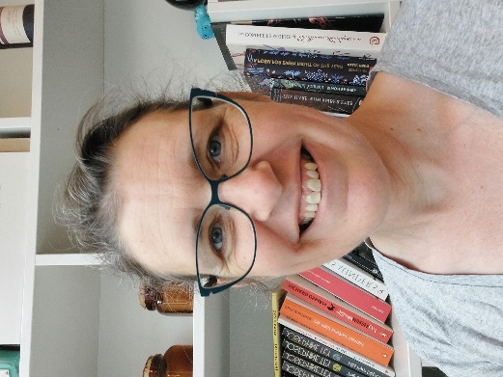
Kate Victoria HANNAH (Netherlands), who accepts the nomination

Nominated by: Lucy Marsh-Smith (Jersey)
Seconded by: Claire Morgan (Australia)

Overview:
Kate has significant experience and skills working in the editor field in two jurisdictions that she can bring to the role of Secretary. These skills are supplemented by previous involvement in the Australasian Parliamentary Counsel’s Committee forums, and activities like co-ordinating and hosting the first CALC forum for Editors and Translators in September last year. This exposure to different ways of working, systems and ideas has allowed Kate to develop broad knowledge and insight into how drafting offices make the most of the legislative systems they have. Her years of experience have also allowed her to meet and work with many other people with shared interests in legislation quality. Kate is excited at the prospect of bringing this expertise and interests to a role supporting CALC and promoting similar opportunities to staff in drafting offices everywhere.
Experience:
The most recent of the two jurisdictions is the Jersey Legislative Drafting Office, where Kate has worked as a consultant since early 2019, logging in remotely from the Netherlands. Her role has covered an array of editorial and technical work, including reviewing draft legislation, consolidating legislation, developing processes, maintaining and developing the drafting template, requirements development and user-end configuration for the document management system, setup of the office wiki, and related staff training. This breadth of work gives a view into what helps make a drafting office work, where some of the challenges are, and how to make a difference to them.
Before Jersey, Kate was in the editorial team in the Parliamentary Counsel’s Office, NSW, Australia for 24 years. She was involved in editorial reviews of draft legislation and managed the SGML database of legislation (and supporting the underlying SGML DTDs). She was part of a team of people who developed the office wiki and created content for it. She also has experience in management functions, training programs and all the many activities that are needed to maintain a modern office and to drive change.

