|  |  |
| --- | --- |
| CALC logo | **Newsletter**  July 2023 |

Contents

CALC Europe Regional Conference 2

‘Forty Years On’ – Some reminiscences of CALC 5

Vale Ian Turnbull KC 9

Model Law on cross-border internet activities and other model law developments from the Regulatory Institute 10

News from Nigeria 11

Crowning achievement 11

Jersey news 12

Recent publications and postings 13

Call for papers: Commonwealth Cybercrime Journal 14

Coming up…events in person and online 15

CALC Africa conference 15

Australasian PCC / CALC Asia-Pacific conference 15

CALC international conference 15

Hybrid AI for Legislation: from theoretical model to empirical use-cases 16

Plain Language Association International (PLAIN) biennial conference 16

New CALC members 16

Newsletter information 18

​​Published online at [calc.ngo/publications/newsletters](http://www.calc.ngo/publications/newsletters)

Editor: Kate Hannah, c/- Legislative Drafting Office, Morier House, St Helier, Jersey.

k.hannah@gov.je

# CALC Europe Regional Conference

Cardiff, Wales / Caerdydd, Cymru

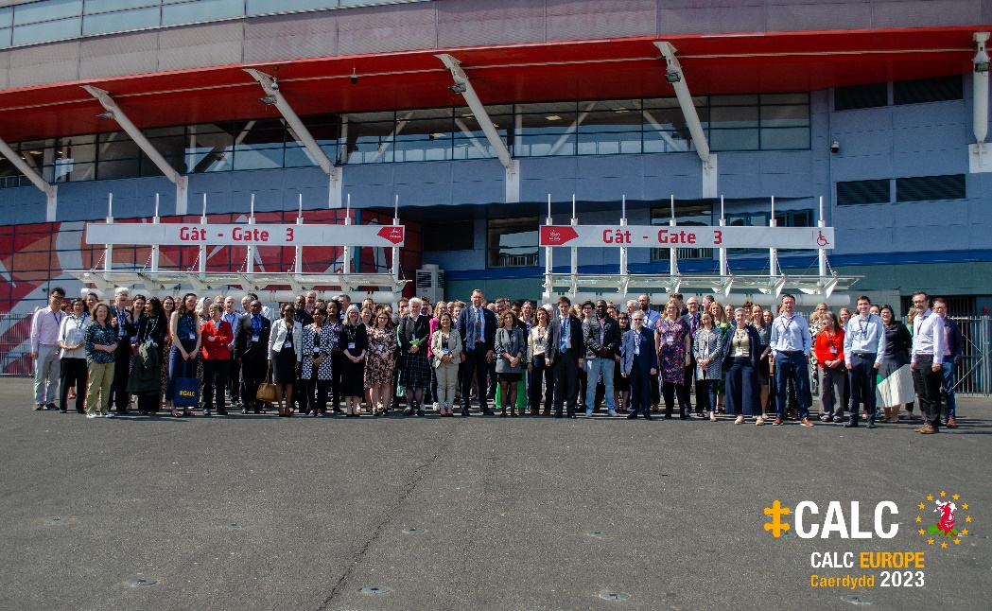

The CALC Europe Conference 2023, our first in-person event for over 4 years, took place over two beautifully sunny May days in Cardiff.

The Counsel General for Wales, Mick Antoniw MS, issued a warm Croeso i Gymru – Welcome to Wales – to the 140 delegates gathered at the impressive Principality Stadium (Cardiff Arms Park), home of Welsh rugby. Over the next couple of days all attending were treated to a host of enlightening sessions and workshops led by CALC members from across Europe and beyond.

Day 1 kicked off with Dylan Hughes (Wales) reflecting on the impact of the pandemic on the rule of law, contrasting efforts to make the legislative restrictions accessible with normal practice, and Garret Salmon (Ireland) exploring the role of parliamentary counsel as constitutional actors.

The Conversations marking CALC’s 40th anniversary continued with former CALC President, Dame Brenda King, reflecting on her lengthy career as a legislative drafter, ruminating on how that had prepared her for her current role as Attorney General for Northern Ireland and entertaining with a few tales from previous CALC Conferences (full transcript expected to be available in a later Newsletter).

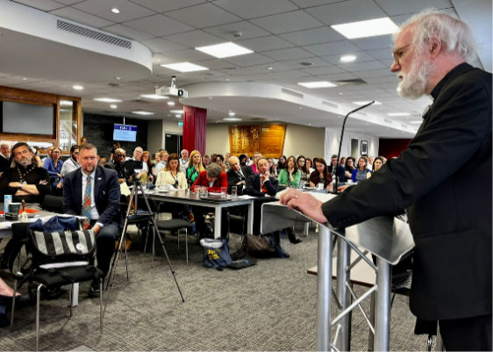The Rt Revd and Rt Hon Dr Rowan Williams provided the day’s keynote address. The renowned polyglot, former Cambridge University academic, former Archbishop of Wales, and the first person in modern times to become Archbishop of Canterbury from outside the Church of England, gave his reflections on law and sovereignty gleaned from his role leading the Independent Commission on the Constitutional Future of Wales.

Rt Revd and Rt Hon Dr Rowan Williams

A video of the talk, and the transcript, are available to CALC members from the conference page: <https://calc.ngo/europe-conference-wales-2023>.

After lunch, delegates enjoyed debating with each other on the drafting dilemmas presented by Dr James George and Natalie Lancey from OLC Wales. Break-out sessions followed with Elena Bosi (New Brunswick), Nia Evans and Dewi Jones (Wales) and Matt Bell (The UK National Archives) presenting on bilingual drafting, Manfred Kohler (Regulatory Institute) and Neil Shah (UK) talking on regulation of the internet and Sonia Rodrigues (University of Lisbon) and Dr Robert Black (Ocimum Biosecurity) reflecting on recent reforms of environmental regimes.

Jersey’s Legislative Drafting Office rounded out the day with Matthew Waddington updating on progress made with his Computer-Readable Legislation project and Zoë Rillstone leading a workshop on application of the basics of formal logic to legislation. The room was buzzing as the day ended with everyone getting to grips with various legislative logical conundrums.

|  |  |
| --- | --- |
| The choir sings before an audience seated at dining tables in the Coal Exchange hotel  Côr Caerdydd | John Wilson talking at the podium inside the dining hall at the Coal Exchange hotel  John Wilson |

The Conference Gala Dinner was held in the majestic Trading Hall of the Coal Exchange Hotel, the place where the worldwide price of coal was once settled and the site of the world’s first ever £1 million deal. Guests arriving for the champagne reception were reminded why Wales is the “land of song” as the simply phenomenal Côr Caerdydd (featuring singing drafters Nia Evans and Rhian Williams from OLC Wales) performed a string of unforgettable choral numbers. An evening of congenial company followed with wonderful Welsh produce served up throughout and Dr Sara Elin Roberts provided a fascinating treatise on mediaeval Welsh laws.

The evening was closed out, as Welsh cakes and coffee were served, by CALC founder member, John Wilson. Having attended CALC’s inaugural Conference in Hong Kong in 1983, and many more since, John entertained with tales of how CALC has benefited many thousands of members, and fostered so many friendships, over the past 40 years and treated us all to a rendition of “My Way” cleverly adapted to a drafter’s life (talk and lyrics to “I drafted my way” set out later in the Newsletter).

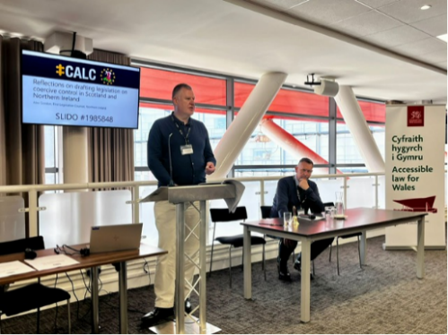Alex Gordon (Northern Ireland) woke everyone up on Day 2 by diving straight into legislative drafting matters, reflecting on his involvement in creating novel coercive control laws in multiple jurisdictions, drawing out both the opportunities of learning from where drafters have trodden before and the pitfalls of blind repetition when importing provisions into a distinct legal framework.

An enlightening session focussed on training, developing and mentoring drafters followed, with Scott Wortley (University of Edinburgh), Fraser Gough (Scotland) and Maria Mousmouti (IALS) each providing insights on how to develop legislative drafting skills for everyone from fledgling university students to experienced counsel in established legislative drafting offices.

Rugby-loving delegates enjoyed a tour of the stadium over lunch, and the sunlit seats provided the perfect spot to catch some midday sun.

|  |  |  |  |
| --- | --- | --- | --- |
| Dylan Hughes sitting in the rugby changing room | *Dylan Hughes, dreaming of leading a different Welsh team* | Members of CALC sitting in the stands at Principality Stadium during a lunchtime tour | *CALCers enjoying the midday sun pitch side* |

Day 2’s break-out sessions provided more difficult choices. Terry Kowal (Qatar) and Felicity !Owoses (Namibia) shared experiences of working in their own jurisdictions with Kritika Khanijo (World Health Organisation) giving an international perspective on legislating controls for alcohol and tobacco. Ronan Cormacain (UK) and Pippa Matthews (Ireland) explored the challenges presented by Private Members’ Bills, and Simon Hodgett (Guernsey) and Lucy Marsh-Smith and Eloise Layzell (Jersey) delved into the unique aspects of Royal Assent in Crown dependencies.

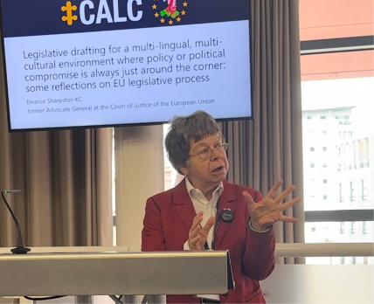Eleanor Sharpston KC delivered the day’s keynote address. A former Advocate General at the Court of Justice for the European Union, she offered her reflections on legislative drafting in the multi-lingual, multi-cultural EU environment where policy or political compromise is a significant feature in settling legislative text.

Diggory Bailey and Luke Norbury (UK) and Ian Davis (Guernsey) shared thoughts and triggered debate on clarity in legislative drafting and, after a break for tea and a final Welsh cake, a panel of drafters - Huw Davies (Wales), Margaret Kelleher (Ireland) and Phil Chessum (UK) – engaged in enthusiastic debate when asked to provide their top tips for tackling a number of familiar predicaments and quandaries faced by legislative drafters.

Eleanor Sharpston KC

Segametsi Mothibatsela provided an update on recent work being done by Commonwealth Secretariat, in partnership with the Trinidad & Tobago drafting office, to help support and develop legislative drafting capability in small, island jurisdictions. She revealed another Commonwealth Secretariat initiative which will soon be launched in south-east Africa, and Dr Johnson Okello (Kenya) informed delegates on plans for an Africa Regional Conference in late October.

The closing reception was a chance to make some final connections, learn some final Welsh phrases and revel in the unique atmosphere that only a gathering of legislative counsel generates. Delegates dispersed into a fine Cardiff summer evening with a committed few continuing conversation in nearby Cardiff hostelries and during the following morning’s tour of the Welsh Senedd.

As always, the success of the Conference was due to the collective contribution of every CALC member who helped organise, facilitate, present and participate. All attendees were particularly grateful to the host office, Office of the Legislative Counsel Wales.

CALC Council Europe representative Neil Martin, CALC member Claire Fife and many of their OLC colleagues worked tirelessly to ensure that presenters and delegates had a wonderful experience and left Wales having learned a lot, renewed old friendships and made many new ones.

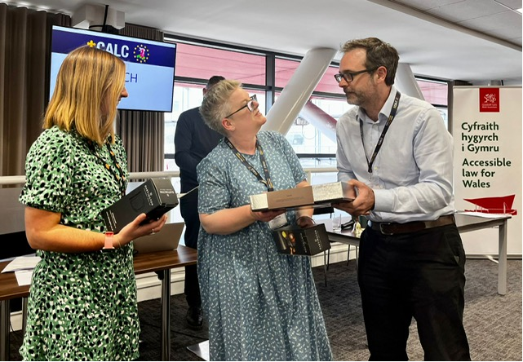

Diolch - Neil Martin, Claire Fife and Lowri Harries (right to left)

Papers from the Conference, and a video of Dr Rowan Williams’ keynote address, can be accessed through the Members’ page on the CALC website.

# ‘Forty Years On’ – Some reminiscences of CALC

*‘Noswaith Da’!* (Welsh for ‘good evening’).

This was how I began my after-dinner address to the ‘CALC in Europe’ Conference in Cardiff on 24 May 2023. The dinner was held in the 150-year old ballroom of the Coal Exchange Hotel; very august surroundings, and the nearest I have ever got to being at the coal-face, despite being born in Nottinghamshire.

I could claim stronger credentials to speak in Wales, as my mother was born in Colwyn Bay (north Wales, it has to be said.) So I was able to take the closed scholarship exam at Jesus College, Oxford and got an exhibition to read law. Jesus College has strong connections with Wales and I was glad to be able to tell Dr Sara Roberts (who spoke earlier in the evening about ancient Welsh law) that the college owns the ‘Red Book of Hergest’, with many old Welsh laws in it.

The reason I was asked by the President of CALC to speak at the dinner is that I was the only person there who was at the *inaugural meeting of CALC in Hong Kong in 1983.* At that time I had just joined the Law Drafting Division of the AG’s Chambers after 20 years varied legal experience.[1] Gerry Nazareth was Law Draftsman (as he was called) and he and George Engels (First Parliamentary Counsel in London) and the heads of the offices in Australia, Canada and New Zealand organised an inaugural meeting of what became our beloved organisation.

I don’t recall the details of the *preparatory meetings,* of which there must have been many, or the precise role that I played, but it was only a fetch-and-carry one as I was very new to the city and to the Chambers and to the team. What I do remember is that we met in various large reception rooms in various lavish 5-star hotels; Hong Kong was already an amazingly successful business city – as it still is.

There was a (to me) surprisingly large number of law drafters from around the Commonwealth in attendance, including several senior military people from each of the states of Nigeria. The CALC archives will show who was actually there and what the proceedings were, but I do remember a discussion about the *CALC Logo (the ‘Loophole’.)* Sir George Engels introduced it and explained that it was a replica of a loophole in one of the Crusader forts in Europe. I have a collection of photos of loopholes, none of which are exactly the same as our logo, but I am told the original does exist.

All loopholes can be shot into by a clever marksman, which of course is why we try to avoid creating them in the laws we draft. The Loophole logo was duly adopted at the 1983 inaugural meeting, and has been worn with pride by law drafters around the Commonwealth ever since. It is the name of our flagship publication, and appears on tote bags, ties, scarves – and even on spectacle cleaning cloths; I use mine every day.[2]

The other main topic I remember being discussed is *the name of our organisation.* It was felt that it was important that it should be gender-neutral, but that it should also reflect the fact that law drafters do a lot more than draft laws. They also advise on legislative topics, they might be asked to attend meetings of parliamentary committees, they might even be involved in policy decisions if legislation is concerned.[3] The term ‘Legislative Counsel’ is a good fit for what most law drafters around the Commonwealth do, and the name Commonwealth Association of Legislative Counsel was duly adopted.

Brenda King gave a paper at the Cardiff conference about the history of CALC during its first 40 years, so I will not try to cover the same ground. However, I will summarise a few of the salient features of the organisation that make it so special to me and other drafters.

*The Constitution* is a remarkably resilient document and has stood the test of time really well, with only minor amendments since it was adopted in 1983. The main features are:

CALC is open to all Commonwealth law drafters, free, and without any entry qualification except an assertion that the person is doing drafting.

There is no disciplinary or procedure by which members can be expelled.

Although CALC is a professional body, it doesn’t impose any continuing education requirement and it has no control over the products of its members.

So membership of CALC is not itself a proof of competence; but I like to think that every member of CALC aims to keep abreast of developments in the law drafting field in the Commonwealth and to produce work that other members would approve of.

CALC is run efficiently by an elected *Council* consisting of law drafters representing every region. After a total of 15 years in Hong Kong I became a consultant drafter based in the UK. That is when my ‘island-hopping’ in the Pacific and the Caribbean really began, funded by the South Pacific Commission, Commonwealth, UN agencies, etc. So I could never be on the CALC Council as I didn’t represent any one region; but I admire the work they do and thank them for it.

CALC can take pride in its high quality publications, *‘The Loophole’ and the Newsletter*. The Loophole was edited for many years by Duncan Berry (who was also the Secretary for many years – and who was also at the inaugural meeting in 1983.) Currently it is edited by John Mark Keyes in Canada and is a genuinely useful academic journal for drafters. I have a few items in it, though more in the Newsletter, which carries some of the lighter contributions from members.

CALC is a valuable *recruiting ground* for drafting jobs around the Commonwealth by means of adverts on the website. This provides a useful service not only to members but also to governments and other bodies seeking law drafters. Members don’t have to pay to apply for any of the jobs, but much of CALC’s income derives from charging for adverts for job vacancies.

I myself benefitted from *CALC as an employment agency* many years ago. At the conference in London, I gave a paper on the joys and challenges of drafting in small island jurisdictions. Someone from Gibraltar decided I was just the person to do some drafting for them. From that emerged two major bills drafted by me on criminal law – a Crimes Bill, and a Criminal Evidence & Procedure Bill (which were both enacted and are on the Gibraltar statute book.)

More recently, I applied to be on a panel of drafters of secondary legislation for Northern Ireland – a post advertised by CALC – and I picked up a few bits of work that way.

For people such as me, CALC is a vital professional lifeline. It keeps us in touch with other drafters around the Commonwealth and keeps us up to date on developments in drafting techniques, through the publications and the conferences. I will always be grateful to it.

I included in my speech in Cardiff a few words about *the Commonwealth*, as it is part of CALC’s name. We have all heard a lot of (mostly ill-informed) talk about the Commonwealth disintegrating during the reign of King Charles III (who is also Head of the Commonwealth.) Whatever the political arguments, there is no doubt the Commonwealth as a grouping of mostly former British colonies, with similar legislative, administrative and judicial systems, will remain valuable for many years. CALC is just one of a number of professional legal organisations that benefit from being associated under the umbrella of the Commonwealth – the C. Law Association, the C. Magistrates & Judges Association, the C. Association of Law Reform Agencies, the C. Legal Education Association, as well as non-legal organisations. I hope that CALC will continue to make the most of these connections to foster the spirit of the common law around the world.

Finally, I spoke about the *CALC Conferences.* These have been held up to now at the same time and in the same city or town as the Commonwealth Law Association but are probably going their own way in future. I have attended nearly every conference (at my own expense, I might say) and have found something of interest, as well as entertainment, each time. Perhaps the most memorable for me was Hyderabad, where the band ended the dinner party by playing ‘I did it my way’. Katy Le Roy (then Secretary) and I said to each other that we needed our own version of that song. So I wrote one. Here it is:

“I DRAFTED MY WAY”

*(with apologies to Frank Sinatra and other performers)*

And now the end is near,

And so we reach the final clauses.

I’ve made a law that’s clear

In both its structure and its causes.

I’ve made a Bill to pass

Like razors sell, though blunt they may be;[4]

And more, much more than this –

I drafted plainly.

Mistakes, I’ve made a few,

But then again, too few to mention.

A comma here, a typo there,

A few departures from convention.

I planned each section head,

Each signpost on the statute’s highway;

And more, much more than this –

I drafted my way.

Yes, there’ve been times, I’m sure you know,

I found the DI’s fairly useless.[5]

But through it all, when there was doubt,

I made a guess to sort it out.

I made a Bill, and it stands still –

It’s drafted my way.

I’ve worked alone through long weekends,

I’ve drafted Bills that were rejected;

And, when the tears subsided, wondered –

Just what was expected?

To think I did all that – and then the legislature voted.

But in committee stage[6] –

They saw it my way.

For what I draft is what they get,

If not exactly per instructions.

I write the things they truly need,

According to the best constructions.

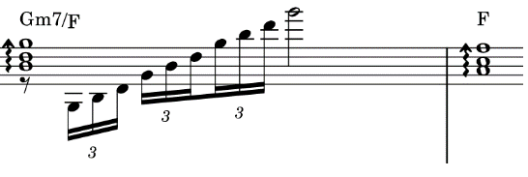The record shows I took the blows –

And drafted my way!

John F Wilson

(Law Drafting Consultant based in England),

Written for the Commonwealth Association of Legislative Counsel (CALC)

First performed at the PLAIN/Clarity online Conference, October 2020

_____________________________

# Vale Ian Turnbull KC

(Ian Maclean Lindsay Turnbull KC

First Parliamentary Counsel, 1986 - 1993

Australian Government’s Office of Parliamentary Counsel

5 November 1930 - 26 April 2023)

“We have a very important duty to do what we can to make laws easy to understand. If laws are hard to understand, they lead to administrative and legal costs, contempt of the law and criticism of our Office. Users of our laws are becoming increasingly impatient with their complexity. Further, if we put unnecessary difficulties in the way of our readers, we do them a gross discourtesy. Finally, it’s hard to take pride in our work if many people can’t understand it.”

I wish I could say that I had written those words, words that simply and powerfully summarise our role as legislative drafters. But these are the words of the late Ian Turnbull KC, former First Parliamentary Counsel of the Australian Government’s Office of Parliamentary Counsel between 1986 and 1993, who died recently after battling cancer for a number of years.

This quote is from my office’s Plain English Manual, written by Ian. While I never met Ian personally, as I read these words, I can almost hear his voice. I can certainly see his values, as a drafter and as a human. The Plain English Manual is a manual that is practical, realistic and elegant in its simplicity. Released in 1993, its recommendations and drafting approaches are still current thirty years on. For those of you who have not read it, I recommend you do so. (It is available on OPC’s website: [Plain language | Office of Parliamentary Counsel (opc.gov.au)](https://www.opc.gov.au/drafting-resources/plain-language).)

Ian has had an enduring impact on OPC, and I believe many other drafting offices both in Australia and around the world, having been an absolute leader in the Plain English movement. When Ian was first appointed as First Parliamentary Counsel, he was active in reviewing OPC’s approach to drafting, promoting innovation and discussions within the office, and drawing on external expertise to influence drafting approaches. Such were the changes to OPC’s drafting style under Ian’s leadership, that Canadian lawyer David Elliott described OPC in 1991 as ‘perhaps the most innovative legislative drafting office in the [British] Commonwealth’ (*Fitting the Bill*, Carmel Michaeljohn, p 232).

It is easy to underestimate the importance of many of the changes Ian brought about within the office, or the challenges he faced in dealing with those changes. As Carmel Michaeljohn says in *Fitting the Bill*:

Endeavouring to cooperate with vocal critics of Commonwealth style he was branded as overly conservative by the more intemperate ‘Plain English’ campaigners, criticised as doing too much by some conservative lawyers, viewed with deep suspicion by the most conventional drafting offices and described as ‘a wild radical’ by one State colleague.

We are all beneficiaries of Ian’s work, and I, for one, will remain grateful that he came before me.

Meredith Leigh

Australian Government’s First Parliamentary Counsel

11 June 2023

# Model Law on cross-border internet activities and other model law developments from the Regulatory Institute

Valerie Thomas

President and General Manager, Regulatory Institute

At the recent 2023 CALC Conference in Cardiff, the Regulatory Institute’s Founder, Manfred Kohler, presented the world’s first [model law on cross-border internet activities and virtual worlds](https://eur02.safelinks.protection.outlook.com/?url=https%3A%2F%2Fwww.howtoregulate.org%2Finternet_rels&data=05%7C01%7C%7C81fa17746fcf46555e8108db6cd9012e%7C2b5615117ddf495c8164f56ae776c54a%7C0%7C0%7C638223452243055777%7CUnknown%7CTWFpbGZsb3d8eyJWIjoiMC4wLjAwMDAiLCJQIjoiV2luMzIiLCJBTiI6Ik1haWwiLCJXVCI6Mn0%3D%7C3000%7C%7C%7C&sdata=rMzcKHXVfbZVExsDZQCkcXJWVKJfspWiFQoYqAkIL1Y%3D&reserved=0). There has been interest from several jurisdictions about how to regulate this complex policy field. More and more aspects of life are covered by the internet. This fact increases the number of relationships that arise between natural and legal persons. These relationships can arise via the internet in general, on platforms like LinkedIn, in internet games or in virtual worlds. The “metaverse” or similar “virtual worlds” aim to supplant the real world, creating even more complex legal relationships and encompassing ever more spheres of life, including professional contexts. The goal of the Regulatory Institute's model law is to describe a way to adapt the principles of international private law and the applicable national rules to the particularities of international internet-based relationships and to complement these provisions when needed. Therefore, we mainly suggest interface provisions that ensure the correct application and better functioning of international private law and the applicable national rules to the international internet-based relationships, including those in virtual worlds. Our model law contains comprehensive lists of obligations for all actors from which legislators are invited to choose as appropriate. Lastly, our model law establishes a system in which actors control each other so as to complement and even partly replace the work of enforcement authorities.

The Regulatory Institute is now focussing its attention on developing two additional model laws. The first concerns a model law on pandemics noting the WHO negotiations towards a [convention on pandemic prevention, preparedness and response](https://eur02.safelinks.protection.outlook.com/?url=https%3A%2F%2Fapps.who.int%2Fgb%2Finb%2Fpdf_files%2Finb5%2FA_INB5_6-en.pdf&data=05%7C01%7C%7C81fa17746fcf46555e8108db6cd9012e%7C2b5615117ddf495c8164f56ae776c54a%7C0%7C0%7C638223452243055777%7CUnknown%7CTWFpbGZsb3d8eyJWIjoiMC4wLjAwMDAiLCJQIjoiV2luMzIiLCJBTiI6Ik1haWwiLCJXVCI6Mn0%3D%7C3000%7C%7C%7C&sdata=PY0uummMNCZ3LLKBDGaLWuzwpocK6KDWX%2BmyaU6bGHw%3D&reserved=0). The second model law concerns our furry friends, covering animal protection and welfare. As always, the Regulatory Institute welcomes suggestions for future model law topics and co-conspirators interested in drafting or commenting on our model laws, get in touch with the [General Manager](mailto:manager@regulatoryinstitute.org).

In other news, we are proud of publishing late last year our [Model Laws Library](https://eur02.safelinks.protection.outlook.com/?url=https%3A%2F%2Fwww.howtoregulate.org%2Fthe-model-laws-library%2F&data=05%7C01%7C%7C81fa17746fcf46555e8108db6cd9012e%7C2b5615117ddf495c8164f56ae776c54a%7C0%7C0%7C638223452243055777%7CUnknown%7CTWFpbGZsb3d8eyJWIjoiMC4wLjAwMDAiLCJQIjoiV2luMzIiLCJBTiI6Ik1haWwiLCJXVCI6Mn0%3D%7C3000%7C%7C%7C&sdata=vtJXkCGmLmI1OqgS9ulrdwgVP65dfDS1G3aR1TLXLtI%3D&reserved=0). The Model Laws Library contains hundreds of model laws that we have either drafted or searched for, reviewed and compiled, covering a variety of topics. We have developed the Model Laws Library because of the many positive benefits such as:

* A more complete compendium of laws of each jurisdiction, with each law being more comprehensive, will support certain global issues such as those against organised crime, pandemics and risks to mankind;
* At least the model laws developed by us will contain clauses facilitating international cooperation which are absent today;
* Indirectly, the use of model laws will promote international harmonisation of laws, harmonisation also reduces costs for economic operators, and such cost reductions often leads to reduced prices to the benefit of all; and
* Whilst policies should not be reduced to laws, good (model) laws also enhance good policies and thus increase human wellbeing, protection of the environment and of animals.

# News from Nigeria

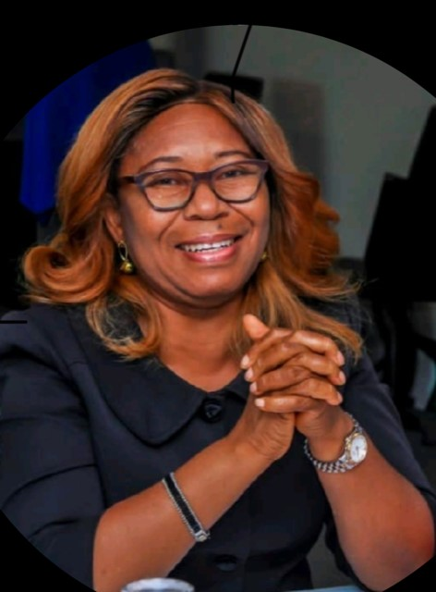Ms Ifunanya Nwajagu has recently retired as the Director, Legal Drafting of the Federal Ministry of Justice, Nigeria, after 32 years in the Public Service. During that time, she served the Ministry and Government in various capacities including Legal Adviser (Gas) due to her competence in the energy sector. She represented the Ministry and Government at different National and international fora. She had presented papers in diverse sectors including legislative drafting, energy and environment. In her capacity as the Draftsman General of the Federation and Director Legal Drafting, she superintended over the passage of critical legislation and subsidiary instruments with far reaching implications for Nigeria touching on Nigeria's socio-economic, financial, business, and political wellbeing, infrastructure, National Development, and international relations. Ifunanya has won several awards including Presidential Award, for her diligence, skill, knowledge and efficient execution of legislative assignments, and for her integrity in job delivery. With her retirement from the Public Service, Ifunanya is now succeeded in office by Dr. Patrick Etta Oyong.

# Crowning achievement

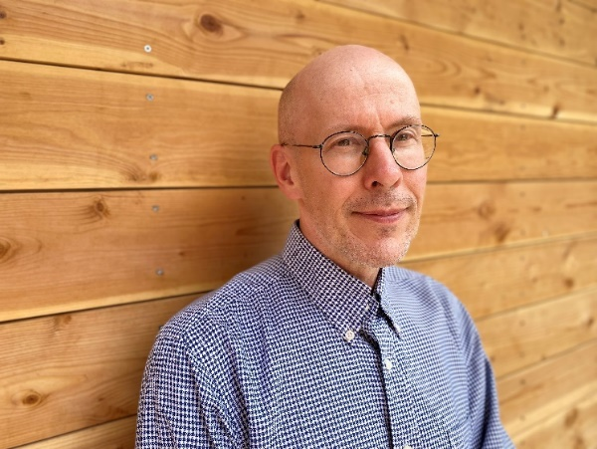The Ontario Government, in celebration of the coronation of His Majesty King Charles III, is returning to the tradition of recognizing Ontario lawyers with the honorary title of King’s Counsel. The KC designation is given to lawyers who have demonstrated a commitment to the pursuit of legal excellence in service to the Crown, the public and their communities and the first round of recipients include Ontario’s Chief Legislative Counsel, Mark Spakowski.

# Jersey news

Matthew Waddington on the Computer-Readable Legislation Project

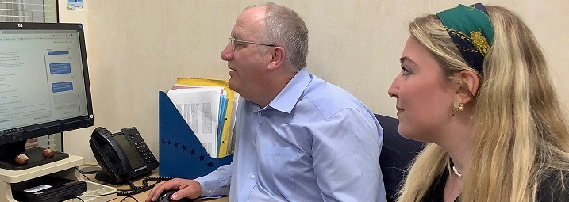

Matthew Waddington and Margaux McQuilton

The Computer-Readable Legislation Project at Jersey’s Legislative Drafting Office has taken on two interns over twelve weeks this summer.

The first, Margaux McQuilton, is a student from Jersey's Institute of Law. She is now four weeks into her six week internship, and she has been busy parsing real and imaginary provisions of legislation for us. She then marks up the text that she has parsed, using colour highlighting for now (maybe XML tags later). She then turns that into questions and conclusions, sticking to the wording of the legislation, by adding “Is it the case that …” or “It is/not the case that …” before the text of the extract from the legislation. She annotates the questions with instructions (such as “Yes – Go to question 4”) that follow the logical structure that she parsed. That means that, depending on the answer – yes or no – the instructions send the user to another question, or to an interim or final result. Doing this also helps her to check if she has captured the logical structure of the law correctly, without missing out anything, to be able to take it to the next step.

Then she turns those instructions into the elements needed by Mermaid’s free website [https://mermaid.livet](https://eur02.safelinks.protection.outlook.com/?url=https%3A%2F%2Fmermaid.livet%2F&data=05%7C01%7C%7Ce88c455ad4c2478568e408db7d7a8de6%7C2b5615117ddf495c8164f56ae776c54a%7C0%7C0%7C638241737533838988%7CUnknown%7CTWFpbGZsb3d8eyJWIjoiMC4wLjAwMDAiLCJQIjoiV2luMzIiLCJBTiI6Ik1haWwiLCJXVCI6Mn0%3D%7C3000%7C%7C%7C&sdata=Q8Ult5tSJFMjRkHmjEiPwlmROX5%2Fmcb0xGAoD3dq8H8%3D&reserved=0). Again she is just representing the if-then logic in the legislation as the way to steer through the questions and conclusions. The result is that Mermaid generates a flowchart for the questions and conclusions, which could be used for instance by an instructing officer to check the effects are as intended.

She then converts the parsing, again just to represent the if-then logic in the legislation, into the format needed by QnA Markup [https://qnamarkup.org](https://eur02.safelinks.protection.outlook.com/?url=https%3A%2F%2Fqnamarkup.org%2F&data=05%7C01%7C%7Ce88c455ad4c2478568e408db7d7a8de6%7C2b5615117ddf495c8164f56ae776c54a%7C0%7C0%7C638241737533838988%7CUnknown%7CTWFpbGZsb3d8eyJWIjoiMC4wLjAwMDAiLCJQIjoiV2luMzIiLCJBTiI6Ik1haWwiLCJXVCI6Mn0%3D%7C3000%7C%7C%7C&sdata=3Zte%2BOQMaIGTQImYLhKNfptdfClJkgnmXx0brlzdpAQ%3D&reserved=0), which is a free web-based questionnaire program (so no need to download any software). That then presents the questions in the right sequence, depending on each answer, to take the user to the right conclusions.

The key to all of this is that we are sticking to the wording of the legislation, so that all we are capturing is the logical structure of the legislation, not the meaning of undefined expressions, and not adding any additional interpretation.

The next steps will include trying to get generative AI (ChatGPT, Bing Chat) to write the QnA and Mermaid elements. We will also be looking at LegalRuleML and other forms of markup for tagging the text, ideally in a way that a free reasoning program can work with. We will see whether we can publish the whole set of documents once they are finished, along with some videos, as these things are always easier to demonstrate than explain. We will post information on our progress on Substack [https://digitallegislation.substack.com/](https://eur02.safelinks.protection.outlook.com/?url=https%3A%2F%2Fdigitallegislation.substack.com%2F&data=05%7C01%7C%7Ce88c455ad4c2478568e408db7d7a8de6%7C2b5615117ddf495c8164f56ae776c54a%7C0%7C0%7C638241737533838988%7CUnknown%7CTWFpbGZsb3d8eyJWIjoiMC4wLjAwMDAiLCJQIjoiV2luMzIiLCJBTiI6Ik1haWwiLCJXVCI6Mn0%3D%7C3000%7C%7C%7C&sdata=0fEB7Yq%2FUw9uzSBcvoSEg%2FHrF3VXT6813lW2ODG7wzQ%3D&reserved=0) (and on Twitter and LinkedIn).

Lucy Marsh-Smith, Principal Legislative Drafter

Further news from Jersey is the arrival of new drafter Shane Williams from New Zealand. Shane will be leading on climate change and financial services legislation, but expects to be involved in a number of other areas of drafting. With Zoë Rillstone having left Wellington to settle in Jersey nearly 4 years ago, that’s 2 Kiwis in the Jersey Office. But to even things up, Diana Sargent will join Legislation Services Consultant and CALC Secretary, Kate Hannah, in representing Australia later in the year, though she is being recruited from the UK. Nearly a third of the Jersey office being Antipodeans? No wonder Jersey is having to publish new “current drafting practice”!

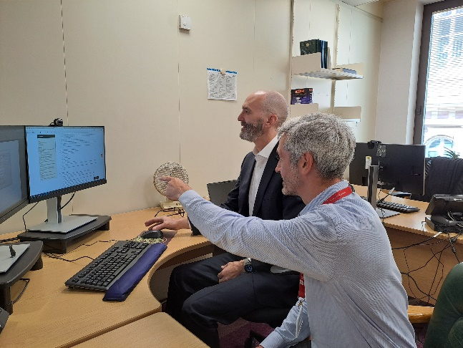

The photo shows Shane (left) in discussions with Legislation Editor, Graham Halpin, as he learns to master the legislation website (onscreen), drafting template and case management system.

Nothing to do with legislation, but why not check in on the [Tortoise Takeover Trail](https://tortoise.durrell.org/) put together by Durrell. The tortoises have turned up in the drafting office in-house chat channel.

# Recent publications and postings

**“A general inaccessibility of law … erodes societal well-being on individual and collective levels”**

[Is Every Law for Everyone? Assessing Access to National Legislation through Official Legal Databases around the World](https://doi.org/10.1093/ojls/gqac032). Andreas Nishikawa-Pacher and Hanjo Hamann. Oxford Journal of Legal Studies, 4 February 2023.

**[find out what would] “…trouble our minimalist souls…”**

What is ‘this’? Ken Adams on [‘this’ in contract drafting](https://www.adamsdrafting.com/the-rules-of-this-in-contract-drafting/), and Matthew Waddington with a drafter’s (and rules as code nerd’s) [perspective on LinkedIn](https://www.linkedin.com/posts/matthew-waddington-04084429_the-two-rules-of-using-this-in-contract-activity-7057981189025865728-vf58?utm_source=share&utm_medium=member_desktop).

[ISO 24495-1:2023, Plain language — Part 1: Governing principles and guidelines](https://www.iso.org/standard/78907.html) has been published. As an ISO standard, it needs to be purchased to read more than the informative sections. See also the [International Plain Language Federation](https://www.iplfederation.org/iso-standard/) and its information about the development of the standard.

**“Extensive studies have shown that writing in plain language saves time or money (or both) for readers and organizations.”**

The love letter contextualized – Hamish Fraser. A follow-up to his original [declaration of love and call for (an) engagement](https://hamish.dev/a-love-letter-to-the-parliamentary-counsel-of-the-world). See how research into ELI, AKN and USLM went (no, it isn’t all acronyms).

**“It's always encouraging to find someone else invented the wheel in a similar fashion to the way you did”**

Read the extensive work that has gone into the [PCO Standard: A guide to drafting principles for NSW legislation](https://pco.nsw.gov.au/download/PCO_Standard-9May2023.pdf).

**“The objective of the document is to provide a collective base for legislative drafting resources in the office, ensure a consistent style is implemented by PCO for the NSW statute book and offer insight into PCO’s approach to drafting.”**

Hallucinated legislation websites? See this Tweet from Matthew Waddington about work by Pierre-Loic Doulcet: <https://twitter.com/DigitalLawsJsy/status/1679070849289326592?s=20>.

**“Results are not really good.”**

Gov.UK has published a page on [Working for the Office of Parliamentary Counsel](https://www.gov.uk/government/publications/working-for-the-office-of-the-parliamentary-counsel). Find out who said -

“I’ve heard the core of the job, drafting, being described as Marmite-y[7] and I would agree. There is no getting away from the fact that drafting is hard and requires deep concentration. The job is however immense amounts of fun, unique and by definition at the cutting edge of the law. If you enjoy thinking conceptually, have an eye for detail and want a legal job the essence of which is creative, a career as a drafter might be for you.”

# Call for papers: Commonwealth Cybercrime Journal

Published by the [Commonwealth Secretariat](https://thecommonwealth.org/), the Commonwealth Cybercrime Journal (CCJ) is a peer reviewed journal featuring policy-influencing articles and commentary by academics, policymakers, practitioners and experts on the benefits, challenges, and risks of digital technologies.

There is currently a call for papers for Volume 2. See the full details in the [call for papers document](https://calc.ngo/sites/default/files/documents/CW%20Cyber%20Journal%20-%202nd%20Ed_CFPs.pdf), including dates and editorial information. Abstracts for papers must be submitted by 17 August 2023, with draft papers due by 30 November 2023.

The first volume is also available: [Commonwealth Cybercrime Journal, Volume 1, Issue 1](https://thecommonwealth.org/publications/cybercrime-journal-1-1).

# Coming up…events in person and online

## CALC log with the head of the Kenya lion on the right hand sideCALC Africa conference

**23-25 October 2023**

*“The Future of Legislative Drafting in Africa – What lies ahead?”*

At the [Sarova Whitesands Hotel](https://www.sarovahotels.com/whitesands-mombasa/), Mombasa, Kenya.

The Conference is being hosted by the Parliament of Kenya and the Office of the Attorney General for Kenya.

The conference fee is $250 USD. This covers all days of the Conference, and a Gala dinner on 24 October. The guest fee, for the Gala dinner only, is $50 USD.

You can register to attend the Conference here: [REGISTER FOR CALC AFRICA 2023](https://www.tickettailor.com/events/calc/948132)

[](https://www.tickettailor.com/events/calc/948132)

For full information, including visa and other details for delegates, go to <https://www.calc.ngo/conferences>.

**Call for Papers**

Submissions are also open for Conference papers. The Conference theme is “*The Future of Legislative Drafting in Africa – What lies ahead?*”. See the [CALC website](https://www.calc.ngo/conferences) for how and when to submit papers.

## Australasian PCC / CALC Asia-Pacific conference

The conference will take place at The Mint, Sydney, from Wednesday 2 August – Friday 4 August 2023.

Registration closed on 16 June. But you can still see the website for more information and be duly envious: <https://calc.ngo/conferences>

You can also contact the NSW PCO Conference team at [ea@pco.nsw.gov.au](mailto:ea@pco.nsw.gov.au).

## CALC international conference

Coming to the Caribbean in 2024 – more details soon!

## Hybrid AI for Legislation: from theoretical model to empirical use-cases

When: 24 July 2023, 12-1 pm (Ottawa time)

Where: University of Ottawa and online on Zoom

See the [poster](https://www.calc.ngo/sites/default/files/Hybrid%20AI%20for%20Legislation%20Poster%20Draft%20Final.pdf) for more details and the link to register.

## Plain Language Association International (PLAIN) biennial conference

[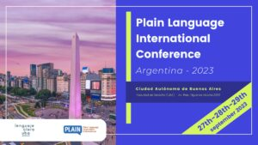](https://plainlanguagenetwork.org/plains-conference-is-going-to-argentina-in-2023/)**When**: 27-29 September 2023

**Where**: Buenos Aires, Argentina

**Includes**:

* special Clarity track on Day 1 of the conference: The Clarity Sessions.
* because it is being hosted at a law school, additional law-related sessions.

Clarity members get a discount for this conference.

Website with registration pages and further details at the [Faculty of Law, University of Buenos Aires](http://www.derecho.uba.ar/institucional/conferencia-internacional-plain-language/inscripciones.php).

# New CALC members

The following new members have joined CALC since 22 May 2023 (when the last update was published). Welcome to all!

Want to join these members? Use the [online registration form](http://www.calc.ngo/user/register).

| Name | Country |
| --- | --- |
| Vivian Njoroge | Kenya |
| Stefania Arlotto | Canada |
| Amani Mussa | Malawi |
| Clarissa Chern | Singapore |
| Moses Mwariri | Kenya |
| Hannah Starkey |  |
| Emma Anderson | United Kingdom |
| Ben Zurawel | United Kingdom |
| Alice Harrison |  |
| Diana Luft | United Kingdom |
| Nathalie Déziel | Canada |
| Ashleigh Elsworthy | Australia |
| Patrick Crocco | Canada |
| Ma'ata Laukau 'Ovava Toe'api | Tonga |
| Brian Jalonen | Canada |
| Audrey Ogutu | Kenya |
| Peter Barasa | Kenya |
| Blossom Tsiode | Nauru |
| Thau Yu Tsen | Malaysia |
| Malachai Joe | Vanuatu |
| Keneilwe Pearl Marata | Botswana |
| Anne Paskin |  |
| Siovia Florina Liu-Tea | Samoa |
| Shirley Hunt | Samoa |
| James Wigzell |  |
| Joshua Fineblit | Canada |
| Tom Simon | Vanuatu |
| Rajab Mwachia | Kenya |
| Harriett Anderson | Virgin Islands, British |
| Nikolaos Nikou | Greece |
| Sade Piper | Virgin Islands, British |
| Ryoko Skelton | Virgin Islands, British |
| Siphiwo Khoza | South Africa |
| Ugyen Lhamo | Bhutan |
| Kira Larwill | Australia |
| Alexa Reid | New Zealand |
| Huw Williams | United Kingdom |
| Natalie Diana Moore | New Zealand |
| Abigail Milburn | New Zealand |
| Ruby Iyer | New Zealand |
| Aoife Kavanagh | Ireland |
| Esther Mukami Nyaga | Kenya |
| Christine Righa | Kenya |
| Winnie Sankale | Kenya |
| Nancy Brenda Seko | Kenya |
| Cheekati Radha Krishna | India |
| Nelly Muriuki | Kenya |
| Gainilung Panmei | India |
| Jay Sikuku Buhere | Kenya |
| Judith Kanyoko | Kenya |
| Akali V Konghay | India |
| Mahesh Babu S | India |
| Alison Grant | Guernsey |
| Michael Wright |  |
| Claire Chester | United Kingdom |
| Lenny Muchangi Kabinga | Kenya |
| Patricia Gichane | Kenya |
| Khurram Mughal | Pakistan |
| Mariam Ibrahim Possi | Tanzania, United Republic of |
| Ray George | Vanuatu |
| Siau Yan Tang | Singapore |
| Matthew Bell | United Kingdom |
| Weijie Kelvin Know | Singapore |
| Caitriona Harte | Ireland |
| Ashley Jennifer Hill | Canada |
| Jess Zheng | Australia |
| Isaac Mok | Australia |
| Rebekkah Brennan | Ireland |
| Yvonne Kose Chilume | Botswana |

# Newsletter information

The Newsletter is published on an ad hoc basis by the CALC Council. It contains articles, news and other updates on anything of interest to drafters of legislation and the staff and agencies that support them. The items are written by members and friends of CALC from around the Commonwealth.

Great thank yous to everyone who contributed to this Newsletter – articles, pictures, news, suggestions, reassurance, proofreading (including for the Welsh), everything.

Do you have an item you would like included in the next edition of the Newsletter? Contact CALC’s Secretary (and Newsletter editor), Kate Hannah: [k.hannah@gov.je](mailto:k.hannah@gov.je).

You can also ask about membership, or any other CALC matter.

1. Ten years at the common law Bar in Birmingham followed by 7 years as Senior Crown Counsel in Solomon Islands and Attorney General in Tuvalu and Montserrat. Of all the work of an AG, I found legislative drafting most satisfying, and applied for a post in the Law Drafting Division in HK in 1983.
2. Some irreverent drafters from the antipodes have likened the logo to a squashed iguana…
3. In England and Wales the name of the office is Parliamentary Counsel Office. In Fiji, as in London, my title was ‘First Parliamentary Counsel’ – some people asked if there had not been one before!
4. Lord Thring, the first Parliamentary Counsel in London, said that Bills were made to pass “as razors are made to sell.”
5. The Drafting Instructions
6. Comes after 2nd reading in Westminster-type jurisdictions
7. Or Vegemite-y, if you are Australian. These products are salty intensely flavoured yeast extracts that are known for either being loved or hated (with a fair bit of bafflement thrown in). They are usually spread (sparingly) on toast…or used to make gravy (one of the treats of the Editor’s childhood).