Newsletter
of the
Commonwealth Association of Legislative Counsel
June 2015

Published in Canberra, Australia, by the Commonwealth Association of Legislative Counsel. Online at www.opc.gov.au/calc/newsletters.htm
Editor: Ross Carter, c/- Parliamentary Counsel Office, Level 12 Reserve Bank Building, No 2 The Terrace, Wellington, New Zealand.

In this issue―
CALC President’s Report: June 2015 2
Cayman Islands Drafting Office Profile 5
CALC Conference—Edinburgh, 15 – 17 April 2015 15
Belfast Workshop Report 29
Items of Interest 31
Membership 35
Secretary Contact Details 36
Minutes of CALC General Meeting on 16 April 2015 37

CALC President’s Report: June 2015

CALC Conference—Edinburgh, Scotland
As you would all be aware, the highly successful CALC Conference was held in Edinburgh during April. This was by far the largest CALC Conference ever held and has set a very high standard for other conferences to aim for.
The quality of speakers and papers was superb. Many of the papers that were delivered will be published in The Loophole over the next year or so. I would like to thank all of the speakers and all of the session chairs.
A detailed report from the Conference is in this Newsletter.
The Conference was the culmination of more than a year of planning and organisation by the CALC Council and I would like to thank all of the CALC Council members for their contribution. I would like to make particular mention of John Mark Keyes, Katy Le Roy and Fiona Leonard who had particularly large roles in relation to the Conference.
I would like to thank Mr Andy Beatty and the staff of the Parliamentary Counsel Office of Scotland for their support and assistance in staging the Conference. They did an enormous amount of work selecting and securing venues and organising the multitude of things that are required for a conference such as this. In particular, I would like to thank Madeleine MacKenzie, Fraser Gough, Annalee Murphy, Heather Wortley and Meryl Skene who have been working on this since the beginning. It was this group who selected the wonderful venues and did all of the “on the ground” work that is so necessary for a conference such as this.
I would also like to thank the staff of my office who have done a lot of the behind the scenes work in organising the Conference and in supporting the work of CALC between conferences.
I would also like to thank to guest speakers and the hosts of the various social events.
I would also like to thank our conference sponsors: Lexis Nexis, Irosoft and Lexum.
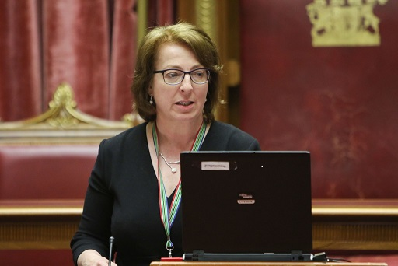
Finally, I would like to thank the many CALC members who are attended the Conference. It is the active participation of so many members that makes the CALC conferences the success that they are.

Workshop in Belfast
On the Tuesday after the CALC Conference, a CALC Workshop was held in Belfast, Northern Ireland.
The one day conference was organised by Brenda King and the Northern Ireland drafting office with support from PoliticsPlus who are a philanthropic organisation.
Brenda King – CALC Workshop in Belfast
Quite a number of delegates from the CALC Conference attended. In addition, there were other CALC members who had been unable to attend the CALC Conference.
The workshop, which was held at the very impressive Stormont, looked at the legislative system in Northern Ireland. Brenda had managed to organise a wide range of high powered speakers including a number of members of the Northern Ireland legislature.
The workshop was a fantastic addition to the CALC Conference and I want to thank Brenda and all of her staff for the work that they put in to organise the event. I would also like to thank PoliticsPlus for their support which made the workshop possible.

CALC Council
There was an election for CALC Council at the CALC General Meeting. The new Council is as follows:
Title | Name | Country
President | Peter Quiggin | Australia
Vice-President | Katy Le Roy | New Zealand
Secretary | Ross Carter | New Zealand
Treasurer | John Mark Keyes | Canada
Council member (Africa) | Jacques Wolmarans | South Africa
Council member (Africa) | Estelle Appiah | Ghana
Council member (Americas) | Philippe Hallée | Canada
Council member (Americas) | Bethea Christian | Cayman Islands
Council member (Asia) | Therese Perera | Sri Lanka
Council member (Asia) | Lawrence Peng | Hong Kong
Council member (Europe) | Adrian Hogarth | United Kingdom
Council member (Europe) | Brenda King | Northern Ireland
Council member (Pacific) | Don Colaguiri | Australia
Council member (Pacific) | Theresa Johnson | Australia

As you will see there is a mixture of returning Council members and new members.
I would like to thank all Council members for their active participation in Council matters over the last 2 years and particularly acknowledge those who are retiring from the Council at this conference.
I would also like to welcome the new CALC Council and congratulate them on their election to the various positions. I look forward to working with all of you over the next 2 years.
The CALC Council has already commenced work on a number of matters that were discussed at the CALC General Meeting.

Missing CALC members
We have quite a few CALC members for whom we no longer have a current email address. If you know a CALC member who is not getting our emails, please ask them to contact calc@opc.gov.au to update their membership details.
We have also circulated a list of those members so that other members can provide any information that they have. We do not intend to use this process to terminate any members under section 7A of the CALC Constitution. It is just a process to try and find as many members as possible.

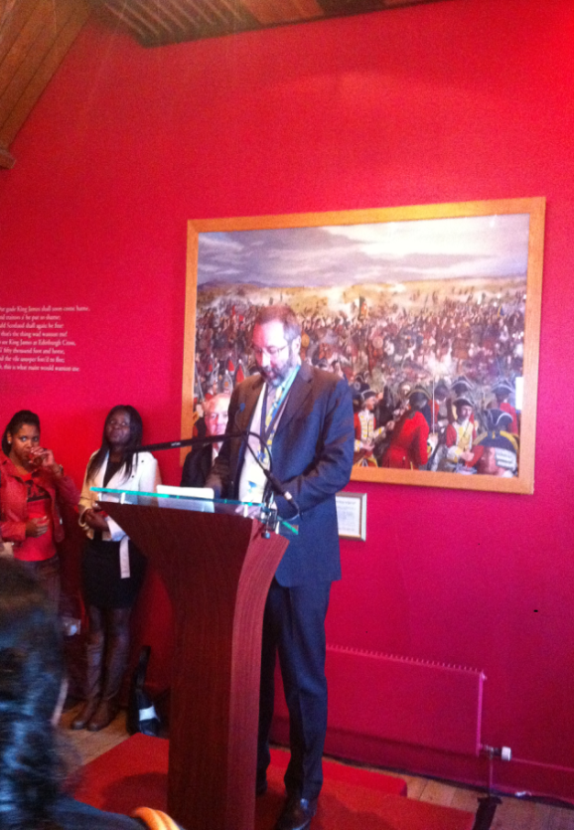
Peter Quiggin PSM,
CALC President,
June 2015

Peter Quiggin, CALC President
Edinburgh Castle, 15 April 2015

Cayman Islands Drafting Office Profile

The Cayman Islands – location and geography

The Cayman Islands – Grand Cayman, Cayman Brac, and Little Cayman –are a British Overseas Territory located in the western Caribbean. They are approximately 460 miles south of Miami, Florida, USA. Their closest Caribbean neighbours include Cuba and Jamaica, with the Islands lying 149 miles south of Cuba, and 167 miles northwest of Jamaica.
The Cayman Islands have relatively flat terrain. The offshore reefs are the main source of protection for the coastline, other than the mangrove fringe (which sometimes extends into inland swamps). However, with Cayman forming part of the Cayman Ridge (which extends westward from Cuba), you will find more diverse terrain underwater, in particular, in places like the Cayman Trench, which, at over four miles deep, is the deepest part of the Caribbean, and separates the Cayman Islands from Jamaica.

Grand Cayman
Grand Cayman

The largest of the three islands is Grand Cayman, which is about 22 miles long and 8 miles wide, with an area of about 76 square miles. The capital, George Town, is located on the western shore of Grand Cayman, where one can often see the cruise ships dock while driving through ‘town’ across the ‘harbour front’. Grand Cayman is generally low-lying; the highest point on the island is approximately 60 feet above sea level.

In addition to the world-famous Seven Mile Beach (recently voted the best beach in the world), one of Grand Cayman’s most-striking features, is the shallow, reef-protected lagoon, the North Sound, which is approximately 35 square miles and boasts the world-famous “Stingray City”.

Stingray City – Grand Cayman Seven Mile Beach - Grand Cayman

Cayman Brac
Cayman Brac

The second largest island of the three, Cayman Brac, is about 12 miles long and 1.25 miles wide, giving it an area of about 15 square miles. It is located 89 miles north-east of Grand Cayman, which is only a 30 minute plane flight away from there. The terrain in Cayman Brac is probably the most spectacular of the three islands as it boasts a massive central limestone outcrop that rises steadily along the length of the island up to 140 feet above sea level at the eastern end, known as “the Bluff”.

Little Cayman
Little Cayman

Last, but certainly not least, is the smallest island, Little Cayman. Located 5 miles west of Cayman Brac, it is only ten miles long and about 1 mile wide, with an area of about 10 square miles. Its terrain is mainly low-lying but there are a few areas on the north shore which rise to about 40 feet above sea level.

Westminster-style parliamentary democracy
The Cayman Islands operate under a Westminster-style parliamentary democracy with a tripartite system, including the judiciary, the legislature, and the executive branches of government, along with a UK-appointed Governor.

The Governor and Deputy Governor
The Islands are not entirely self-governing, and have a Governor, who is appointed by Her Majesty the Queen, as her representative in the Islands, with each appointment lasting for a period of four years, coinciding with the election cycle. The current Governor, Her Excellency, Ms. Helen Kilpatrick, is the Islands’ first female Governor. The Governor’s Office, which forms part of the Foreign and Commonwealth Office's global network, is responsible for the security and good governance of the Cayman Islands.

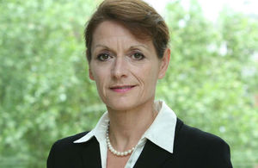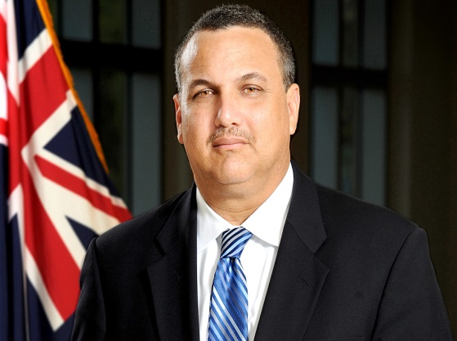
Governor Helen Kilpatrick, CB Franz Manderson, CERT HON. JP.
Governor’s Office Deputy Governor and Head of the Civil Service

The Governor is aided by the Deputy Governor, who acts as Governor in her absence. The Deputy Governor is Head of the Civil Service, and is a non-voting member of Cabinet and the Legislative Assembly. The Office of the Deputy Governor is responsible for leadership of the Civil Service, Public Sector Reform, citizenship, legislative matters, archives, and providing administrative support to the Parole and Prisons' Inspection Board and the Advisory Committee for the Prerogative of Mercy.

The Judiciary
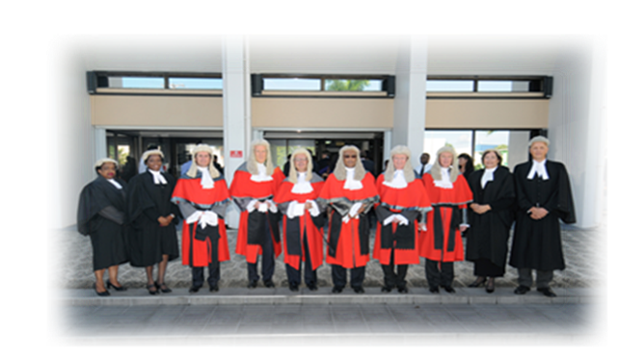
Judges and Magistrates of the Cayman Islands Grand Courts and Summary Courts

The judiciary is one of the three separate arms of Government, whose function is to administer the law fairly, efficiently, in the interests of justice, and independently of the Executive and Legislative branches. The Judges of the Grand Court also provide international legal assistance pursuant to treaties such as the Legal Assistance Treaty with the United States of America. The Judiciary is comprised of the following jurisdictions in ascending order within the hierarchy of the courts: THE SUMMARY COURT, which hears civil and criminal matters (and includes Family, Youth and Coroner’s Courts) and THE GRAND COURT, which hears applications for judicial review, cases on criminal, civil, family, and estate matters, and appeals from the Summary Courts. In addition to the general Civil and Criminal Divisions, The Grand Court has three specialist Divisions: the Admiralty Division, the Family Division, and the Financial Services Division. In addition, there is the COURT OF APPEAL, the Highest Court in the Cayman Islands, in which civil and criminal appeals from the Grand and Summary Courts can be heard; and the PRIVY COUNCIL, the highest Court, and which can hear and determine an appeal from the Court of Appeal.

The Legislature
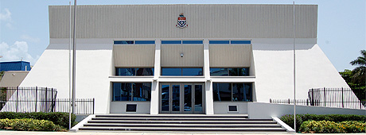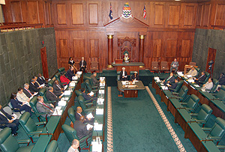
The Cayman Islands Legislative Assembly (“the LA”) The House in Session (in the LA)

The Legislature is unicameral and comprises the Governor, two Ex-Officio Members (the Deputy Governor and the Attorney General) appointed by the Governor, and eighteen democratically-elected members, known as Members of the Legislative Assembly (“MLAs”) for the Islands' six districts. There are six elected members from George Town, four from West Bay, four from Bodden Town, two from Cayman Brac and Little Cayman, and one each from North Side and East End. The Speaker of the Legislative Assembly, or “Speaker of the House”, who may be chosen from outside the LA, or from the eighteen MLA’s, presides over the proceedings of the Legislative Assembly.
The Governor may, at any time, by Proclamation, prorogue or dissolve the Assembly. However, the Governor must dissolve the Assembly four years after its first meeting following a general election, unless it has been dissolved sooner, and a general election must be held within two months after the dissolution of the Assembly, at a time appointed by the Governor, by Proclamation. The Governor also appoints, by Proclamation, the day on which the first meeting of every session of the House shall be held. A session usually consists of four meetings. A meeting comprises several sittings.

The Executive – The Cabinet
A change brought about by the new Cayman Islands Constitution in 2009, which came into effect on 6 November, 2009, is that the Premier, instead of the Governor, now heads up Cabinet meetings. The Cabinet is comprised of seven appointed Ministers of Cabinet, the Governor, the Deputy Governor (Head of the Civil Service), the Attorney General (Government’s principal Legal Advisor and Head of the Portfolio of Legal Affairs), and the Cabinet Secretary.
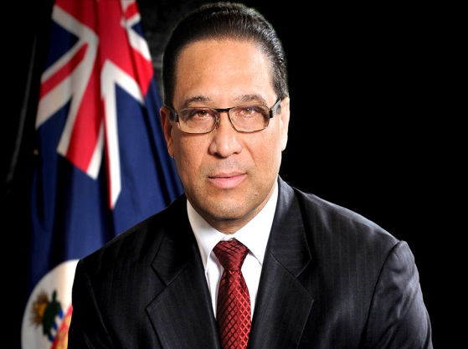
The Premier, Hon Alden M McLaughlin Jr. MBE JP MLA
Ministry of Home Affairs, Health & Culture

The Premier of the Cayman Islands is the political leader and head of Government and is appointed by the Governor in accordance with the Cayman Islands Constitution, 2009. The 2009 Cayman Islands Constitution caused additional devolution of power from the Governor to the Executive, and the Executive now has greater responsibility for some matters relating to external affairs, formal negotiations, international agreements, and local political declarations that affect foreign policy.

The Cayman Islands Constitution
After an extensive period of discussion and negotiations, and following the first local Referendum, the new Cayman Islands Constitution was approved by Her Majesty Queen Elizabeth II in the Privy Council on 10 June, 2009 and came into force, in part, on 6 November, 2009 (because the Bill of Rights came into force three years later).
The Cayman Islands Constitution, 2009, is the fourth and latest constitution of the Cayman Islands, and contains, for the first time, a Preamble, which reflects the identity of the Caymanian people and recites Cayman’s unique culture, Christian heritage, and the fact that the society is based on certain moral, spiritual, social, and democratic values that have guided its development and brought peace, prosperity, and stability to the Islands.
The Cayman Islands Constitution, 2009 also comprises Cayman’s first Bill of Rights, which came into force on 6 November, 2012, three years after the 2009 Constitution came into force, and closely mirrors the European Convention on Human Rights. However, in addition to most rights found under the ECHR, a notable addition, in the Cayman Islands constitutionally-entrenched Bill of Rights, is the Right to the Protection of the Environment.

Protection of the Environment
The Caymanian people will have the right to the protection and preservation of the environment. The Government is obligated to implement legislation and other measures to protect Cayman’s heritage, wildlife, and land and sea biodiversity; prevent pollution and ecological degradation; promote biodiversity; and secure ecologically sustainable development and use of natural resources.
When making human rights judgments, Cayman courts must consider European Court case law. However, local courts would also be required to interpret some Rights using the principle of a “margin of appreciation,” which means that a government may lawfully infringe human rights if that is justified, serves a legitimate aim, and is a proportionate response to that aim.
If the judiciary finds a law to be, in part or as a whole, incompatible with the Bill of Rights, then a Declaration of Incompatibility may be made. However, it is left to the legislature to remedy it by amending the offending law or provision that is contrary to the Bill of Rights. The Attorney General is responsible for advising the Cabinet and Legislature in respect of the compatibility of any proposed legislation with the constitutionally- entrenched Bill of Rights.

Institutions supporting democracy
Part 8 (sections 116 – 122) of the Constitution sets out the new and existing offices and initiatives that the Constitution empowers to act as a check and balance on the power of the executive and administrative arms of Government. For example, the primary responsibility of the Human Rights Commission (established under section 116 of the Constitution, and which replaces the previous, Human Rights Committee) is to promote understanding and observance of human rights in the Cayman Islands. Therefore, its role would include bringing to the awareness of the Government, where necessary, any legislation, process, or procedure which may not accord with the various rights under the Bill of Rights, or an international human rights convention or treaty, in respect of which the Cayman Islands is not in compliance, where non-compliance has not been justified.
Under the 2009 Constitution, the Freedom of Information (FOI) Office, although an agency which existed prior to the 2009 Constitution, is now constitutionally enshrined, while the independence and political neutrality of the post of Complaints Commissioner has been secured. New agencies supporting democracy also include the Constitutional Commission (CC), Human Rights Commission (HRC) (as noted above), the Commission for Standards in Public Life (CSPL), and the Advisory District Councils (ADC).

The Portfolio of Legal Affairs - Legislative Drafting Department

Hon Samuel Bulgin, QC, JP
Attorney General
Ex-Officio Member Responsible for Legal Affairs

The Honourable Samuel Bulgin, QC, JP, Attorney General and Head of the Portfolio of Legal Affairs, is an ex-officio member of the Legislative Assembly and an official member of Cabinet. The Portfolio of Legal Affairs advises the Government (and its affiliated bodies, statutory boards, and corporations) on all legal matters. The portfolio includes responsibility for: The Attorney General’s Chambers; The Office of the Solicitor General; The Law Reform Commission; The Law Revision Commissioner; The Legislative Drafting Department; The Cayman Islands Law School (now called the Truman Bodden Law School and affiliated with the University of Liverpool, from which the LLB (Hons.) degree is conferred); and the Financial Reporting Authority. The Mission Statement of the Portfolio of Legal Affairs can be found on the Portfolio’s website.

The Legislative Drafting Department
The Legislative Drafting Department has an integral role in the Portfolio of Legal Affairs, and its primary duties include: drafting primary legislation; drafting subordinate legislation (which includes regulations and orders, directions and rules); and advising on proposals for legislation, statutory interpretation, and some constitutional matters. Various other aspects of the Department’s role are set out in the document entitled ‘The Role of the Legislative Drafting Department’. That document is available here.

The Staff
The Cayman Islands First Legislative Counsel is accountable to the Attorney General for providing an efficient legislative drafting service, including related legislative advice for the Islands. The First Legislative Counsel heads up the Legislative Drafting Department, and is supported by two Senior Legislative Counsel and three Legislative Counsel, who assist her with the drafting of primary and secondary legislation and the provision of legal advice to the Government. The Department is also aided by one Administrative Secretary.

Drafting – Legislative process
The Cabinet has to approve policy proposals before any legislation is drafted, and any subsequent drafts of legislation must also be approved by Cabinet. However, drafts of primary legislation, i.e. Bills, which are approved by Cabinet and published in the official Cayman Islands Gazette as Green Bills, must be laid in the Legislative Assembly for three Readings and a final vote by the voting Members of the Legislative Assembly.
The Cayman Islands Legislative Assembly has full power to make Laws (primary legislation), subject only to the Governor’s Assent (as the power of disallowance may be exercised). Once a Bill is passed by the Legislative Assembly and assented to by the Governor, making it Law, it must be published in the official Cayman Islands Gazette (which is available in print and electronically, on the Cayman Islands Gazettes website).
A law will not always automatically come into force after it is published in the Gazette because a law may contain a commencement provision which sets a specific date, or a time following the happening of a particular act or event, on which the law, or a part, or parts of it, will come into force. A Commencement Order specifying the date upon which the law, or a specified part, or parts of it, will come into force, is published in the official Cayman Islands Gazette.
However, Cabinet has the power to make secondary legislation (such as Regulations) which, once made by Cabinet, must also be gazetted in the Cayman Islands Gazette, before it comes into force.

Language in which drafting is done
While the Islands boast residents from over 100 different nationalities, English remains the only official language, and the only language in which legislation is drafted.

How drafters are trained
Drafters are Government lawyers, called Legislative Counsel. Before being appointed, they will usually have received formal training in Legislative Drafting and possess a Diploma or LLM in Legislative Drafting in addition to having some experience drafting primary and secondary legislation.

Drafting tools used
Legislative Counsel use a model template for Legislative Drafting. However, changes are being made to update the drafting template.

Involvement, if any, in publishing and consolidating law
Legislation is published by Government Information Services (“GIS”), which is responsible for publishing primary and secondary legislation and legislative instruments, in Government Gazettes, which are available online. GIS does not fall under the Legislative Drafting Department, but is a separate government department. Legislation is also published by the Judicial and Legal Information website (jointly-sponsored by the Judicial Administration and the Portfolio of Legal Affairs): https://www.judicial.ky/.
Cayman Islands Laws are generally consolidated on an annual basis by the Law Revision Commissioner, and are also made available on the Cayman Islands Gazettes website: http://www.gazettes.gov.ky.

Interaction with CALC and other drafters
The Legislative Drafting Department in the Cayman Islands is still in the process of building local capacity. As such, there are many foreign Legislative Counsel. The Legislative Drafting Department employs drafters from countries such as Guyana, Trinidad and Tobago, Barbados, and Jamaica. In the past, there have been drafters from the United Kingdom, Botswana, Zambia, and St. Lucia. Legislative Counsel in the Cayman Islands Legislative Drafting Department have generally been trained in Canada, the Caribbean (mainly the University of the West Indies), or the UK (most notably the IALS in London).

Bethea Christian
Legislative Counsel

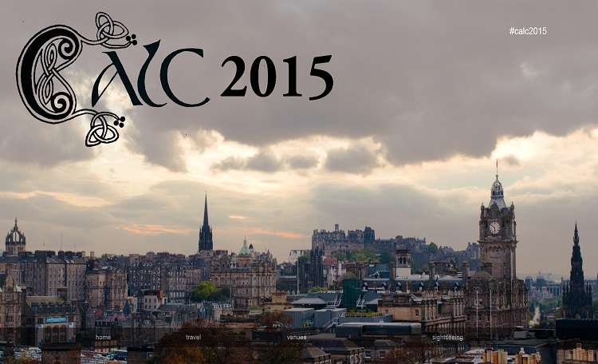

CALC Conference—Edinburgh, 15 – 17 April 2015
Who on earth would want to go to a conference in Edinburgh in mid-April ???
Drafters.
Lots of drafters.
In fact so many drafters (200+) that the books had to be closed well before the Conference started (a first for a CALC conference).

So who came?
While not quite 200 registrants managed to get to Edinburgh, it wasn’t far short of that. Those who did make it came from a very wide range of countries and jurisdictions: at least 48 jurisdictions in 36 countries. Jurisdictions ranged in population size from the Canadian territories of Nunavut and the Yukon (the latter has a population of about 36,000, the former even less) to Nigeria (174+ million); and in geographical size from Gibraltar and the Falkland Islands to Australia and Canada. 14 African countries were represented, as were 6 non-Commonwealth countries. Australia had representatives from 8 of its 9 jurisdictions (even Tasmania, the Northern Territory and the A.C.T. !!).
As with previous Conferences there was also a refreshing range of people from fairly wet-behind-the-ears drafters to Office heads, to the superannuated, and everything in between. In addition to drafters there were academics and others for whom drafting is relevant. We also had perpetual conference-attendees (with Messrs. Berry and Moloney meriting particular mention) mingling with first-time attendees. The fact that the UK was in the middle of an election campaign meant that many English drafters were able to attend, and of course the host Office was also very well represented.

Venues
What will probably be remembered about this Conference long after anything that was said at it is forgotten was the venues at which the Conference was held (see the photographs and details at the special Conference webpage: www.calc2015.tk/index.htm). First there was Edinburgh itself. All of the Conference venues were in the Old Town, which together with the neighbouring New Town constitutes a World Heritage listed area. Just being in this area is a noteworthy experience: history combines with aesthetics combines with culture combines with Scottishness to create a feeling that cannot properly be described (by the likes of me, in any event).
But the Conference organisers took this a step further by providing probably the pick of the buildings in the Old Town as Conference venues. The Conference itself was held in the Playfair Library Hall at the Old College of Edinburgh University. Not only is the Library Hall across the road from one building where J.K. Rowling wrote the early chapters of her first Harry Potter novel, and another building that was a pub where J.M. Barrie, Arthur Conan Doyle and Robert Louis Stevenson used to hang out, but it is also a bit of stunning architecture and workmanship that has seen its fair share of legal luminaries.

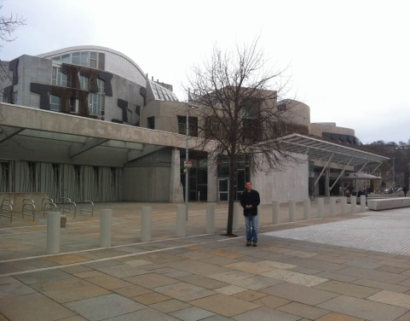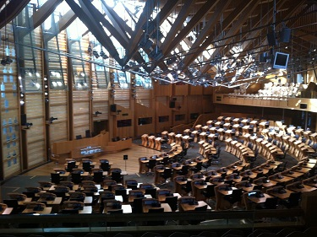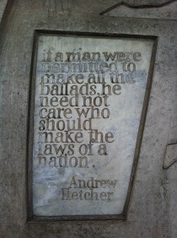
Scottish Parliament

First night drinks were in a large room in Edinburgh Castle with a stunning view; 2nd night drinks were at an amazing space in the Scottish Parliament, which shows that the new can work quite well in the old once it actually gets built; and the Conference dinner on the 3rd night was held in a room that managed the amazing feat of being even more spectacular than the Playfair Library: the Signet Library.
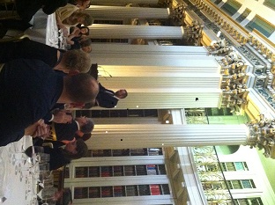
Signet Library – Conference dinner (Peter Quiggin introducing Lord Hodge SCJ)

Day 1
Opening remarks and 1st Session keynote address
The Conference was opened by its host, Andy Beattie, Scotland’s Chief Parliamentary Counsel, who graciously welcomed us all. Andy exhibited considerable courage in appearing, as he was still suffering fairly significantly from the consequences of being a cyclist. Andy was followed by Peter Quiggin, long-serving and suffering (?) CALC President, who also welcomed us to the Conference.
The 1st Session then kicked off. This was a keynote speech from the Right Honourable Lady Dorrian, Senator of Scotland’s College of Justice (a Judge of the Inner House (primarily the appeal court) of the Court of Session, Scotland’s highest civil court). Lady Dorrian reminded us of some of the luminaries who were commemorated in the Library Hall, and generally made remarks complimentary to drafters and their task.
2nd session – Multiple roles of legislative counsel
Lady Dorrian was immediately followed by the 2nd session. Alex Gordon from the Scottish Office gave us a run down on Scotland’s legislative history. Unfortunately this defies a brief outline, as it is quite convoluted, to say the least, and goes back a very long time.
As we listened to Alex, those of us from afar had no idea that we were listening to the closest thing that there is to an indestructible drafter. By the end of the Conference we knew that Alex could eat and drink continuously, that he needed no sleep, and that it was safe to go with him into anywhere in Edinburgh at any time, and that he had an encyclopaedic knowledge of when places of refreshment were open.
After the Conference we further learned that Alex is a poet, although perhaps not yet ready to be ranked with Burns (but then, who is ?). Alex’s balladic description of the Conference (“Ode to CALC”) can be found on the Conference section of the CALC website, and better summarises in 12 neat verses what I am struggling to convey in as many pages.
Alex was followed by Brenda King, First Legislative Counsel for Northern Ireland. She fortunately confined herself to describing the multiple roles of legislative counsel in Northern Ireland, and further confined herself to the traditional roles that apply fairly universally to drafters. I say fortunately, because it was only when those of us who went to Northern Ireland the following week got there that we discovered that “convoluted” doesn’t even begin to describe the political and legislative situation that applies there, and what drafters there have to cope with.
It was clear from Brenda’s talk in Edinburgh that legislative counsel in Northern Ireland need to be able to be comfortable travelling in small boats, and she had the photos to prove it!
Dylan Hughes, First Legislative Counsel to the Welsh Government, was listed as the second speaker for the session. Before speaking he gave us a demonstration of the perils of attempting to do same-day commutes in the UK. Thanks to the weather with which the UK is blessed, apparently this is a highly stressful activity. Fog in Cardiff resulted in Dylan arriving in our midst at the start of the 3rd session.
When he was finally able to speak Dylan outlined the legislative history of Wales disguised as a talk on the multiple roles of drafters in Wales. If we thought Scotland’s history was involved, it wasn’t a patch on that of Wales. Among the claims that Dylan made were that at one time in the distant past Wales apparently controlled the area on which Edinburgh stands, and that the name ‘Edinburgh’ comes from Welsh. For good measure Dylan also pretty much laid a claim for Wales founding the plain language movement some considerable time before the 20th century.
Speakers’ slides, and underlying papers, are available to conference attendees via the CALC website. The papers will also be available via forthcoming editions of CALC’s journal The Loophole.
Morning tea
In fact we had morning tea before Dylan spoke, but I thought it best to keep things together as much as possible. In keeping with that spirit, although my natural tendency would be to mention each break and to discuss the merits of each offering at that break, I will simply say that our hosts provided us over the course of the Conference with a superb selection of local cakes, slices, biscuits and the like in the morning and afternoon tea breaks, and an equally superb selection of pretty much anything one could imagine wanting for lunch at the lunch breaks. Everything was of the highest quality.
3rd session – Government context for legislative drafting
Rebecca Considine of the Australian Office of Parliamentary Counsel started this session by describing the systems her Office has in place to attempt to ensure that all government departments that might wish to have a say on a draft bill in fact get that chance before the bill reaches its final stages. This system is designed to try to prevent last minute obstacles arising in the bill-drafting process, and it appears to be working quite well according to Rebecca.
Siti Rahmah Mohammad of the Attorney-General’s Chambers, Brunei Darussalam then told us how her Office, which is responsible for the drafting of laws in Brunei Darussalam, manages the often unreasonable expectations of its clients. The Office has had considerable success in reducing unreasonable expectations by educating its clients in various ways about the Brunei Darussalam legislative process. Siti mentioned 3 things that were of particular interest:
- there is no formal legislative programme in Brunei Darussalam, which can create a bit of tension in determining what gets done when
- the Office has unbelievable patience: it has a process of sending follow up letters if instructors have been inactive on a draft bill for a few months – the bill file is closed if there is no response after the first 7 follow ups
- the pace of drafting life in Brunei Darussalam is somewhat different to that in many other jurisdictions – the Office has a key performance indicator that requires that there be a response to drafting instructions within 6 months after the instructions are received.
4th session – Roles of legislative counsel outside drafting offices
Adrian Hogarth, the senior parliamentary counsel at the Law Commission of England and Wales, began this session by describing how the Commission operates, particularly in regard to the drafting of bills relating to its proposed reforms, and how those bills then become law, or not, as the case may be. Gregor Clark, the counsel at the Scottish Law Commission, then gave similar details in relation to his Commission. Both speakers made it clear that while the drafting environment at the Commissions differs somewhat from the environment of a ‘normal’ drafting office, they both enjoyed working at their respective Commissions.
Elizabeth Bakibinga-Gaswaga, the Legal Adviser to the Commonwealth Secretariat, had then intended to give a presentation on “Shaping global governance through law – the role of legislative counsel within the UN Secretariat” but was unfortunately unable to do so. However, she prepared detailed slides to accompany her presentation, and these were available to conference attendees.

5th session – The effect of the judiciary on the statute book
Daniel Lovric of the Australian Office of Parliamentary Counsel then presented a paper that started by asking whether drafters construct laws in the same way that judges interpret them. The answer given was: “in most cases, yes”. Daniel then went on to look, at great depth, at the exceptional cases. His conclusion was that drafters may be able to pre-empt problems with judicial interpretation in future if they do more to make visible, and to publicise, their working methods.
Daniel Greenberg, formerly of the UK Drafting Office, and now a consultant Parliamentary Counsel, finished the session with a powerful presentation on the judicial rectification of drafters’ mistakes. As Daniel himself mentioned, no one at one of his presentations has ever had to ask him to speak more loudly. Daniel suggested that the incidence of judicial rectification of English laws is increasing, as are the number of obvious mistakes in those laws. He did not think that either of these occurrences was desirable for a number of reasons: in particular, unnecessary judicial rectification was white-anting democracy by making the law harder to find and understand.
Daniel also described a number of ways in which executive government in the UK is usurping the functions of judges. In particular he expressed his dislike of what he termed “gesture-politics legislation”, which are essentially laws that appear to impose rights or obligations, but which are then immediately qualified so as to render the right or obligation nugatory. Daniel finished by putting forward his ideas as to how the concerns he raised might be made to disappear. These might be very crudely summarised as: more resources for drafters and less reliance on manuals.

Day 2
6th session – Drafting training
This was a one man session. Douglass Bellis, Senior Counsel in the Office of the Legislative Counsel, United States House of Representatives (and frequent CALC conference attender), addressed the question of whether legislative drafting can be taught at university. He immediately ended the suspense engendered by the question by answering it “no”, but with the qualification that one “can go rather far” in preparing prospective drafters for the job by academic means alone. His response was based on his own experience of teaching a drafting course at the George Washington University. He described at length how he runs the course and what he covers.
7th session – Challenges of small jurisdictions
This was also a one man session. In a recent office clean-up, Howard Connell of the Isle of Man Legislative Drafting Division had come across a paper delivered in 1990 by William Cain Q.C., the then Attorney-General for the Isle of Man, on the difficulties encountered in drafting in a small jurisdiction like the Isle of Man. Howard thought it might be useful to follow up on the issues raised in this paper to see if things had changed over the past 25 years. In essence, Howard was of the opinion that things had improved considerably. Various training programs that the Division now runs had resulted in a significant improvement in the quality of instructions that Isle of Man drafters now receive. The Division has also been able to attract adequate numbers of competent staff for quite some time now.
8th session – Towards an effective statute book: drafting tools and devices
The final session for the day saw 4 speakers.
Louise Finucane of the Australian Office of Parliamentary Counsel started things off by describing a technique being used in her Office in relation to the placement of definitions. Essentially, the technique involves placing definitions so that they fall within the natural flow of the provisions that they apply to. In the past there were instances where definitions were placed in a way that sent readers back and forth through a Bill. While there are limits on how much natural flow can occur, Louise gave examples that showed that the technique effected a great improvement in particular instances.
I might mention that in my subsequent conversations with those at the Conference, Louise’s talk probably had the greatest resonance of all the talks given. There appears to be a great appetite among drafters to discuss nuts and bolts drafting issues at Conferences such as these.
Next followed the double act of John Mark Keyes, former Chief Legislative Counsel of Canada, and now an adjunct professor at the University of Ottawa, and Dale Dewhurst, an associate professor at Athabasca University. They spoke to a joint paper, although Dale let John Mark do most of the talking.
Their talk and paper was concerned with the distinction between what is a policy matter, and thus essentially in the domain of the instructor, and what is a technical legal or drafting matter, and thus essentially in the domain of the drafter. This distinction was explored in the particular context of the preliminary and final provisions of a bill. The distinction is of importance, as if drafters mistakenly deal with matters that are really policy matters they are subverting the proper democratic processes that should apply to those matters.
John Mark suggested that the dividing line between what is policy and what is technical was not static. He gave as an example the title of Bills, which previously was a matter which had been left entirely to drafters, but which now often had, or was given, a political element and thus became a policy issue.
Towards the end of the presentation it was suggested that legislative drafting as a discipline might benefit from “wider discussion of its more technical aspects”, echoing a suggestion made by Daniel Lovric on Day 1.
Dale finished the presentation by outlining a mechanism Athabasca University has established to facilitate discussion on drafting practices.
The final speaker of the session was Adam Bushby, of the Office of the Chief Parliamentary Counsel, Victoria, Australia. He described the formalisation in 2011 in Victoria of a process for dealing with legislative instruments. While the relevant law under which the process was set up does not define ”legislative instrument” substantively, they are essentially instruments that are legislative, rather than administrative, in character, and that are made in a less formal way than subordinate laws. The Victorian scheme essentially provides a more transparent process for the making and finding of these instruments.
CALC General Meeting
The rest of Day 2 was devoted to a CALC General Meeting. I’m not sure that a blow by blow description of this would be of particular interest here, but I will make 2 observations:
- Given that a number of constitutional amendments were put up, there was surprisingly little blood on the floor at the end of the meeting, which can only be a good thing.
- It is clear that the CALC Council will soon have to take on significant new responsibilities. The financial report presented to the Meeting makes it clear that CALC is going to have significant cash surpluses well into the future owing to funds generated by charging for job advertisements sent to the CALC membership. The surpluses will be in amounts that cannot be ignored. Stay tuned. [Editor’s note: See, on this topic, the General Meeting minutes.]

Day 3
9th session – Legislative counsel – contributing to democratic government?
Teri Cherkewich, Legislative Counsel for the government of Yukon, in the guise of presenting a paper on the role of drafters in advancing and protecting democracy, actually presented an extended advertisement for Yukon, home of cute mooses and the like (with lots of photos). In fact the bulk of her presentation examined the issue of what drafters should do when presented with “underdeveloped” instructions. The presentation was based on Teri’s experience in working for a “small maturing government”. Teri deftly explored the tension for drafters in, on the one hand, wanting to help by making sure that an effective law got made, and on the other hand in meddling with issues that are best dealt with by proper democratic processes. As suggested by the title of her paper, Teri was of the view that there was no global approach that could be taken – when these issues arose they were best handled “one word at a time”.
Teri was followed by Ronan Cormacain, now a consultant legislative drafter. Ronan’s topic was “Role of the drafter: servant or master?” He started by outlining some of the difficulties drafters can face during the course of drafting, and made suggestions as to how to make the drafting process smoother. If a drafter is asked to draft a provision that the drafter thinks is inadvisable, Ronan suggested that it was best to avoid or delay the drafting of the provision for as long as possible. Once the drafter’s feet were put to the fire, Ronan suggested that the provision should be drafted in a way that made the problem with it as obvious as possible.
Early in his talk Ronan presented a slide that showed that he had a keen appreciation of where consultants, and Chief Parliamentary Counsel, respectively, sat on the master-servant spectrum.
10th session – Gender issues in the legislative context
This session saw discussion on what are arguably policy issues, but in my opinion it was one of the most valuable of the sessions we had, as in addition to the very interesting content of the presentations, it behoves drafters to remain aware of the processes by which laws are made, and the fact that laws cannot, of and by themselves, even hope to effect social change. That applies with bells on if a law has no effective enforcement mechanisms.
Estelle Appiah, former director of the Legislative Drafting Division of the Attorney-General’s Department of the Ministry of Justice, Ghana, and now a legislative drafting consultant, was the first speaker. She described the background behind the drafting of the Affirmative Action Bill in Ghana. Essentially the Bill is an attempt to ensure that Ghana complies with its international obligations in relation to human rights generally, and the UN Convention on the Elimination of All Forms of Discrimination against Women specifically. The specific obligation crystallised in 1998. The Bill was introduced into Parliament in 2013, and still remains a Bill.
Estelle outlined a number of concerns that she has about the Bill, and explained why some things in it are the way that they are. Of particular interest is how the Bill intends to operate with respect to the obligations that it imposes on the private sector. Although some penalties are provided for non-compliance, the intention is that the prime compliance factor will be a scheme of tax incentives that will be available to complying employers.
Estelle was essentially pessimistic on how effectively the Bill would and could be implemented. As she noted, effective implementation would depend on considerable effort on the part of many people and bodies.
Estelle’s presentation also raises the interesting question of why there are aren’t more affirmative action laws in place around the world. The obligations that apply to Ghana also apply to many other countries, and the position of women in Ghana in terms of their participation in particular activities in society is no worse than the position of women in many other countries, including G20 countries.
Estelle was followed by Tsitsi Chitsiku, Director: Intergovernmental and Fiscal Legislation in the National Treasury, South Africa. Tsitsi described to us another 2013 Bill: the Women Empowerment and Gender Equality Bill that has been introduced into the South African Parliament. She noted that this was not the first South African law on the subject of gender equality. In fact she recited quite an imposing list of laws that already exist on the subject in South Africa. This led her to the natural question: Is it the quantity of legislation that matters or does it take more than legislation to eliminate discrimination against women ?
Tsitsi noted that unhelpful attitudes and systematic behaviours have continued in South Africa despite all the laws on gender equality that have been passed. She gave us a number of anecdotes, some of her personal experiences, to illustrate these attitudes and behaviours. This led to further natural questions: do we need more laws or better enforcement ?; can gender equality be achieved by legislation ? Tsitsi also noted that a number of existing South African laws did not have any enforcement mechanisms that were remotely adequate. In fact the 2013 Bill specifically states that it imposes no new obligations in relation to gender discrimination itself, it only aims to strengthen existing legislation.

11th session – What is needed for an effective statute book ? Issues of design and accessibility
Ross Carter began this session by describing steps New Zealand is taking to revise its statute book. He began by noting that laws can be, or become, inaccessible, and that it is highly desirable to keep this issue of accessibility under constant review. After discussing ways in which laws can be revised, he then described the way New Zealand is going to revise its laws over the next few years.
The Legislation Act 2012 of New Zealand sets out a process for the systematic review of New Zealand’s laws over 3 year cycles. The process allows an existing law to have its title changed; to have new provisions added to aid accessibility and readability; to have its intent clarified; and to have monetary amounts specified in it to be updated. Consequential amendments to other laws are also allowed. In all other respects the revision process may not change the effect of a law. Once a law is revised, the draft revised law is submitted to certifiers. If the certifiers certify that the draft makes no unauthorised change to the existing law, the draft law is sent to Parliament. The Parliament has revised its Standing Orders to provide an expedited process for the passage of the draft law.
The first 3 year cycle will begin this year. The laws to be revised have already been selected.
Ross outlined 4 significant risks in this process (lack of resources, “un-co-ordination” with proposed new laws, lack of parliamentary time, and unintended consequences), but he was confident that these could be successfully managed. He was therefore confident that the process holds great promise that the laws of New Zealand can be made easier to understand, and thus to remain relevant.
John Sheridan, Head of Legislation Services at the National Archives, UK, then gave a talk on using data to understand how the statute book works. New technology that was almost inconceivable even a few years back means that all of the laws of a jurisdiction can be put into a database that can be readily and speedily interrogated in relation to all sorts of issues. John presented an interesting example that showed how the use of “shall” in UK laws had declined to the point of vanishing.
John is currently engaged in a project that is attempting to detect patterns in sets of provisions. Once these patterns are found and understood they may make drafting easier. John concluded that the surface of what could be done with legislative databases had barely been scratched, and there was an exciting future ahead in this area.
12th session – Case studies in working towards greater accessibility
Audrey Lim, Deputy Chief Legislative Counsel of the Legislative Drafting Division (Attorney-General’s Chambers) of Singapore started this session by describing Singapore’s PLUS Project. The acronym is short for “Plain Laws Understandable by Singaporeans (and the rest of the world)”. The project is a very considerable undertaking that will see Singapore’s laws modernised in their content and style, and by ensuring that they are all electronically available. With respect to the content and style of the laws, the Division conducted a public survey in late 2013 that sought public input on a whole range of drafting and stylistic issues. The responses to the survey have been used to inform the changes that will be made by the PLUS Project.
The Project is about to enter a 6 year phase that will see Singaporean law improved through the use of plain language, simplified text and shorter sentences. Ultimately the Project will see the revision of every Singaporean law.
Audrey was followed by Hayley Rogers, a legislative drafter at the Office of the Parliamentary Counsel in London, and John Sheridan. They described the Office’s Good Law initiative, which is essentially a project to ensure that the laws that the Office produces are good laws. Hayley’s vision for a good law is a law that is accessible, both physically and in the sense of being able to be understood by those that it affects. This involves looking at the needs of readers of laws, which then in turn raises questions of who the readers are and what knowledge they have, and what assumptions they are likely to make. It also involves exploring the obstacles to good law, such as complex policy, time constraints and the existing legislative landscape. Various things that might help make laws more accessible have been put forward on the initiative’s website, and feedback is sought on them.
The initiative can be found at www.gov.uk/good law - Hayley and John emphasised that they were seeking input from everyone, regardless of where they were from.
13th session – Legislative counsel as keeper of an effective statute book: past, present and future
Eamonn Moran QC, former head of the Drafting Offices of Victoria and Hong Kong, and now a consultant legislative counsel, started the last session of the Conference by exploring the question: Is your statute book fit for purpose in the information age? Starting from the proposition that there is no point in having a wonderfully drafted law if no one can find it, Eamonn suggested that on the basis of his web surfing it seemed to him that not every jurisdiction had a website that made finding laws in the jurisdiction easy. Rather than name names, Eamonn held the Tasmanian (Australia) website up as an exemplar of what he considered a user-friendly site, in that you could construct a text as at any given date, and he mentioned the Victorian website as a great model for being able to find the law right as at today. After exploring a number of other issues concerning the keeping of an effective statute-book, Eamonn concluded by suggesting that we should all pick up our surfboards and go surfing (or did I misunderstand that ?)
The last presentation of the Conference was by Don Colaguiri SC, Chief Parliamentary Counsel of New South Wales (Australia) and Robyn Hodge, Deputy Parliamentary Counsel of N.S.W.. Robyn let the paper that she had prepared speak for her, leaving Don to talk about the issue of the outsourcing of drafting and the briefing of experienced retired drafters to do drafting work.
I should also mention that Robyn’s paper contains an excellent description of how drafting has changed over the last 30 years. It has probably changed more over that time than it had over the preceding century. The paper also contains a very good description of what drafters actually do in terms of adding value to the legislative process.
Social events
I have already mentioned that there were twilight drinks on Day 1 at Edinburgh Castle and on Day 2 at the Scottish Parliament building. Both of these occasions were very pleasant and gave Conference attendees a further chance to talk to each other. These events were held in response to feedback sought and received by the CALC Council after the 2013 Cape Town CALC Conference. The impression I got was that the overwhelming feeling was that these events were a very good idea very well executed.
For the sake of completeness I should mention that the Day 1 event was hosted and briefly addressed by the Solicitor General for Scotland, Lesley Thomson (who has over 25 years’ experience as a prosecutor in criminal cases), and that the day 2 event was hosted and briefly addressed by Elaine Smith ESP, Deputy Presiding Officer of the Scottish Parliament. Ms. Smith revealed that she had had a go at drafting as a private member, and that she had drafted a bill that dealt with breast-feeding. By coincidence, this was a subject that Peter Quiggin was quite familiar with (in his professional capacity), and he was able to relate an amusing anecdote on that topic that involved a Minister, a cake having a distinct shape and a knife (and which confirmed the suspicion held in the rest of Australia that they do things a bit differently in Canberra).
It might also be worth mentioning that although most members of the Scottish Office were quite familiar with the Scottish Parliament building, even though their workplace is quite some distance from it, for most of them on Day 1 it was the first time that they had visited Edinburgh Castle since they were children.
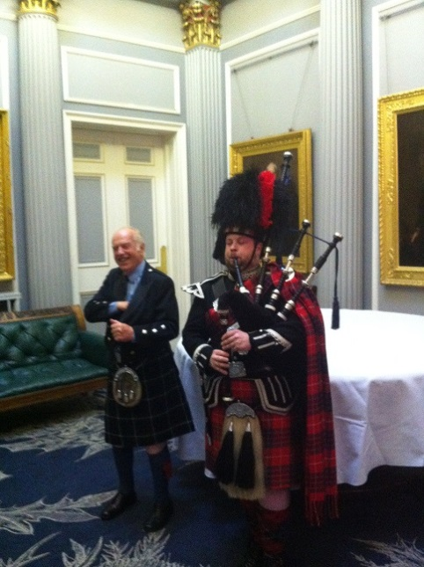
On the evening of Day 3 the Conference dinner was held in the stunning surrounds of the Signet Library. On arrival we were greeted by a piper in full regalia playing the bagpipes for all he was worth. Fortunately this didn’t appear to deter anyone from entering, and some even lingered to listen, proving that drafters come from a broad church (just kidding, I’m partial to the odd bit of piping at times). On entering we discovered that all of the Scottish males in attendance were kilted.
After an excellent meal we were addressed by Lord Hodge, a home-grown Scottish judge of the Supreme Court of the UK. His Lordship delivered an erudite address on the restraints that exist on judicial law-making. Peter Quiggin then concluded the formal part of the Conference by thanking all those responsible for making the Conference the undoubted success that it was. The Vice-President and Treasurer of CALC managed to give Peter a bit of a surprise by presenting him with a cake and cards signed by all those present to celebrate the fact that the day was in fact his birthday.
Dr Duncan Berry (with Piper)
However that was not the end of Conference activities.
Of course drinks and conversation continued at the Signet Library for a considerable time after the formalities were finished.
Day 4 saw 12 intrepid Conference attendees take up Fraser Gough’s offer to escort us to the summit of Arthur’s Seat, Edinburgh’s most prominent landmark. There are various ways to get up to the top, and Fraser chose a route that stopped just short of us needing to use ropes and crampons. The weather was co-operative, the scenery was wonderful and we all survived. What more could you ask for? It was a great experience enjoyed by us all.
Day 5 saw about 30 or so of us board a bus for what was billed as a Stirling tour. We did see Stirling, but not before we had visited Glasgow, and the National Park of Loch Lomond and the Trossachs (a small woodland glen in the Stirling council area). We had a very knowledgeable tour guide, the weather was again co-operative and all in all it was also a very enjoyable experience.
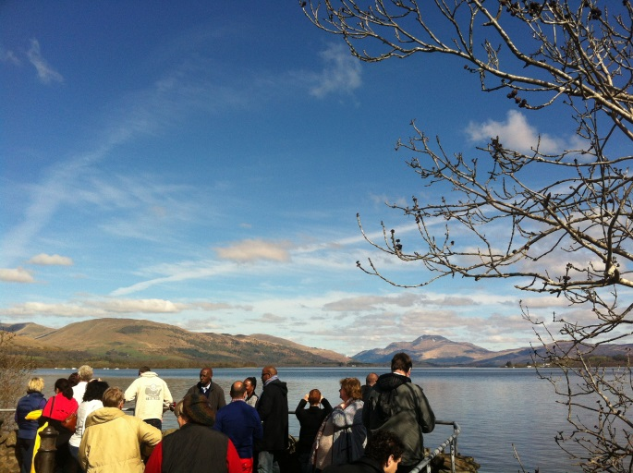
Loch Lomond
Stirling Castle
On behalf of all those who attended those Day 4 and 5 events, I thank the organisers very much for putting them on. [Editor’s note: Likewise for the superbly learned and entertaining lecture on ‘Edinburgh and the Enlightenment’, illustrated with images from the Scottish National Archive, and given specially for Conference delegates at the Scottish Arts Club by the leading authority Professor David Purdie of the Institute for Advanced Studies in the Humanities at the University of Edinburgh.]

The organisation
It is easy to forget to mention the organisers of such a Conference when all runs so seamlessly that they merge into invisibility. Everything did run well, including, most importantly, the sessions themselves. Adequate time was left for questions at the end of each session (some might be aware that this a topic dear to my heart, as it is of el Presidente, Peter Quiggin), and the sessions otherwise ran to time. This was in no small part due to the efforts of timekeeper-extraordinaire, Heather Wortley.
It should be mentioned, too, that the question sessions at the end of the sessions were all well utilised, and some very interesting discussions arose from them.
Returning to the organisers, the most visible of the organisers were Annalee Murphy and Fraser Gough. They each probably needed a new pair of shoes by the end of the Conference. Nothing was too much trouble for them. And, while she wasn't visible, because unfortunately she wasn't able to attend at the last minute, the fingerprints of Madeleine MacKenzie were clearly all over the Conference.
Although Peter Quiggin thanked all everyone at the Conference dinner, I would very much like to give my own thanks to Andy, Heather, Annalee, Fraser, Madeleine , Meryl and all of the people whose names I don’t know who made the Conference the event that it was. I’m sure everyone who attended would like to do the same.

Conclusion
This has been a somewhat lengthy report of the proceedings of the Conference, but it was hard to find a half-way position between reproducing the Conference programme and fleshing it out in a way that did not give overdue emphasis to any particular aspect of the Conference.
It was a great Conference. That is my personal opinion, but I have heard no opinions to the contrary.
Drafting is a very small profession and it is great to have an opportunity to talk drafting with those who understand what you are talking about and to discover that drafters face much the same problems wherever they are. I strongly urge any drafter who has not attended a CALC Conference to go to the next one, wherever it might be (and that is as yet unknown). And obviously if you decide to go, you need to register as soon as possible after registration opens if you want to be sure that you will be able to attend.

Ben Piper

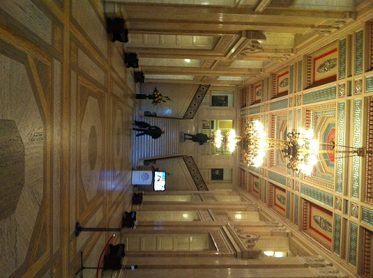
Belfast Workshop Report
On 21 April 2015, Brenda King, First Legislative Counsel for Northern Ireland, hosted this intensive one-day Workshop linked to, and soon after, the 2015 Edinburgh CALC Conference. The venue was the historic former Senate Chamber in the Parliament Buildings for the (now unicameral) Northern Ireland Legislative Assembly at Stormont, near Belfast.
PoliticsPlus is a philanthropic trust that supports initiatives contributing to a positive future for politics (including cross-community sharing of devolved UK government powers after the Peace process’s 1998 Belfast “Good Friday” Agreement). PoliticsPlus generously co-hosted, in conjunction with the Northern Ireland Office of the Legislative Counsel, the Workshop.
Over 60 drafters from across the world, most of whom had spent the previous week in Edinburgh at the 2015 CALC Conference, made the onward journey to Stormont to be welcomed by Mitchel McLaughlin MLA, Speaker of the NI Assembly, and Martin McGuinness MLA, deputy first Minister for NI, and to hear presentations on—
• the legislative process in Northern Ireland,
• the increasing focus on collaborative practices, and
• the role of Assembly legal advisors in terms of assessing legislative competence:
• Members’ perspectives from Paul Givan MLA and Raymond McCartney MLA.
Over lunch, participants had the opportunity to meet with MLAs and gain first hand insight into the needs of legislators.
The event concluded with speeches from Trevor Reaney, Clerk and Chief Executive of the Northern Ireland Assembly, Peter Quiggin, First Parliamentary Counsel for Australia, and Dr Malcolm McKibbin, Head of the Northern Ireland Civil Service.
Delegates’ geographical spread was such that Dr McKibbin remarked that, by the time they return home, they will have collectively travelled over 500,000 miles to attend these events.
In contrast to the serious discussions that characterised most of the day, delegates made their return journey to Belfast City centre in an open-top bus. This afforded them the opportunity to take in many of the key sights, including Saint Anne’s Cathedral, Titanic Belfast, and the Crumlin Road Jail. Delegates enjoyed a related dinner at Ivory Restaurant.
The Workshop enabled attendees to discuss, and learn about, how MLAs, officials, and drafters collaborate to make Northern Ireland law. Attendees were, and are, very grateful to Brenda King and her Northern Ireland Office of the Legislative Counsel, and to PoliticsPlus, for this valuable training and development opportunity, and for their generous hospitality to attendees, many enjoying for their first time experiencing Belfast and Northern Ireland.
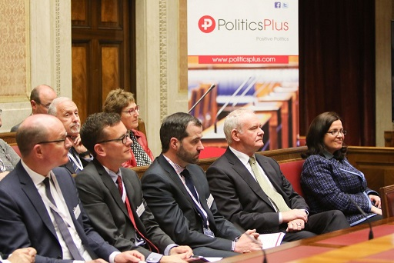
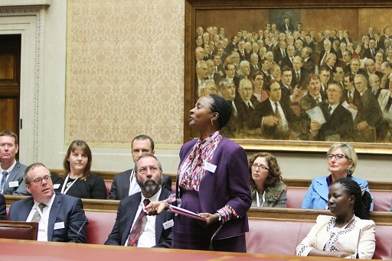
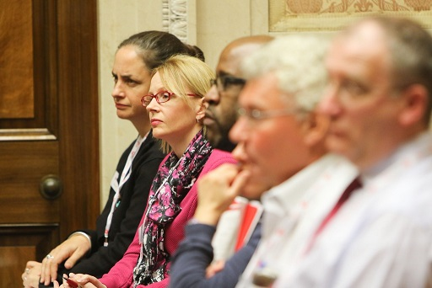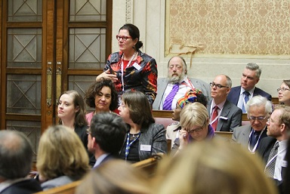

Further workshop photos are at http://politicsplus.com/news-item/collaborative-law-making/

Items of Interest
Obituary: Francis Alan Roscoe Bennion (1923−2015) – Part 2
- “Francis Bennion, barrister, writer and academic, was renowned as a statute and constitutional lawyer and parliamentary draftsman . . . Bennion was driven all his life by the need to defend the rule of law in general and the finer points of jurisprudence and statute law in particular . . . He first came to public prominence in the early 1970s when he took the unusual and expensive step of taking out a private prosecution against Peter Hain for criminal conspiracy. This related to Hain’s activities as chairman of the Stop the Seventy Tour campaign, which disrupted sporting events involving South Africa as a protest against apartheid. It was the first public display of Bennion’s fervent belief in the rule of law. After a lengthy trial Hain was found guilty and fined £200, but the case took its toll on Bennion, costing him his home and his first marriage . . . Much of his legal career was spent at the Parliamentary Counsel office where he was responsible for drafting legislation, including such important bills as the Consumer Credit Act 1974 and the Sex Discrimination Act 1975. For the rest of his life he worked independently, lecturing and writing books on a range of subjects, the best known of which is Bennion on Statutory Interpretation, the fifth edition of which ran to more than 1800 pages and is recognised worldwide as the definitive textbook on this subject. . . He will be remembered for his work on statutory interpretation and it was a tribute to him that, despite its subject, many commented that it was an enjoyable read. As one friend put it: ‘He had this knack of drawing out the fascinating aspects of jurisprudence, injecting humour and amusing anecdotes. Lawyers throughout the common law world will be reaching for their “Bennion” for many years to come.”: “Francis Bennion—Barrister who relentlessly defended the rule of law and took out a private prosecution that cost him his home and marriage”, The Times, Thursday April 2, 2015, page 66 (Editor: thanks to Dr Duncan Berry for his help with this item, and see also the item in the CALC Newsletter February 2015, pp 15-16).
Oaths and validations in Australasia
- In Australia, Queensland’s State Parliament on 7 May 2015 enacted, urgently, validating legislation to address doubts that arose from incorrect oaths having been used to swear in about 24 magistrates and acting magistrates between April 2013 and April 2015. Another magistrate did not take an oath or affirmation at all. The following 3 links are to related news items, and to the 2015 validating Act as enacted:
  - http://www.abc.net.au/news/2015-05-07/queensland-magistrates-used-wrong-oath-during-swearing-in/6451980
  - http://www.theguardian.com/australia-news/2015/may/07/queenslands-magistrates-sworn-in-on-wrong-oath-for-two-years
  - https://www.legislation.qld.gov.au/LEGISLTN/ACTS/2015/15AC001.pdf

Evidence that Acts of this kind are needed elsewhere from time to time includes the Policing (Constable's Oaths Validation) Amendment Act 2009 (NZ) and the Policing (Constable’s Oaths Validation) Amendment Act 2013 (NZ).
Constitutional principles in legislation in New Zealand
- New Zealand’s Justice Minister, The Honourable Amy Adams, said recently that “Some commentators have suggested our constitution is under grave threat because the Judicature Modernisation Bill – which is currently before Parliament – does not include a reference to ‘New Zealand’s continuing commitment to the rule of law and the sovereignty of Parliament’. That phrase is in the [2003] Act that set up the Supreme Court in 2003. The Judicature Modernisation Bill preserves much of the content of that Act, but places it in a new statute covering the Supreme Court, Court of Appeal and High Court . . . To suggest the rule of law and the sovereignty of Parliament are under threat is scaremongering. These principles have always been the foundation of New Zealand’s constitutional arrangements and that won’t change.”: LawTalk Issue 864, 8 May 2015: https://www.lawsociety.org.nz/lawtalk/issue-864/constitutional-principles-in-legislation
Old law, gender neutral drafting, and statute law knowing no doctrine of desuetude
- The 800th anniversary of Magna Carta 1215 has naturally prompted (re)analysis of, and events commemorating, this foundational legislation. Professor Dawn Oliver found, on reading it, some “Surprises in Magna Carta”. Ferdinand Mount’s item “Back to Runnymede” in the 23 April 2015 LRB ended with the claim (given the effect of modern human rights instruments) “Magna Carta is back”. But the item also prompted 2 letters in the 7 May 2015 LRB.
One letter was about whether Magna Carta 1215 was (at least in part) gender neutral drafting. John Gillingham’s letter says Magna Carta “protected the property rights of widows and female heirs as well as those of male heirs. This fundamental fact about English law as declared in Magna Carta is hopelessly obscured by the usual translation of liber homo as ‘free man’.” (Gillingham says “The Latin words in Magna Carta that are conventionally translated as ‘man’ and ‘men’ are homo and homines. But those words in fact meant ‘person’ and ‘people’.”) (Editor: Plain Latin, but lost in translation?)
And Scott Herrick “was disappointed that Ferdinand Mount did not mention A.P. Herbert’s Uncommon Law case Rex v. Haddock of 1926 or so, in which Mr Justice Lugg concludes:

‘I am satisfied that so little of Magna Carta is left that nothing of Magna Carta is left, and therefore that chapter on which the appellant relies must be taken to have perished with the others.
The appellant has done his country an ill service in raising this point, for but for his rash act generations of English orators might have continued in the fond belief that Magna Carta was still the abiding bulwark of our liberties, and for that act I shall order him to pay a further fine of five pounds. But it is no part of my duty to conceal the truth, and I am compelled to declare with some reluctance that Magna Carta is no longer law.’”
While in theory statute law knows no doctrine of desuetude, Imperial legislation is, in New Zealand anyway, prone to fade in effect. As Randerson J said of a submission a jury trial under the Juries Act 1981 (NZ) breached Imperial Acts, “Although these statutes remain in force, they are best viewed as informing the construction to be given to modern statutes, the latter generally being accorded precedence.” The chunk of the Magna Carta 1297 that is part of New Zealand’s laws is very small, and, as Hon David Parker MP argued in New Zealand’s Parliament on 16 May 2015, is mainly – as the great Australian jurist Dennis Denuto submitted (in 1997 Australian comedy film The Castle) – about ‘the vibe of the thing’.
Effect of human rights legislation on assisted suicide legislation
- A terminally ill New Zealand lawyer sought an urgent High Court ruling on whether and, if so, how, New Zealand assisted suicide legislation can be given a meaning consistent with rights affirmed by the New Zealand Bill of Rights Act 1990. The case was informed by, and drew on, similar litigation (invoking different human rights, and with very different outcomes) in the UK, Canada, and South Africa. The outcome has surely set a key precedent in New Zealand, even if it was perhaps not available in time for it to make a difference for that New Zealand lawyer. A statement on behalf of her family said she died (of natural causes) at about 00.35 (New Zealand standard time) on 5 June 2015. The court decision was available to her and her family only just before she died, and released publicly only at 15.00 on 5 June 2015. The litigation and decision has prompted calls for renewal of New Zealand parliamentary consideration of the issues. In the UK, a member’s Bill on this topic is reportedly to be debated in the House of Commons.
Disallowance by Parliament of Judge-made, but ultra vires, Court procedural rules
- In Western Australia, a report dated 24 October 2013 of the Delegated Legislation Committee related to an amendment to the Rules of the Supreme Court. The report recommended disallowance of the amendment on the grounds that it was ultra vires (not ‘within power’ of the Supreme Court Act 1935 (WA)). The disallowance motion was passed by the WA Parliament on 29 October 2013. Supreme Court Rules in Western Australia are made by the judges, not the Executive, but are disallowable. One of the interesting arguments raised by the Chief Justice of WA was that the separation of powers required the Parliament to defer to the courts when it came to the vires of subsidiary legislation made by the judges. See section 9 of the report. The Committee did not accept that view. The report contains interesting discussion of the scope of statutory powers to make rules about Courts’ practice or procedure, and of the roles of Parliament and the Courts. The Delegated Legislation Committee formed the view that in this instance, the boundaries of permissible rule-making had been exceeded and there had been an intrusion into rule-making with respect to substantive rights of parties. In this case, the existing common law right of an administrative decision maker not to give reasons for a decision.

Membership

New CALC members
The following have been recorded as members of CALC from 2 February 2015.

Name |  | Country
Hayes, Julia Margaret |  | New Zealand
Williams, Shane Regan |  | New Zealand
Orr, Amy |  | New Zealand
Dima, Wilson Dima |  | Nairobi
Giacometti, Suzanne Ruth |  | New Zealand
Tannock, Lovette E |  | Bermuda
Black, Dr Robert Leslie Brian |  | UK
Anderson-Lindsay, Stella Marlaine |  | Canada
Egan, Michelle |  | Canada
Grondin, Jacinthe |  | Canada
Corke, Alison Clare |  | Australia
Reardon, June |  | Ireland
Olivier, Michelle E |  | UK
Drennan, Mary |  | Ireland
Norton, Nicola |  | Australia
Lugayizi, Irene |  | Uganda
Denault, Philippe |  | Canada
Onoge, Elohor Stephanie |  | Nigeria
Shamsy, Maleka |  | Canada
Riethmuller, Claire Elizabeth |  | Australia
Rapando, Justin Malala |  | Kenya
Comino, Belinda |  | Australia
Piccolo, Raffaele |  | Australia
Lewandowska, Kate |  | Wales
Treanor, Francis William |  | Ireland
Greene, Latoya Kathryn |  | Bahamas
MacKenzie, Andrea |  | Canada
Kifile, Belayihun Yirga |  | Ethiopia
Oozeer, Ammar |  | Mauritius

CALC member since 2012

Olusegun Lanre-Iyanda, of the Legislative Drafting Office, Legislative Drafting Office, Ministry of Justice/House Of Assembly, Ogun State Of Nigeria, has been a member of CALC since 2012.

Secretary Contact Details
If you wish to contact the CALC Secretary, Ross Carter, regarding membership or any other CALC matters (for example, to suggest or send items for this Newsletter), his email address is:
ross.carter@parliament.govt.nz

Minutes of CALC General Meeting on 16 April 2015
The following are the minutes of the CALC general meeting held on 16 April 2015 at the Playfair Library Hall, Old College, Edinburgh University, Edinburgh, Scotland.

1. Opening of meeting
The meeting began at 2pm and was opened by the CALC President, Peter Quiggin PSM, First Parliamentary Counsel, Office of Parliamentary Counsel, Australia.

2. Apologies and proxies
No express apologies were received. An express apology from Walter Iles (New Zealand) was noted later by Ross Carter (at the time helping give members their voting papers).
A total of 182 proxies were lodged within the time limit prescribed by the CALC Constitution. (A list of the 24 people holding those 182 proxies, and of the number that each person held, is in Appendix 1.) Those proxies were taken as apologies.

3. Minutes of previous CALC general meeting
The meeting confirmed unanimously the minutes of the previous general meeting held in Cape Town on 11 April 2011.
Proposer: Theresa Johnson (Australia)
Seconder: Sandra Markman (Australia)

4. President’s report
The President, Peter Quiggin, summarised the report (which was provided to attendees in the conference registration pack). Among the matters noted were:
- the organisation of the 2015 CALC Conference, with particular thanks being given to Katy Le Roy (programme committee chair), John Mark Keyes (finance committee chair), and the Office of Scottish Parliamentary Counsel for local support (in particular Andy Beattie, Fraser Gough, Madeleine MacKenzie, Annalee Murphy, Meryl Skene, Heather Wortley, and Ian Young):
- CALC’s work on its engagement with the Commonwealth Secretariat:
- CALC’s representation at the Commonwealth Heads of Government (CHOGM) meeting in Sri Lanka in 2013:
- CALC’s being represented on a working party for a Commonwealth Secretariat project established to investigate a low cost IT system for smaller drafting offices:
- CALC’s publications The Loophole and the CALC Newsletter:
- CALC’s webpage and the Linked-In Forum established for CALC members:
- CALC Council Working Groups established to investigate various things raised in a paper presented to the CALC Council by Eamonn Moran and Duncan Berry:
- amendments to the CALC Constitution to be put before the General Meeting:
- review of CALC’s payment arrangements and use of PayPal to receive payments:
- the ongoing review of CALC’s taxation status:
- the work and contribution of CALC Council members, especially ones not standing for re-election (Elizabeth Bakibinga-Gaswaga, Fiona Leonard, Empie Van Schoor, Bilika Simamba, Beng Ki Owi, Paul Peralta and Edward Stell):
- greater involvement of CALC in regional activities such as conferences:
- CALC merchandise and job advertisements on CALC’s webpage.
A copy of the report is contained in Appendix 2.

5. Secretary’s report
The Secretary, Fiona Leonard, summarised this report, which covers about 25 months (from CALC’s last general meeting, in Cape Town, on 11 April 2013, to 16 April 2015), and was provided to attendees in the conference registration pack.
The Secretary advised the meeting that membership had continued to grow and, as at 31 March 2015, the total number of full members was 1,491 (up from 1288), and the total number of associate members was 131 (up from 114). There are CALC members in 85 countries. Other matters particularly mentioned were as follows:
- the CALC Council’s meeting and decision-making in the period:
- CALC’s publications and their notification and availability to members
- updating of the CALC membership application form, and how CALC membership applications are processed:
- the Linked-In Forum established for CALC members.
A copy of the report is contained in Appendix 3.

6. Treasurer’s report
The Treasurer, John Mark Keyes, presented this report, which focussed especially on the CALC financial statements, 5 March 2015, as reviewed (but not audited) in the 6 April 2015 review report by McCay Duff LLP, Licensed Public Accountants, Ottawa, Ontario, which was provided to attendees in the conference registration pack.

Matters particularly mentioned were as follows:
- the statement of financial position as at 5 March 2015:
- the statement of operations for the 23-month period ended 5 March 2015:
- the statement of cash flows for the period ended 5 March 2015:
- the ongoing review of CALC’s taxation status:
whether clauses 11(6)(b) and 13(3)(b) of the CALC Constitution should be amended to refer to a review (rather than an audit) of CALC’s financial statements (and notably subclause (1) of clause 11 could also usefully be numbered “(1)”).
A motion to accept all three reports was moved by Estelle Appiah and seconded by Paul Peralta and the motion was carried.
The financial statements were previously sent to CALC members (and a copy can be obtained by CALC members, on request, from the CALC Secretary, President, or Treasurer).

7. Election of CALC Council
Executive members
The meeting elected unopposed the following officers:
- President: Peter Quiggin
Proposer: Therese Perera (Sri Lanka)
Seconder: Eamonn Moran (Australia)
- Vice-President: Katy Le Roy
Proposer: Peter Quiggin (Australia)
Seconder: Elizabeth Bakibinga-Gaswaga (Uganda)
• Secretary: Ross Carter
Proposer: Fiona Leonard (New Zealand)
Seconder: David Noble (New Zealand)
• Treasurer: John Mark Keyes
Proposer: Philippe Hallée (Canada)
Seconder: Janet Erasmus (Canada)
Non-executive members
Non-executive members of the Council were, under clause 9(3) of the Constitution, elected for 5 regions (Africa, Asia, Europe, the Americas, and Australasia and the Pacific).

The meeting elected unopposed the following candidates as Council members for Asia:
• Lawrence Peng (Hong Kong)
Proposer: Eamonn Moran (Australia)
Seconder: Theresa Johnson (Australia)
• Therese Perera (Sri Lanka)
Proposer: Katy Le Roy (New Zealand)
Seconder: Eamonn Moran (Australia)
The meeting elected unopposed the following candidate as a Council member for the Americas:
• Philippe Hallée (Canada)
Proposer: John Mark Keyes (Canada)
Seconder: Janet Erasmus (Canada)
A nomination was sought from the meeting for a second Council member for the Americas, and resulted in the election unopposed of the following candidate:
• Bethea Christian (Cayman Islands)
Proposer: Bilika Simamba (Cayman Islands)
Seconder: Duncan Berry (Kenya)
The meeting elected unopposed the following candidates as Council members for Australasia and the Pacific:
• Don Colagiuri (Australia)
Proposer: Eamonn Moran (Australia)
Seconder: Robyn Hodge (Australia)
• Theresa Johnson (Australia)
Proposer: David Noble (New Zealand)
Seconder: Walter Munyard (Australia)
The following 3 candidates were nominated for Africa:
• Estelle Appiah (Ghana)
Proposer: Dale Dewhurst (Canada)
Seconder: Elizabeth Bakibinga-Gaswaga (Uganda)
• Isabel Fremone Omal (Uganda)
Proposer: (Uganda)
Seconder: (Uganda)
• Jacques Wolmarans (South Africa)
Proposer: Catherine Elizabeth Dalby (South Africa)
Seconder: Mark Vivian Serfontein (South Africa)

After a ballot, Estelle Appiah and Jacques Wolmarans were declared duly elected to represent Africa.
The following 4 candidates were nominated for Europe:
• Adrian Hogarth (United Kingdom)
Proposer: Alex Gordon (Scotland)
Seconder: Edward Stell (United Kingdom)
• Brenda King (Northern Ireland)
Proposer: Eamonn Moran (Australia)
Seconder: Madeleine Mackenzie (Scotland)
• Lucy Marsh-Smith (Jersey)
Proposer: Clive Borrowman (Jersey)
Seconder: Theresa Graves (Jersey)
• Muhammad Majibar Rahman (Gibraltar)
Proposer: Paul Peralta (Gibraltar)
Seconder: Duncan Berry (Kenya)
After a ballot, Adrian Hogarth and Brenda King were declared duly elected to represent Europe.

8. Constitutional changes
The President, Peter Quiggin, indicated notices of motion had been given for, and related information copied to members on, these 4 proposals for changes to CALC’s Constitution:
• Proposal 1—notice of motion moved by resolution of CALC Council—amendments relating to Treasurer—the President explained these amendments were technical and to make clearer the Treasurer’s functions—discussion was called for, but very limited, on these proposed amendments. They were voted on and carried:
• Proposal 2—notice of motion moved by resolution of CALC Council—amendments related to regional representation and election of non-executive council members—most of the outgoing CALC Council opposed these changes, but the outgoing CALC Council did consider members needed to be given a chance to vote on the matter—discussion was called for, and considerable, on these proposed amendments (speakers against included Katy Le Roy, Bilika Simamba, Duncan Berry, John Wilson, Paul Peralta, and Eamonn Moran, and speakers for included Daniel Greenberg, John Mark Keyes, Sandra Markmnan, and John Ugolo). They were voted on and failed:
• Proposal 3—notice of motion moved by resolution of CALC Council—amendments related to timing of proxies—the outgoing Secretary explained these amendments were to make proxies easier to manage and work with for General Meetings—discussion was called for—Duncan Berry proposed altering “24” to “2” hours before the General Meeting’s start—but the President ruled the alteration out of order as it lacked the requisite special notice of motion. They were voted on and carried:
• Proposal 4—notice of motion proposed by Duncan Berry and seconded by Eamonn Moran—electronic voting and postal voting, and abolition of voting by proxy, for constitutional amendments and Council elections—Duncan Berry explained the proposed amendments were meant to enhance participation and that electronic voting had worked extremely well for regional organisations—Eamonn Moran expressed reservations about postal voting—the President’s report had earlier expressed substantial concerns about the practicality of the proposal and the burden placed on the returning officer, and suggested a better approach would be for the matter to be (and the President gave an undertaking that the electronic voting aspect would be) referred to Council for detailed consideration—speakers for the motion included John Wilson, Dale Dewhurst, and Thomas Ahflors, and speakers against the motion (most of whom did not oppose electronic voting per se but did not support the detail of the present motion) included Peter Quiggin, Katy Le Roy, David Noble, and Don Colagiuri—the electronic voting aspect of the proposed amendments was put to a vote and failed, but the undertaking for the Council to consider the merit of proposed changes stands—the President indicated one option may be to develop or explore a proposal based on election rules allowing members to use proxies to direct the President or Secretary to vote as directed at General Meetings.

9. General business
Ben Piper (Australia) moved a vote of thanks to all officers of the Council, and especially the President, Peter Quiggin, for all their hard work and tremendous contribution to the CALC. Ben noted in particular the support given to CALC and its webpage by the Australian Commonwealth Office of Parliamentary Counsel. The motion was carried with acclamation.
Duncan Berry raised for consideration, and further discussion and work, the matters raised in a paper earlier presented to the CALC Council by Eamonn Moran and Duncan Berry, and related to CALC’s goals and objectives in helping smaller drafting offices and jurisdictions. Eamonn Moran suggested CALC’s activities and resources could be properly directed to these ends. Lucy Marsh-Smith asked about the proposed IT systems project. The President indicated the CALC Council’s work on these matters is ongoing, and that preliminary reports had been prepared by Council working groups on some of these matters. The President also indicated the IT systems project was ambitious and potentially hard to implement.
The host country and precise location of the next Commonwealth Law Conference – and hence of the next CALC Conference – was also discussed, but was not yet known. Members would be advised as soon as this information became available to the Council. The requirements of clause 12(1) of the CALC Constitution – and their interpretation in respect of the 2015 General Meeting (held at Edinburgh, 45 minutes from the 2015 Commonwealth Law Conference held in Glasgow), were also noted.
The President moved a vote of thanks to Douglass Bellis (USA) for acting as a returning officer for, and announcing the outcomes of, the ballots. The motion was carried.
The President also indicated the incoming CALC Council members attending the Conference would (in line with clause 10(1) of CALC’s Constitution) meet at 12.45pm on 17 April 2015 at the Playfair Library Hall, Old College, Edinburgh University, Edinburgh, Scotland.

10. Closure of meeting
The meeting closed at about 4.40pm.

Ross Carter
Secretary of CALC
8 May 2015

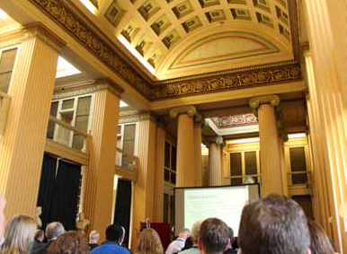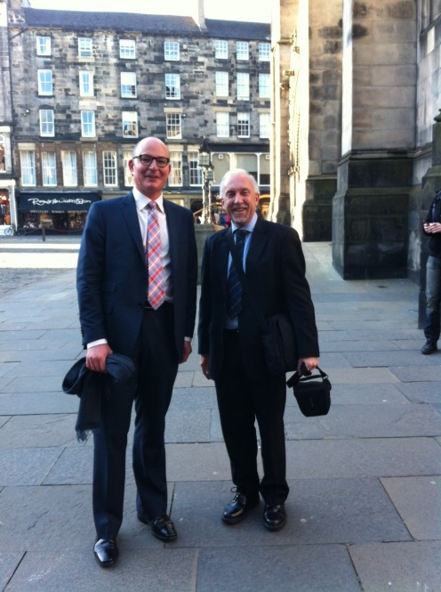
Ross Carter (and Geoff Lawn), outside Signet Library, Edinburgh
Playfair Library Hall, Edinburgh University

Appendix 1 (1 page) – People holding proxies and number

Name Number of proxies
Estelle Appiah 6
David Bingham 4
Don Colagiuri 8
Duncan Berry 4
Tsitsi Chitsiku 3
Joanne Guzman 1
Phillipe Hallée 11
Theresa Johnson 18
Catherine Johnston 13
John Mark Keyes 6
Geoff Lawn 15
Fiona Leonard 3
Katy Le Roy 4
Amanda MacFarlane 1
Sandra Markman 1
Lucy Marsh-Smith 1
Eamonn Moran 5
Scott Murray 1
David Noble 4
Leeanne O’Brien 3
Paul O’Brien 10
Peter Quiggin 44
Muhammad Majibar Rahman 7
Mary Toohey 9

Totals

24 names 182 proxies

Appendix 2 (6 pages) – President’s report

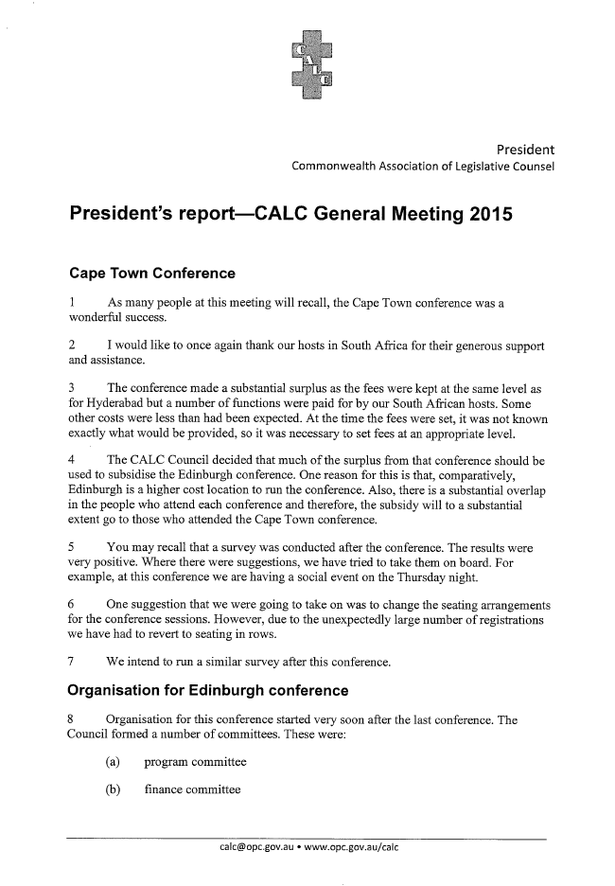
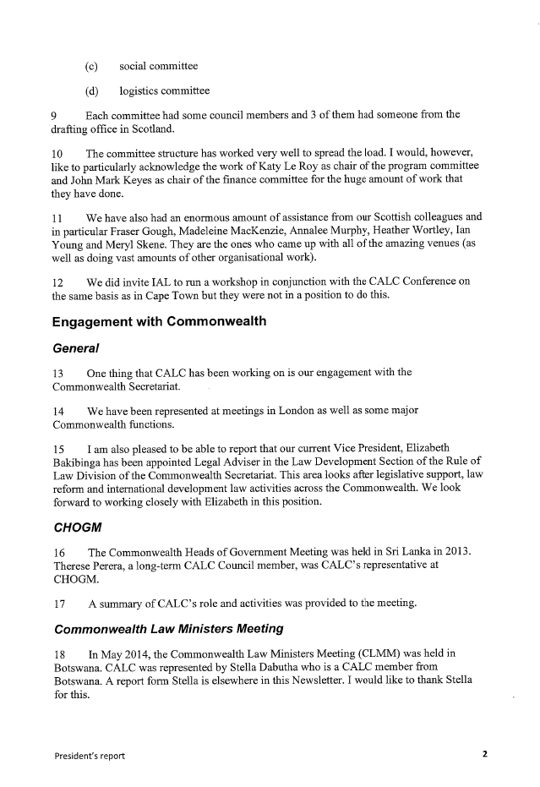
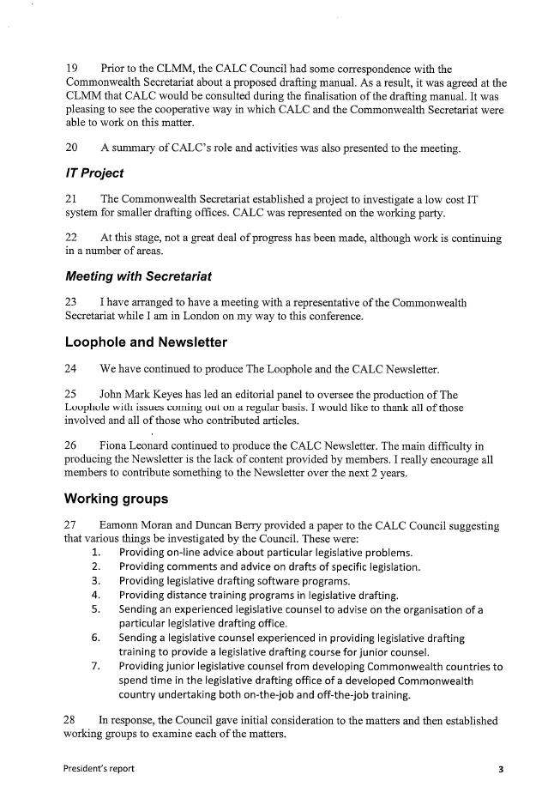
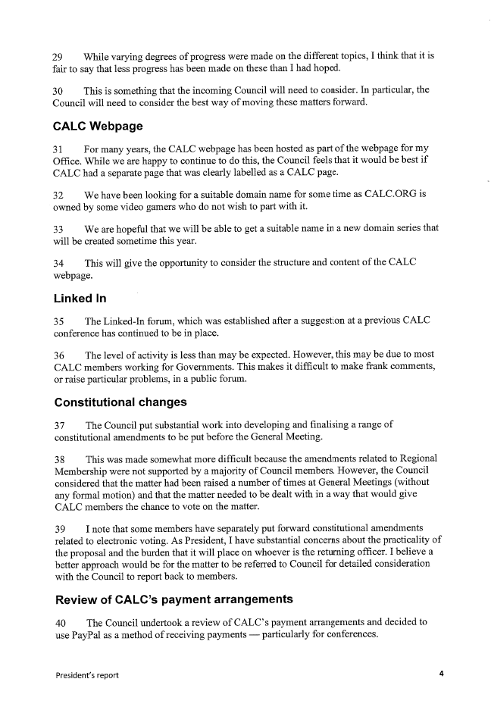
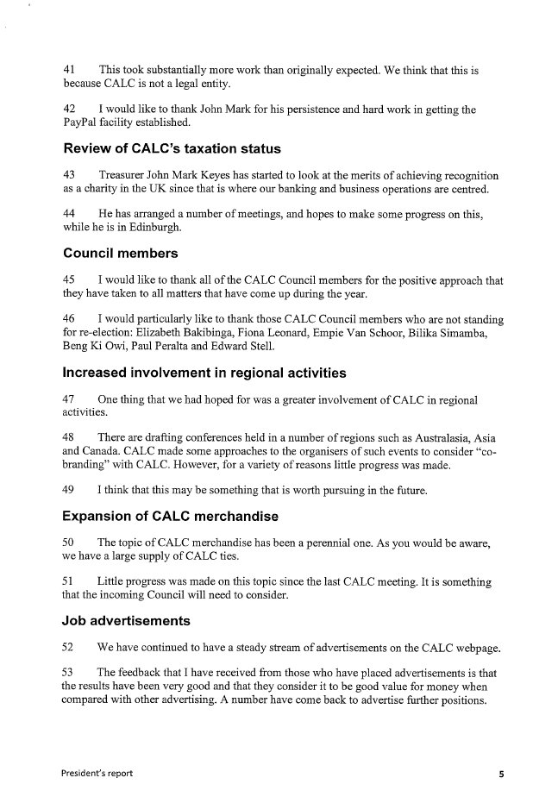
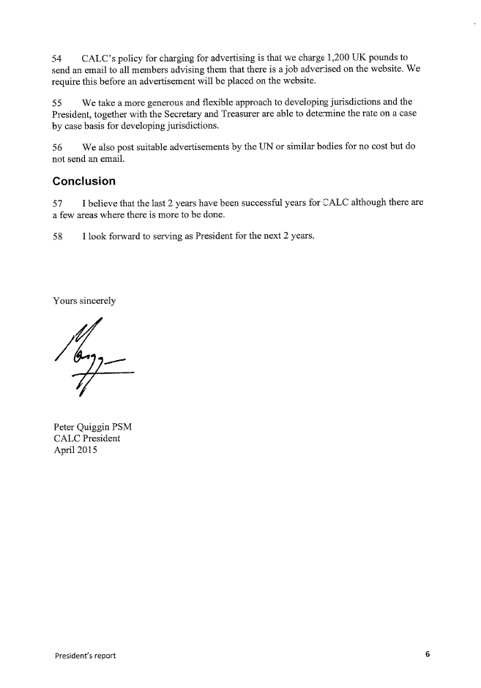

Appendix 3 (2 pages) – Secretary’s Report

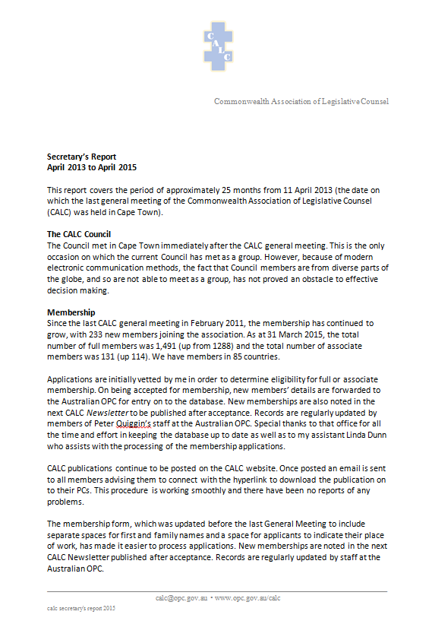
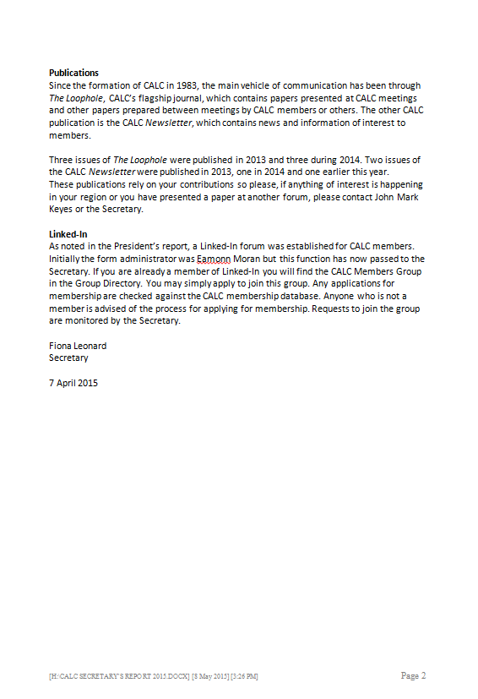

https://www.gov.uk/government/world/cayman-islands
https://www.gov.uk/government/world/organisations/the-governors-office-cayman-islands
http://www.gov.ky/portal/page?_pageid=4741,7910876&_dad=portal&_schema=PORTAL
https://www.judicial.ky/home/judicial-administration/about-us-judicial-admin
http://www.legislativeassembly.ky/portal/page?_pageid=4242,7282842&_dad=portal&_schema=PORTAL
https://www.gov.uk/government/world/organisations/the-governors-office-cayman-islands
http://www.legislativeassembly.ky/portal/page?_pageid=4242,7282365&_dad=portal&_schema=PORTAL
http://www.legislativeassembly.ky/portal/page?_pageid=4242,7395784&_dad=portal&_schema=PORTAL
http://www.constitution.gov.ky/www.constitution.gov.ky/portal/pagee8bf.html
http://www.constitution.gov.ky/www.constitution.gov.ky/portal/pagee8bf.html
http://www.constitution.gov.ky/www.constitution.gov.ky/portal/page927f.html
https://www.judicial.ky/home/the-portfolio-of-legal-affairs/about-us-legal-affairs
https://www.judicial.ky/home/the-portfolio-of-legal-affairs/about-us-legal-affairs
http://www.gazettes.gov.ky/portal/page?_pageid=5281,1&_dad=portal&_schema=PORTAL
http://www.gazettes.gov.ky/portal/page?_pageid=5281,1&_dad=portal&_schema=PORTAL
http://www.gazettes.gov.ky/portal/page?_pageid=5281,1&_dad=portal&_schema=PORTAL
It might be mentioned that a life-sized (at least) statue of Robbie Burns stands about 200 metres from the Office of the Chief Parliamentary Counsel in Victoria, Australia, and that a previous Victorian Chief Parliamentary Counsel (Bernard O’Dowd) was a published poet, although neither of these facts has inspired Ode writing in that Office recently.
On Day 1 Daniel Greenberg, in response to a question about what a drafter should do if asked to draft a ‘gesture-political’ provision, lamented that this technique didn’t work so well these days – what a drafter thought was an obvious ‘horror’ was often exactly what the policy maker was after.
http://www.legislation.govt.nz/bill/government/2013/0178/latest/versions.aspx
http://www.legislation.govt.nz/act/public/2003/0053/latest/DLM214035.html
See, for example, https://magnacartanz.wordpress.com/events-in-nz-in-2015/ and http://magnacarta800th.com/events/ and http://www.theguardian.com/uk-news/2015/jun/15/queen-leads-celebration-of-800-years-of-magna-carta-at-runnymede and http://beehive.govt.nz/release/government-commemorates-800th-anniversary-magna-carta
http://ukconstitutionallaw.org/2015/03/23/dawn-oliver-surprises-in-magna-carta/
Vol. 37 No. 8 · 23 April 2015 pages 15-18: http://www.lrb.co.uk/v37/n08/ferdinand-mount/back-to-runnymede
Ellis v R [2011] NZCA 90 at [70] per Randerson J; [2011] NZSC 60.
http://www.legislation.govt.nz/act/imperial/1297/0029/latest/DLM10929.html.
http://lecretia.org/ and http://www.listener.co.nz/current-affairs/health-current-affairs/dying-wishes/ and http://www.otago.ac.nz/cs/groups/public/@otagocommunications/documents/webcontent/otago107806.pdf
For example, Nicklinson [2014] UKSC 38 (http://www.bailii.org/uk/cases/UKSC/2014/38.html); Stransham-Ford [2015] ZAGPPHC 230 (http://saflii.org/za/cases/ZAGPPHC/2015/230.html); and Carter 2015 SCC 5 (http://www.canlii.org/en/ca/scc/doc/2015/2015scc5/2015scc5.html).
http://m.nzherald.co.nz/nz/news/article.cfm?c_id=1&objectid=11457940
Seales v Attorney-General [2015] NZHC 1239: http://www.nzlii.org/cgi-bin/sinodisp/nz/cases/NZHC/2015/1239.html.
http://www.theguardian.com/society/2015/jun/09/assisted-dying-mps-debate-legislation-lord-falconer-bill-terminally-ill-right-to-die.
http://www.parliament.wa.gov.au/Parliament/commit.nsf/(Report+Lookup+by+Com+ID)/50DE213607802F0148257C0E0007DA46/$file/dg.3901.131024.rpf.066.xx.pdf?-CSLNAUTHV10=000A05EC00010093
Interpretation Act 1984 (WA),s 42: http://www.austlii.edu.au/au/legis/wa/consol_act/ia1984191/s42.html.

